GLUCOTWIN
Architecture Workflow & System Diagram
Multimodal glucose-risk prediction for Type 2 Diabetes
PURPOSE
This document explains the GlucoTwin prototype architecture, end-to-end data workflow, major technical components, and evaluation and safety considerations. It is technical project documentation, not evidence of clinical validation.

1. System Architecture Diagram
The diagram shows the main sequence from data acquisition to application delivery. Evaluation and platform services support the end-to-end workflow.
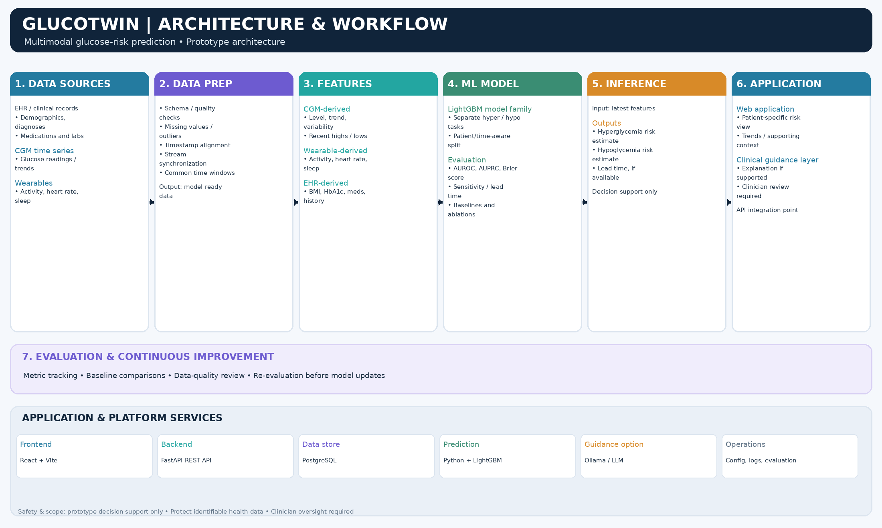
Figure 1. High-level architecture. Confirm exact data fields, prediction horizons, and deployment boundaries against the current implementation.

2. End-to-End Architecture Workflow

Step 1 — Data sources
The workflow can combine electronic health record (EHR) information, continuous glucose monitoring (CGM) time series, and wearable signals when available. EHR data may include demographics, diagnoses, medications, laboratory results, and history. CGM data provides glucose measurements and temporal trends. Wearables may provide activity, heart-rate, and sleep-related signals.

Step 2 — Data preparation
Inputs are checked for schema consistency and quality. The preparation stage handles or flags missing values and outliers, aligns timestamps, synchronizes available streams, and creates consistent time windows. Quality issues should be flagged rather than silently treated as valid measurements.

Step 3 — Feature engineering
Features may include current glucose level, trend and variability; activity, heart-rate and sleep summaries; and selected clinical context such as BMI, HbA1c, medications, comorbidities, and prior history. Only fields actually present and validated in the implementation should be described as active inputs.

Step 4 — Model training
The documented prototype uses a LightGBM model family for separate hyperglycemia and hypoglycemia prediction tasks. Training and evaluation should avoid patient leakage and respect time order where applicable. Target labels and the prediction horizon must be explicitly defined.

Step 5 — Model evaluation
Use complementary metrics such as AUROC, AUPRC, Brier score, sensitivity at a defined operating point, and lead-time analysis where supported. Baselines and feature ablations can test the contribution of additional data sources. Metrics must come from a verified, consistent evaluation run.

Step 6 — Inference
At inference time, the latest validated features are passed to the model service. Outputs may include hyperglycemia and hypoglycemia risk estimates and an estimated lead time if supported. Present outputs with relevant context, data-quality caveats, and model-version information.

Step 7 — Application and review
The frontend presents patient-specific outputs and context. A backend API coordinates requests, data access, and inference. Any language-model guidance layer is optional and must be grounded in available evidence. Clinical interpretation and decisions remain with qualified professionals.

Step 8 — Monitoring and improvement
Track data quality, model performance, input-distribution changes, and versioned evaluation results. Evaluate updates before release. Reviewer feedback can inform improvements but should not automatically be treated as ground truth.

3. Main Technical Components
Component | Technology | Role
Frontend | React + Vite | Web interface and patient-specific views.
Backend API | FastAPI | REST endpoints and orchestration between UI, data store, and inference.
Data store | PostgreSQL | Structured storage for application and patient/event records, according to configured schema and access controls.
ML inference | Python + LightGBM | Model training/evaluation and risk-estimation workflow.
Optional guidance | Ollama / LLM layer | Optional contextual language output if configured; must not invent clinical facts or replace clinician review.
Operations | Evaluation scripts, metrics, logs, versioning | Repeatable evaluation, monitoring, debugging, and traceability.

4. Data Flow and Interfaces
At a logical level, the frontend sends requests to the backend API. The backend validates requests, accesses authorized records from the configured data store, prepares model inputs, and invokes prediction logic. Estimates and supporting context are returned to the frontend. If an optional language-model layer is enabled, it should receive only the minimum necessary context and operate within explicit safety and privacy constraints.
- Input boundary: validated records and time-series data, with timestamps and provenance where available.
- Processing boundary: data-quality checks, time alignment, feature generation, and inference.
- Output boundary: model estimates, supporting context, version metadata, and clear limitations.
- Security boundary: authentication, authorization, secret management, encryption, logging, and access controls must be configured before real patient data is used.

5. Evaluation and Reporting
A defensible report should state the data source, patient/time split, target labels, prediction horizon, sample counts, class balance, model version, baseline results, and metric definitions. AUROC alone is not sufficient for imbalanced event prediction; AUPRC and calibration-related metrics are also useful. Lead-time results require a clear definition and unit.
Do not combine headline metrics from one evaluation run with ablation metrics from another without explaining the difference. Reconcile inconsistent values before submission. Evaluation on development or synthetic data is not proof of clinical performance.

6. Safety, Privacy, and Limitations
- Prototype status: this architecture does not establish regulatory clearance or clinical validation.
- Human oversight: risk estimates are decision-support outputs, not autonomous diagnoses or treatment instructions.
- Data quality: missing, delayed, inaccurate, or misaligned data may affect estimates.
- Generalization: performance may change across populations, devices, care settings, and collection practices.
- Privacy: protect identifiable health information with least-privilege access, secure configuration, and appropriate auditing.
- LLM limitation: generated explanations must be grounded in available records and model outputs; exclude unsupported claims.

7. Summary
GlucoTwin is organized as a modular workflow: acquire available patient signals, validate and synchronize data, derive features, train and evaluate prediction models, serve risk estimates, and present outputs for human review. Credibility depends on reproducible evaluation, transparent limitations, privacy safeguards, and qualified clinical oversight.
Implementation note: verify every listed input, service, and deployment control against the current repository before external submission.

