DIGITAL TWIN CHALLENGE 2026 | HAPPIEST HEALTH | REIMAGINING & REFORMING HEALTHCARE IN INDIA SUMMIT
GlucoTwin
A dual-stream Digital Twin for predicting glycaemic events in Type 2 Diabetes, with evidence-linked investigation support for clinicians

Project type: Proof-of-concept prototype and technical proposal
Condition: Type 2 Diabetes Mellitus (India)
Predicted adverse events: Hyperglycaemia (> 180 mg/dL) and hypoglycaemia (< 70 mg/dL) within the next 120 minutes
Data: Synthetic EHR (Synthea-style) fused with simulated wearable time series (CGM, HRV, sleep, steps)
Submission deadline: 20 October 2026, 7:00 PM IST

TEAM DETAILS (fill before submission)
Team name: [Team Name] | College / incubator: [College Name] | Team leader: [Name, email, phone] | Members: [Name 1], [Name 2], [Name 3], [Name 4]

DATA AND SAFETY STATEMENT
All data in this project is synthetic. The prototype is a research and education proof of concept. It is not a medical device, has not been clinically validated, and does not diagnose, prescribe, order or cancel tests. Final decisions always remain with the clinician.

1. Executive summary
GlucoTwin is a proof-of-concept Digital Twin of a patient with Type 2 Diabetes. It keeps one continuously updated virtual replica per patient by fusing two data streams: a static stream (simulated electronic health record) and a dynamic stream (simulated wearable data, mainly continuous glucose monitor readings, heart-rate variability, sleep and steps).
A predictive model reads both streams and estimates the probability that the patient's glucose will go above 180 mg/dL (hyperglycaemia) or below 70 mg/dL (hypoglycaemia) within the next 2 hours, so the care team can act before the event. A clinician dashboard shows the live twin, the forecast, the reason behind each alert, and a short list of investigations that may be due, based on versioned, evidence-linked rules.

What makes the project different
- True dual-stream fusion. The EHR changes how the model reads the sensor data (for example, medication type and HbA1c shift the baseline and the hypoglycaemia risk), and we prove this with an ablation: EHR-only vs CGM-only vs fused.
- A twin, not just a model. Each patient has a persistent state (recent trends, last-test dates, risk history) that updates as new readings arrive and as the doctor records decisions.
- Explainable and safe. Every alert comes with the factors behind it. Investigation suggestions are review prompts linked to a rule version and a source, never orders.
- Honest evaluation. We report patient-wise held-out results, calibration and lead time, and we state clearly what synthetic data can and cannot prove.

2. Problem statement and healthcare use case
Type 2 Diabetes is a prevalent chronic condition in India, and day-to-day glucose control is the part that most often slips between clinic visits. Patients typically see a doctor every few months, while dangerous glucose excursions happen in hours. At the same time, the clinician has to decide which investigations are due without a consolidated view of the patient's history.
Gap today | Consequence | What GlucoTwin does
Glucose problems are noticed after they happen | Avoidable hypo- and hyperglycaemic episodes | Forecasts events up to 2 hours ahead from CGM trends plus patient context
Sensor data and clinical record live in separate places | No single patient picture at the point of care | Fuses both into one twin state per patient
Alerts without reasons are ignored | Alert fatigue, low trust | Shows top contributing factors for each alert
Due and recent tests are hard to track | Missed or redundant investigations | Evidence-linked rules show what is due, what is recent, and why

Target user: the treating doctor or diabetes care team (primary), with patient-facing alerts as a future extension.
Problem statement: Build a proof-of-concept Digital Twin that ingests simulated EHR data and simulated wearable time series for a Type 2 Diabetes patient, and predicts a glycaemic adverse event two hours in advance, with a clinician-facing dashboard concept.

3. How the project maps to the challenge requirements
Challenge requirement (from the Unstop page) | How GlucoTwin meets it | Where in this document
One specific chronic or lifestyle condition prevalent in India | Type 2 Diabetes | Section 2
Static/historical stream: simulated EHR (demographics, diagnoses, labs, genetic markers) | Synthea-style synthetic EHR: demographics, comorbidities, HbA1c, eGFR, lipids, medications, a synthetic genetic risk score | Sections 5 and 6
Dynamic/real-time stream: wearable or IoT time series (HRV, CGM, sleep stages, step count) | Simulated CGM (5-minute), heart rate and HRV, sleep stages, steps; open CGM dataset used as a sanity check | Sections 5 and 6
Fusion of the two streams | Early fusion of engineered sensor features with EHR context features; ablation proves the value of fusion | Section 7
Working model that predicts an adverse event in advance | Hyper- and hypoglycaemia risk within the next 120 minutes | Section 7
Conceptual doctor dashboard for the virtual patient | Clinician console wireframe and interaction flow | Section 9
Only anonymized, open-source or synthetic data | 100 per cent synthetic data; no real patient data at any stage | Section 5, 11
Public GitHub repo with README, 20-minute video, architecture diagram, presentation, license | Repository layout, README checklist, video outline and license plan | Sections 13 to 15

4. Solution overview and architecture
The system has five layers. Data flows from left to right; clinician decisions and fresh data flow back to update the twin state.
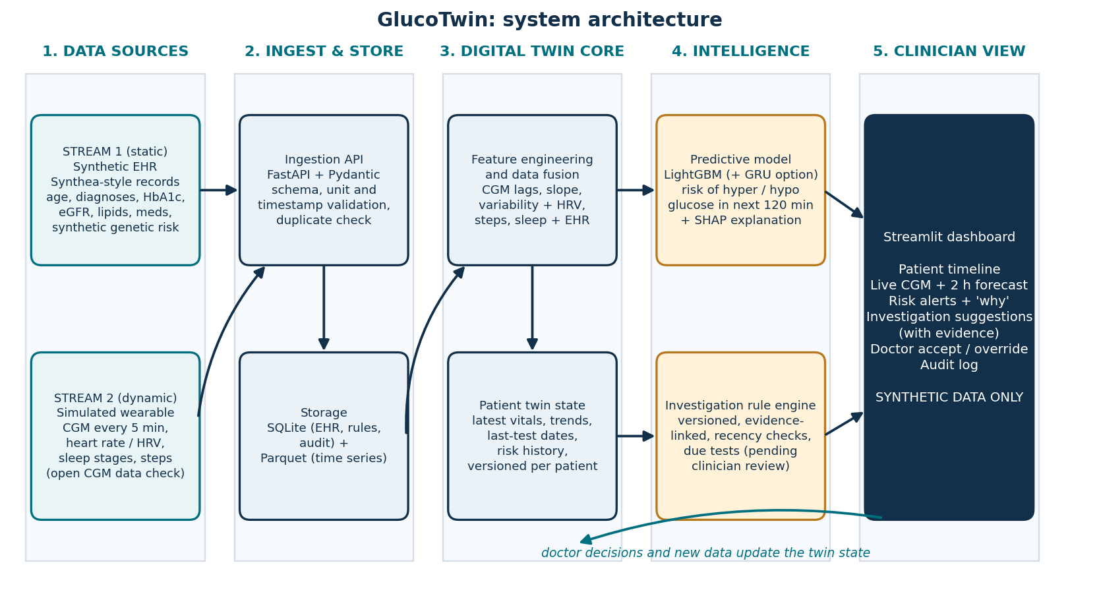
Figure 1. GlucoTwin system architecture (dual-stream fusion, twin state, prediction and rule engine, clinician dashboard)
Layer | Responsibility | Key technology
1. Data sources | Stream 1: synthetic EHR. Stream 2: simulated wearable time series. Optional open CGM dataset for a sanity check. | Synthea, custom Python simulator
2. Ingest and store | Validate schemas, units and timestamps; reject duplicates; keep raw and cleaned data. | FastAPI, Pydantic, SQLite, Parquet
3. Digital twin core | Build fused features and maintain a per-patient twin state that updates with each new reading or visit. | Pandas, NumPy
4. Intelligence | Predict 2-hour hyper- and hypoglycaemia risk; explain it; evaluate investigation rules. | LightGBM, optional GRU (PyTorch), SHAP, rule engine
5. Clinician view | Show timeline, live CGM with forecast, alerts with reasons, investigation suggestions, doctor decisions. | Streamlit, Plotly

5. Data strategy
The challenge requires anonymized, open-source or synthetic data. We use a two-source plan that is fully reproducible and works without waiting for any access approval.

5.1 Stream 1: static / historical (EHR)
- Primary: a synthetic cohort of 300 to 500 adult Type 2 Diabetes patients. Demographics, diagnoses, medications and lab history follow a Synthea-style structure (CSV or FHIR R4). Where Synthea's default modules do not provide the fields we need (for example, a complete HbA1c history), we generate them with a documented script and say so in the README.
- Fields: age, sex, BMI, years since diagnosis, comorbidities (hypertension, CKD stage), medications (metformin, sulfonylurea, insulin, others), HbA1c history with dates, eGFR, UACR, lipid profile with dates, family history, and a synthetic genetic risk score.
- Not used as the main source: MIMIC-IV. It needs credentialed access and a data-use agreement, and it is ICU data, so it does not match an outpatient Type 2 Diabetes use case.

5.2 Stream 2: dynamic / real-time (wearable)
- Primary: a physiologically inspired simulator that produces, per patient, 14 to 30 days of 5-minute CGM readings plus heart rate and HRV, sleep stages and step counts.
- Link to the EHR: the simulator ties glucose behaviour to each patient's record. For example, baseline glucose is derived from HbA1c using the published estimated-average-glucose relationship; insulin sensitivity depends on BMI and drugs; sulfonylurea or insulin use raises hypoglycaemia likelihood; poor sleep and low activity raise next-day glucose. This is what makes fusion meaningful rather than cosmetic.
- Realism features: three meals a day with variable carbohydrate load, dawn effect, post-meal response curve, exercise effect, autocorrelated sensor noise, and random sensor dropouts.
- Sanity check: run the same feature pipeline and a pre-trained-on-synthetic model on an open CGM dataset (see below) to confirm the pipeline handles real-world signal shape. We report this as a pipeline check, not as clinical validation.

5.3 Datasets and sources
Confirm each licence and access condition on the source page before use. Links below were listed from known official project pages and should be re-checked before final submission.
Dataset / tool | What it is | Access | Role in GlucoTwin
Synthea  sample downloads | Open-source synthetic patient generator (CSV, FHIR exports) | Open | Stream 1 structure and base cohort
CGMacros (PhysioNet) | CGM and meal data with participants across healthy, pre-diabetic and Type 2 Diabetes groups | Open on PhysioNet (check the data licence) | Optional real-signal sanity check
BIG IDEAs Lab glycemic variability and wearable data (PhysioNet) | CGM with wrist-wearable signals from adults with elevated HbA1c | Open on PhysioNet (check the data licence) | Optional multimodal sanity check
OhioT1DM | CGM, insulin and wearable data in Type 1 Diabetes | Data-use agreement required | Not used: Type 1, and access takes time
MIMIC-IV | De-identified ICU EHR data | Credentialed access, training and DUA | Not used for the prototype; future work
Shanghai T1DM / T2DM datasets (Scientific Data, 2023) | CGM with clinical information, including Type 2 Diabetes participants | Open (search the paper's data repository) | Optional: Type 2 Diabetes sanity check

DATA LIMITATIONS WE WILL STATE IN THE README
Synthetic data cannot capture the full demographic, dietary and care-pathway variation of Indian patients, and model scores on simulated signals reflect the simulator's assumptions. Results show that the pipeline works end to end; they are not evidence of clinical effectiveness.

6. Data model
Table / file | Granularity | Main fields
patients | 1 row per patient | patient_id (synthetic), age, sex, bmi, diabetes_duration_years, comorbidities, genetic_risk_score
medications | 1 row per drug episode | patient_id, drug_class, start_date, end_date, hypoglycaemia_risk_flag
lab_results | 1 row per result | patient_id, test_code, value, unit, performed_date, reference_range
cgm | 1 row per 5-minute reading | patient_id, timestamp, glucose_mg_dl, sensor_quality_flag
activity_sleep_hrv | 1 row per 5 or 15 minutes | patient_id, timestamp, heart_rate, hrv_rmssd, steps, sleep_stage
twin_state | 1 row per patient and update | patient_id, updated_at, time_in_range_7d, hypo_events_14d, avg_sleep_h, last_hba1c_date, risk_history
rules / evidence | 1 row per rule version | rule_id, version, criteria, source_url, source_version, review_status
predictions | 1 row per patient and forecast time | patient_id, forecast_time, p_hyper_120, p_hypo_120, top_factors, model_version
clinician_decisions | 1 row per suggestion | suggestion_id, decision (accept / defer / override), reason, timestamp
Data rules: missing values stay missing (never zero); timestamps are stored in UTC with the performed date kept separate from any upload date; units are preserved; each prediction stores the model version so it can be reproduced.

7. Predictive model

7.1 Prediction task
Input at forecast time t: the last 6 hours of CGM, heart rate, HRV, steps and sleep, plus the patient's EHR context.
Outputs: p_hyper_120 = probability that glucose exceeds 180 mg/dL at some point in the next 120 minutes, and p_hypo_120 = probability that it drops below 70 mg/dL in the same window. Thresholds follow the widely used consensus time-in-range cut-offs.
Sampling: a forecast every 15 minutes. For the hyperglycaemia model we use only moments when the current glucose is at or below 180 mg/dL, so the model predicts a new excursion rather than repeating one already in progress (and likewise for hypoglycaemia).

7.2 Fusion and features
Feature group | Examples | Stream
Glucose level and trend | current value, lags at 15, 30, 60, 120 min, slope over 15 and 30 min, rolling mean and SD, coefficient of variation | CGM
Glucose context | time since last meal-like rise, area above 140 mg/dL in last 2 h, overnight minimum | CGM
Physiology and behaviour | heart rate, HRV (RMSSD) trend, steps in last 30 and 120 min, previous night's sleep duration and efficiency | Wearable
Time | hour of day (sine/cosine), day of week | Derived
Patient context | age, BMI, diabetes duration, HbA1c, eGFR, insulin or sulfonylurea flag, comorbidities, genetic risk score | EHR

Fusion method: early fusion. Sensor-derived features and EHR features are concatenated into one vector per forecast time, so the model can learn interactions such as 'falling glucose plus sulfonylurea plus low HbA1c means higher hypoglycaemia risk'.

7.3 Models
- Baselines: (a) persistence (current glucose carried forward), (b) linear extrapolation of the recent slope, (c) logistic regression on glucose features only.
- Main model: gradient-boosted trees (LightGBM). Fast to train, handles mixed static and temporal features, and works well with SHAP for explanations.
- Optional extension: a small GRU over the 6-hour sequence with the EHR vector concatenated before the output layer, to compare a sequence model with the tabular one.
- Calibration: isotonic or Platt calibration on a validation set, so the dashboard's risk bands correspond to real frequencies.

7.4 Evaluation protocol
- Split by patient, never by time window. Training, validation and test sets contain different patients, to avoid leakage between overlapping windows.
- Metrics: AUROC, AUPRC (events are imbalanced), sensitivity at a fixed specificity, Brier score and calibration curve, and mean lead time (minutes between the first alert and the actual event).
- Ablation: EHR-only, CGM-only, CGM + wearable, and full fusion, reported side by side to show what each stream contributes.
- Stratified results: by medication group (sulfonylurea or insulin vs others), by age band and by HbA1c band.
Model | AUROC hyper | AUPRC hyper | AUROC hypo | AUPRC hypo | Mean lead time
Persistence baseline | to be filled | to be filled | to be filled | to be filled | to be filled
Linear extrapolation | to be filled | to be filled | to be filled | to be filled | to be filled
CGM-only LightGBM | to be filled | to be filled | to be filled | to be filled | to be filled
EHR-only LightGBM | to be filled | to be filled | to be filled | to be filled | to be filled
Fused LightGBM (main) | to be filled | to be filled | to be filled | to be filled | to be filled
Fused GRU (optional) | to be filled | to be filled | to be filled | to be filled | to be filled
Fill this table with the real numbers from the held-out test patients. Do not report figures that were not produced by the final code in the repository.

7.5 Twin update loop
- A new CGM or wearable reading arrives through the ingestion API and is validated.
- The twin state for that patient is updated: rolling time-in-range, hypoglycaemia count, sleep and activity summaries.
- Fused features are rebuilt and the model produces fresh p_hyper_120 and p_hypo_120.
- If a risk band changes or a threshold is crossed, an alert is created with its top contributing factors (SHAP).
- New lab results or visits update the EHR side of the twin; clinician decisions are stored in the audit log and shown on the next view.

8. Investigation support module (smart test review)
This module carries over the team's original idea: help the doctor see which investigations are due, which are recent, and why. It sits inside the twin as a rule engine, not as a free-text chatbot, so every suggestion is traceable.
IMPORTANT: RULES ARE CANDIDATES UNTIL A CLINICIAN REVIEWS THEM
The intervals below reflect commonly cited diabetes monitoring practice and must be checked against the current ADA Standards of Care and applicable Indian guidance (for example ICMR and RSSDI) and confirmed by a qualified clinician before being shown as real recommendations. Until then the dashboard labels them 'pending clinician review'.

Rule | Trigger (inputs) | Output to the doctor | Source to verify | Status
R1 HbA1c | Date of last HbA1c, whether glycaemic target was met, recent therapy change | 'Recent result available, review before repeating' or 'HbA1c due' | ADA Standards of Care, glycaemic assessment | Pending clinician review
R2 Kidney | Date of last eGFR and UACR | 'Annual kidney check due' or 'recent' | ADA Standards of Care, CKD section | Pending clinician review
R3 Lipids | Date of last lipid profile, CV risk | 'Lipid profile due' or 'recent' | ADA Standards of Care; Indian lipid guidance | Pending clinician review
R4 Eye and foot | Date of last retinal and foot exam | Referral reminder | ADA Standards of Care | Pending clinician review
R5 CGM-triggered review | Hypoglycaemia count or time-in-range drop over 14 days, using thresholds the clinician sets | 'Review therapy and recent data' flag | Consensus time-in-range targets; clinician-defined | Thresholds to be set by clinician
R6 Context override | New symptoms, therapy change or red-flag alert | Never suppress a suggestion because an older normal result exists | Safety design rule | Always on

Behaviour rules: a suggestion only appears if its rule is active, versioned, linked to a source and in scope; if required data is missing the engine says what is missing instead of guessing; a recent test never automatically cancels a new one; and the doctor can accept, defer or override with a reason, which is stored in the audit log.

9. Clinician dashboard concept
The dashboard is built for a doctor who has two minutes per patient. It answers four questions in one screen: Who is this patient? What is happening now? What will happen in the next 2 hours, and why? What should I review?
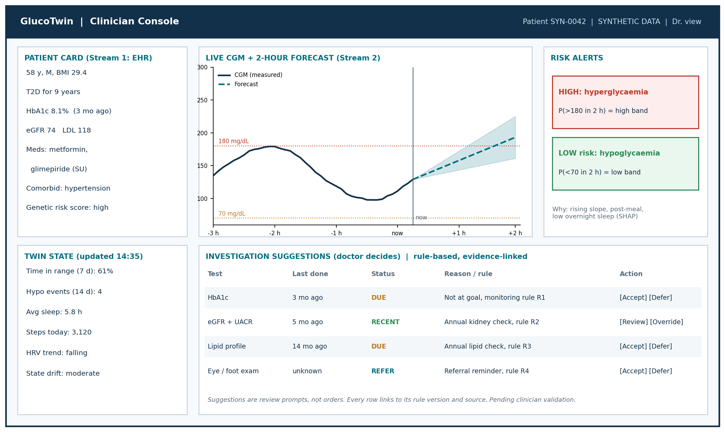
Figure 2. Clinician console wireframe (illustrative values on a synthetic patient)
Panel | What it shows | Interaction
Patient card | Demographics, diabetes duration, latest labs with dates, medications, comorbidities, genetic risk score | Click a lab to open its history
Live CGM and forecast | Measured glucose, 2-hour forecast with uncertainty band, 70 and 180 mg/dL lines | Hover for values; choose 6, 12 or 24 hour window
Risk alerts | Hyperglycaemia and hypoglycaemia risk bands with top contributing factors | Expand 'why' to see SHAP factors; acknowledge alert
Twin state | Time in range, hypoglycaemia events, sleep, steps, HRV trend, drift indicator | Compare with previous week
Investigation suggestions | Due, recent and referral items with rule ID, rule version and source | Accept, defer or override with reason
What-if (stretch goal) | Simple scenarios such as 'add a 20-minute walk after dinner' using the simulator | Slider and re-forecast
Audit log | Doctor decisions, model version, rule version, timestamps | Filter and export

10. Technology stack
Area | Choice | Why
Language | Python 3.11 | One language for data, model, API and dashboard
EHR generation | Synthea (Java) plus Python post-processing | Standard synthetic EHR tool named in the challenge
Wearable simulation | NumPy, SciPy, Pandas | Controlled, reproducible, linked to patient records
Modelling | scikit-learn, LightGBM, optional PyTorch (GRU) | Strong tabular baseline with a sequence-model option
Explainability | SHAP | Per-alert factor explanations for clinicians
Backend | FastAPI, Pydantic, Uvicorn | Typed ingestion and prediction endpoints
Storage | SQLite and Parquet (PostgreSQL as an upgrade path) | Zero-setup for a demo; easy to scale later
Dashboard | Streamlit and Plotly | Fastest route to a working clinical UI
Testing | pytest | Unit tests for simulator, features, rules and API
Packaging | Docker, requirements.txt, Makefile | One-command reproducible run
Repo and docs | GitHub (public), Markdown README, draw.io or PowerPoint for diagrams | Matches the submission format
Interoperability (design) | HL7 FHIR R4 resource mapping: Patient, Observation, DiagnosticReport | Shows a path to real EHR integration

Planned API endpoints
Endpoint | Purpose
POST /api/v1/ehr/patients | Load or update a patient's static record
POST /api/v1/stream/readings | Ingest CGM and wearable readings (batch or one by one)
GET /api/v1/twin/{patient_id} | Current twin state and latest forecast
GET /api/v1/predict/{patient_id} | p_hyper_120, p_hypo_120 and top factors
GET /api/v1/investigations/{patient_id} | Rule-based due and recent test review
POST /api/v1/decisions | Record accept, defer or override with a reason
GET /api/v1/health | Service health check

11. Safety, privacy and ethics
- Synthetic data only. No real patient data is collected, stored or used, consistent with the DPDP Act and HIPAA constraints named in the challenge.
- Human in the loop. The system forecasts and suggests; the doctor decides. No automatic orders, cancellations or prescriptions.
- Transparency. Each alert shows its top factors; each suggestion shows its rule version and source; each model run stores its version.
- Fail-safe defaults. If data is missing or stale (for example, sensor dropout), the twin shows the data gap and lowers confidence instead of producing a silent forecast.
- Fairness checks. Performance is reported by medication group, age band and HbA1c band. We note that synthetic data cannot establish fairness across real Indian populations.
- Regulatory note. A real deployment would need clinical validation and review under applicable Indian medical device software requirements. This prototype makes no claim of regulatory clearance.

12. Risks and mitigations
Risk | Mitigation
Model performance only reflects the simulator | State this clearly; run a sanity check on an open CGM dataset; focus claims on pipeline and method
Data leakage from overlapping windows | Patient-wise split; fixed random seeds; tests that assert no patient appears in two splits
Rules not reviewed by a clinician | Label every rule 'pending clinician review'; seek a faculty or medical mentor review before the video
Too much scope for 3 days | Core path first (data, model, dashboard); what-if and GRU are stretch goals
Demo failure during the jury presentation | Pre-generated demo patients, local Docker run, recorded fallback video
Synthea setup time | Fallback to a documented Python EHR generator that follows the same schema

13. Execution plan to the deadline
Today is Saturday 17 October 2026 and the deadline is Tuesday 20 October, 7:00 PM IST. The plan below runs four tracks in parallel for a team of four.
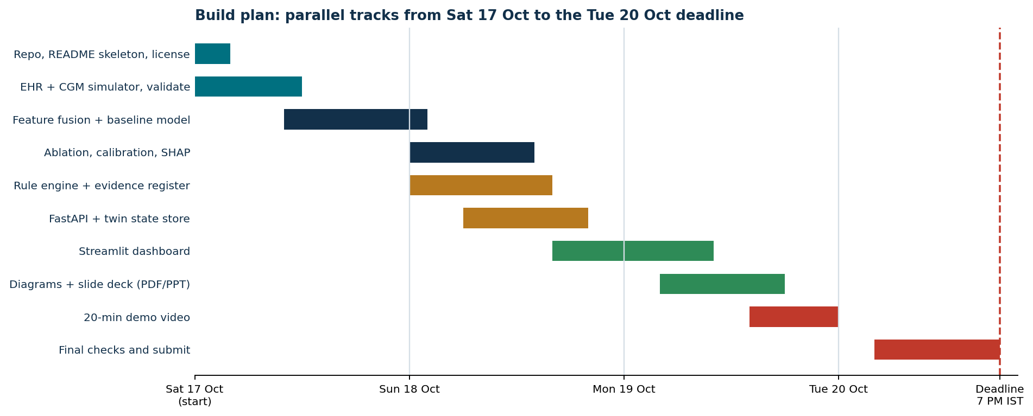
Figure 3. Build plan from now to the submission deadline
Role | Owner | Main deliverables
Data and simulator | [Member 1] | EHR cohort, CGM and wearable simulator, data validation, data README
Modelling | [Member 2] | Features, baselines, LightGBM, ablation, calibration, SHAP, results table
Backend and rules | [Member 3] | FastAPI, twin state store, rule engine, evidence register, tests
Dashboard and presentation | [Member 4] | Streamlit console, architecture diagram, slides, 20-minute video

Day by day
Day | Goal | Done when
Sat 17 Oct | Repo, simulator, EHR cohort, first CGM dataset | A CSV of at least 300 patients with linked CGM exists and passes validation tests
Sun 18 Oct | Features, baselines, main model, ablation; rule engine started | Results table has real numbers; R1 to R4 return correct outputs on test cases
Mon 19 Oct | API, dashboard, diagrams, slides; record the video in the evening | End-to-end demo runs from a clean clone
Tue 20 Oct | Final checks, README, license, folder naming, submit before 2 PM | Public repo opens in a private browser window; form submitted with buffer before 7 PM

14. Submission checklist (from the official page)
The repository must be public and contain everything in the README. The submission form takes only the team leader's name, phone number, email and the public repository link.
Item | Status
Team details and college / incubator information in README | [ ]
Project title | [ ]
Problem statement and healthcare use case | [ ]
Technical stack and AI/ML model or framework details | [ ]
Video of at least 20 minutes (PowerPoint recording or unlisted YouTube link) | [ ]
Open-source license details (for example MIT or Apache-2.0, plus dataset licence notes) | [ ]
Architecture diagram in PDF or PPT format | [ ]
Presentation in PDF or PPT format with project details and outcome | [ ]
Folder named Team Name_College Name | [ ]
Repository set to Public; all links open without login | [ ]
Form filled with leader's name, phone, email and repository link | [ ]

Suggested repository layout
TeamName_CollegeName/
README.md
LICENSE
requirements.txt
docker-compose.yml
docs/
architecture.pdf
presentation.pdf
video_link.md
data/
generate_ehr.py
simulate_wearable.py
sample/ # small synthetic sample, safe to share
twin/
features.py
state.py
model_train.py
predict.py
rules/
rules_v1.yaml # versioned, pending clinician review
evidence_register.csv
api/
main.py
dashboard/
app.py
tests/
results/
metrics.json
figures/

README outline
- Title, one-line pitch, team and college details
- Problem statement and use case
- Architecture diagram and how the two streams are fused
- Data: sources, how synthetic data is generated, limitations
- Model: task, features, results table, ablation, calibration
- Investigation rules and their review status
- How to run (three commands) and how to run tests
- Tech stack, license, dataset licences, links to video and slides

15. 20-minute video outline
The video can be a recorded PowerPoint or an unlisted YouTube upload. A 20-minute minimum leaves room to show the working prototype, not only slides.
Time | Segment | What to show
0:00 to 2:00 | Problem and use case | Type 2 Diabetes, events between visits, why a twin helps
2:00 to 5:00 | Architecture | Figure 1; dual-stream fusion; twin state
5:00 to 9:00 | Data | Synthetic EHR, simulator design, how EHR shapes glucose, data limitations
9:00 to 14:00 | Model and results | Task definition, features, ablation table, calibration, lead time, SHAP example
14:00 to 18:00 | Live demo | Pick a patient, play CGM forward, forecast and alert appear, open 'why', review investigation suggestions, record a decision
18:00 to 19:30 | Safety and limits | Synthetic data, human in the loop, rules pending clinical review, regulatory note
19:30 to 21:00 | Impact and roadmap | Real wearable integration, FHIR connectors, clinical validation, patient app, other conditions

16. Future work
- Validate with real, consented, de-identified Indian cohort data and clinician-defined outcomes.
- Connect to real wearables and FHIR-based EHR sources; add HRV and sleep models for cardiovascular risk.
- Add personalised what-if simulation and treatment-adjustment support under clinician control.
- Extend to hypertension and cardiovascular risk using the same twin framework.
- Patient-facing nudges and a care-team workflow with notifications.

17. References and links
Re-check each link and its licence before the final submission.
- Digital Twin Challenge 2026 (Unstop) - official problem statement and submission rules
- Synthea - synthetic patient generator
- Synthea sample data - ready-made synthetic records
- CGMacros on PhysioNet - open CGM and meal dataset
- BIG IDEAs Lab dataset on PhysioNet - CGM with wearable signals
- OhioT1DM - Type 1 CGM dataset (access request needed)
- MIMIC-IV on PhysioNet - credentialed clinical dataset
- ADA Standards of Care in Diabetes - monitoring intervals and glycaemic targets (verify current year)
- ICMR - Indian clinical guidance (verify exact document)
- HL7 FHIR R4 - interoperability reference

FINAL DISCLAIMER
GlucoTwin is a student proof of concept built on synthetic data. It is not a medical device and has not been clinically validated. No clinical recommendation in this prototype should be used for patient care before review by qualified clinicians and applicable regulators.

