INTERNSHIP REPORT
ON
EcoNexus
AI-Powered Wildlife Conflict Prediction and Management System
Submitted to
School of Computer Science and Engineering
IILM University, Greater Noida, Uttar Pradesh
In partial fulfilment of the requirements for the degree of
Bachelor of Technology in Computer Science and Engineering
Submitted By
Ayush Rastogi
Roll No.: 25SCS1003000430
Batch: 2025–2026
Internship Organization
MARS – Centre for Sustainable Community Development
Domain: Full Stack Development
Internship Duration: 01 June 2026 – 15 July 2026
Mentor: Dr. Saurabh Shanu

CANDIDATE'S DECLARATION
I, AYUSH RASTOGI, Roll No. 25SCS1003000430, hereby declare that this internship report titled “EcoNexus: AI-Powered Wildlife Conflict Prediction and Management System” has been prepared as a record of my internship work carried out at MARS – Centre for Sustainable Community Development from 01 June 2026 to 15 July 2026.
I further declare that the work presented in this report is based on the project development, technical implementation, documentation, and learning undertaken during the internship. Wherever external libraries, frameworks, documentation, datasets, or other resources have been used, they have been appropriately acknowledged.
I understand that the report is intended for academic evaluation and that I am responsible for the originality and accuracy of the work presented.
Signature: __________________________
Name: AYUSH RASTOGI
Roll No.: 25SCS1003000430
Date: ______________________________

ACKNOWLEDGEMENT
I sincerely express my gratitude to MARS – Centre for Sustainable Community Development for providing me with the opportunity to undertake an internship in Full Stack Development and work on a technology-driven sustainability problem.
I am especially thankful to my mentor, Dr. Saurabh Shanu, for guidance, feedback, and encouragement during the development of EcoNexus. I also thank the School of Computer Science and Engineering, IILM University, Greater Noida, for providing the academic environment and support necessary to complete this internship.
I would like to acknowledge my teammates—Prangita Baruah, Himoghno Ghosh, and Adarsh Singh—for their collaboration throughout the project.
Finally, I acknowledge the open-source communities behind React, Vite, Flask, SQLAlchemy, SQLite, Scikit-learn, Git, GitHub, and related libraries and documentation that supported the implementation of the system.

INTERNSHIP COMPLETION CERTIFICATE
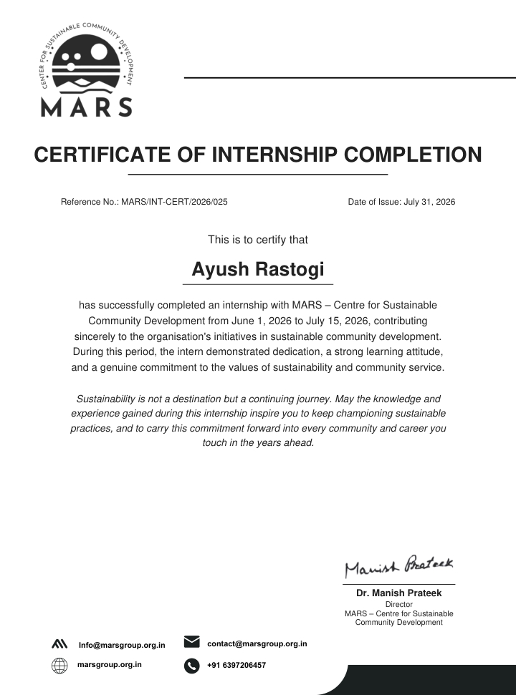
Figure 10. MARS Internship Completion Certificate

EXECUTIVE SUMMARY
The internship at MARS – Centre for Sustainable Community Development provided practical exposure to full-stack software development for a sustainability-focused problem. The internship was completed from 01 June 2026 to 15 July 2026, and the principal project developed during the internship was EcoNexus, an AI-powered wildlife intelligence platform designed to support proactive monitoring and management of human-wildlife conflict.
EcoNexus combines a React-based frontend with a Python Flask backend, SQLite database management through SQLAlchemy ORM, REST APIs, geospatial visualization, analytics, and a Random Forest machine-learning model. The platform provides a command-center style interface for forest officers, allowing them to review wildlife incidents, visualize incident locations, submit new incident reports, obtain AI-assisted risk predictions, view alerts, analyze trends, and generate reports.
The machine-learning module uses historical wildlife conflict records and geographical/environmental attributes to classify conflict severity into High, Medium, or Low and provide a probability-based risk indication. The backend performs preprocessing, categorical encoding, feature validation, and model inference before returning results to the frontend.
This internship has strengthened my skills in data collection, MS Excel, GIS mapping, and team coordination. It provided me with practical experience in collecting and organizing data, analyzing information using MS Excel, preparing and working with GIS maps, and collaborating effectively with team members to complete assigned tasks.

TABLE OF CONTENTS
Section | Title | Page
1 | Introduction | 7
1.1 | Internship Overview | 7
1.2 | Organization Profile | 7
1.3 | Problem Context | 8
1.4 | Project Overview | 8
1.5 | Objectives | 9
1.6 | Scope | 9
2 | Internship Experience and Team Management | 10
2.1 | Team Composition | 10
2.2 | My Role as a team member | 10
2.3 | Development Approach | 11
3 | Technology and System Design | 12
3.1 | Technology Stack | 12
3.2 | System Architecture | 13
3.3 | Database Design | 14
3.4 | REST API Structure | 15
4 | Methodology and Implementation | 16
4.1 | Data Preparation | 16
4.2 | Machine Learning Pipeline | 17
4.3 | Backend Implementation | 18
4.4 | Frontend Implementation | 19
4.5 | Geospatial Mapping | 20
5 | Functional Features and Screens | 21
5.1 | Authentication | 21
5.2 | Command Center Dashboard | 22
5.3 | Incident Reporting | 23
5.4 | AI Prediction | 24
5.5 | Wildlife Map | 25
5.6 | Reports and Alerts | 26
5.7 | Settings | 27
6 | Testing and Results | 28
6.1 | Functional Testing | 28
6.2 | Prediction Verification | 29
6.3 | Observed Outcomes | 30
7 | Learning Outcomes and Challenges | 31
8 | Conclusion and Future Scope | 33
 | References | 34
 | Appendix A – Internship Evidence | 35

LIST OF FIGURES
Figure 1 — EcoNexus login and secure access interface
Figure 2 — EcoNexus Command Center dashboard
Figure 3 — Dashboard analytics, quick actions, AI insights and weather panel
Figure 4 — Smart Wildlife Incident Reporting interface
Figure 5 — AI Wildlife Conflict Prediction interface
Figure 6 — Wildlife Conflict Map with active incident markers
Figure 7 — Wildlife Incident Reports and export interface
Figure 8 — Live Wildlife Alerts interface
Figure 9 — System Preferences and Forest Officer settings
Figure 10 — MARS Internship Completion Certificate
Figure 11 — MARS Internship Offer Letter
LIST OF TABLES
Table 1 — Internship details
Table 2 — Team composition
Table 3 — Technology stack
Table 4 — Major application modules
Table 5 — Wildlife incident database fields
Table 6 — REST API modules
Table 7 — Functional test cases
Table 8 — Prediction verification scenarios

CHAPTER 1: INTRODUCTION
1.1 Internship Overview
The internship was undertaken at MARS – Centre for Sustainable Community Development in the domain of Full Stack Development. The internship period was from 01 June 2026 to 15 July 2026. The organization’s offer letter describes MARS as a Section 8 company focused on technology-enabled sustainable development, with wildlife conservation identified as one of its core missions.
Parameter | Details
Organization | MARS – Centre for Sustainable Community Development
Domain | Full Stack Development
Internship Period | 01 June 2026 – 15 July 2026
Student | Ayush Rastogi
Roll Number | 25SCS1003003430
Mentor | Dr. Saurabh Shanu
Role | Project Team Member

1.2 Organization Profile
MARS – Centre for Sustainable Community Development is described in the internship offer letter as a Section 8, non-government organization working on technological solutions for sustainable development. Its technology-oriented initiatives include web development, mobile application development, extended reality, new tools and techniques, and IoT devices. Wildlife conservation is specifically identified as an important mission area.
The internship environment therefore provided a useful context for applying software engineering and machine-learning concepts to a real-world sustainability problem. The project work aligned particularly with the 'Life on Land' problem area identified in the offer letter, which focuses on protecting biodiversity, forests, wildlife, and natural habitats.
1.3 Problem Context
Human-wildlife conflict can arise when wildlife corridors intersect with settlements, agricultural areas, roads, and other human activity. Traditional reporting processes can become fragmented when incident information, location information, environmental indicators, and response decisions are handled separately. The project therefore focused on developing a unified digital interface capable of bringing these information streams together.
1.4 Project Overview
EcoNexus is an AI-powered wildlife intelligence and decision-support platform. It integrates incident reporting, wildlife corridor information, geospatial visualization, analytics, alerts, and machine-learning-based conflict risk prediction into one web application. The system is designed primarily around the operational needs of forest officers and conservation teams.
1.5 Objectives
• Develop a unified full-stack platform for wildlife incident monitoring and management.
• Provide a structured interface for recording wildlife-human conflict incidents.
• Use machine learning to estimate conflict severity and provide risk-oriented decision support.
• Visualize incident locations and wildlife corridors using geospatial mapping.
• Provide dashboards, alerts, analytics, and downloadable reports for operational awareness.
• Maintain a modular architecture that separates frontend, backend, database, service, and ML responsibilities.
• Strengthen practical skills in team leadership, integration, debugging, and technical presentation.
1.6 Scope
The implemented scope covers a browser-based forest-officer interface, Flask REST APIs, SQLite persistence, Random Forest inference, incident reporting, wildlife map visualization, analytics, reports, alerts, and system settings. The architecture is also suitable for future integration with real-time sensors, camera traps, satellite imagery, drone feeds, GPS telemetry, offline mobile workflows, and cloud deployment.

CHAPTER 2: INTERNSHIP EXPERIENCE AND TEAM MANAGEMENT
2.1 Team Composition
Member | Role
Himoghno Ghosh | Team Leader
Prangita Baruah Kumar | Project Team Member
Ayush Rastogi | Project Team Member
Adarsh Singh | Project Team Member

The project was developed by a four-member team. The team worked collaboratively across the application’s development activities, with the Team Leader responsible for coordination and integration.
2.2 My Role as a Team Member
My contribution in this project was the data collection and geospatial mapping component of EcoNexus. As a team member, I was individually responsible for building the corridor dataset and converting it into geo-referenced maps using QGIS — work that formed the ecological foundation for the platform's corridor database, risk-prediction model, and dashboard.
I independently compiled a dataset of 62 wildlife corridors across 20+ Indian states, covering five species — Asian Elephant, Bengal Tiger, Indian Leopard, Sloth Bear, and Indian Wolf. For each corridor I recorded: species, name and state; blockage/conflict type and severity (High/Medium/Low); GPS coordinates; Latitude , Longitude , environmental indicators (forest cover, NDVI, elevation, distance to road/rail, population density, land use, rainfall, temperature); conflict frequency, peak season and protected-area details; and linked satellite and blockage imagery. Data was cross-verified from WWF Nepal, MoEFCC, NTCA, PIB, and WTI sources, ensuring it was consistent and analysis-ready.
I used QGIS, an open-source GIS platform, to plot all 62 corridors as a point layer on a base map of India using their coordinates. I then colour-coded corridors by severity — 34 High, 19 Medium, 9 Low — to produce a national severity map, along with additional layers for species-wise distribution and state-wise corridor density.
This dataset and the QGIS maps I produced served as the ecological ground-truth for EcoNexus, feeding the machine learning risk model's features and validating the platform's dashboard, incident map, and alert modules against real, India-specific data.

2.3 Development Approach
The development approach was incremental and module-oriented. Core application requirements were first translated into frontend pages, backend API modules, data structures, and machine-learning components. These components were then integrated and tested together. Git and GitHub were used for version control and project collaboration.
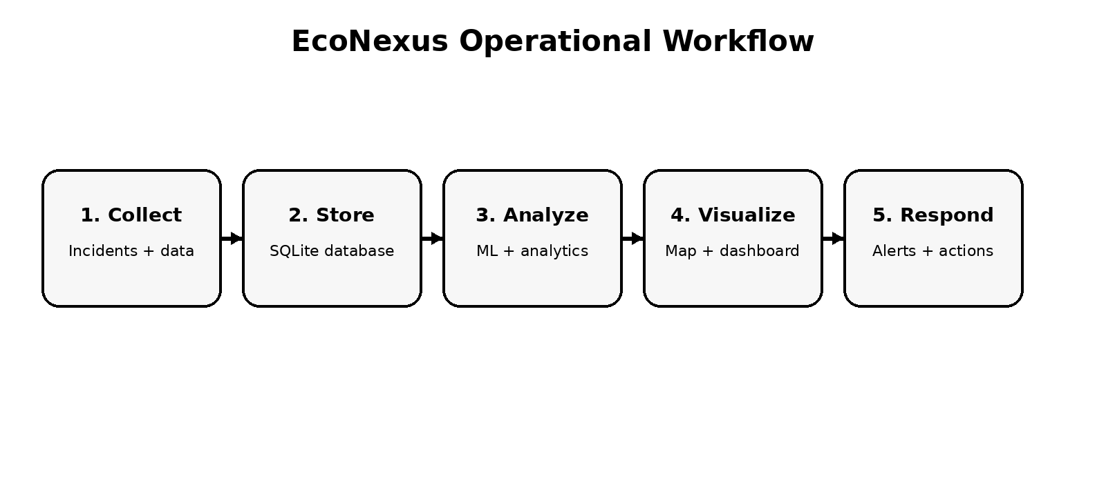
Figure 11. EcoNexus operational workflow

CHAPTER 3: TECHNOLOGY AND SYSTEM DESIGN
3.1 Technology Stack
Layer | Technologies / Tools
Frontend | React.js, Vite, JavaScript (ES6+), Tailwind CSS, React Router DOM, Lucide React
Backend | Python, Flask, Flask Blueprints, Flask-CORS
Database | SQLite, SQLAlchemy ORM
AI / ML | Scikit-learn, Random Forest Classifier, Joblib / .pkl model artifacts
Maps / GIS | Google Maps JavaScript API, latitude-longitude mapping, GeoJSON corridor visualization
Data Visualization | Pie charts, line charts, dashboard cards, analytics widgets
Development | Visual Studio Code, Git, GitHub, npm, Python virtual environment

3.2 System Architecture
EcoNexus follows a modular architecture in which the React frontend communicates with a Flask REST backend. The backend handles authentication, dashboard data, incident management, prediction requests, corridor information, map data, reports, analytics, and dynamic options. SQLite provides persistent storage through SQLAlchemy ORM, while the machine-learning layer loads trained Random Forest artifacts for inference.
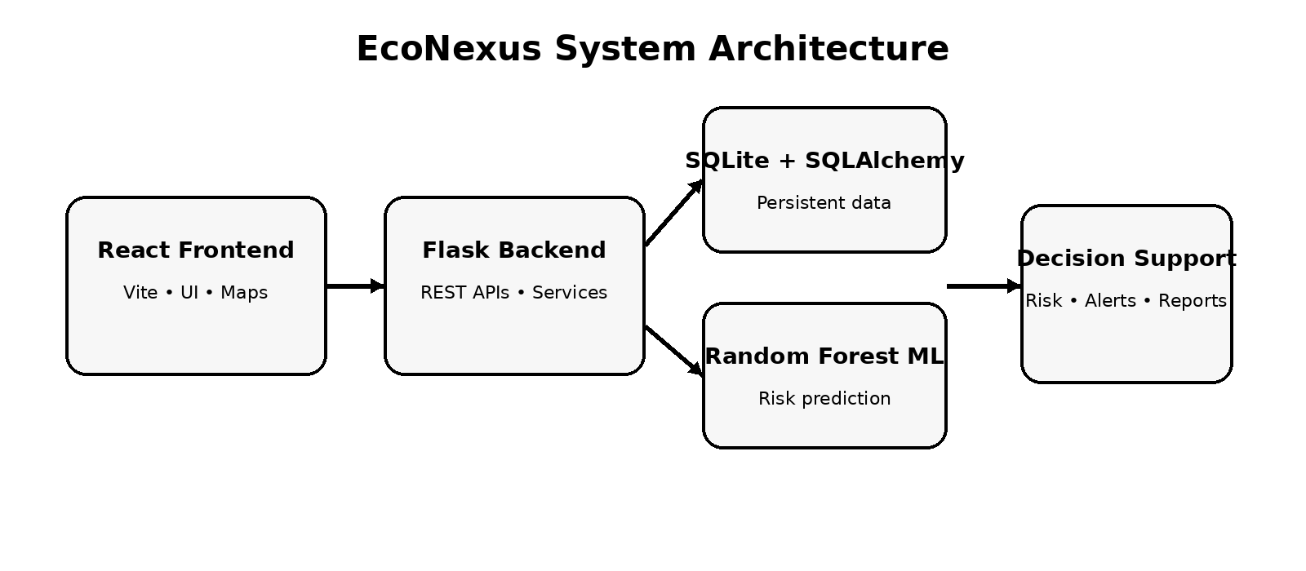
Figure 12. EcoNexus system architecture
3.3 Database Design
The central wildlife incident structure stores the information required for reporting and later analysis. The documented ORM model contains identifiers, species, corridor, state, district, latitude, longitude, severity, conflict type, animal count, description, image path, and creation timestamp.
Field | Type | Purpose
id | Integer | Unique incident identifier
species | String | Wildlife species involved
corridor | String | Wildlife corridor / protected area
state | String | State of occurrence
district | String | District of occurrence
latitude / longitude | Float | Geographical coordinates
severity | String | Low / Medium / High
conflict_type | String | Conflict category
animals_count | Integer | Number of animals involved
description | String | Incident narrative
image_path | String | Supporting evidence path
created_at | DateTime | Incident creation timestamp

3.4 REST API Structure
API Module | Primary Responsibility
Authentication | Officer login / authentication
Dashboard | Dashboard statistics and overview information
Incidents | Create and retrieve wildlife conflict incidents
Prediction | ML-based risk prediction
Corridors | Wildlife corridor information
Map | Geospatial wildlife and incident data
Analytics | Aggregated conflict and trend analytics
Reports | Incident reporting and export
Options | Dynamic species, states, corridors and related selections

CHAPTER 4: METHODOLOGY AND IMPLEMENTATION
4.1 Data Preparation
The machine-learning workflow depends on structured historical wildlife conflict data. During development, the dataset was cleaned so that categorical values and geographical fields could be consumed consistently by the model. The project also used separate corridor and environmental data sources to support the application's monitoring and analytical views.
The final prediction interface uses categorical attributes such as species, state, corridor, and conflict type together with geographical information. The preprocessing stage performs encoding and aligns the incoming feature vector with the feature columns expected by the trained model.
4.2 Machine Learning Pipeline
• Collect historical wildlife conflict and corridor-related records.
• Clean and validate the data and standardize categorical values.
• Prepare model input features and target severity labels.
• Encode categorical variables for machine-learning consumption.
• Train a Random Forest classification model.
• Store the trained model and supporting feature metadata as reusable artifacts.
• Load the model through the Flask prediction service.
• Generate a predicted severity and probability-based risk score for a new scenario.
4.3 Backend Implementation
The Flask backend acts as the application gateway. Flask Blueprints divide the API surface into functional modules, while a service layer keeps business logic separate from route definitions. Flask-CORS enables communication between the React development server and backend APIs. SQLAlchemy provides structured access to the SQLite database.
The prediction route receives JSON input, constructs a single-row dataframe, performs the required encoding and column alignment, and passes the resulting feature vector to the trained Random Forest model. The response contains the species, risk score, severity classification, and recommended actions.
4.4 Frontend Implementation
The frontend is implemented using React and Vite. Reusable components are used for cards, charts, navigation, maps, prediction forms, alerts, and tables. React Router DOM provides page-level navigation. Tailwind CSS supports the responsive dark-themed command-center interface, while Lucide icons provide consistent visual controls.
4.5 Geospatial Mapping
The map module visualizes wildlife conflict locations using geographical coordinates and corridor information. The interface displays incident markers across India and provides a spatial view that complements the tabular reports and analytical dashboard. GeoJSON assets are also used for wildlife corridor visualization.

CHAPTER 5: FUNCTIONAL FEATURES AND SYSTEM SCREENS
5.1 Authentication
The login interface provides a dedicated entry point for the Forest Officer role. The screen presents username and password fields, a remember-me option, and a command-center access action. The interface also communicates the application's monitoring and authentication status.
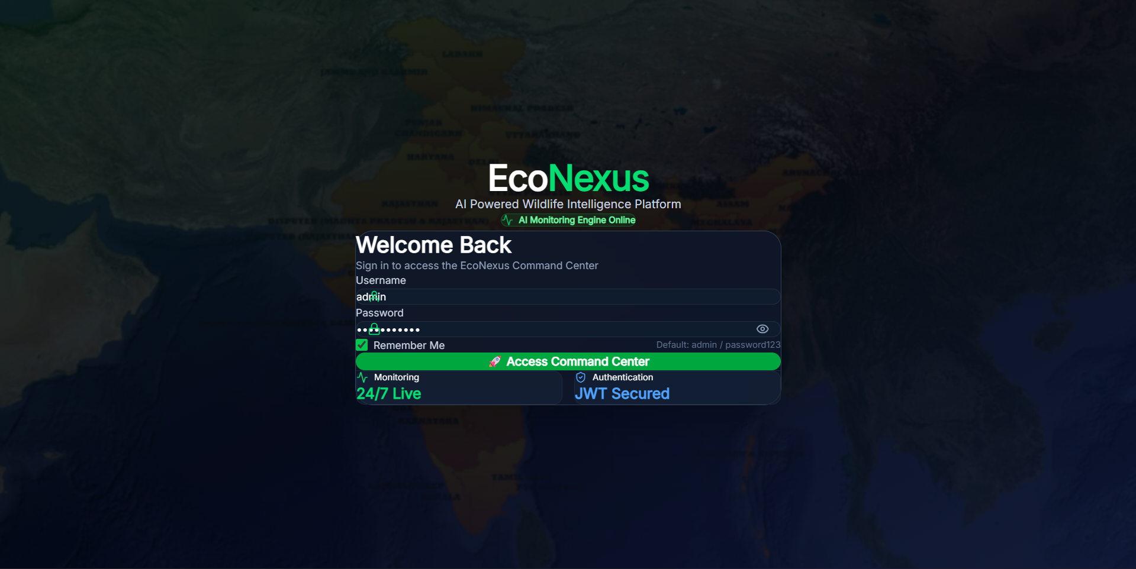
Figure 1. EcoNexus login and secure access interface
5.2 Command Center Dashboard
The dashboard is the primary operational screen. It brings together system status, AI-related indicators, active alerts, high-risk zones, protected corridors, monitored species, the wildlife intelligence map, and a live incident feed. This design gives an officer a consolidated overview rather than requiring navigation across multiple independent tools.
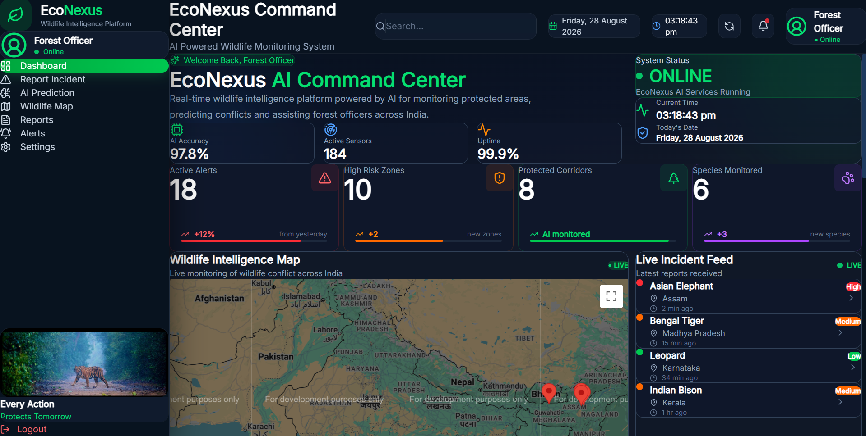
Figure 2. EcoNexus Command Center dashboard
5.3 Dashboard Analytics and Quick Actions
The extended dashboard view provides quick actions for reporting incidents, running AI predictions, viewing reports, and exporting data. It also contains an AI control center, weather information, severity distribution, and species distribution visualizations. These widgets support rapid interpretation of operational data.
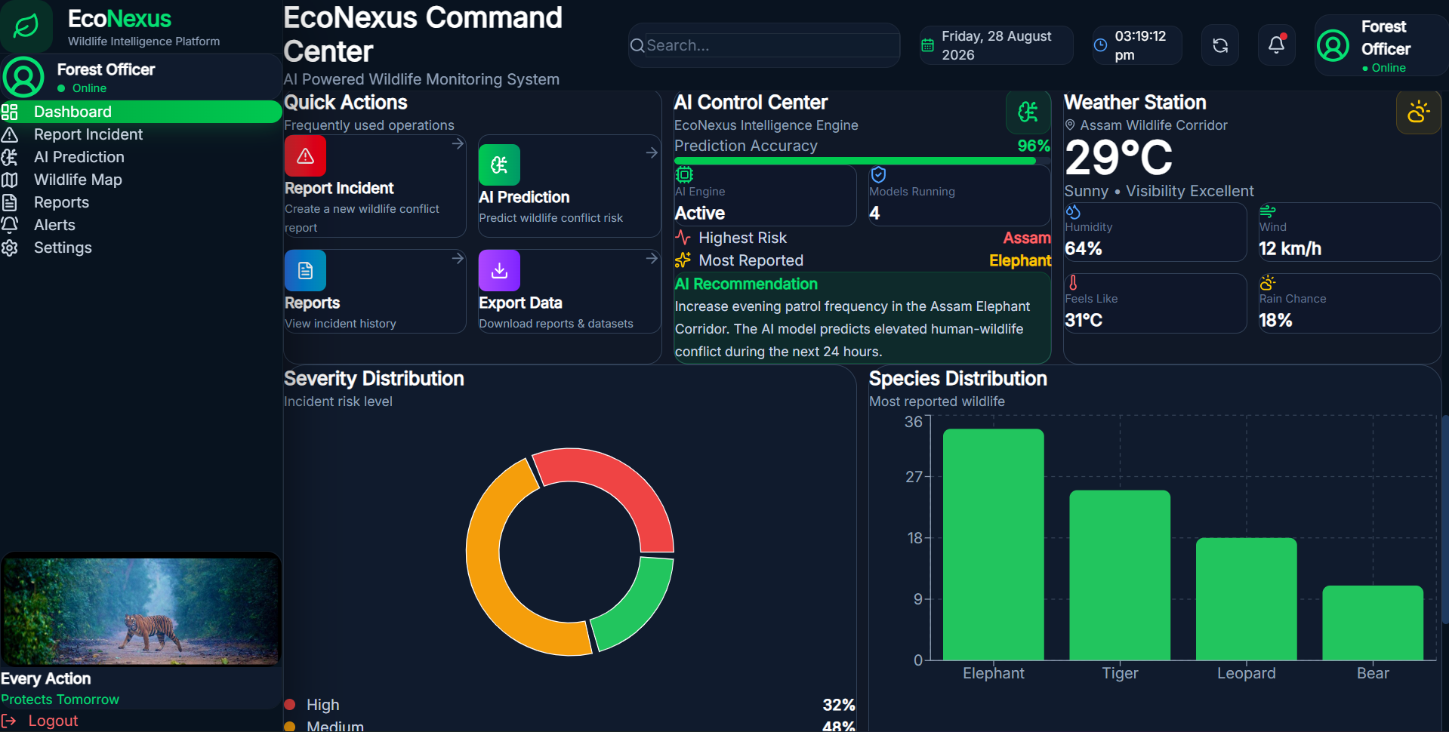
Figure 3. Dashboard analytics, quick actions, AI insights and weather panel
5.4 Smart Incident Reporting
The incident reporting module allows an officer to select species, state, and wildlife corridor and then review corridor information before submitting an incident. The captured form includes coordinates, severity, conflict type, and animal count. The interface can display corridor-related environmental indicators such as forest cover, NDVI, rainfall, and temperature.
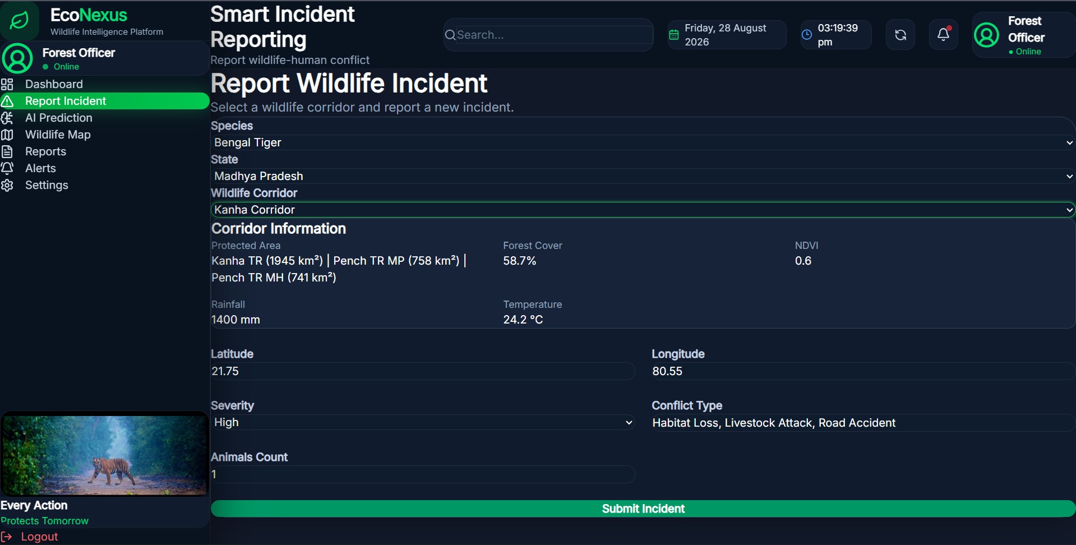
Figure 4. Smart Wildlife Incident Reporting interface
5.5 AI Wildlife Conflict Prediction
The prediction module provides a dedicated interface for selecting species, state, corridor, and conflict type and entering latitude and longitude. The request is passed to the backend prediction service, which uses the trained Random Forest model to estimate conflict risk. The design is intended to support proactive assessment before or during field response.
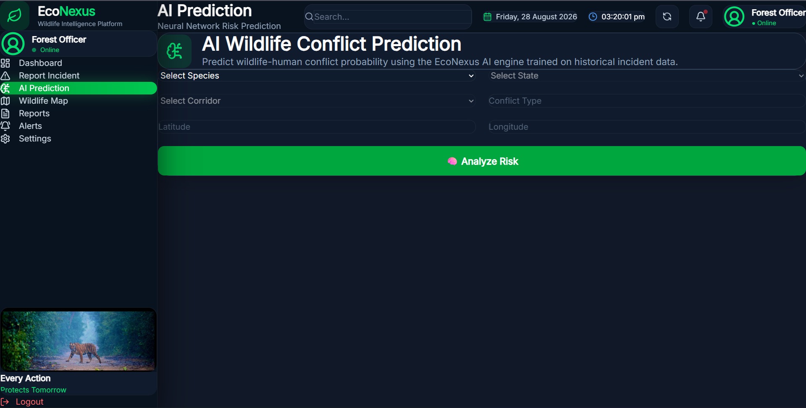
Figure 5. AI Wildlife Conflict Prediction interface
5.6 Wildlife Conflict Map
The Wildlife Intelligence Map provides a geographic view of active incident locations across India. Incident markers are displayed over a map background, allowing spatial patterns and concentration areas to be identified visually. This complements the analytical and tabular views of the same information.
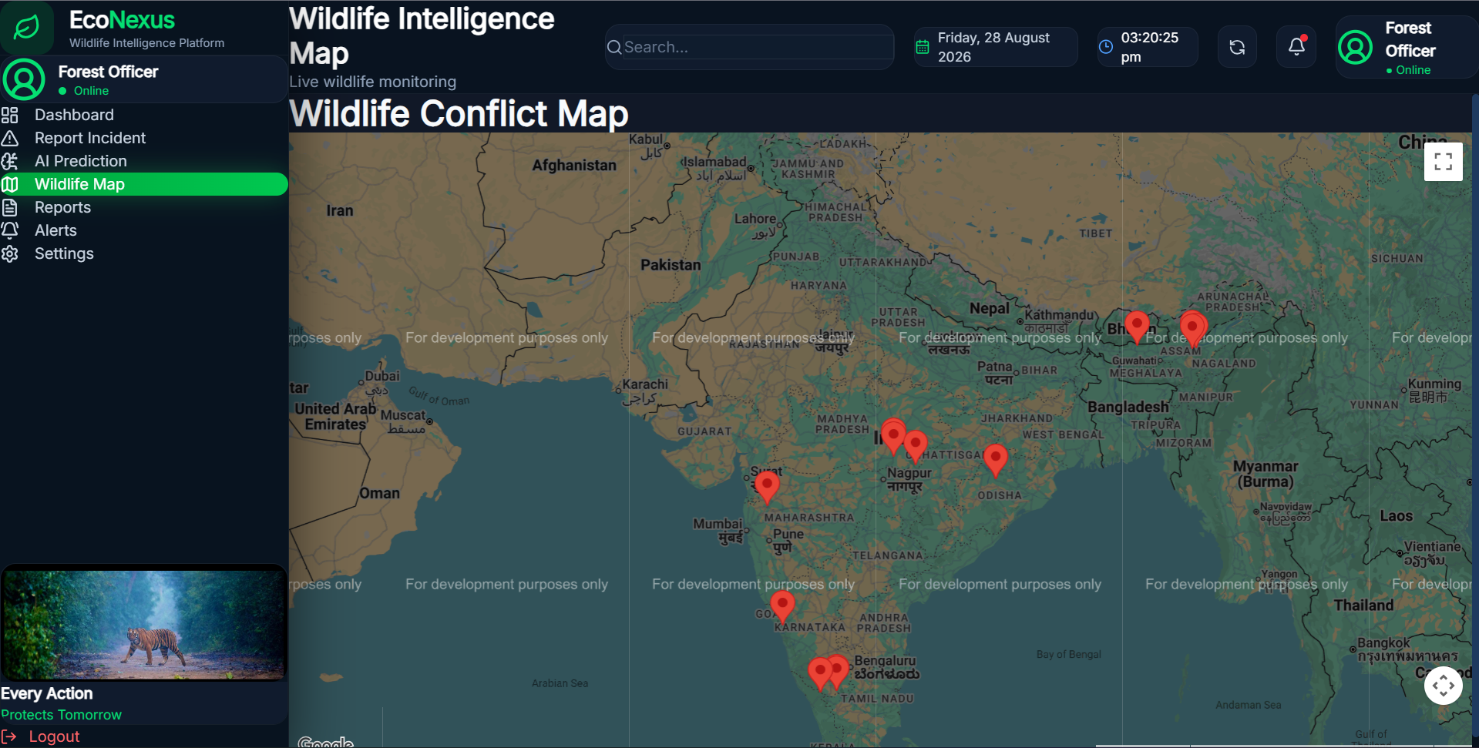
Figure 6. Wildlife Conflict Map with active incident markers
5.7 Reports and Alerts
The reports module presents logged incidents in a structured table containing species, state, district, corridor, conflict, and severity. A report download control supports exporting incident information. The alerts module provides a focused view of active wildlife threats and their urgency, helping users prioritize responses.
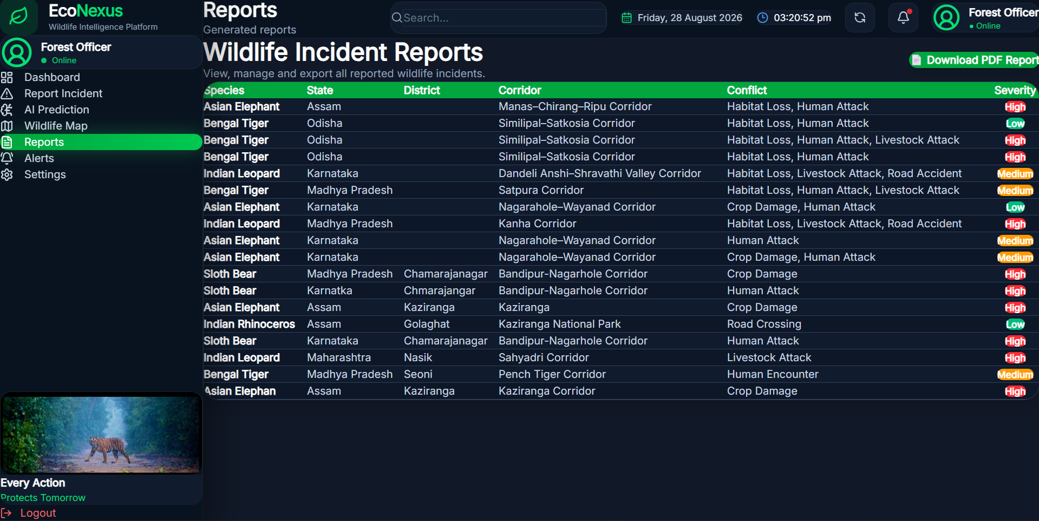
Figure 7. Wildlife Incident Reports and export interface
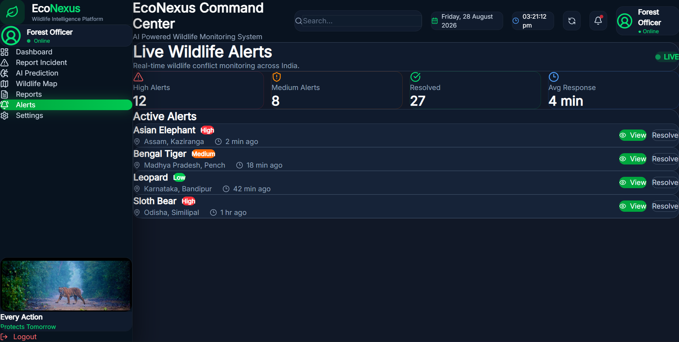
Figure 8. Live Wildlife Alerts interface
5.8 System Settings
The settings interface provides a Forest Officer profile view and application preferences. The displayed controls include notifications, dark mode, automatic dashboard refresh, and GPS location tracking. Such settings are useful for adapting the interface to operational conditions.
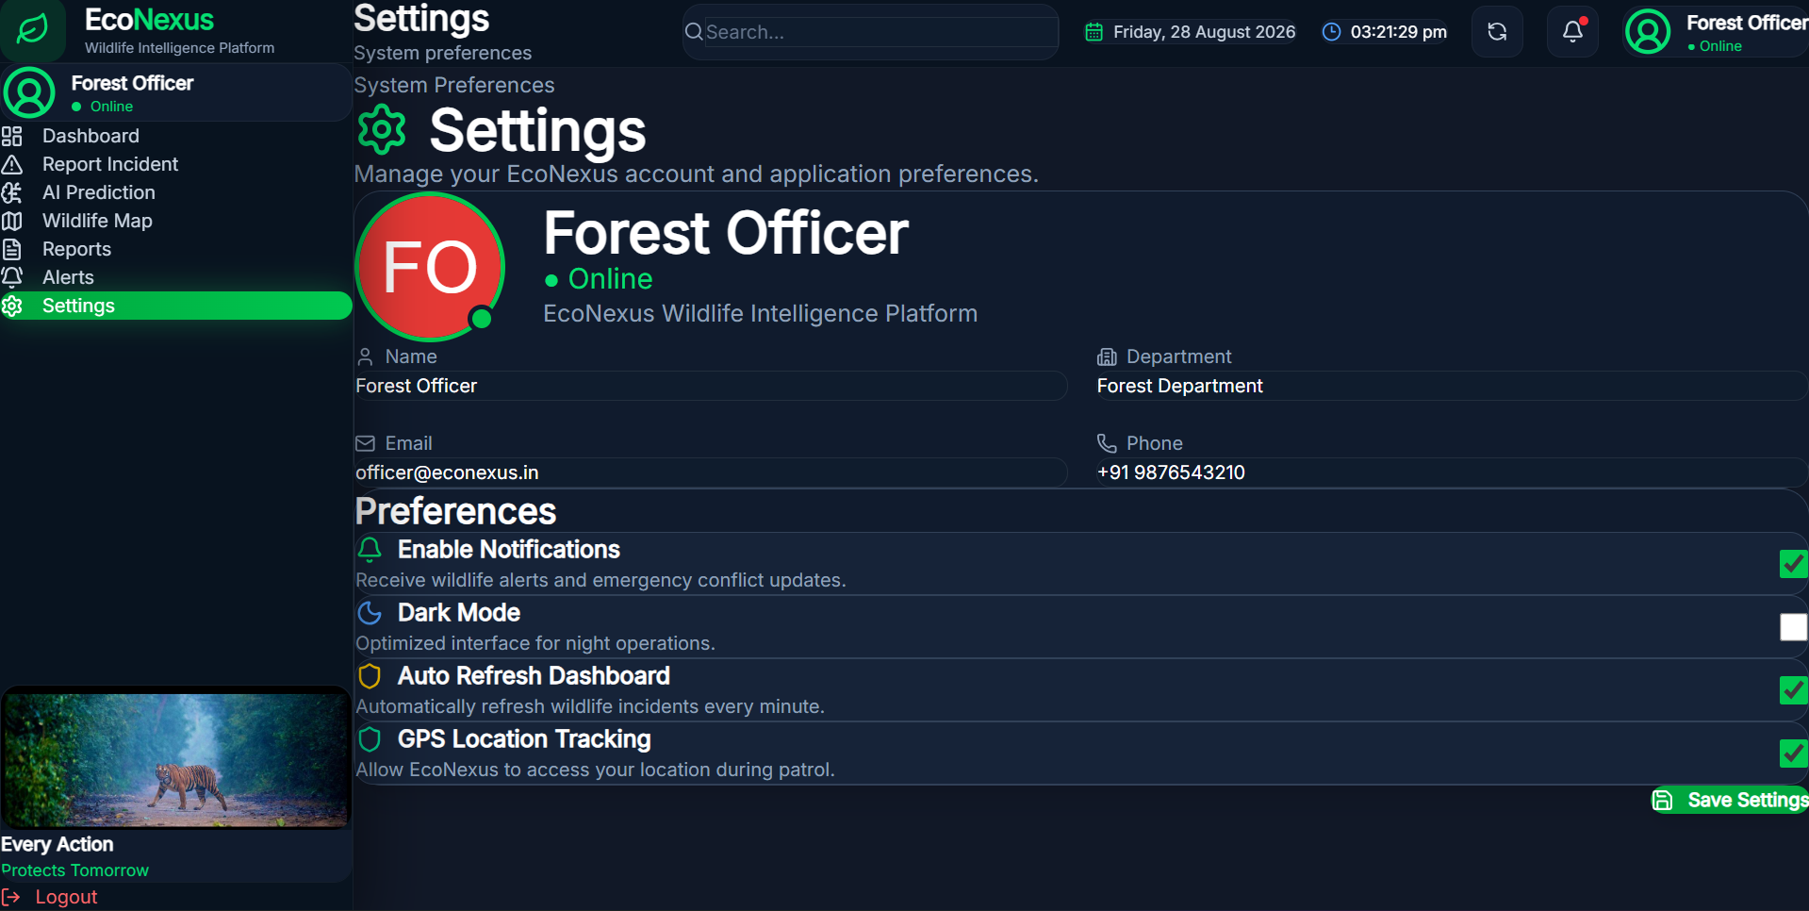
Figure 9. System Preferences and Forest Officer settings

CHAPTER 6: TESTING AND RESULTS
6.1 Functional Testing
Functional testing was carried out by checking whether the major user flows behaved as intended across the integrated application. The following table summarizes representative test cases for the implemented system.
Test Case | Expected Result | Observed Result
Login | User reaches command center after valid authentication | Login interface and command center flow available
Incident form | User can select species, state and corridor and enter incident details | Form fields and corridor information displayed
Incident submission | Incident is sent to backend and stored | Backend incident route supports POST creation
Prediction request | Input reaches ML service and returns risk result | Prediction interface and backend model integration available
Map | Incident locations are shown geographically | Markers displayed on wildlife conflict map
Reports | Historical incidents appear in tabular form | Reports table displays incident attributes
Alerts | Active risks are shown with urgency levels | High/Medium/Low alert presentation available
Settings | Preferences can be viewed and managed | Officer settings interface available

6.2 Prediction Verification
The project documentation records representative prediction scenarios used to verify the inference workflow. These values are demonstration cases from the project environment and should be interpreted as model outputs for the configured dataset rather than as real-world guarantees.
Scenario | Input Summary | Recorded Output
Tiger Movement | Bengal Tiger, Kaziranga, NDVI 0.64, 26.57 °C | 81.5% risk — High
Elephant Movement | Asian Elephant, Assam, NDVI 0.64, 3000 mm rain | 92.1% risk — High
Leopard Sighting | Leopard, Bandipur, NDVI 0.78, 22.0 °C | 34.2% risk — Low
Bear Movement | Sloth Bear, Similipal, NDVI 0.55, 28.4 °C | 76.8% risk — High

6.3 Observed Outcomes
• A unified interface was created for wildlife incident monitoring and decision support.
• Frontend and backend modules were integrated through REST APIs.
• SQLite and SQLAlchemy provided structured persistence for wildlife incident records.
• The Random Forest model was integrated into the backend inference workflow.
• Geospatial incident markers and corridor information were presented through an interactive map.
• Dashboard, analytics, reports, and alerts provided multiple views of the same operational data.
• The modular structure improved maintainability by separating routes, services, data, and ML artifacts.

CHAPTER 7: LEARNING OUTCOMES AND CHALLENGES
7.1 Technical Learning Outcomes
• Practical experience in data collection from relevant sources and field-based information.
• Data organization and management to maintain accurate and structured datasets.
• Data cleaning and preprocessing to identify errors, remove inconsistencies, and improve data quality.
• Practical use of GIS software for handling spatial data and working with maps.
• Experience in GIS mapping and spatial data visualization using coordinates and other geographic information.
• Improved understanding of how properly collected, organized, and cleaned data supports accurate GIS-based analysis and project outcomes.
7.1 Team Work and Professional Learning
During the internship, I contributed to the project as a Project Team Member, with a primary focus on data collection and GIS mapping. This role gave me practical exposure to collecting, organizing, and managing data and using GIS tools to develop and interpret maps. Working alongside other team members also enhanced my communication, coordination, and teamwork skills. The experience helped me understand how individual technical contributions can be effectively combined to support the successful completion of a project.
7.2 Technical Learning Outcomes
• Practical experience in data collection from relevant sources and field-based information.
• Data organization and management to maintain accurate and structured datasets.
• Data cleaning and preprocessing to identify errors, remove inconsistencies, and improve data quality.
• Practical use of GIS software for handling spatial data and working with maps.
• Experience in GIS mapping and spatial data visualization using coordinates and other geographic information.
• Improved understanding of how properly collected, organized, and cleaned data supports accurate GIS-based analysis and project outcomes.
7.3 Key Challenges
• Collecting accurate and reliable data from different sources while maintaining consistency.
• Organizing large amounts of collected data in a structured and easily manageable format.
• Identifying and correcting missing, duplicate, inconsistent, or incorrect data during the data-cleaning process.
• Handling geographical and spatial data correctly while working with GIS software.
• Ensuring that location information, coordinates, and other spatial attributes were accurate before creating GIS maps.
• Managing and completing assigned data and GIS tasks while coordinating with other team members and meeting project requirements.
7.4 How Challenges Were Addressed
The challenges were addressed through a systematic approach to data collection, organization, and cleaning. Data from different sources was carefully reviewed, compared, and organized to maintain consistency and accuracy. Errors, missing values, duplicates, and inconsistencies were identified and corrected during the cleaning process. For GIS-related tasks, I used QGIS Software to verify spatial information, check coordinates, and create accurate maps. Regular communication and coordination with team members also helped clarify requirements, resolve issues, and complete the assigned tasks effectively.

CHAPTER 8: CONCLUSION AND FUTURE SCOPE
8.1 Conclusion
The internship at MARS – Centre for Sustainable Community Development provided valuable practical experience in data collection, data organization, data cleaning, and GIS mapping for a sustainability-oriented project. As a Project Team Member , I contributed primarily to the collection and preparation of project data and worked with QGIS to manage geographical information and support the development of GIS-based maps.
Through this experience, I developed a better understanding of how accurate and well-organized data contributes to effective spatial analysis and project outcomes. The internship also strengthened my technical, analytical, communication, and teamwork skills, while giving me practical exposure to working with real-world geographical data as part of a collaborative project team.
8.2 Future Scope
The future scope of the project can be expanded through the use of more detailed and regularly updated geographical data. Future improvements may include:
• Integration of real-time geographical and field data for more accurate mapping and analysis.
• Use of satellite imagery and remote-sensing data to monitor changes in land use, vegetation, and wildlife corridors.
• Regular updating of GIS datasets to improve the accuracy and reliability of project maps.
• Development of more advanced spatial analysis and visualization techniques for identifying patterns and high-risk areas.
• Integration of additional field data and GPS-based information to improve location accuracy.
• Greater use of QGIS and other GIS technologies for detailed spatial planning, monitoring, and decision-making.
8.3 Final Reflection
The internship was a valuable learning experience that helped me apply my knowledge in a practical environment. It strengthened my technical, analytical, and teamwork skills and gave me greater confidence in handling real-world project requirements. Overall, the experience provided a strong foundation for my future professional development.

REFERENCES
- MARS – Centre for Sustainable Community Development, Internship Offer Letter, dated 30/05/2026.
- MARS – Centre for Sustainable Community Development, Internship Completion Certificate, issued 31/07/2026.
- QGIS Documentation, QGIS User Guide — resources related to GIS, spatial data handling, mapping, layers, coordinates, and visualization.
- Microsoft Excel Documentation, Microsoft Support — resources related to data entry, organization, cleaning, sorting, and analysis.
- Wildlife Institute of India (WII) — resources related to wildlife conservation, biodiversity, wildlife corridors, and human–wildlife conflict management.
- National Tiger Conservation Authority (NTCA) — resources on tiger corridors, corridor mapping, and wildlife corridor management in India.
- Ministry of Environment, Forest and Climate Change (MoEFCC), Government of India — resources related to wildlife conservation, protected areas, wildlife corridors, and human–wildlife conflict management.
- Press Information Bureau (PIB), Government of India — official information and reports related to wildlife corridors and human–wildlife conflict management in India.
- Wildlife Trust of India (WTI) — resources related to wildlife corridors, human–wildlife conflict mitigation, and conservation initiatives in India.
- EcoNexus Project Documentation and Dataset — project-specific data, geographical information, and documentation used for data preparation and GIS mapping during the internship.

APPENDIX A: INTERNSHIP EVIDENCE
The following evidence is included to document the internship engagement and completion.

Figure 13. Internship Completion Certificate

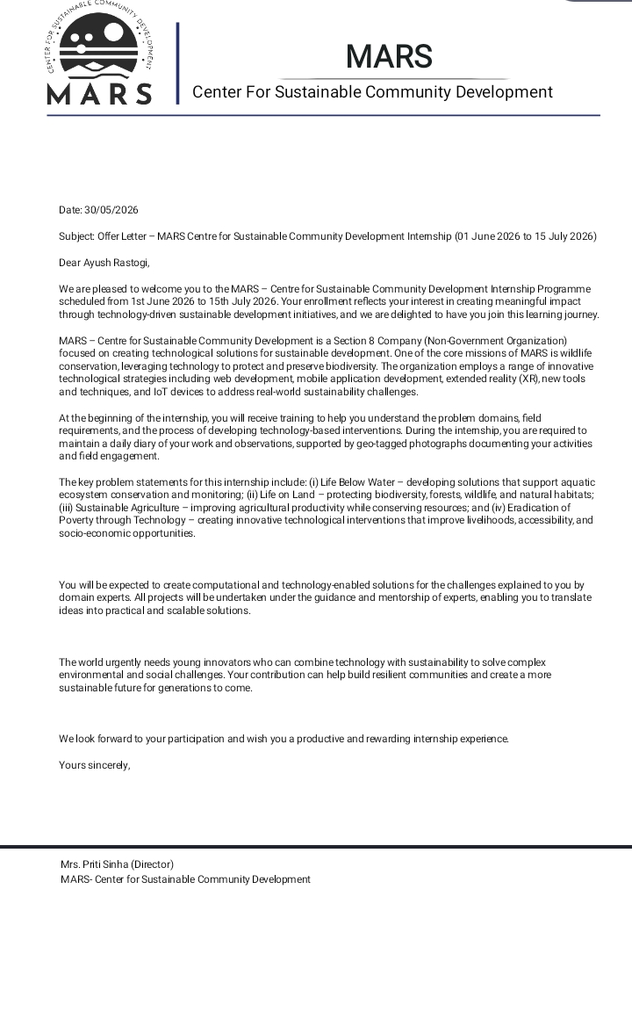
Figure 14. Internship Offer Letter

