OSINT
OSINT is Open Source Intelligence,which uses a multi-method methodology to extract and analyze data from publicly available sources and carry out decision making based on that data for an intelligence context. 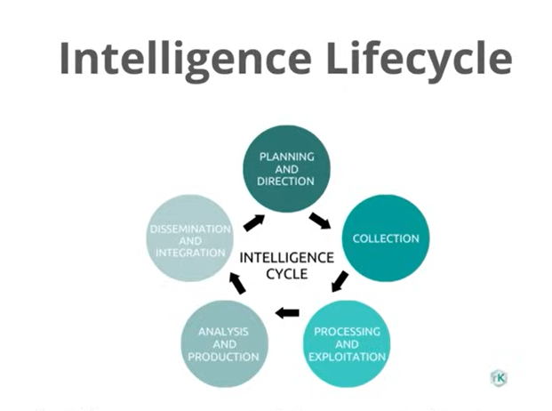
Planning and Direction:- What,when,who,why(identifying what is to be found out)
Collection:- Actual collection of detailed data/information
Processing/Exploitation:- Interpretation of collected data
Analysis/Production:- Process data and identify patterns/links/target
Discrimination:- Writing reports,integrating findings,etc

Sock Puppets
Misrepresentation of online identity is called as a sock puppet.For example,fake accounts,alternate identity,etc.
Purpose of a sock puppet is to not draw attention to yourself while investigating.
Should be disconnected completely from personal information/accounts.(different IP,different device,no links to personal information)
To make sock puppets believably genuine/legitimate, a fake history is necessary.
That is,sock puppets are actually fake users that we can using OSINT investigations to hide our real identity and make the adversary overlook our activities(if identified)
‘A social persona worn while engaging in the targets of the investigation.’
Creating Sock Puppets
- Come up with a persona for the sockpuppet account.
- Use Fake Name Generator to create a person whom you feel fits your sockpuppet persona.
- Use This Person Does Not Exist to generate an image. Make sure you inspect the image closely and get one that doesn't have any obvious flaws, as they often do. It is worth picking up some Photoshop, GIMP, Affinity Photo or Designer, or other basic image manipulation skills to fix them and change the background of the image(The users in the images do not exist).
- Get a burner phone, completely wiped and fresh. Can be any brand that will accept a Mint Mobile SIM card.
- Get a burner credit card from Privacy.com to use for on Amazon and possible the Mint Mobile setup. They might need it to set up the account.
- Set up a burner Amazon account. We're only going to use it once.
- Buy two Mint Mobile SIM cards. You can find them various places online and in stores near you, but you can get two of them for $5 on Amazon. They also give you 1 week free trial with something like 100 text messages, which we're going to use. This gives you two cards for two sockpuppet accounts for only $5.
- I like to use Amazon to have the card sent to an Amazon pickup box, which can be anonymous.
- Get a VPN that you can set to the physical area in which you want your sockpuppet to "exist."
- Set up the Mint Mobile trial account somewhere away from your home; as far as you're willing to go.
- Use this Mint Mobile trial phone number to set up all of the websites you need.
- I recommend at least set up a Google account and Protonmail account. Both will come in handy at different times.
- Once you've set up all the accounts with your trial Mint SIM, set up 2FA on all of the accounts.
- After setting up 2FA on all of the accounts, change the phone number to one you have more permanent access to, such as MySudo or Google Voice.
- Make sure everything works!
- Destroy the SIM card.
- Wipe the phone.
https://www.secjuice.com/the-art-of-the-sock-osint-humint/
https://web.archive.org/web/20210125191016/https://jakecreps.com/2018/11/02/sock-puppets/
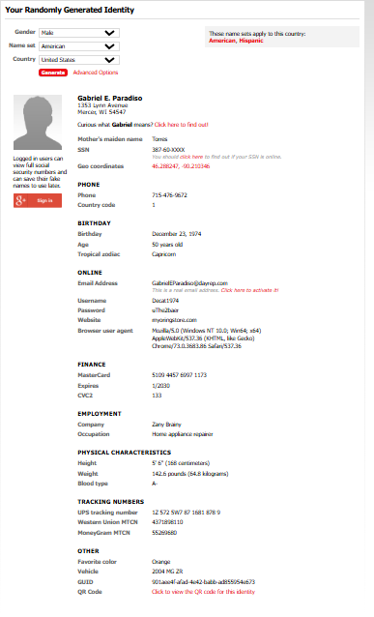
Search Engine Operators
Search engines which can be used:-
-Google Dorks
-DuckDuckGo - Privacy based search engine
-Bing
-Yandex - Russian based search engine
(Results may differ across search engines. So always recommended to search across all of them)

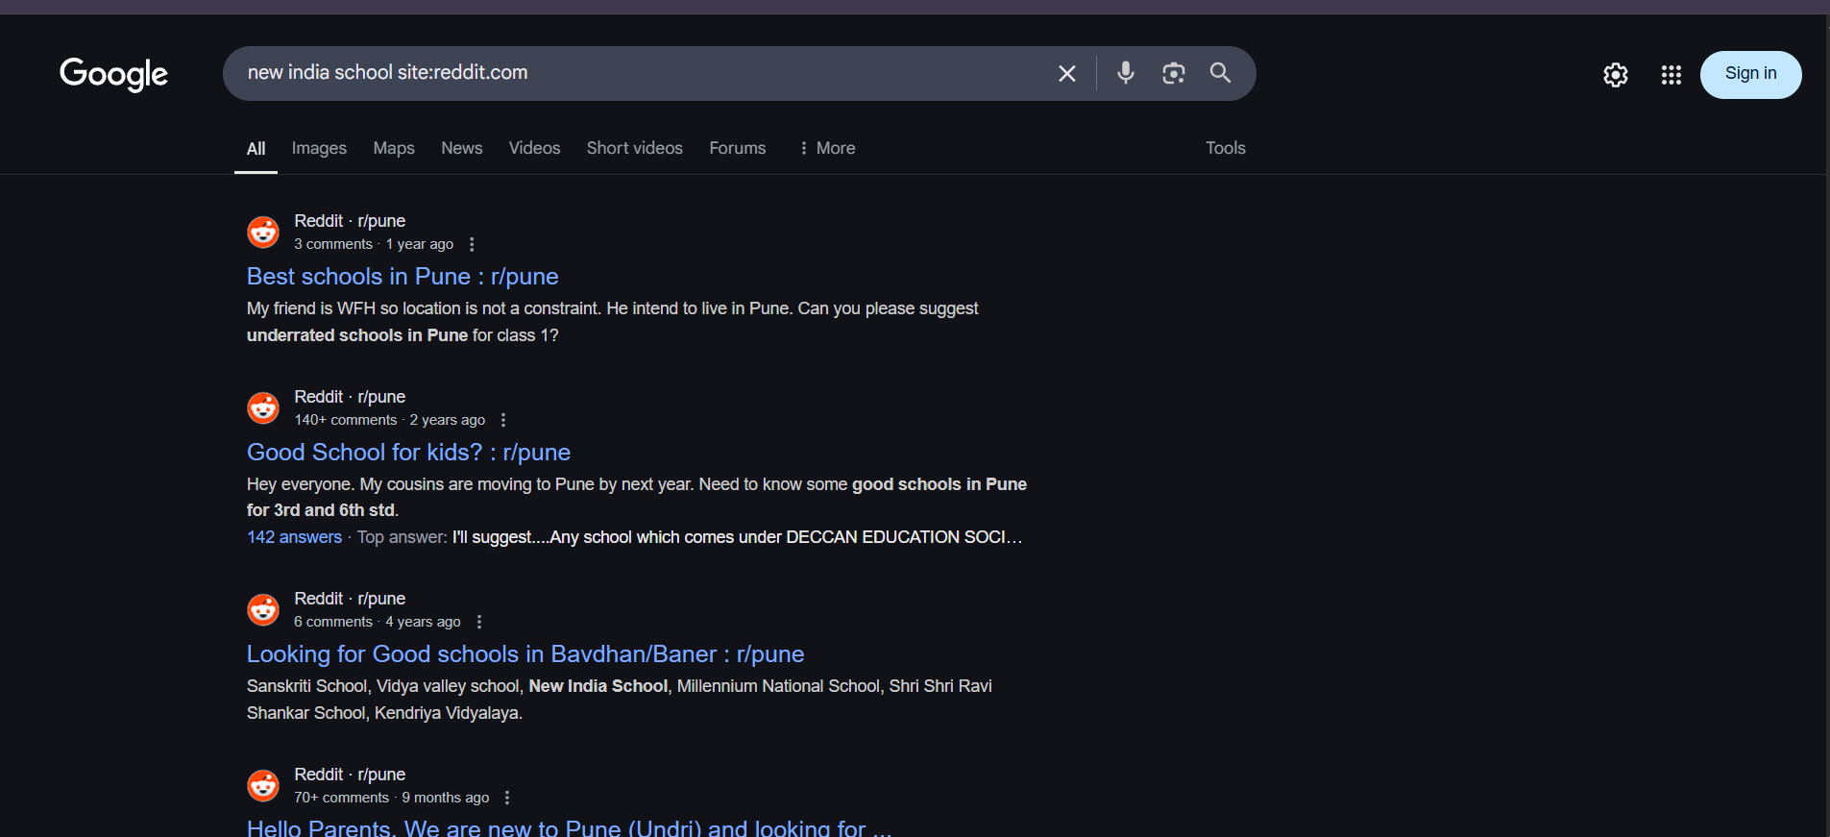
site:reddit.com
-Limits search results to the results belonging to the specified domain
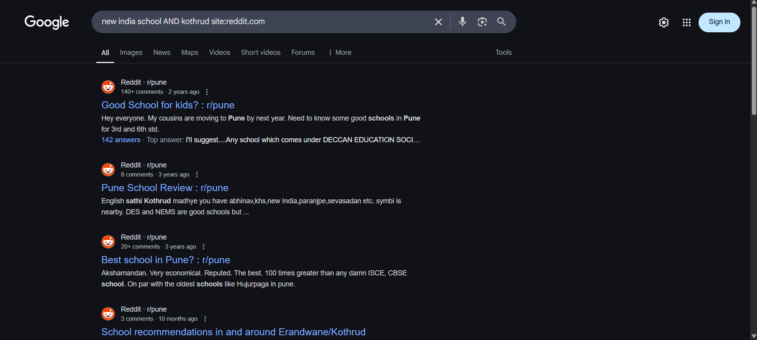
New india school AND Kothrud
The result should contain both prompts- new india school,Kothrud.
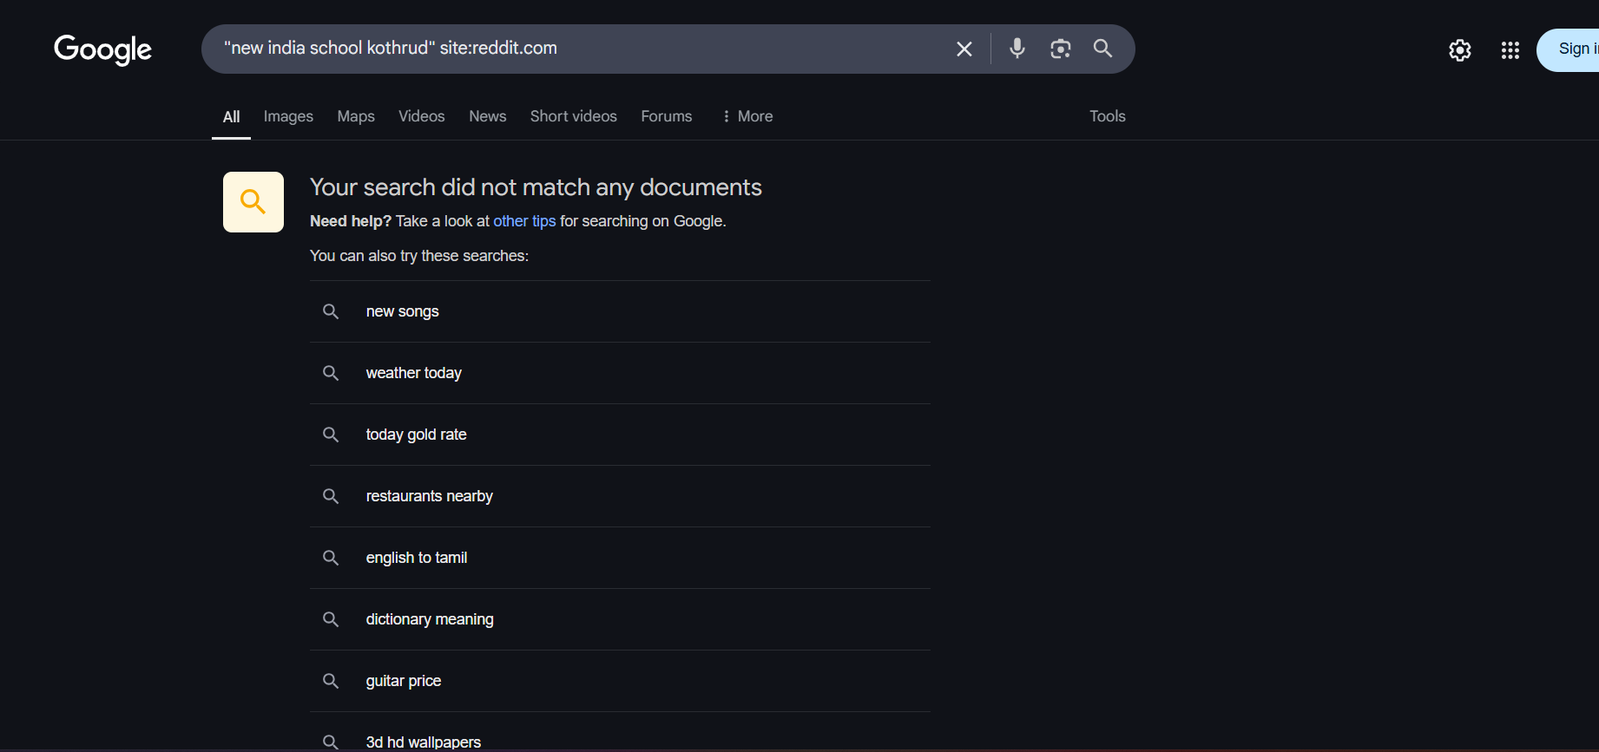
“new india school Kothrud” should contain the given prompts in the specified order

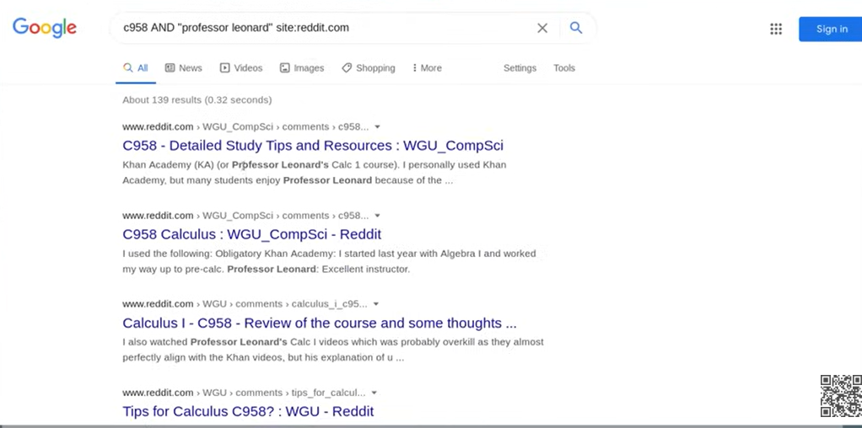
-OR /NOT can also be used as conditional operators in place of AND
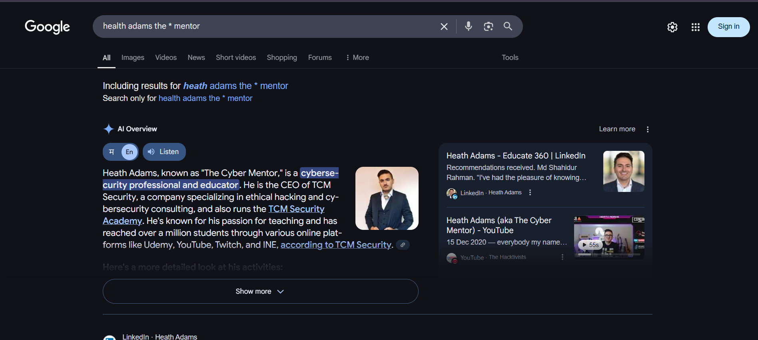
‘*’ operator is the wildcard operator which can be used to identify strings that we may not know about in our searches.
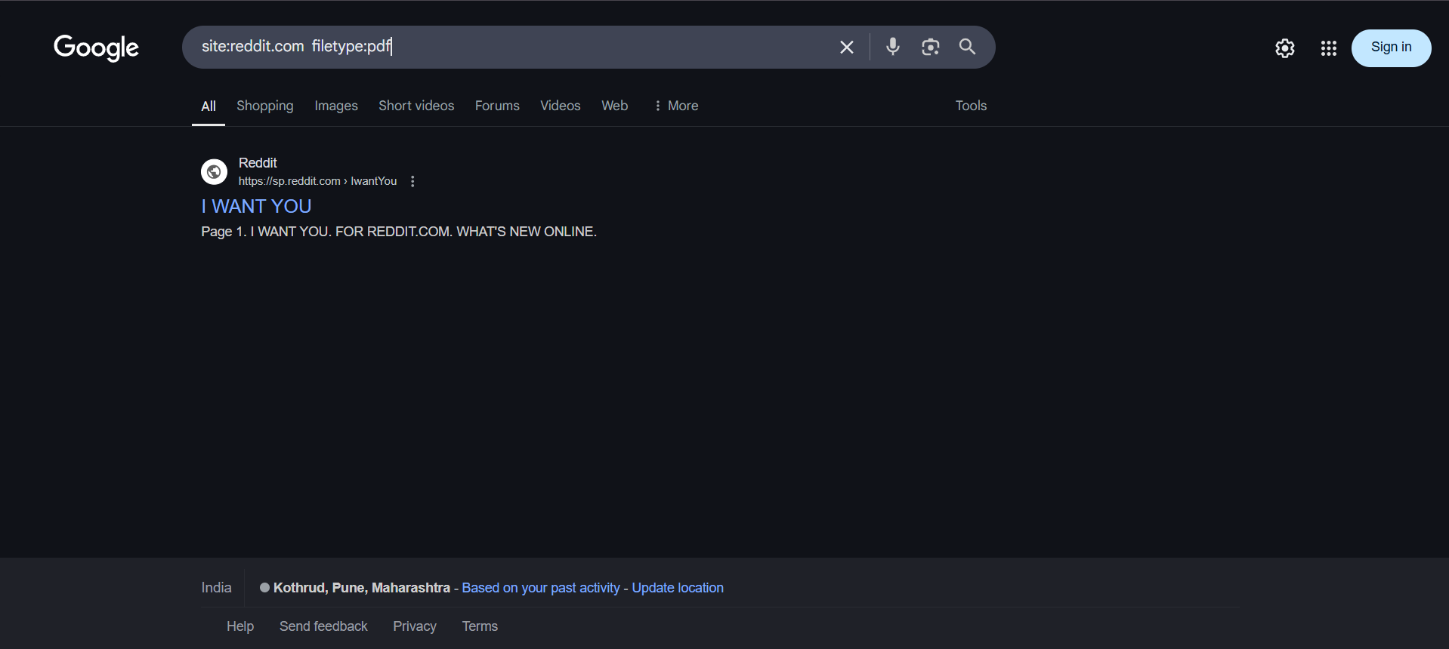
Filetype:extension defines the filetype results that are to be shown
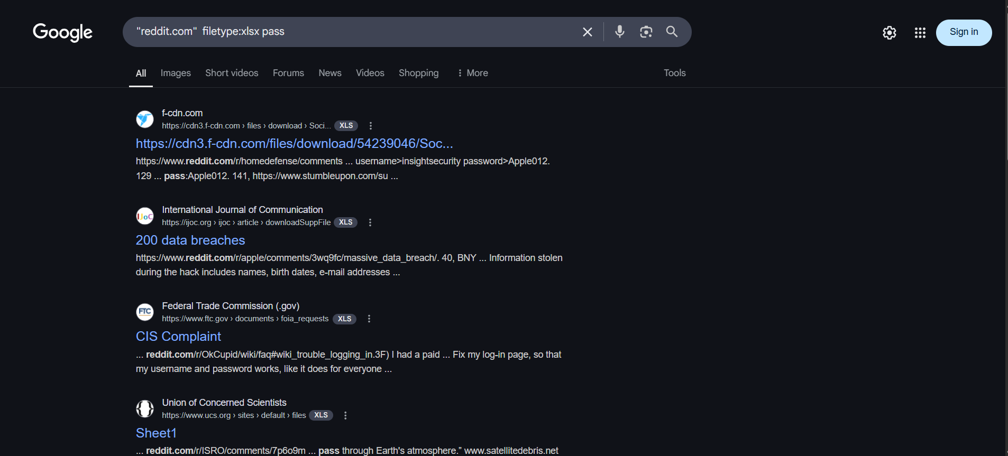
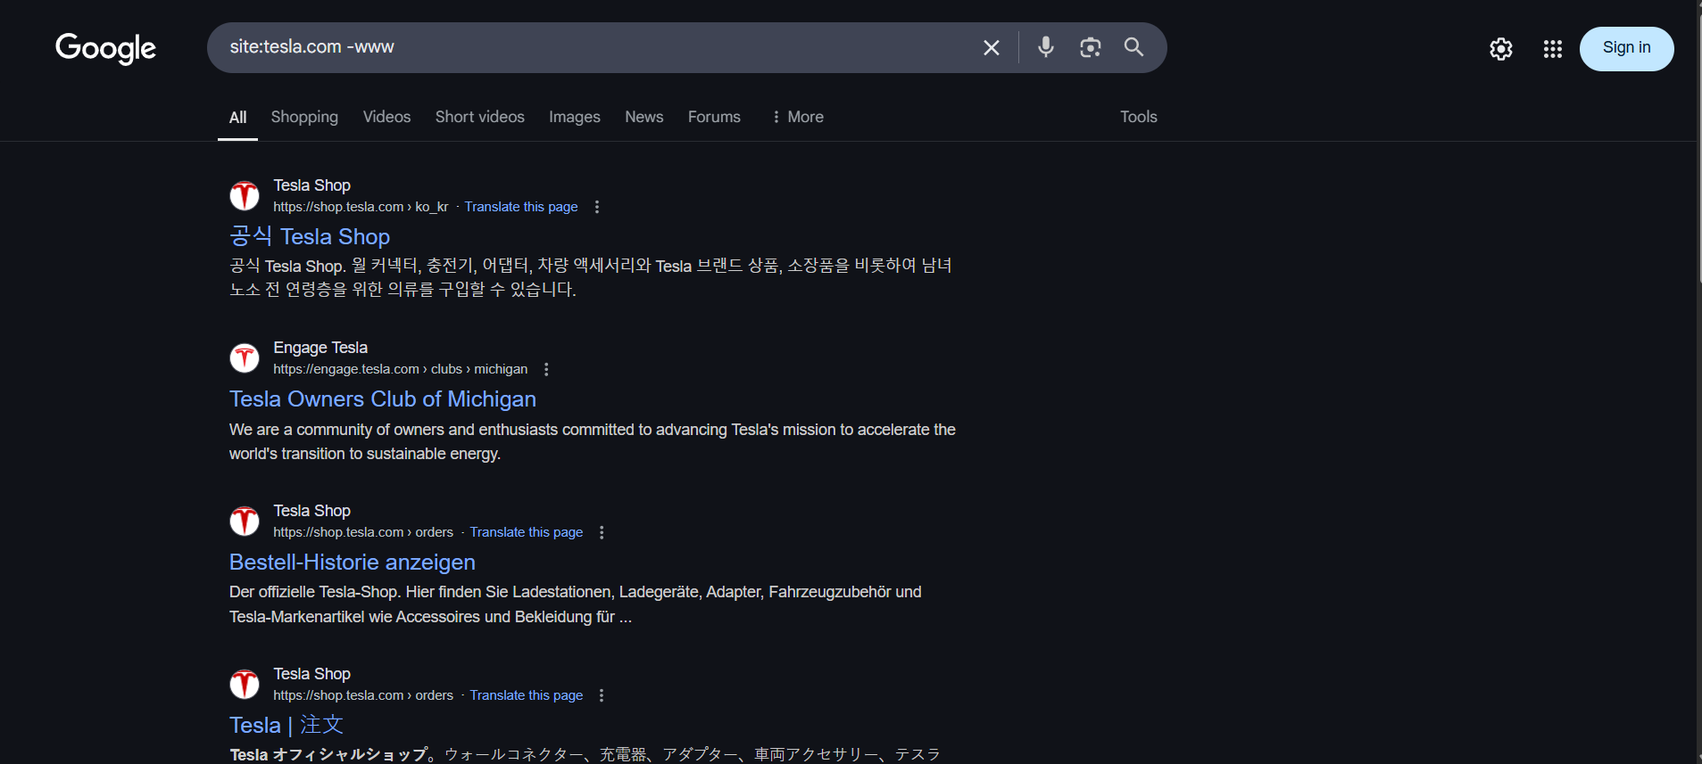
-www excludes www from subdomain
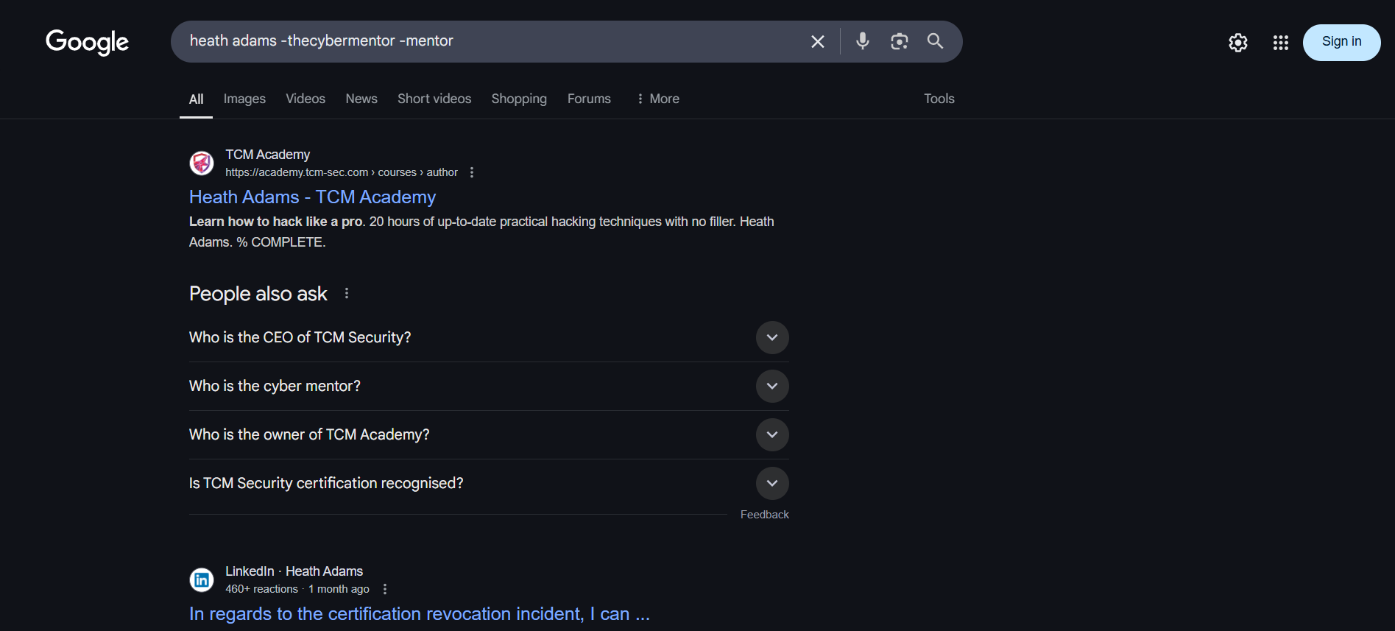
Will not show results having thecybermentor or mentor
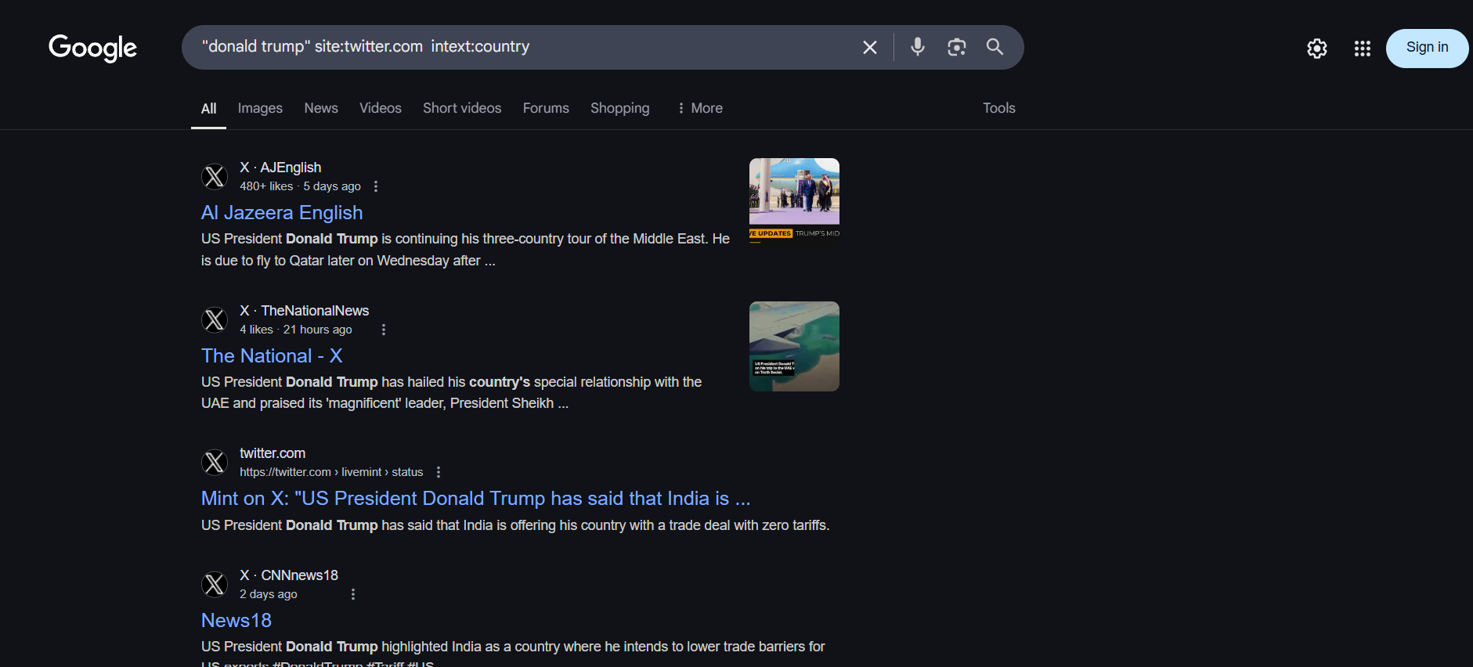
Checks for text in intext
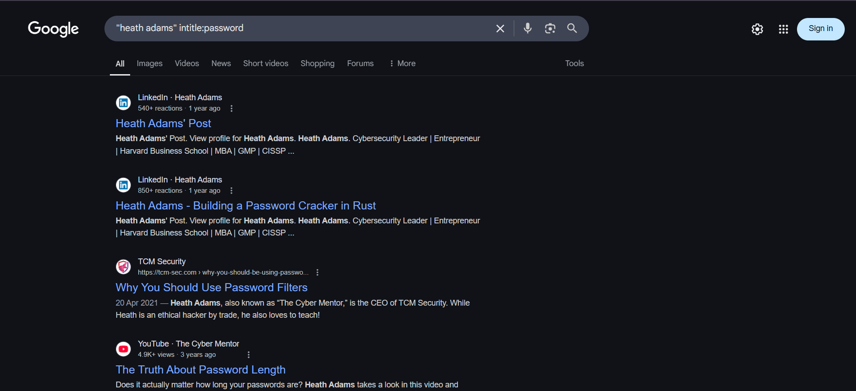
Instead of operators,google advanced search can also be used
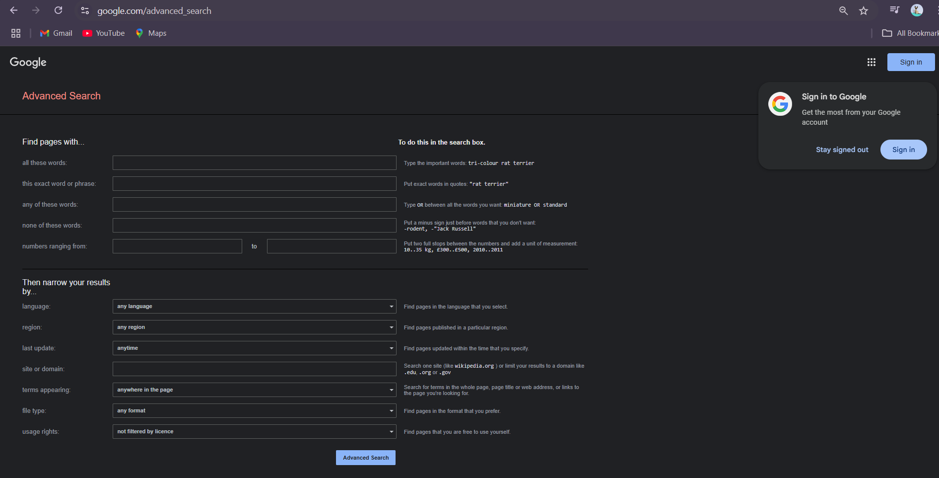

These techniques/conditions can be used to narrow down searches/view results for specified searches.

Reverse Image Searching:-
Exercises done in OSINT Exercises.
Usually carried out in images.google.com
Should also be done on TinEye,Yandex.(It also picks up similar images/other images of a person)
New,additional information can be discovered using this.

Viewing EXIF data:-
EXIF stands for Exchangeable Image File Format .EXIF data can provide a lot of information.EXIF data can provide a location,the device,timestamp,etc.
EXIF (Exchangeable Image File Format) data is a standardized way of storing metadata within digital image files. It contains technical information about how an image was created, such as the date and time it was taken, camera settings, and location if GPS data is included.
Exif data can be obtained from exif.regex.info or exifinfo.org
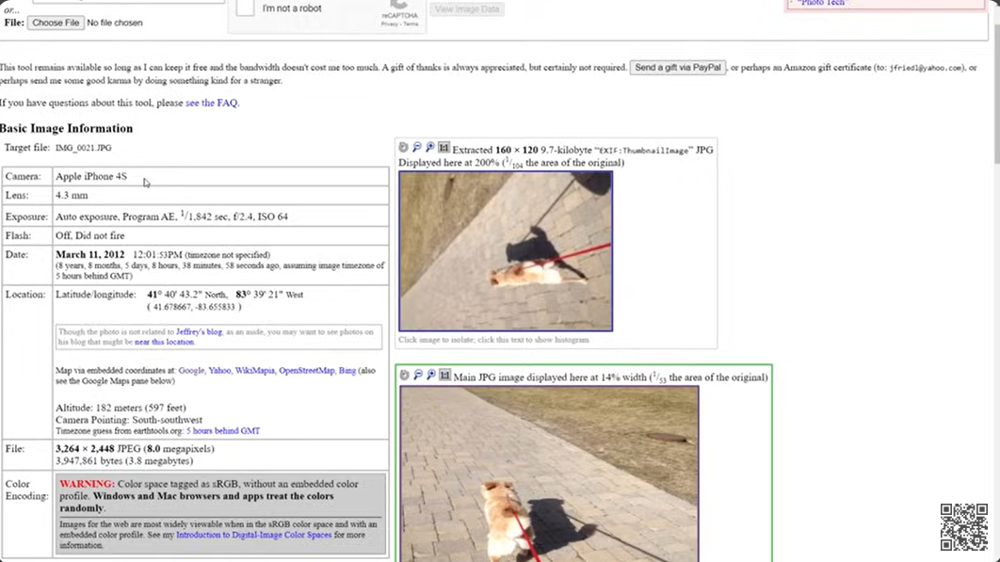

Physical Location OSINT:-
Done in OSINT Exercises.
Can be used for onsite reconnaissance/physical security breaches
Identifying information based on geolocation.

PimEyes-Can be used for facial recognition over the internet

Discovering Email Addresses:-
Discovers email addresses within a specified domain:
https://hunter.io/
(requires work account)
phonebook.cz
https://www.voilanorbert.com/
Used to verify if email addresses exist:
https://tools.emailhippo.com/
https://email-checker.net/check
Works from the business data availability perspective.After finding an email,forgot password can also be used to check for additional information or connections that connect to the person/that specified email.In this way,correlations can be carried out by checking online username.
Password OSINT:-
Password OSINT consists of analysing data that has been obtained through data breaches and outdated data which has been dumped on the internet.
Hunting Breached Credentials:-
https://dehashed.com/ (Requires payment)
What Dehashed does:-
Scans breached data databases for identifying and providing relevant information
Ability to identify data leaked in breaches by searching by IP address,email,username,name,address,phone number,password etc and also displaying other relevant data.
Passwords can also be entered in the search engine to search for other relevant leaked information
Useful for integrating findings and patterns on the online presence of a specific individual/individual.
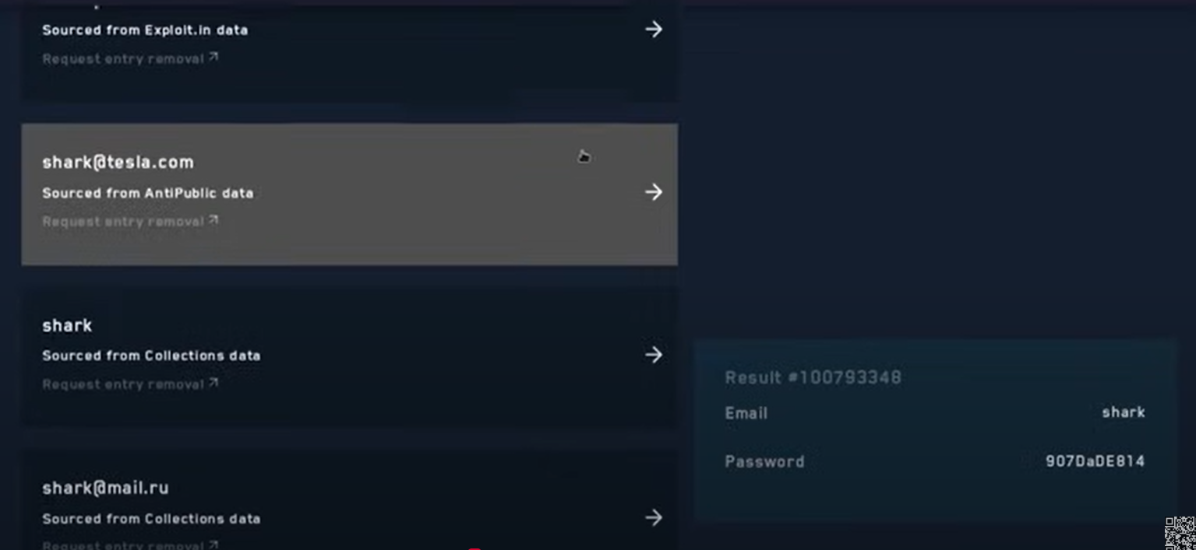
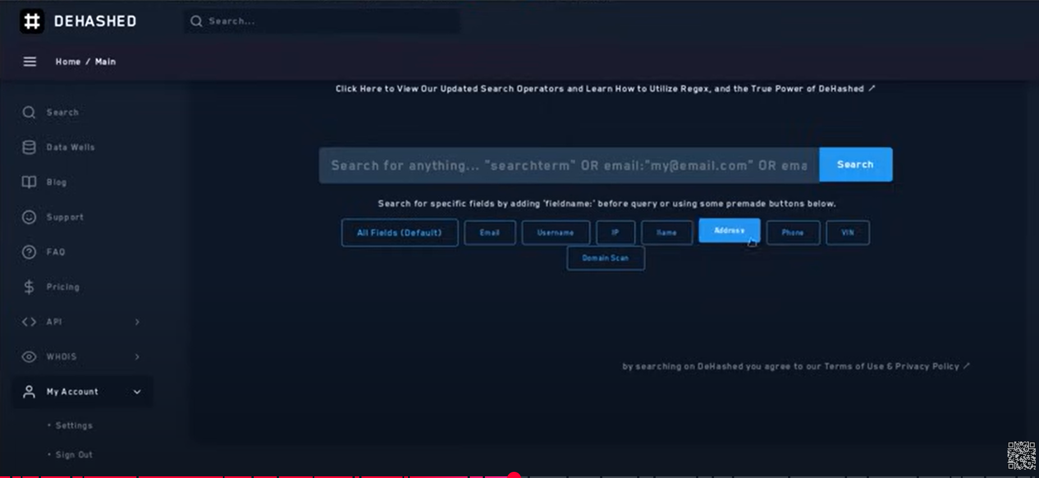
hashes.org for cracking hashes(may not work with some hashing mechanisms)
Other sources like Dehashed:
https://snusbase.com/
https://leakcheck.io/en
****VERY IMPORTANT****
https://haveibeenpwned.com/
This website checks whether the email provided by the user has been breached or identified in a data breach.It has upto date regularly updated databases of breached data,and also offers API services.(CAN BE USED IN PROJECT)
-Scylla(Also has API)->Down
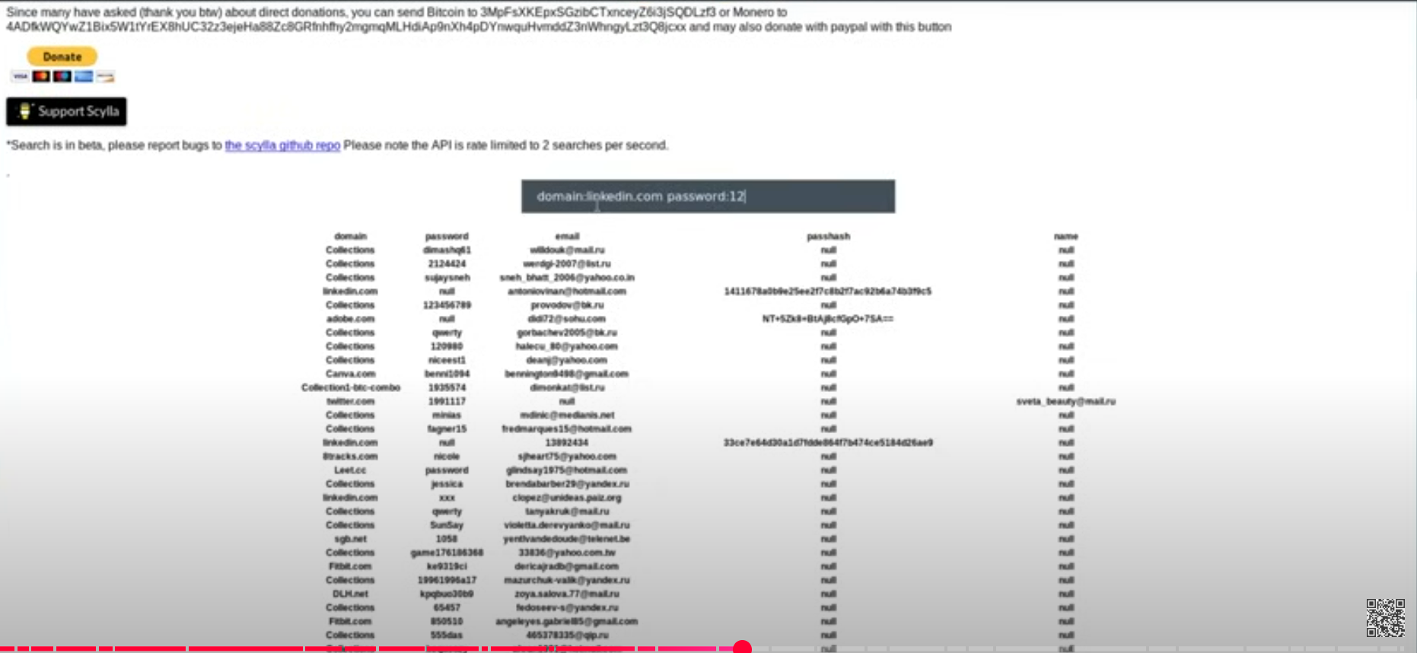

Hunting For Usernames and Accounts:-
https://namechk.com/
Checks whether a username exists on a platform or in a domain name or not.
https://whatsmyname.app/
https://namecheckup.com/

Wifi BSSID /Location detection:
https://wigle.net/
For decoding hashes
https://md5hashing.net/hash

