DATA ANALYST INTERNSHIP
Data Transformation and Pivot Table Analysis
Global meat and food supply trends, 1961 to 2017 (FAO data), analysed in Excel for Project FOODFLOW
Prepared by: Ayush Yadav
Date: 16 October 2026
Tool: Microsoft Excel (Tables, formulas, PivotTables, PivotCharts)
11,028  rows imported (18 columns) | 8,977  rows analysed: 174 countries | 4  PivotTables built | +77%  rise in average meat supply per person, 1961 to 2017

1. Introduction and Objective

1.1 Context
In Week 1, Project FOODFLOW set out a plan for analysing production efficiency in virtual food processing using advanced Excel. Week 2 puts that plan into practice. It takes one of the public data sources named in the plan (the Food and Agriculture Organization of the United Nations, FAO) and carries it through the full workflow: import, cleaning, transformation, and PivotTable analysis.
The point of this report is the method as much as the findings. Every step from importing the file to the final pivot is documented, with the reasoning behind each decision, so that anyone could repeat the work and reach the same numbers.

1.2 Objectives
- Import a public food dataset into Excel and describe its source, structure, and quality.
- Clean and transform it using advanced Excel features, logging every issue found and every decision made.
- Build four PivotTables, each answering a different question: the trend over time, the mix of products, a ranking of countries, and the rate of growth.
- Extract insights that matter to food processing and link them back to the research questions and hypotheses in the Week 1 plan.

1.3 Why this analysis matters to food processors
A processor decides how much capacity to build, and which product lines to run, partly on what people will eat. Trends in how much meat each person has available, and which types, are a demand signal for slaughter, cutting, packaging and cold-chain capacity. This report reads that signal from FAO data.

2. The Dataset

2.1 Source
Item | Detail
Dataset | Food supply (FAO, 2020): food available per person by country and year.
Source | FAO Food Balance Sheets, published through FAOSTAT.
Obtained from | The Our World in Data "owid-datasets" repository on GitHub (CSV file), retrieved on 15 October 2026.
Why it was chosen | It is free and public; it comes from FAO (one of the five sources in the Week 1 plan), and it supports the Week 1 question on trends and volatility (RQ1). Animal-product supply is also a demand signal for meat and dairy processing.

2.2 Size and structure
Property | Value
Rows and columns | 11,028 rows and 18 columns, one row per entity and year.
Entities | 216 in total: 174 current countries, 34 regions or groups (such as World and Europe) and 8 historical states (such as USSR).
Time span | 1961 to 2017 for countries. Regions and groups stop at 2013.
Key | Entity plus Year is unique: the file has no duplicate pairs.
Blank cells | Only the pigmeat column has blanks (276 in total).

2.3 Fields used
The original headers were long, with the unit buried inside each one. They were shortened to the names below, with the unit recorded in this table instead.
Column (clean name) | Meaning | Unit
Entity | Country, region or group name | Text
Year | Calendar year (1961 to 2017) | Year
Calories_kcal | Total food supply | kcal per person per day
Fat_g | Fat supply | g per person per day
Protein_g | Protein supply | g per person per day
Meat_kg | Total meat supply | kg per person per year
Bovine_kg | Beef and buffalo meat | kg per person per year
Poultry_kg | Poultry meat | kg per person per year
Pig_kg | Pigmeat | kg per person per year
Mutton_kg | Mutton and goat meat | kg per person per year
OtherMeat_kg | Other meat | kg per person per year
Eggs_kg | Eggs | kg per person per year
Milk_kg | Milk, excluding butter | kg per person per year
Fish_kg | Fish and seafood | kg per person per year
AnimalProtein_g | Animal protein supply | g per person per day
VegProtein_g | Vegetable protein supply | g per person per day
Fruit_kg | Fruit, excluding wine | kg per person per year
Veg_kg | Vegetables | kg per person per year

What this data does and does not measure
These figures are food supply available per person: a measure of what reaches the market, after trade but before household waste. It is not factory output. In this report, it is read as a demand signal that processors respond to, not as a measure of efficiency inside a plant.

3. Data Cleaning Log
Cleaning followed three rules: keep an untouched copy of the raw data, never fix anything silently, and never invent values. Each issue below was found during a first look at the data, and each decision is recorded with its reason.
# | Issue found | Evidence | Action taken and reason | Rows affected
1 | Raw data protected | The imported file must never be edited. | Kept it on a sheet named Raw_Data and worked on a copy named Clean_Data, so any step can be checked against the original. | All 11,028
2 | Headers too long | Unit text embedded in 18 column names. | Renamed the columns (Section 2.3) and recorded units in a field table. | 18 columns
3 | Duplicates | Checked for repeated Entity and Year pairs. | None found. No removal needed. | 0
4 | Regions and groups mixed with countries | 34 aggregates such as World, Europe, Least Developed Countries. | Added a Type column ("Aggregate") through a lookup. Excluded from country pivots, because adding a region to its own countries would count them twice. | 1,771 (16.1%)
5 | Historical states overlap successors | USSR, Yugoslavia, Czechoslovakia and five others exist next to the countries that replaced them. | Marked Type "Historical" and excluded from trends and rankings. | 280 (2.5%)
6 | Blank pigmeat values | 276 blanks, of which 225 are in current countries (for example, Kuwait, UAE, Saudi Arabia, Afghanistan). | Left blank and flagged "Not reported". Pork is not part of the food supply in these countries, so zero or an average would be false. | 276 (2.5%)
7 | Does the meat total add up? | Meat total compared with its five meat types. | Added a check column. The largest difference is 0.16 kg per person (rounding), so all rows pass a 0.2 kg limit. | 0 failures
8 | Uneven year coverage | Aggregates end in 2013. The country list grows from 147 (1991) to 166 (1992). | No change made. Documented as a limitation and tested with a balanced panel (Section 5.1). | Whole file
9 | Mixed units | Kcal, grams, and kilograms sit in one table. | Kept every measure separate. Never added across different units. | Whole file

Result: 8,977 of the 11,028 rows (81.4%) are used in the pivot tables, covering 174 current countries from 1961 to 2017.

4. Transformations and Formulas Explained

4.1 Step-by-step process
- Import. Opened the FAO CSV in Excel and saved it as a workbook.
- Protected the original. Duplicated the sheet: Raw_Data stays untouched, Clean_Data is the working copy.
- Profile. Counted rows, blanks, minimums, and maximums for every column, and listed the entities and years.
- Convert to a table. Selected the data and used Insert, then Table, naming it tblFood. Formulas then use column names and fill down automatically. The table finishes with 22 columns after the four added ones.
- Rename headers. Replaced the 18 long headers with the short names in Section 2.3.
- Classify entities. Built a lookup list (Entity_Types) marking each entity as Country, Aggregate, or Historical, and added a Type column to the table, placed next to Entity.
- Flag blanks. Added a Pig_Flag column so blanks are labelled instead of filled.
- Validate. Added Meat_Check and Meat_Status columns to test that the meat total equals the sum of its parts.
- Analyse. Built four PivotTables from tblFood, each with Type set to Country.
- Interpret. Wrote the explanation and insight for each pivot and linked them to Week 1.

4.2 Workbook structure
Sheet | Contents
Raw_Data | The original FAO file: 11,028 rows and 18 columns. Never edited.
Entity_Types | Lookup list of the 216 entities, each marked Country (174), Aggregate (34), or Historical (8).
Clean_Data | The working copy, stored as the table tblFood. It has 22 columns: the 18 renamed originals plus four added ones (Type, Pig_Flag, Meat_Check, Meat_Status).
Pivot_1 | Average meat supply per person by year.
Pivot_2 | Average supply of each meat type by year, with a stacked column chart.
Pivot_3 | Top 10 countries by meat supply in 2017.
Pivot_4 | Average meat supply by year, with the year-on-year growth rate.

4.3 Formulas
Column | Formula | What it does and why
Type | =INDEX(Entity_Types!$B:$B, MATCH([@Entity], Entity_Types!$A:$A, 0)) | Looks up each entity in the classification list and returns Country, Aggregate, or Historical. This is what lets the pivots filter out regions.
Pig_Flag | =IF([@Pig_kg]="", "Not reported", "OK") | Labels blank pigmeat cells instead of filling them, so the gap is visible and explained.
Meat_Check | =ROUND([@Meat_kg]-SUM([@Bovine_kg],[@Poultry_kg],[@Pig_kg],[@Mutton_kg],[@OtherMeat_kg]),2) | Subtracts the five meat types from the meat total. A result near zero means the numbers agree. SUM ignores blanks, so rows with no pigmeat still work.
Meat_Status | =IF(ABS([@Meat_Check])<=0.2, "Pass", "Check") | Turns the difference into a clear Pass or Check label. The 0.2 kg limit allows for rounding.
Check count | =COUNTIF(tblFood[Meat_Status],"Check") | Counts rows that fail. The result is 0, so every row passes.

Excel shows the formulas with short column names such as [@Entity]. In the saved workbook, the same formula is stored as tblFood[[#This Row],[Entity]]. The two forms mean the same thing.

4.4 Key decisions and the reasoning behind them
- Average, not Sum, in every pivot. The measures are per person, so adding countries together would be meaningless. Each pivot reports the average across countries.
- Type = Country on every pivot. This keeps regions, groups, and former states out, so no country is counted twice, and no row is a region.
- Blanks left as blanks. Replacing missing pigmeat with zero or an average would invent data and distort the meat mix.
- Number format of one decimal place. The data is reported to two decimals, but one is enough to read trends, and it keeps tables clean. This changes only how numbers display, not their values.

5. PivotTable Analysis
Four PivotTables were built from tblFood, each from a different angle. All four are filtered to Type = Country.

5.1 Pivot 1: average meat supply per person by year
Purpose: show the long-run trend in meat supply (Week 1, RQ1).
Pivot area | Fields
Rows | Year
Columns | None
Values | Average of Meat_kg (1 decimal place)
Filters | Type = Country

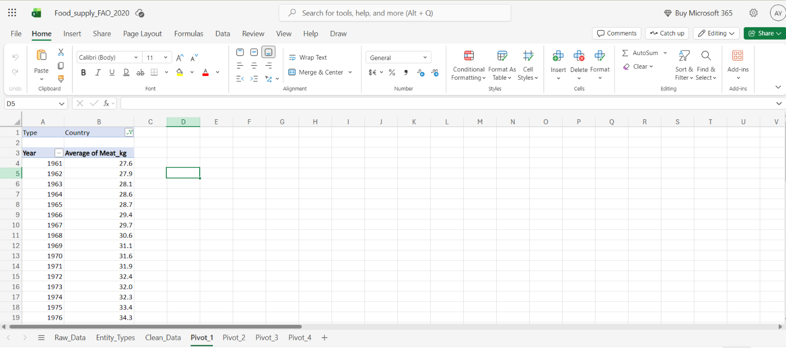
Pivot 1: average Meat_kg by Year, with the Type = Country filter visible
Figure 1. Average meat supply per person by year (screenshot of PivotTable).
Why these fields? Year in Rows turns the table into a time series. Meat_kg in Values gives total meat supply per person. Average is used instead of Sum because the values are already per person. Filtering to Country removes regions, so the figure describes countries only. The Grand Total row (40.1 kg) is the average of every country-year, and is not used in the analysis.
Key results (average across countries):
Year | Average (kg per person) | Countries in the average | Note
1961 | 27.6 | 146 | Start of the series
1992 | 41.2 | 166 | Country count jumps from 147 (new states appear)
2000 | 43.9 | 171
2013 | 50.8 | 174 | Peak of the series
2017 | 48.8 | 172 | Last year

Insight. Average meat supply rose by 77% between 1961 and 2017, from 27.6 to 48.8 kg per person, which is about 1.0% per year. Because the country list changes over time (it jumps in 1992), the trend was re-tested on a balanced panel of the 144 countries present in every year. It gives the same 1.77x rise (27.1 to 47.9 kg), so the growth is real and not an artefact of new countries joining.

5.2 Pivot 2: the meat mix by year
Purpose: see which types of meat are driving the change (Week 1, RQ1 and the processing demand signal).
Pivot area | Fields
Rows | Year
Columns | None (the five meat types appear as separate value columns)
Values | Average of Poultry_kg, Bovine_kg, OtherMeat_kg, Pig_kg and Mutton_kg
Filters | Type = Country

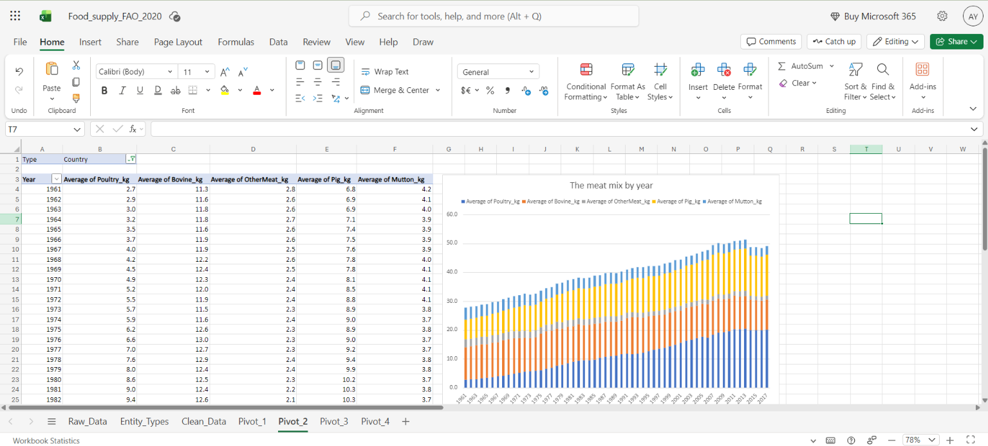
Pivot 2: five meat types by Year, plus the stacked column PivotChart
Figure 2. Average supply of each meat type per person, by year.
Why these fields. Splitting the total into its five types shows what changed underneath the overall rise. A stacked column chart makes the shifting shares visible at a glance. The five types are averaged separately, so they add up to slightly more than the total average (blank pigmeat values are excluded from the pig average).
Key results:
Meat type | 1961 (kg) | 2017 (kg) | Change | Share 1961 | Share 2017
Bovine (beef) | 11.3 | 10.3 | x0.91 | 40.8% | 21.0%
Poultry | 2.7 | 20.2 | x7.4 | 9.8% | 41.3%
Pig | 6.8 | 14.2 | x2.1 | 24.5% | 28.9%
Mutton and goat | 4.2 | 2.9 | x0.70 | 14.9% | 6.0%
Other meat | 2.8 | 1.4 | x0.50 | 9.9% | 2.8%

Insight. The mix changed far more than the total. Poultry grew about 7.4 times and went from 10% to 41% of meat supply, overtaking beef, which fell from 41% to 21%. Pig meat roughly doubled. For a processor, this points demand towards poultry and pork lines (slaughter, cutting, portioning, packaging) and away from beef, mutton and other meat.

5.3 Pivot 3: top 10 countries by meat supply in 2017
Purpose: show how unequal supply is between countries, to see where the largest per-person markets are.
Pivot area | Fields
Rows | Entity
Columns | None
Values | Average of Meat_kg (one row per country in 2017, so the average equals the value)
Filters | Type = Country and Year = 2017. A Top 10 value filter keeps the highest ten, and the rows are then sorted from largest to smallest.

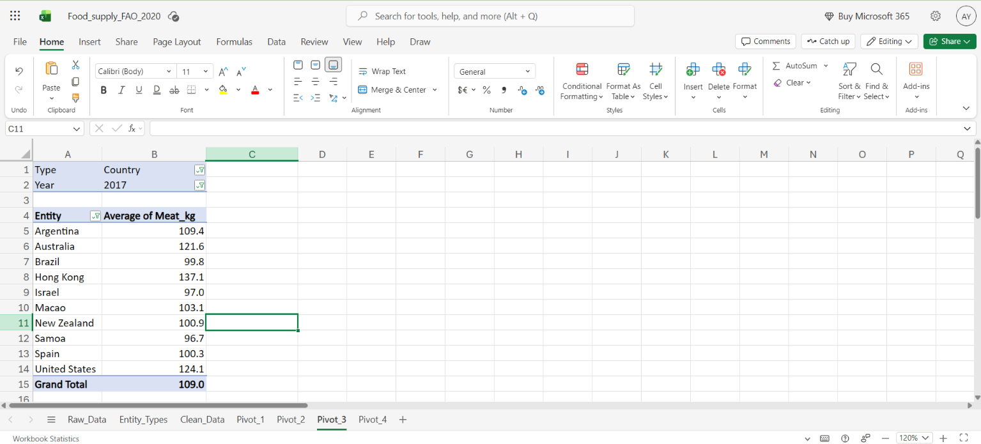
Pivot 3: top 10 countries by Meat_kg in 2017
Figure 3. The ten countries with the highest meat supply per person in 2017.
Why these fields? Entity in Rows lists countries. Year sits in Filters so only one year shows. The Top 10 filter keeps the highest ten, sorting makes it a ranking, and Grand Total is their average.
Key results:
Rank | Country | Meat (kg) | Poultry (kg) | Pig (kg)
1 | Hong Kong | 137.1 | 53.5 | 59.1
2 | United States | 124.1 | 55.7 | 30.0
3 | Australia | 121.6 | 47.6 | 25.9
4 | Argentina | 109.4 | 42.2 | 10.7
5 | Macao | 103.1 | 34.5 | 53.0
6 | New Zealand | 100.9 | 34.8 | 23.9
7 | Spain | 100.2 | 30.4 | 53.6
8 | Brazil | 99.8 | 48.0 | 13.6
9 | Israel | 97.0 | 67.4 | 1.5
10 | Samoa | 96.7 | 64.8 | 17.3

Insight. The gap between countries is very large: Hong Kong at 137.1 kg is about 36 times India at 3.8 kg (Bangladesh is 4.0 and Ethiopia 5.4). Across the 172 countries in 2017, the mean is 48.7 kg, but the median is 45.4 kg, so a few very high values pull the average up. The top ten mixes very different profiles: the United States, Australia and Argentina are large meat-eating markets, Spain is pork-led, and Israel and Samoa are poultry-led. The ten countries together average 109.0 kg, more than double the all-country mean. A processor would therefore size lines by market, not by a global average.

5.4 Pivot 4: year-on-year growth of average meat supply
Purpose: measure how fast supply grows and how steady that growth is (Week 1, RQ1: trends and volatility).
Pivot area | Fields
Rows | Year
Columns | None
Values | Average of Meat_kg (twice). The second copy is shown as "% Difference From" the previous year.
Filters | Type = Country

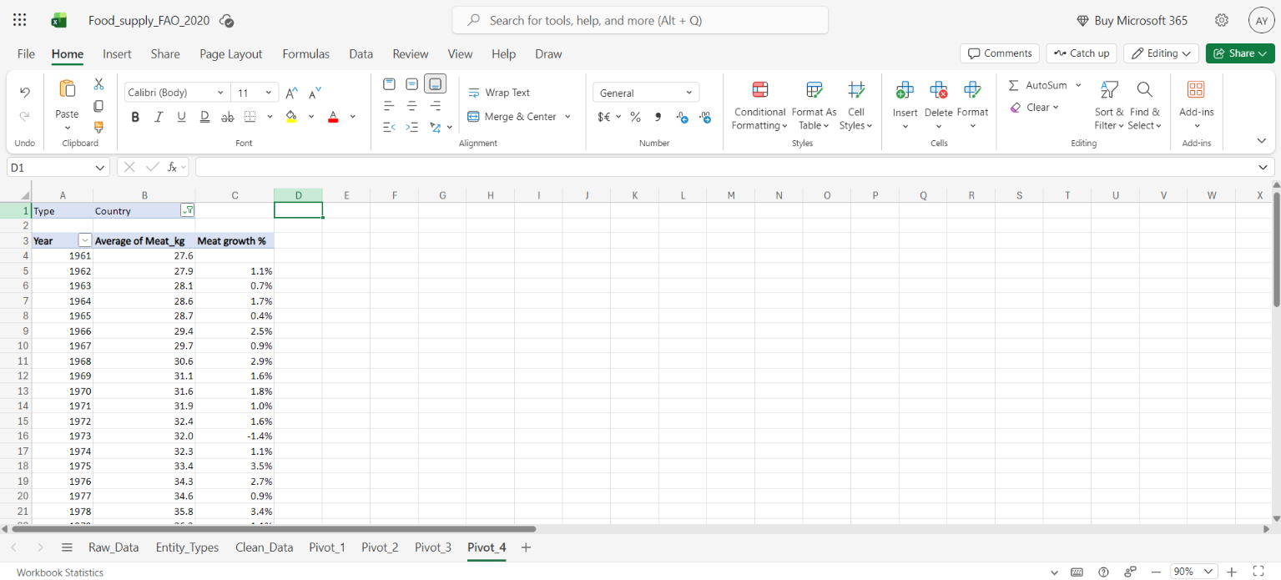
Pivot 4: average Meat_kg and the year-on-year % change
Figure 4. Average meat supply per person and its year-on-year change.
Why these fields? Using the same measure twice, once as a level and once as a change from the previous year, turns the trend into a growth rate. Year-on-year change is also the volatility measure adopted in the Week 1 hypothesis tests.
Key results:
Statistic | Value
Average yearly growth, 1962 to 2017 | +1.03%
Standard deviation of yearly growth | 1.32 percentage points
Largest rise | +3.82% (2007)
Largest fall | -4.70% (2014)

Insight. Growth is steady and mild: about 1% a year with small swings. The 2014 fall of 4.7% is the biggest in the series, but the number of countries in the data drops from 174 to 172 that year, so it should be treated as a data change to investigate before reading it as a real drop in meat eating.

6. Key Insights and Links to the Week 1 Plan
# | Insight | Evidence | Link to Week 1
1 | Meat supply per person is rising steadily. | The average rose 77% (27.6 to 48.8 kg), about 1% a year. The same 1.77x rise holds on a balanced panel of 144 countries. | Answers RQ1 (trends over 10 to 15 years) with a longer 56-year series.
2 | The product mix is shifting to poultry. | Poultry went from 9.8% to 41.3% of meat supply, about 7.4 times larger in kg. Beef fell from 40.8% to 21.0%. | Gives NutriLine Foods a demand signal for which product lines to expand, as context for the Week 1 scenarios.
3 | Markets differ enormously by country. | Hong Kong 137.1 kg against India 3.8 kg (about 36x). Mean 48.7 kg but median 45.4 kg. | Supports using country-level benchmarks (US, India, EU) in Week 1 rather than one global figure.
4 | Growth is steady even though individual countries swing. | Average yearly change has a standard deviation of only 1.3 points. The Week 1 pilot found meat supply more volatile than cereals in 77% of countries (median 7.1% against 4.7%). | Connects to H4: volatility is high country by country, but it averages out across countries into a smooth trend.
5 | Cleaning decisions protect the results. | 2,051 rows (18.6%) were excluded as aggregates or historical states. For the average, including them would change 2013 by only 0.4%, but sums, counts and rankings would be wrong. | Applies the data-quality gates (completeness, consistency, plausibility) from the Week 1 methodology.

Overall: the data shows a steady rise in meat supply with a strong swing towards poultry. For a processor, the signal is to expect growing demand and to favour poultry and pork lines. This dataset cannot say how efficiently any plant converts inputs into products, so Hypotheses H1 to H3 (capital, price and energy) are not tested here and remain for the later data sources.

7. Limitations
- Supply, not production or consumption. The data measures food available per person, so it shows demand conditions and not what factories produce or how efficiently they run.
- Unweighted averages. Each country counts equally, so a small country weighs as much as a large one. A population-weighted average would give different levels, though not necessarily a different trend.
- The country list changes over time. The number of countries rises from 147 to 166 in 1992 and falls from 174 to 172 in 2014. A balanced-panel check supports the long-run trend, but year-to-year changes around those dates should be read with care.
- Small trading hubs inflate rankings. Places such as Hong Kong and Macao have high per-person supply partly because of trade and tourism, which a per-person figure cannot separate.
- Structural blanks. Pigmeat is missing for some countries because pork is not supplied there. These blanks were left unfilled, which means the pig average covers fewer countries than the other meat types.
- Descriptive, not causal. The pivots describe patterns. They do not show why poultry grew or what drives differences between countries.
- Limited tools. The workbook was built in Excel for the web, which has no Power Query, so cleaning was done with formulas and a lookup list. The desktop version would allow the same steps to be recorded as one refreshable query.
- Source revisions. FAO revises its data over time, so figures may differ slightly if the file is downloaded again later.

