Group Image Disintegrator is an efficient web-based application which allows the user to get two folders of segregated images (male and female) from the group picture that is uploaded on the website.

This application called Close-Ups utilizes convolutional neural networks which consists of a Convo2D layer, pooling layer, batch normalization layer and the last layer is sigmoid activation function which is a two class based model. Our model has a learning rate of 0.01 and the number of epochs is 100.

The home page asks the users to upload a group picture. Once the picture is uploaded it appears on the home page itself and the user is required to click on the upload button.



The next page asks the users to click the process button in order to have a look at the results.

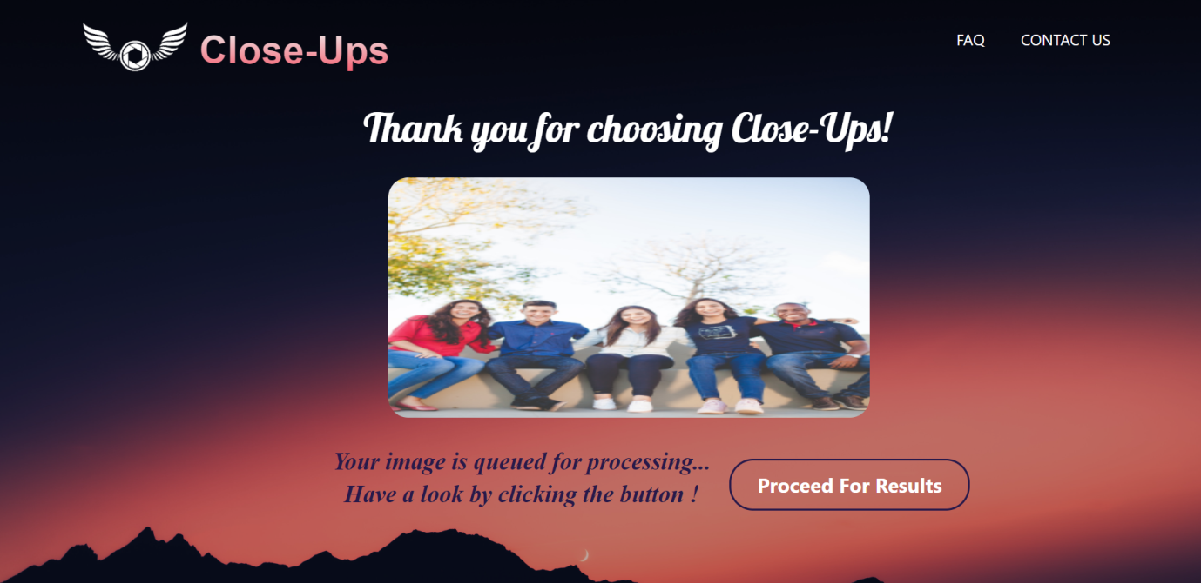

This is the preview page which displays both the sets of male and female members in form of a collage. Various details related to the images also get displayed here.

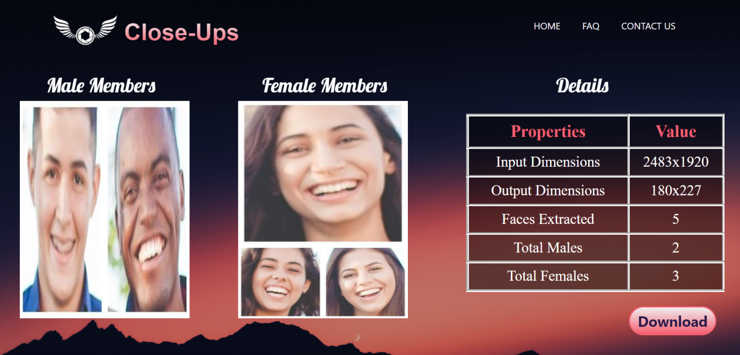

Here users can download the folders categorized into male set and female set by clicking the buttons respectively.

