AI FOR SOCIAL GOOD
-TECH NINJAS
Problem Statement: Design an AI/ML-powered video surveillance system that analyzes real-time CCTV footage to detect and classify unusual events such as violence, theft, or accidents. The system must distinguish normal behaviors from anomalies despite challenges like limited anomaly data, noisy frames, and incomplete labels, while providing reliable, interpretable, and scalable alerts. For example, in a crowded metro station during rush hour, the model should filter routine passenger movement but quickly flag a sudden fight or accident, explain why it was detected, and notify security staff in real time. Each detected event should be classified on a scale of 1–10, where 1 represents normal activity and 10 indicates the most severe anomaly, enabling security teams to prioritize responses effectively.
DATASET:
1. abuse -> 50 Videos
2. arrest -> 50 videos
3. arson -> 50 Videos
4. assult -> 50 Videos
5. burglary -> 100 Videos
6. explosion -> 50 Videos
7. fighting -> 50 Videos
8. normal -> 60 Videos
9. road accidents -> 90 videos
10. robbery -> 150 videos
11. shooting -> 50 Videos
12. shop lifting -> 50 Videos
13. stealing -> 100 Videos
14. vandalism -> 50 Videos
Total Videos: 950
Total Frames: 740000
Video Resolution: lower than 360p

Architecture: CNN Backbone + LSTM for Temporal Understanding
Input Video (16 frames)
↓
MobileNetV2 (pretrained on ImageNet) — extracts features from each frame
↓
TimeDistributed wrapper — applies CNN to each frame independently
↓
LSTM Layer — learns patterns across time (temporal sequence)
↓
Dense + Dropout — reduces overfitting
↓
Softmax Output — 14 class probabilities

Frames Example:
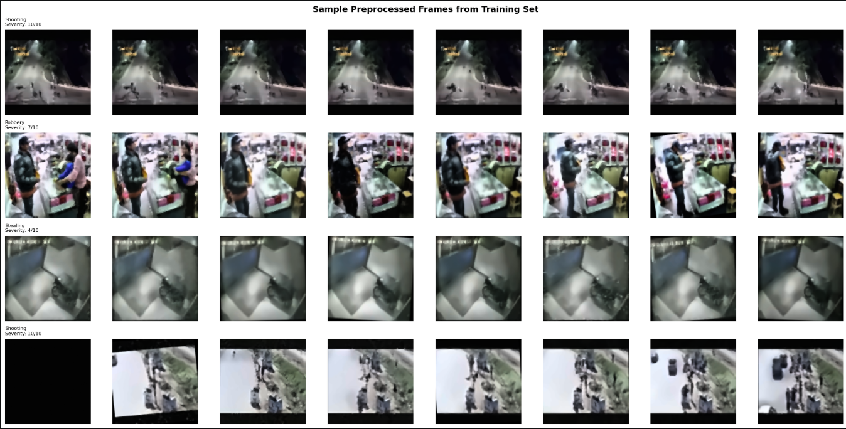

Model Summary:
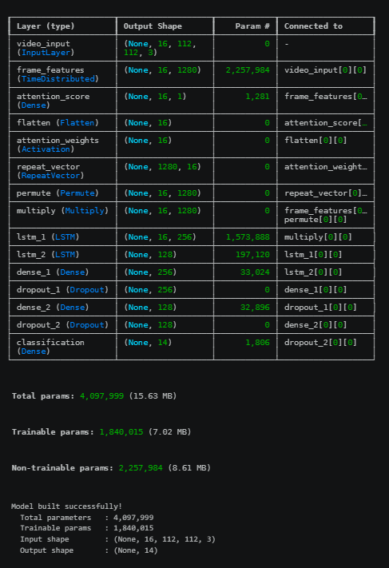

Probability Distribution For Multiple Classes in a Video:
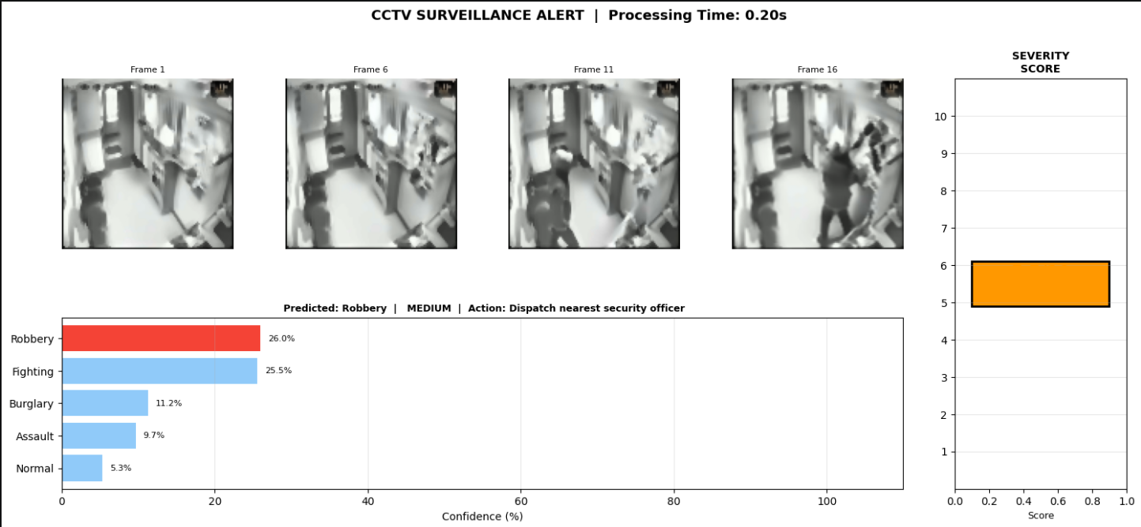
Video ANALYSIS:
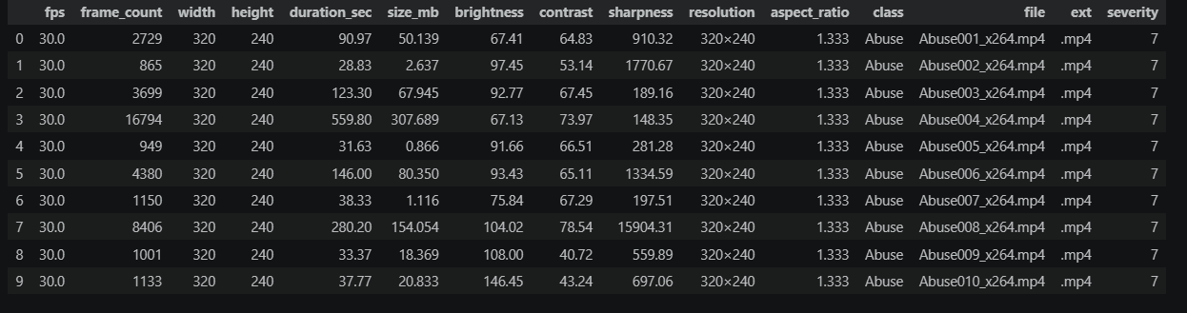
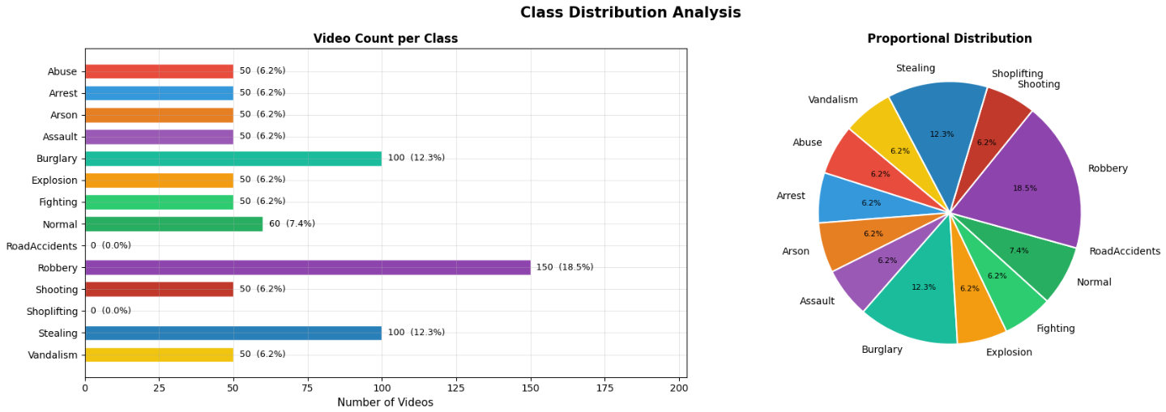
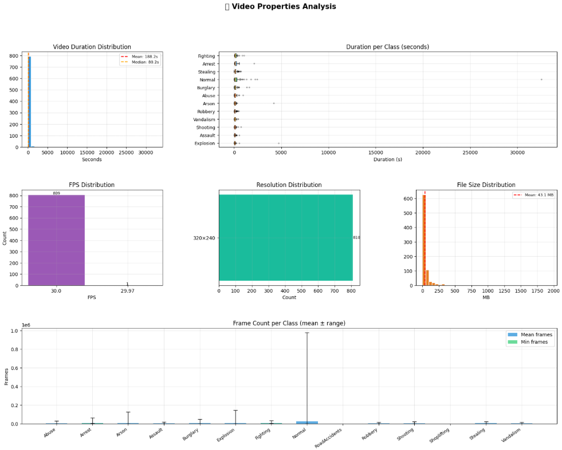

UI Frontend – Developed using HTML and CSS.
Before Video Uploading:
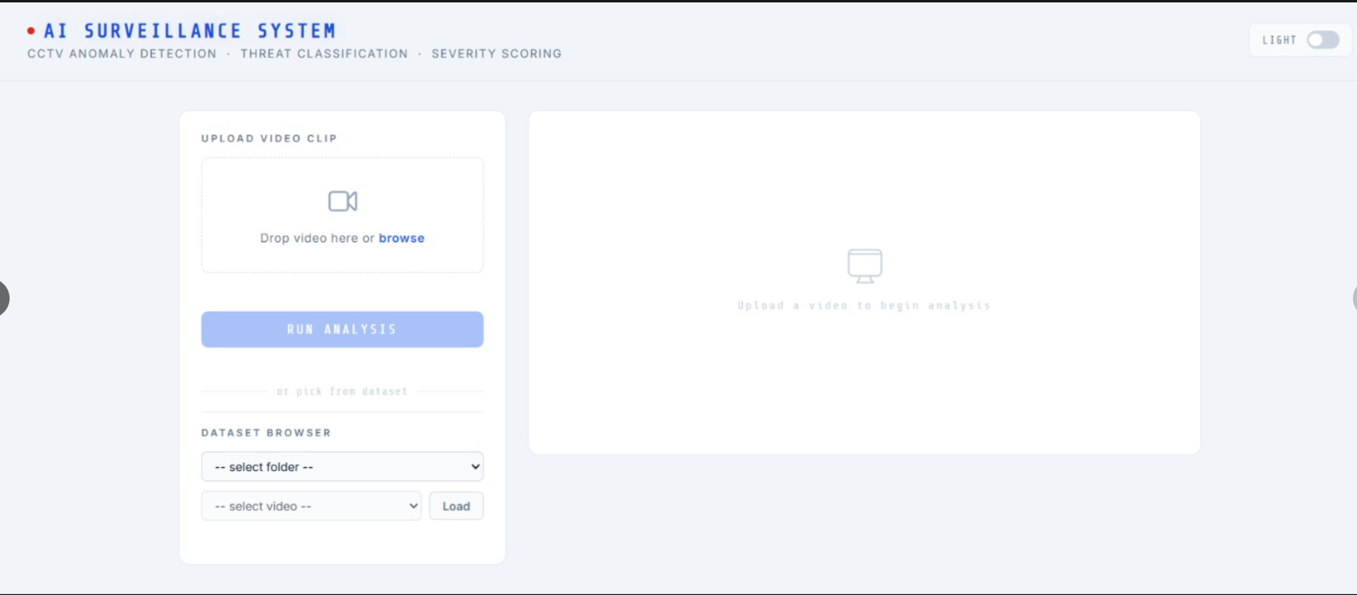
After Video Uploading:
