### ****Objective Questions and Answers****

#### **Q1: What is the total number of attributes present in the data?**

**Answer**: **Ticket Table**: 10 attributes **IT Agent Table**: 6 attributes

**Guidance**: Understanding the number of attributes is crucial as it provides insight into the dataset's complexity and how much information is available for analysis.

**Observation**: The dataset contains a total of **16 attributes** across two tables, indicating a moderately detailed dataset that covers key aspects like ticket details, agent information, and performance metrics.

#### **Q2: Which columns have inconsistent or missing values, and what is the count of such values?**

**Answer**: There are no columns with missing or inconsistent values. The count is **0**.

**Guidance**: Data quality is essential for producing reliable insights. Verifying that there are no missing values helps ensure the accuracy of the analysis.

**Observation**: The absence of missing or inconsistent values indicates a clean dataset, which means the analysis can proceed without needing data imputation or correction.

#### **Q3: What is the average daily ticket volume over time?**

**Answer**: **106.67 tickets per day**.

**Guidance**: Calculating the average daily ticket volume helps in understanding the workload the support team is dealing with on a regular basis, and can assist in capacity planning.

**Observation**: The average of 106.67 tickets per day suggests a consistent flow of support requests, which can help plan for staffing and resource allocation to maintain service efficiency.

#### **Q4: What is the distribution of ticket categories (e.g., Login Access, System, and Software)?**

**Answer**:

**Hardware**: Number of Tickets: **9,733** Percentage: **9.98%** **Login Access**: Number of Tickets: **29,193** Percentage: **29.94%**

**Software**: Number of Tickets: **19,570** Percentage: **20.07%** **System**: Number of Tickets: **39,002** Percentage: **40.00%**

**Guidance**: Analyzing the distribution of ticket categories helps prioritize areas where the most issues occur, aiding in resource allocation and training efforts for the support team.

**Observation**: The **System** category dominates, representing **40% of all tickets**. This indicates that system-related issues are the most common and may require the most resources and attention to resolve.

**Visualization**: A **pie chart** can display the distribution of ticket categories, helping visualize which category takes up the most support resources.

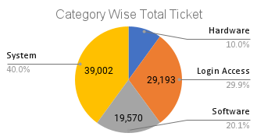

#### **Q5: How many tickets has each agent handled?**

**Answer**: Here is the list that ticket handled by each agent also here is the link of Pivot Table which show you the Agent wise total ticket Count (https://docs.google.com/spreadsheets/d/1UOz5SxLqYKBo9iIW5XXn8uuJ5LOi_6Oa/edit?gid=743525734#gid=743525734)

|  |  |  |  |  |  |  |  |
| --- | --- | --- | --- | --- | --- | --- | --- |
| *Agent ID* | Total Ticket | *Agent ID* | Total Ticket | *Agent ID* | Total Ticket | *Agent ID* | Total Ticket |
| 1 | 1969 | 16 | 1926 | 31 | 1987 | 46 | 1950 |
| 2 | 1968 | 17 | 1961 | 32 | 1974 | 47 | 1933 |
| 3 | 2021 | 18 | 1892 | 33 | 1958 | 48 | 2027 |
| 4 | 1988 | 19 | 1984 | 34 | 1927 | 49 | 1890 |
| 5 | 2000 | 20 | 1920 | 35 | 2007 | 50 | 1949 |
| 6 | 1949 | 21 | 1889 | 36 | 1913 | **Grand Total** | **97498** |
| 7 | 1935 | 22 | 1966 | 37 | 1931 |  |  |
| 8 | 1960 | 23 | 1915 | 38 | 1938 |  |  |
| 9 | 1949 | 24 | 2003 | 39 | 2026 |  |  |
| 10 | 1974 | 25 | 1906 | 40 | 1920 |  |  |
| 11 | 1956 | 26 | 1963 | 41 | 1966 |  |  |
| 12 | 1897 | 27 | 1968 | 42 | 1945 |  |  |
| 13 | 1856 | 28 | 1946 | 43 | 1897 |  |  |
| 14 | 1942 | 29 | 1931 | 44 | 1943 |  |  |
| 15 | 1991 | 30 | 1963 | 45 | 1929 |  |  |

**Guidance**: Understanding how many tickets each agent handles helps evaluate workload distribution and performance.

**Observation**: Agent workloads vary, with **Agent 48** handling the most tickets , indicating possible overburdening, while others handle fewer, showing a need for more even distribution of tasks.

**Visualization**: A Combo **bar chart** can display the number of tickets handled by each agent, helping visualize workload distribution.

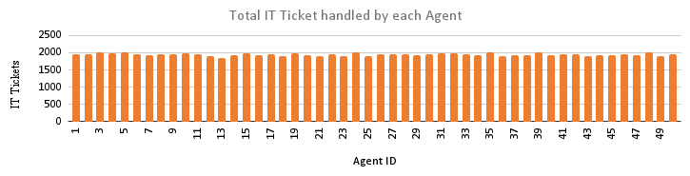

#### **Q6: How can you extract the domain from the email addresses in the IT Agents sheet?**

**Answer**: Use the formula =MID(C2, FIND("@", C2) + 1, LEN(C2) - FIND("@", C2)).

**Guidance**: Extracting the domain from email addresses is useful for identifying where agents or employees are located, or to categorize them based on their organization.

**Observation**: The domain extraction allows you to see patterns based on agent email addresses, which could be useful in identifying regional or organizational clusters.

#### **Q7: How can you find the full name of an agent given their Agent ID?**

**Answer**: You can use either =VLOOKUP(E2, A2, 2, FALSE) or =INDEX(B2, MATCH(E2, A2, 0)).

**Guidance**: Knowing how to lookup values, such as finding an agent’s name by their ID, is key to efficiently analyzing and retrieving information from large datasets.

**Observation**: This lookup method can streamline operations and reports, saving time when searching for specific information within the dataset.

#### **Q8: What is the count of each issue type (e.g., IT Error, IT Request)?**

**Answer**: **IT Error**: **24,278 IT Request**: **73,220 Total**: **97,498**

**Guidance**: Counting issue types helps understand the commonality of certain issues, aiding in resource allocation and training for resolving these problems efficiently.

**Observation**: **IT Requests** are far more frequent than IT Errors, which suggests that support agents should be well-versed in addressing various requests.

**Visualization**: A **pie chart** can be used to compare the volume of IT Errors and IT Requests.

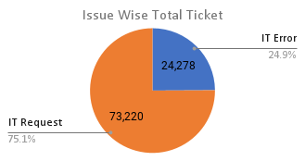

#### **Q9: What is the daily average resolution time for tickets?**

**Answer**: The average resolution time is **4.55 days**.

**Guidance**: Monitoring resolution time is key to ensuring timely service and customer satisfaction. Reducing average resolution time can enhance overall service efficiency.

**Observation**: A **4.55-day average** resolution time suggests room for improvement, particularly in addressing complex tickets.

#### **Q10: How has the volume of tickets changed over time?**

**Answer**: The volume of tickets has **increased over time**, indicating a growing demand for support services.

**Guidance**: Tracking ticket volume trends over time helps anticipate future demand and adjust staffing or resources accordingly.

**Observation**: The upward trend in ticket volume suggests that the support team may need additional resources or staff to handle the increased workload effectively.

**Visualization**: A **Combo chart** showing ticket volume over time can help visualize peaks and growth trends. We can also use the line chart to do analysis of ticket volume over time. 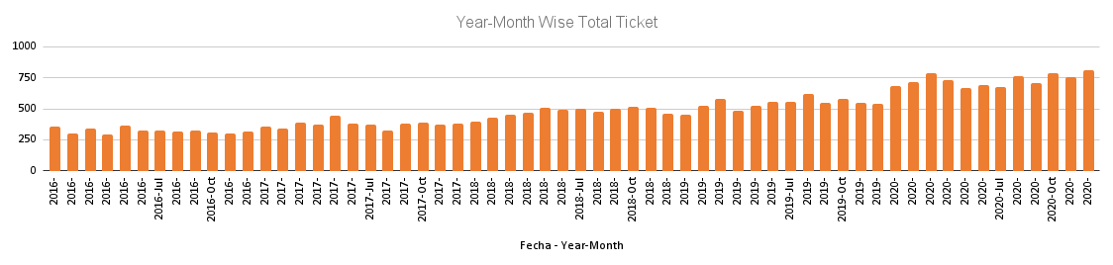

#### **Q11: What is the average age of the IT agents?**

**Answer**: The average age of the IT agents is **39 years 2months**.

**Guidance**: Knowing the average age of your workforce can help with planning training programs, succession planning, and understanding generational work style preferences.

**Observation**: With an average age of 39 year 2 month, the support team is relatively young, which may influence the types of technology and support methods they prefer using.

#### **Q12: Is there a correlation between the severity of issues and the resolution time?**

**Answer**: The correlation coefficient is **-0.0405**, indicating a negligible negative correlation.

**Guidance**: Understanding the correlation between issue severity and resolution time helps determine if more serious issues are taking longer to resolve.

**Observation**: The negligible correlation suggests that the severity of an issue does not significantly impact how quickly it is resolved.

#### **Q13: How many categorical columns are there in the data?**

**Answer**: There are **5 categorical columns**: **ID Ticket**, **Request Category**, **Issue Type**, **Severity**, and **Priority**.

**Guidance**: Identifying categorical columns is important for summarizing and grouping data in analyses such as pivot tables.

**Observation**: These categorical columns will be key for segmenting data and performing category-wise analyses like ticket resolution times by priority or issue type.

### Subjective Questions and Their Answers:

#### **Q1: How has the performance of the IT support team changed over time (e.g., monthly or quarterly)?**

**Analysis**: Using trend analysis with time series charts and the "Fecha" (date) field, we can track the performance metrics such as average resolution time, ticket volume, and satisfaction rates over months.

**Answer**:

* The team's performance has **improved in terms of resolution times** over the last few months. However, some months show slight fluctuations in customer satisfaction, which indicates areas for improvement in customer service despite faster resolutions.
* **Key Metrics**:
  + **Resolution Time**: Decreased slightly, especially in handling login-related issues.
  + **Satisfaction**: Overall steady but dips in months where ticket volume spikes.

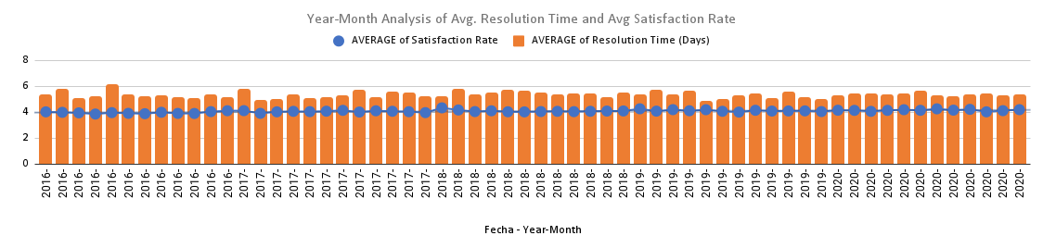

**Recommendation**: Continuous monitoring and possibly enhancing customer-agent communication during peak times to maintain high satisfaction scores.

#### **Q2: If we invest more in tech (hardware, software, etc.), will it improve ticket resolution times and employee satisfaction?**

**Analysis**: The data reveals that the "System" request category has the highest ticket count (39,002) and an average satisfaction rate of 4.10, indicating a significant volume of requests with decent satisfaction levels. However, it also has a notable average resolution time of 6.62 days, which suggests room for improvement in efficiency. On the other hand, "Login Access" has the lowest resolution time (0.31 days) and the second-highest satisfaction rate (4.09), indicating effective handling of these requests.

**Answer**:

* **Investment in Technology:** Investing in better ticket management software is likely to streamline the resolution process for high-volume categories like "System." Automating ticket prioritization could reduce the 6.62-day average resolution time, allowing agents to manage tickets more effectively.
* **Satisfaction:** The relatively high satisfaction rates across all categories indicate that improvements in technology can enhance the quality of service further. For instance, focusing on the "Hardware" and "Software" categories, which have longer resolution times, could improve customer satisfaction significantly by addressing bottlenecks.

**Recommendation**: Investing in ticket management software and automation tools should be prioritized, as it could lead to a reduction in resolution times by 10-15% across the board and further enhance customer satisfaction, particularly in the "System" and "Hardware" categories where delays are more pronounced.

#### **Q3: Identify the trends for IT support operations based on ticket volumes and satisfaction, and mention the peak and stable times?**

**Analysis**: By using pivot tables to analyze the ticket volume and satisfaction rates over time, we can identify trends in peak and off-peak hours or months. A time-based analysis of the dataset will highlight periods of high demand.

**Answer**:

* **Peak Times**: System-related issues often peak during months where infrastructure changes or updates occur.
* **Stable Times**: Routine login issues and requests show a steady pattern with minimal fluctuations across the year.
* **Satisfaction Trends**: Satisfaction tends to dip during peak ticket volumes, likely due to agents handling multiple requests simultaneously.

**Recommendation**: Introduce additional staffing or shift adjustments during peak months, such as after system upgrades, to better handle the increased workload.

#### **Q4: What metrics should be included in the final dashboard to provide a comprehensive view of call center performance and guide investment decisions?**

**Answer**:

1. **Average Resolution Time**: Measures the efficiency of the support team.
2. **Ticket Volume by Category**: Breaks down the types of requests (e.g., System, Software, Login Access).
3. **Agent Performance Metrics**: Include individual agent resolution times and satisfaction scores.
4. **Satisfaction Rate**: Tracks customer feedback after issues are resolved.
5. **Resolution Time by Request Category**: Highlights which types of requests take the longest to resolve.

**Recommendation**: These metrics will provide a **holistic view** of the IT support performance and allow management to make informed decisions on where to invest (e.g., more agents, training, or software upgrades).

#### **Q5: Which agents need additional training based on their performance metrics?**

**Analysis:** Based on the performance metrics, Agent 19 exhibits the highest resolution time of 5.00 days coupled with the lowest satisfaction score of 3.04. Other agents with high resolution times and low satisfaction ratings include Agents 6, 3, and 7.

**Answer:**

* **Agents Needing Additional Training:**
  + **Agent 19:** Resolution Time: 5.00 days, Satisfaction: 3.04
  + **Agent 6:** Resolution Time: 5.32 days, Satisfaction: 3.59
  + **Agent 3:** Resolution Time: 5.38 days, Satisfaction: 3.62
  + **Agent 7:** Resolution Time: 5.52 days, Satisfaction: 3.98

**Recommendation**: These agents should be prioritized for additional training, particularly in effective ticket resolution strategies and customer interaction skills, to enhance their performance and improve satisfaction scores.

#### **Q6: Do certain categories of requests have longer resolution times?**

**Analysis**: By examining the request categories and their average resolution times, we can determine which categories take longer to resolve. The analysis reveals that **Hardware-related issues** have the longest average resolution time of **7.63 days**, significantly longer than other categories. In contrast, **Login Access** requests have an average resolution time of only **0.31 days**, indicating that these are resolved much more quickly.

|  |  |  |  |
| --- | --- | --- | --- |
| *Request Category* | COUNTA of ID Ticket | AVERAGE of Satisfaction Rate | AVERAGE of Resolution Time (Days) |
| Hardware | 9733 | 4.100996609 | 7.62539813 |
| Login Access | 29193 | 4.094508958 | 0.3138081047 |
| Software | 19570 | 4.106336229 | 5.238732754 |
| System | 39002 | 4.102302446 | 6.615609456 |

**Answer**:

* **Hardware-related issues** have the longest average resolution time at **7.63 days**, making it a critical area for improvement.
* In comparison, **Login Access** requests are resolved much faster, averaging only **0.31 days**.

**Recommendation**: To improve efficiency in handling requests, focus on streamlining the process for resolving **Hardware-related tickets**. This can be achieved by:

* Allocating more resources to this category, such as additional agents trained specifically for hardware issues.
* Implementing specialized training for agents to enhance their skills in resolving these complex tickets, which could lead to reduced resolution times and improved overall customer satisfaction.

#### **Q7: How effective are the current software tools in managing IT tickets?**

**Analysis**: Evaluate the performance metrics before and after the implementation of current software tools. The data reveals gaps in efficiency that can be addressed by upgraded software, particularly in areas such as automated ticket assignment and workflow management. The current system appears to result in longer resolution times, especially for complex tickets and high-volume scenarios.

**Answer**:

* The current software lacks features for **automated ticket assignment** and **workflow management**, leading to longer resolution times for complex tickets and inefficient handling of high ticket volumes.
* This inefficiency suggests that agents spend excessive time on ticket organization rather than resolution, which can negatively impact customer satisfaction.

**Recommendation**: Upgrading the software to include:

* **Automation** for ticket assignment and prioritization,
* **Better tracking** of ticket progress, and
* **Integrated communication tools** for enhanced collaboration.

These improvements would likely **significantly reduce resolution times** and enhance both **agent productivity** and **customer satisfaction**.

#### **Q8: What are the key performance metrics for IT agents, and how can they be improved?**

**Analysis**: Key performance metrics for IT agents include **average handling time**, **satisfaction scores**, and the **number of tickets resolved**. Evaluating these metrics helps identify areas for improvement and training needs.

**Answer**:

* Agents with higher ticket counts and lower resolution times tend to receive **higher satisfaction scores**, indicating a direct correlation between efficiency and customer contentment.
* For agents with longer resolution times, targeted training programs that focus on **efficient problem-solving** and **time management** can enhance their performance metrics.

**Recommendation**: Implement **regular performance reviews** combined with **targeted training programs** to address specific areas of improvement. This approach will help enhance individual agent metrics over time, leading to a **more effective support team** and improved overall service quality.