**Procedure for Executing from Scratch**

**Step 1 :**

First you need to install **XAMPP.** It is a free open-source package popular for PHP development.

Follow this link below to download.   
<https://www.apachefriends.org/index.html>

**Step 2 :**

After completing the installation of **XAMPP**, you need to open the **XAMPP Control Panel** and first start the **Apache** module and then **MySQL** module.

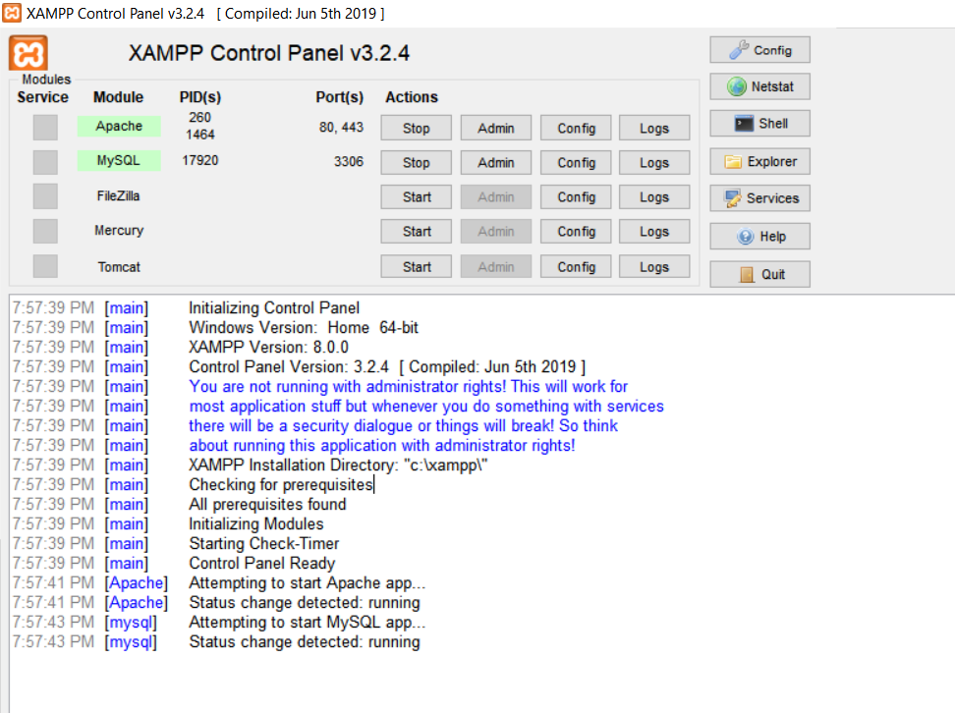

(Note: You might encounter an error saying the port is already used/running . This will happen if you have used the port in another platform (In my case, MySQLWorkBench). The solution is to open task manager and end all the process(usually two) named ‘mysqld’ or similar. )

**Step 3 :**

Then Click on the **Admin** of MySQL.



**IMPORTANT:** Unzip **Code.zip,** that has the actual .php and .csv files inside, in the specified location below.

**C:/xampp/htdocs**

After you have unzipped the file, it should look like:

C:/xampp/htdocs/Code/CUSTOMER.csv

**YOU MUST HAVE THIS PATH BECAUSE THE .csv FILES WILL BE LOADED USING THIS PATH.**

**Step 4 :** Now that the server is set up, you have to create a new database and load it with data from the .csv file. Click on **SQL** at the top of the page.

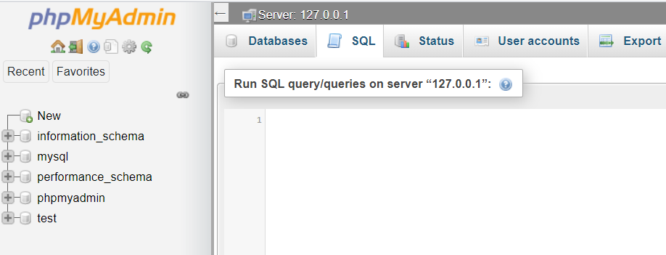

First use the command below to create a database.

**CREATE DATABASE carrental;**

Now Refresh the page and you should see the database name on the left side of the screen (Below “New”). Click the newly made database “**carrental**” which will select that database. Now click on **SQL** at the top of the page and follow the instructions below.

For convenience, the CREATE and LOAD queries are in **CREATE_LOAD.txt** file. Copy the entire content of the file into the **SQL tab** and click **GO.**

This will populate the database with the data files.(All the necessary .csv files were inside the “Code” zip file.)

We have now successfully created the database and populated it with the data files.

**Step 5 :**

Click on the “**carrental**” database and then click on **SQL** at the top of the page.

Now paste both the **queries** onto the tab:

**Query 1:** Add an extra column ‘Returned’ to the RENTAL table. Values will be 0-for non-returned cars, and 1-for returned. Then update the ‘Returned’ column with '1' for all records that they have a payment date and with '0' for those that they do not have a payment date.

ALTER TABLE rental ADD Returned INT;

UPDATE rental SET Returned = IF(PaymentDate = 'NULL', 0, 1);

**Query 2:** Create a view vRentalInfo that retrieves all information per rental.

CREATE VIEW vRentalInfo AS

SELECT OrderDate, StartDate, ReturnDate, (RentalType*Qty) AS TotalDays, rental.VehicleID AS VIN, Description AS Vehicle,

CASE

WHEN vehicle.Type = 1 THEN 'Compact'

WHEN vehicle.Type = 2 THEN 'Medium'

WHEN vehicle.Type = 3 THEN 'Large'

WHEN vehicle.Type = 4 THEN 'SUV'

WHEN vehicle.Type = 5 THEN 'Truck'

WHEN vehicle.Type = 6 THEN 'VAN'

END AS Type,

CASE

WHEN vehicle.Category = 0 THEN 'BASIC'

WHEN vehicle.Category = 1 THEN 'LUXURY'

END AS Category,

rental.CustID AS CustomerID, customers.Name AS CustomerName, TotalAmount AS OrderAmount,

CASE

WHEN Returned = 0 THEN TotalAmount

ELSE 0

END AS RentalBalance

FROM customers, rental, vehicle

WHERE rental.CustID = customers.CustID AND rental.VehicleID = vehicle.VehicleID

ORDER BY StartDate ASC;

Execute it by clicking on **GO**.

**Step 6 :**

We are now finished with writing queries and can move to the GUI part.

For this, you need to make sure that all the php files are in the **location specified below**.

**C:/xampp/htdocs/Code/main.php**

If it is present in the above path, **Copy the link below** and paste it into a web browser.

http://localhost/Code/main.php

This will bring to the homepage of the GUI.

You can select desired options from the menu, BUT you have to press the **back button** of your browser to move back to the previous screen.

Note: Error handling is not implemented. If a “Confirm to resubmit” message pops up, Press **NO.**