**GameBox: Multiplayer & Solo Mode**

**Overview**

This collection includes multiple 2-player and single-player games developed with a graphical user interface (GUI) using **Java Swing**. The games available in this collection are:

**2-Player Games**

1. **Tic-Tac-Toe** - A simple turn-based strategy game where players aim to align three marks in a row.

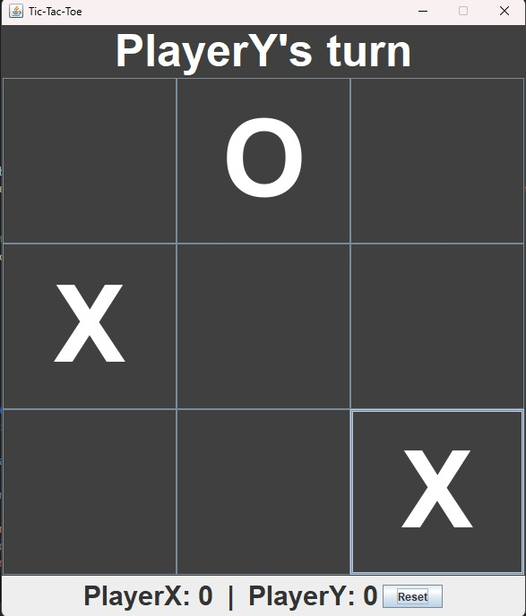

2. **Pokemon Match Cards** - A memory-based matching game using Pokemon-themed cards.

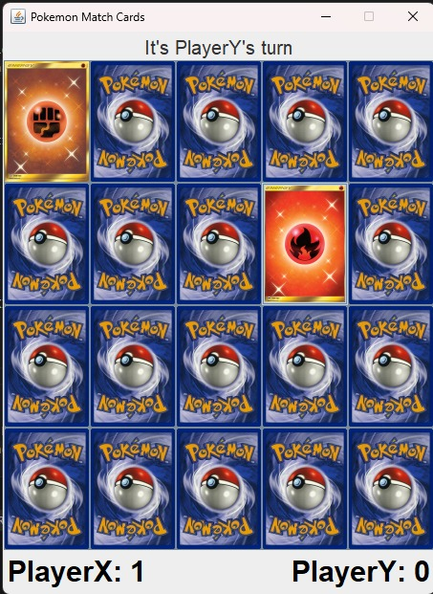

3. **Snakes and Ladders** - The classic board game where players move based on dice rolls, climbing ladders and avoiding snakes.

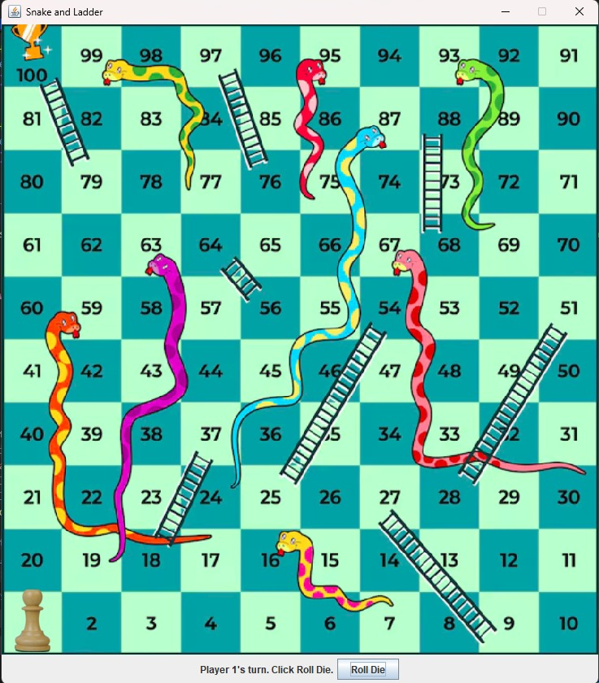

4. **Coin Toss** – A coin will be tossed incase of a tie at the end of the game.

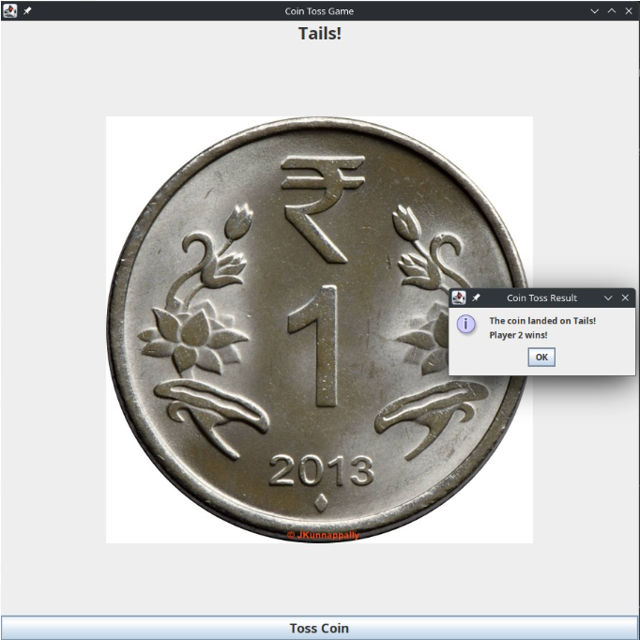

**Single-Player Games**

1. **Pac-Man** - A maze-based arcade game where the player navigates Pac-Man to collect pellets while avoiding ghosts.

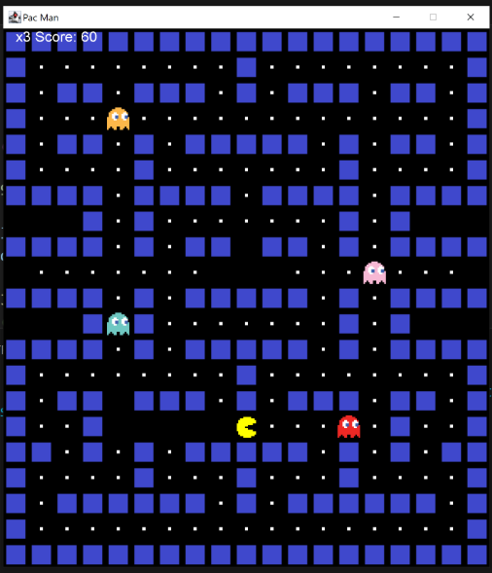

1. **Flappy Bird** - A side-scrolling game where the player controls a bird and navigates through gaps between pipes.

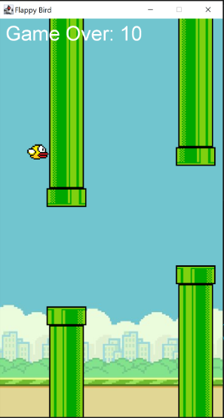

1. **Snake game**- A classic arcade game where the player controls a growing snake to eat food while avoiding collisions.

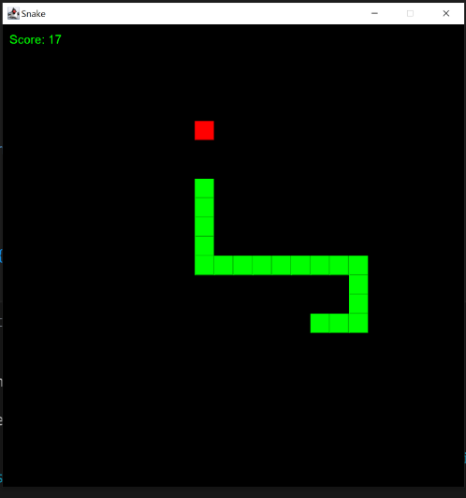

**Game Details**

1. **Tic-Tac-Toe**

* Players take turns placing "X" or "O" on a 3x3 grid.
* The goal is to align three marks in a row, column, or diagonal.
* If all spaces are filled without a winner, the game is a draw. To move to the next round, we must have a winner. In case of a draw, players can reset the board using the “Reset” button to play again.
* Winner gains one point.

2. **Pokemon Match Cards**

* Players take turns flipping two cards at a time to find matching pairs.
* If a match is found, the player earns a point and turn switches to the next player.
* If the cards do not match, the turn switches to the next player.
* The game continues until all pairs are matched.
* The player with the most matches wins.

3. **Snakes and Ladders**

* Players roll a die and move their token accordingly on a 100-square board.
* Landing on a ladder moves the player up, while landing on a snake sends them down.
* The first player to reach square 100 wins the game and earns 2 points.

**Single-Player Games**

1. **Pac-Man**
   * The player controls Pac-Man using keyboard arrows.
   * The goal is to collect all pellets while avoiding ghosts.
   * Power pellets allow Pac-Man to eat ghosts temporarily.
   * The game ends when all lives are lost or all pellets are collected.
2. **Flappy Bird**
   * The player taps or presses a key to keep the bird airborne.
   * The goal is to navigate through gaps between pipes without colliding.
   * The game continues until the bird crashes.
   * The player’s score increases with each successful pass through pipes.
3. **Snake Game**

* The player controls a snake using keyboard arrows.
* The goal is to eat food to grow longer while avoiding collisions with the walls and itself.
* The game ends when the snake crashes into a wall or its own body.
* The player’s score increases with each piece of food eaten.

**Features**

- **Interactive GUI** with easy-to-use controls.

- **Turn-based gameplay** with clear player indication.



- **Score tracking** for competitive play.



- **Pop-up dialogs** for game progression and notifications.

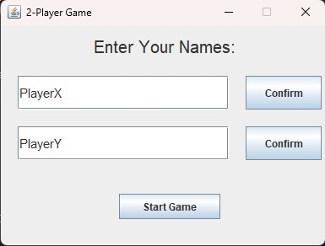 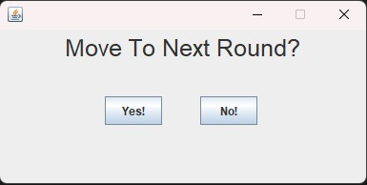

**How to Play**

1. Launch the application for the desired game.
2. Enter player names (if applicable) and confirm before starting.
3. Follow the game rules mentioned above for each game.
4. Continue playing rounds or reset the game as needed.

**System Requirements**

- **Operating System**: Windows / Mac / Linux

- **Dependencies**: Requires Java Runtime Environment (JRE) installed

**Installation & Execution**

1. Clone or **download** the project files.

2. Compile and run the **startGame.java** file.

3. Enjoy the game!

**Team Members**

1. Veenith S Gadad (24124056)
2. Ayush Kumar Sahoo (24124057)
3. Tanishka Gandhi (24124046)
4. Devansh Dengla (24124053)

**Credits**

Veenith S Gadad – TicTacToe, Pokemon Match Cards, overall linking of games, end screen.

Ayush Kumar Sahoo- Snake and Ladders, overall linking of games, username input.

Tanishka Gandhi- Flappy Bird, single player game section overall code.

Devansh Dengla- Pacman, snake game, single player game section overall code.