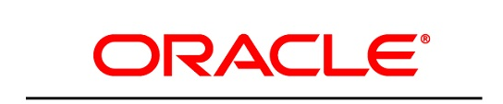
Customer Success Services

<Customer Name>

Application Understanding Document (AUD)
for

Oracle Fusion Cloud <Module Name>

Version 1.0

Oracle CSS Team
Date: <Date>

Document Version History
Version | Date | Author(s) | Reviewed By
<Ver.> | <Date> | <Author>

Contents
Document Version History 1
Introduction 3
Purpose and scope 3
About the Customer 3
Enterprise Structure 4
<Module Name> 4
1.1. Process list 4
1.2. Roles and functions 5
1.3. Legend 6
1.4. Glossary 6
1.5. Key Design Considerations 7
2. Process – <Process Name> 10
2.1. Attributes 10
2.2. Subprocess details 11
2.3. Subprocess details 12
3. Process – <Process Name> 14
3.1. Attributes 15
3.2. Subprocess details 16
4. Process – <Process Name> 19
4.1. Attributes 19
5. Process – <Process Name> 27
5.1. Attributes 27
6. Process – <Process Name> 33
7. Process – <Process Name> 37
7.1 Attributes 38
7.2. Subprocess details 39
7.3. Subprocess details 41
7.4. Subprocess details 42
8. <Process Name> 44
8.1. Attributes 45
8.2. Subprocess details 45
9. Reporting and RICEW 45
9.1. Standard Reports 45
9.2. RICEW 47
10. Open points 49
Scheduler Jobs: 50
<Client Name> Closing Process: 50

Introduction

Purpose and scope
<Ai Generated >

The purpose of this document is to:
- <Provide the applicable content for this section.>
- <Provide the applicable content for this section.>
- <Provide the applicable content for this section.>
- <Provide the applicable content for this section.>
<Provide the applicable content for this section.>

About the Customer
<Customer Description as the sample here>
<Generate from Customer name>

Modules Licensed/ Implemented:
<From User Input>

Enterprise Structure
<Very Important>

<will have an optional input option to upload enterprise structure as image to paste here>
<Try to analyze from KT or ask respective customer enterprise structure>
Business Unit: <Business Unit Name>
Legal Entity: <Legal Entity Name>

<Module Name>

Process list
<Based on KT or PPT >

<Provide the applicable content for this section.(skip business owner if not present)>

Process | Process <Business Owner(s)>
<Name / Activity> | <Owner / Role>
<Name / Activity> | <Owner / Role>
<Name / Activity> | <Owner / Role>
<Name / Activity> | <Owner / Role>
<Name / Activity> | <Owner / Role>
<Name / Activity> | <Owner / Role>
<Name / Activity> | <Owner / Role>
<Name / Activity> | <Owner / Role>

Roles and functions

<Provide the applicable content for this section.>
Process List | Roles / Functions involved
<Name / Activity> | <Placeholder>
<Name / Activity> | <Placeholder>
<Name / Activity> | <Placeholder>
<Name / Activity> | <Placeholder>
<Name / Activity> | <Placeholder>
<Name / Activity> | <Placeholder>
<Name / Activity> | <Placeholder>

Legend

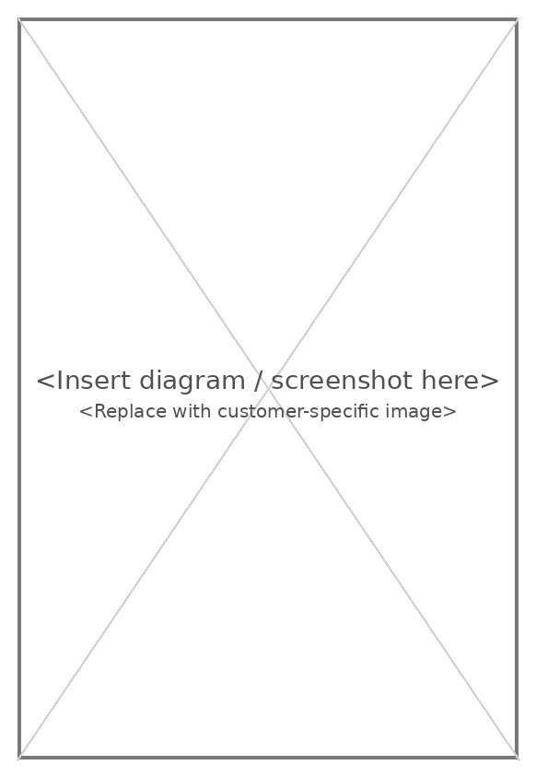

Glossary

<Acronym>: <Definition>
<Acronym>: <Definition>
<Acronym>: <Definition>

Key Design Considerations

<Provide the applicable content for this section.>

- <Placeholder text>

<Provide the applicable content for this section.>

- <Provide the applicable content for this section.>
- <Provide the applicable content for this section.>
- <Provide the applicable content for this section.>
- <Provide the applicable content for this section.>
- <Provide the applicable content for this section.>
- <Provide the applicable content for this section.>
- <Provide the applicable content for this section.>
- <Provide the applicable content for this section.>

- <Placeholder text>

<Provide the applicable content for this section.>

- <Provide the applicable content for this section.>
- <Provide the applicable content for this section.>
- <Provide the applicable content for this section.>
- <Provide the applicable content for this section.>
- <Provide the applicable content for this section.>
- <Provide the applicable content for this section.>
- <Provide the applicable content for this section.>
- <Provide the applicable content for this section.>
- <Provide the applicable content for this section.>

- <Placeholder text>

<Provide the applicable content for this section.>

- <Provide the applicable content for this section.>
- <Provide the applicable content for this section.>
- <Provide the applicable content for this section.>
- <Provide the applicable content for this section.>
- <Provide the applicable content for this section.>
- <Provide the applicable content for this section.>
- <Provide the applicable content for this section.>
- <Provide the applicable content for this section.>

- <Placeholder text>

<Provide the applicable content for this section.>

- <Provide the applicable content for this section.>
- <Provide the applicable content for this section.>

- <Placeholder text>

<Provide the applicable content for this section.>

Name | Description
<Name / Activity> | <Description / Details>
<Name / Activity> | <Description / Details>
<Name / Activity> | <Description / Details>
<Name / Activity> | <Description / Details>
<Name / Activity> | <Description / Details>
<Name / Activity> | <Description / Details>
<Name / Activity> | <Description / Details>
<Name / Activity> | <Description / Details>

2. Process - <Process Name>
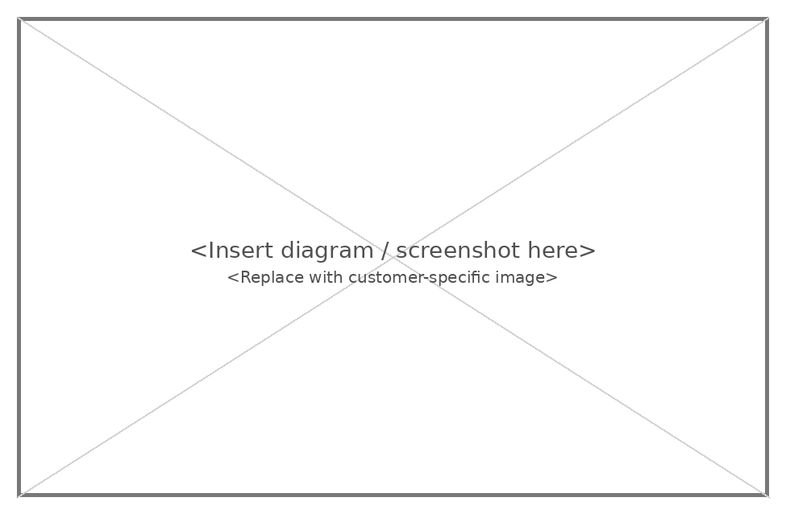

2.1. Attributes

Full name
- <Placeholder text>
Description
- <Provide the applicable content for this section.>
Business Rules and Policies
- <Provide the applicable content for this section.>
- <Provide the applicable content for this section.>
Supporting systems / applications
- <Placeholder text>
- <Placeholder text>
Subprocesses
This process includes the following subprocesses:
- <Placeholder text>
- <Placeholder text>

2.2. Subprocess details

Subprocess diagram - <Subprocess Name>
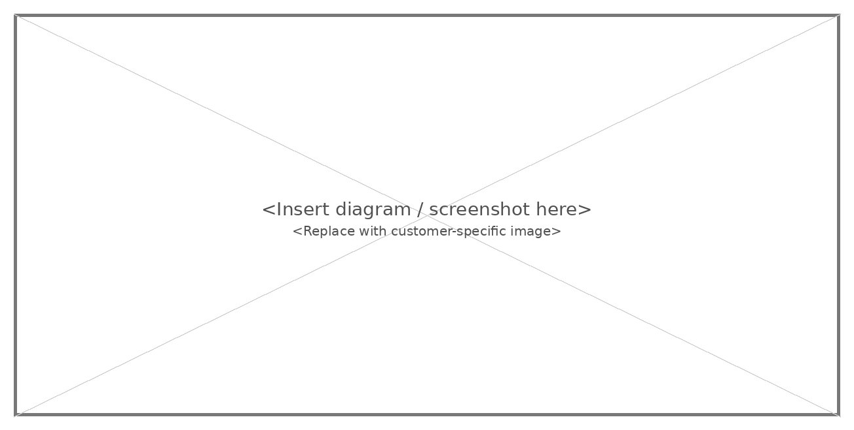

Subprocess description - <Subprocess Name>

Activity | Owner | Automatic/Manual | System | Description
<Name / Activity> | <Owner / Role> | <Automatic / Manual> | <System / Module> | <Description / Details>

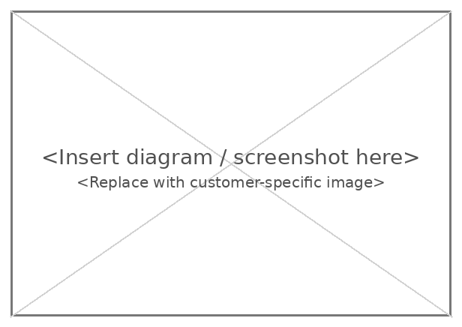

<Provide the applicable content for this section.>

2.3. Subprocess details

Subprocess diagram - <Subprocess Name>
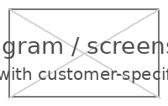

Subprocess description - <Subprocess Name>

<Provide the applicable content for this section.>
- <Placeholder text>

Activity | Owner | Automatic/Manual | System | Description
<Name / Activity> | <Owner / Role> | <Automatic / Manual> | <System / Module> | <Description / Details>

3. Process - <Process Name>

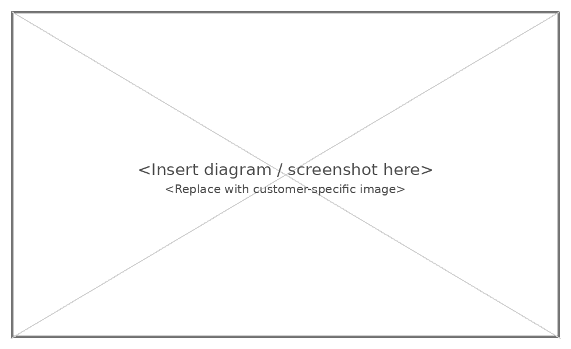

3.1. Attributes

Full name
- <Placeholder text>
Description
- <Provide the applicable content for this section.>
<Provide the applicable content for this section.>

Business Rules and Policies
<Provide the applicable content for this section.>
<Provide the applicable content for this section.>
Supporting systems / applications
- <Placeholder text>
- <Placeholder text>
Subprocesses
This process includes the following subprocesses:
- <Placeholder text>
- <Placeholder text>
- <Placeholder text>

3.2. Subprocess details

Subprocess diagram - <Subprocess Name>
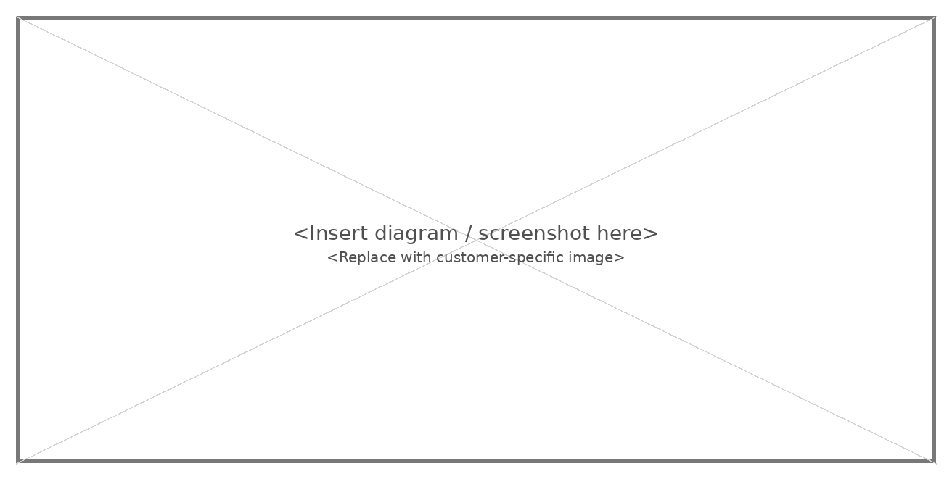

Subprocess description - <Subprocess Name>
<Provide the applicable content for this section.>
- <Provide the applicable content for this section.>
- <Provide the applicable content for this section.>
- <Provide the applicable content for this section.>

Activity | Owner | Automatic/Manual | System | Description
<Name / Activity> | <Owner / Role> |  | <System / Module> | <Description / Details>

3.3. Subprocess details

Subprocess diagram - <Subprocess Name>
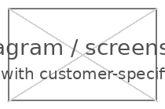
Subprocess description - <Subprocess Name>
- <Provide the applicable content for this section.>
<Provide the applicable content for this section.>
- <Placeholder text>
- <Placeholder text>

Activity | Owner | Automatic/Manual | System | Description
<Name / Activity> | <Owner / Role> | <Automatic / Manual> | <System / Module> | <Description / Details>
<Name / Activity> | <Owner / Role> | <Automatic / Manual> | <System / Module> | <Description / Details>

4. Process - <Process Name>

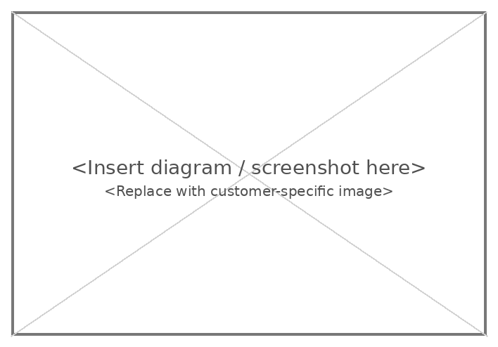

4.1. Attributes

Full name
<Placeholder text>
Description
- <Provide the applicable content for this section.>

Business Rules and Policies
- <Provide the applicable content for this section.>
- <Provide the applicable content for this section.>
- <Provide the applicable content for this section.>
Supporting systems / applications
- <Placeholder text>
- <Placeholder text>
Subprocesses
This process includes the following subprocesses:
- <Placeholder text>
- <Placeholder text>
- <Placeholder text>
- <Provide the applicable content for this section.>

4.2. Subprocess details

Subprocess Diagram - <Subprocess Name>


Subprocess Description - <Subprocess Name>
Activity | Owner | Automatic/Manual | System | Description
<Name / Activity> | <Owner / Role> |  |  | <Description / Details>



4.3. Subprocess details

Subprocess Diagram - <Subprocess Name>


Subprocess Description - <Subprocess Name>
Activity | Owner | Automatic/Manual | System | Description
<Name / Activity> | <Owner / Role> | <Automatic / Manual> | <System / Module> | <Description / Details>



4.4. Subprocess details

Subprocess Diagram - <Subprocess Name>

Subprocess Description - <Subprocess Name>
- <Provide the applicable content for this section.>
<Provide the applicable content for this section.>
<Provide the applicable content for this section.>
- <Placeholder text>

Activity | Owner | Automatic/Manual | System | Description
<Name / Activity> | <Owner / Role> | <Automatic / Manual> | <System / Module> | <Description / Details>

4.5. Subprocess details

Subprocess Diagram - <Subprocess Name>
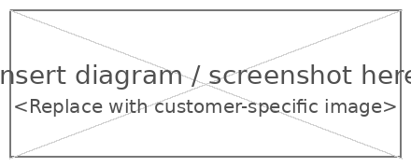

Subprocess Description - <Subprocess Name>
<Provide the applicable content for this section.>
<Provide the applicable content for this section.>
- <Placeholder text>
- <Placeholder text>
Activity | Owner | Automatic/Manual | System | Description
<Name / Activity> | <Owner / Role> | <Automatic / Manual> | <System / Module> | <Description / Details>
<Name / Activity> | <Owner / Role> | <Automatic / Manual> | <System / Module> | <Description / Details>

5. Process - <Process Name>

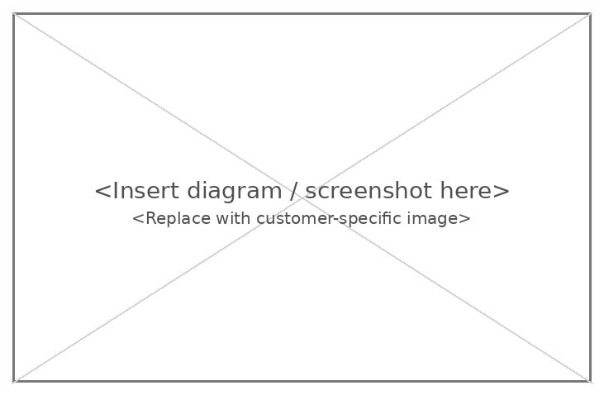

5.1. Attributes

Full name
<Placeholder text>
Description
- <Provide the applicable content for this section.>
<Provide the applicable content for this section.>
<Provide the applicable content for this section.>
Business Rules and Policies
- <Provide the applicable content for this section.>
- <Provide the applicable content for this section.>
- <Provide the applicable content for this section.>
Supporting systems / applications
- <Placeholder text>
- <Placeholder text>
Subprocesses
This process includes the following subprocesses:
- <Placeholder text>
- <Placeholder text>
- <Placeholder text>
- <Placeholder text>

5.1. Subprocess details

Subprocess Diagram - <Subprocess Name>



Subprocess Description - <Subprocess Name>
Activity | Owner | Automatic/Manual | System | Description
<Name / Activity> | <Owner / Role> | <Automatic / Manual> | <System / Module> | <Description / Details>

5.2. Subprocess details

Subprocess Diagram - <Subprocess Name>


Subprocess Description - <Subprocess Name>
Activity | Owner | Automatic/Manual | System | Description
<Name / Activity> | <Owner / Role> | <Automatic / Manual> | <System / Module> | <Description / Details>

5.3. Subprocess details

Subprocess Diagram - <Subprocess Name>


Subprocess Description - <Subprocess Name>
- <Provide the applicable content for this section.>
<Provide the applicable content for this section.>
- <Placeholder text>
- <Placeholder text>

Activity | Owner | Automatic/Manual | System | Description
<Name / Activity> | <Owner / Role> | <Automatic / Manual> | <System / Module> | <Description / Details>
<Name / Activity> | <Owner / Role> | <Automatic / Manual> | <System / Module> | <Description / Details>

6. Process - <Process Name>

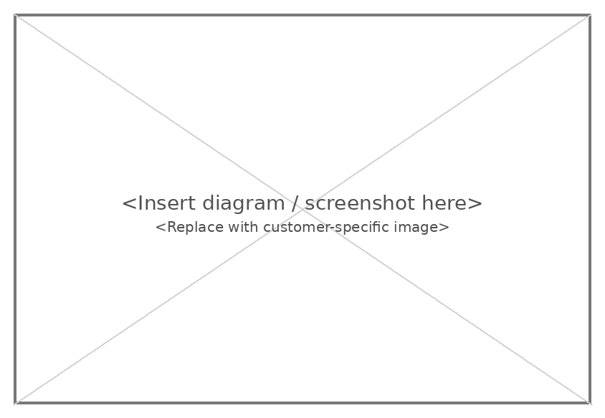

6.1. Attributes

Full name
- <Placeholder text>
Description
- <Provide the applicable content for this section.>

Business Rules and Policies
- <Provide the applicable content for this section.>
Supporting systems / applications
- <Placeholder text>
- <Placeholder text>
Subprocesses
- <Provide the applicable content for this section.>
- <Placeholder text>
- <Placeholder text>

6.2. Subprocess details

Subprocess Diagram - <Subprocess Name>


Subprocess Description - <Subprocess Name>
<Provide the applicable content for this section.>

Activity | Owner | Automatic/Manual | System | Description
<Name / Activity> | <Owner / Role> | <Automatic / Manual> | <System / Module> | <Description / Details>



6.3. Subprocess details

Subprocess diagram - <Subprocess Name>


Subprocess description - <Subprocess Name>

<Provide the applicable content for this section.>
- <Placeholder text>

Activity | Owner | Automatic/Manual | System | Description
<Name / Activity> | <Owner / Role> | <Automatic / Manual> | <System / Module> | <Description / Details>

7. Process - <Process Name>

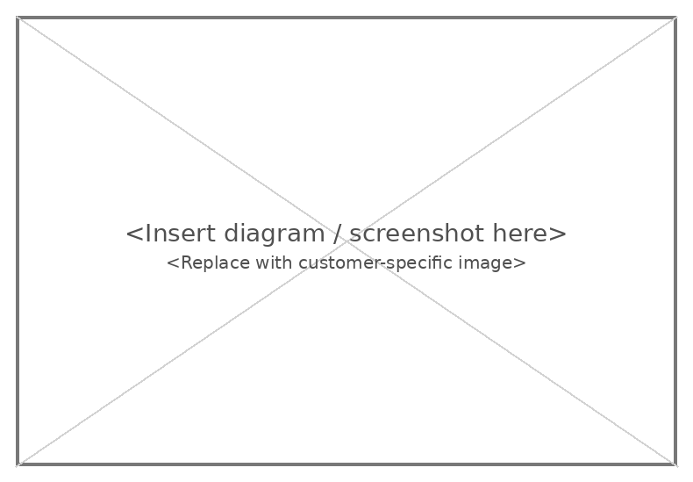

<Placeholder text>

Full name
- <Placeholder text>
Description
<Provide the applicable content for this section.>

Business Rules and Policies
<Provide the applicable content for this section.>
<Provide the applicable content for this section.>
Supporting systems / applications
<Placeholder text>
<Placeholder text>
Subprocesses
This process includes the following subprocesses:
- <Placeholder text>
- <Placeholder text>
- <Placeholder text>

7.2. Subprocess details

Subprocess Diagram - <Subprocess Name>



Subprocess Description - <Subprocess Name>

Activity | Owner | Automatic/Manual | System | Description
<Name / Activity> | <Owner / Role> | <Automatic / Manual> | <System / Module> | <Description / Details>



7.3. Subprocess details

Subprocess Diagram - <Subprocess Name>


Subprocess Description - <Subprocess Name>
<Provide the applicable content for this section.>
- <Placeholder text>

Activity | Owner | Automatic/Manual | System | Description
<Name / Activity> | <Owner / Role> | <Automatic / Manual> | <System / Module> | <Description / Details>

7.4. Subprocess details

Subprocess Diagram - <Subprocess Name>


Subprocess Description - <Subprocess Name>
<Provide the applicable content for this section.>
<Provide the applicable content for this section.>
- <Placeholder text>
- <Placeholder text>

Activity | Owner | Automatic/Manual | System | Description
<Name / Activity> | <Owner / Role> | <Automatic / Manual> | <System / Module> | <Description / Details>
<Name / Activity> | <Owner / Role> | <Automatic / Manual> | <System / Module> | <Description / Details>

8. Process - <Process Name>

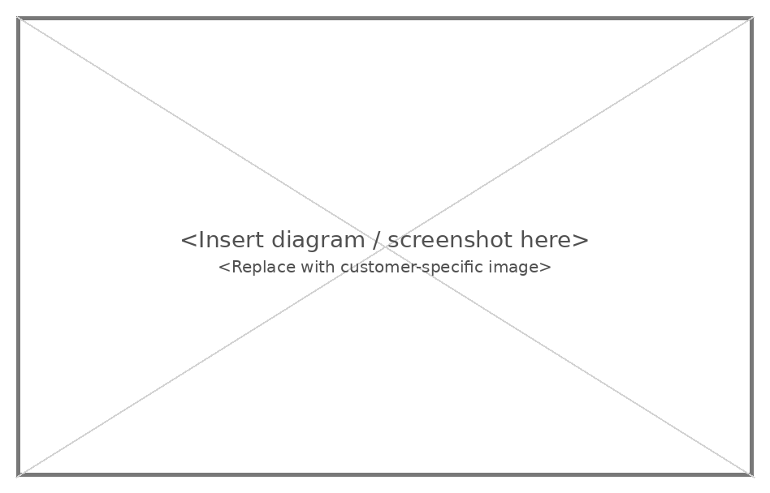

8.1. Attributes
Full name
- <Placeholder text>
Description
<Provide the applicable content for this section.>
Business Rules and Policies
<Provide the applicable content for this section.>
<Provide the applicable content for this section.>
Supporting systems / applications
<Placeholder text>
<Placeholder text>
Subprocesses
This process includes the following subprocesses:
- <Placeholder text>
- <Placeholder text>
- <Placeholder text>

8.2. Subprocess details
<Provide the applicable content for this section.>

<Placeholder text>

<Placeholder text>

<Provide the applicable content for this section.>
<Provide the applicable content for this section.>

Report Name |  | Report Description |  | Module
<Name / Activity> | <Description / Details> |  | <System / Module>
<Name / Activity> | <Description / Details> |  | <System / Module>
<Name / Activity> | <Description / Details> |  | <System / Module>
<Name / Activity> | <Description / Details> |  | <System / Module>
<Name / Activity> | <Description / Details> |  | <System / Module>
<Name / Activity> | <Description / Details> |  | <System / Module>
<Name / Activity> | <Description / Details> |  | <System / Module>
<Name / Activity> | <Description / Details> |  | <System / Module>
<Name / Activity> | <Description / Details> |  | <System / Module>
<Name / Activity> | <Description / Details> |  | <System / Module>
<Name / Activity> | <Description / Details> |  | <System / Module>
<Name / Activity> | <Description / Details> |  | <System / Module>

<Placeholder text>

<Provide the applicable content for this section.>

ID | Type | Name |  | Status Initiating Event |  | Notification Type | Description
<ID> | <Type> | <Placeholder> |  | <Status> | <Status> | <Type> | <Description / Details>
<ID> | <Type> | <Placeholder> |  | <Status> | <Status> | <Type> | <Description / Details>
<ID> | <Type> | <Placeholder> |  | <Status> | <Status> | <Type> | <Description / Details>
<ID> | <Type> | <Placeholder> |  | <Status> | <Status> | <Type> | <Description / Details>
<ID> | <Type> | <Placeholder> |  | <Status> | <Status> | <Type> | <Description / Details>
<ID> | <Type> | <Placeholder> |  | <Status> | <Status> | <Type> | <Description / Details>
<ID> | <Type> | <Placeholder> |  | <Status> | <Status> | <Type> | <Description / Details>
<ID> | <Type> | <Placeholder> |  | <Status> | <Status> | <Type> | <Description / Details>
<ID> | <Type> | <Placeholder> |  | <Status> | <Status> | <Type> | <Description / Details>
<ID> | <Type> | <Placeholder> |  | <Status> | <Status> | <Type> | <Description / Details>
<ID> | <Type> | <Placeholder> |  | <Status> | <Status> | <Type> | <Description / Details>
<ID> | <Type> | <Placeholder> |  | <Status> | <Status> | <Type> | <Description / Details>
<ID> | <Type> | <Placeholder> |  | <Status> | <Status> | <Type> | <Description / Details>
<ID> | <Type> | <Placeholder> |  | <Status> | <Status> | <Type> | <Description / Details>
<ID> | <Type> | <Placeholder> |  | <Status> | <Status> | <Type> | <Description / Details>
<ID> | <Type> | <Placeholder> |  | <Status> | <Status> | <Type> | <Description / Details>
<ID> | <Type> | <Placeholder> |  | <Status> | <Status> | <Type> | <Description / Details>
<ID> | <Type> | <Placeholder> |  | <Status> | <Status> | <Type> | <Description / Details>
<ID> | <Type> | <Placeholder> |  | <Status> | <Status> | <Type> | <Description / Details>
<ID> | <Type> | <Placeholder> |  | <Status> | <Status> | <Type> | <Description / Details>

<Placeholder text>

<Provide the applicable content for this section.>

ID | Topic | Question | Status
<ID> | <Placeholder> | <Description / Details> | <Status>

Scheduler Jobs:
<Provide the applicable content for this section.>
<<Schedule Job List>>

Open Questions:
<Provide the applicable content for this section.>
<<Unsresolved or missing information to be listed here>>

