IILM UNIVERSITY
School of Computer Science and Engineering

SUMMER INTERNSHIP REPORT
on
INTRODUCTION TO MODERN AI
offered by IILM University, delivered through the Cisco Networking Academy Program
Submitted in partial fulfilment of the requirements for the degree of
Bachelor of Technology in Computer Science and Engineering
Submitted by
AYUSH VERMA
Roll No. 2410030722
2026

Candidate's Declaration
I, Ayush Verma, Roll No. 2410030722, a student of B.Tech (Computer Science and Engineering) at IILM University, hereby declare that this report titled “Summer Internship Report on Introduction to Modern AI” is an original and independently prepared account of the structured learning experience I completed through the Cisco Networking Academy program, offered by IILM University. The content presented in this report reflects my own understanding of the concepts covered in the course and has been written in my own words.
I further declare that this report has not been copied from any other student's work and has not been submitted, in full or in part, to any other institute for the award of any degree or diploma. I shall be solely responsible for any discrepancy or inaccuracy found in this report.

Signature:
Ayush Verma
Roll No. 2410030722

Acknowledgement
I would like to express my sincere gratitude to IILM University for offering access to the Cisco Networking Academy program and for encouraging students to build practical exposure to emerging technologies such as Artificial Intelligence alongside their core curriculum.
I am thankful to Ms. Swati Vashisht for her guidance as the instructor of record for the “Introduction to Modern AI” course, and to the faculty of the School of Computer Science and Engineering for their continued support and encouragement throughout my academic journey.
I also acknowledge Cisco Networking Academy for designing a clear and well-structured curriculum that made complex ideas in Artificial Intelligence approachable, and for providing the platform through which this learning experience was delivered.
Finally, I extend my heartfelt thanks to my family and peers for their constant motivation and support.

Ayush Verma
Roll No. 2410030722

Table of Contents
Candidate's Declaration 2
Acknowledgement 3
Certificate of Completion 5
1. Introduction 6
2. About the Learning Program 6
3. Learning Objectives 7
4. Artificial Intelligence, Machine Learning and Models 8
5. Computer Vision 8
6. Machine Translation 10
7. Chatbots: Capabilities and Limitations 11
8. Effective Ways to Use Chatbots 12
9. Generative AI and Multimodal AI 13
10. Skill Stacking and Modern AI Workflows 14
11. Learning Journey and Methodology 14
12. Skills and Learning Outcomes 15
13. Real-World Applications of the Concepts 15
14. Reflection 16
15. Conclusion 16
16. References 16

Certificate of Completion
The certificate reproduced below was issued by the Cisco Networking Academy, confirming successful completion of the course “Introduction to Modern AI”, offered by IILM University. The certificate is authentic and has not been altered in any respect.
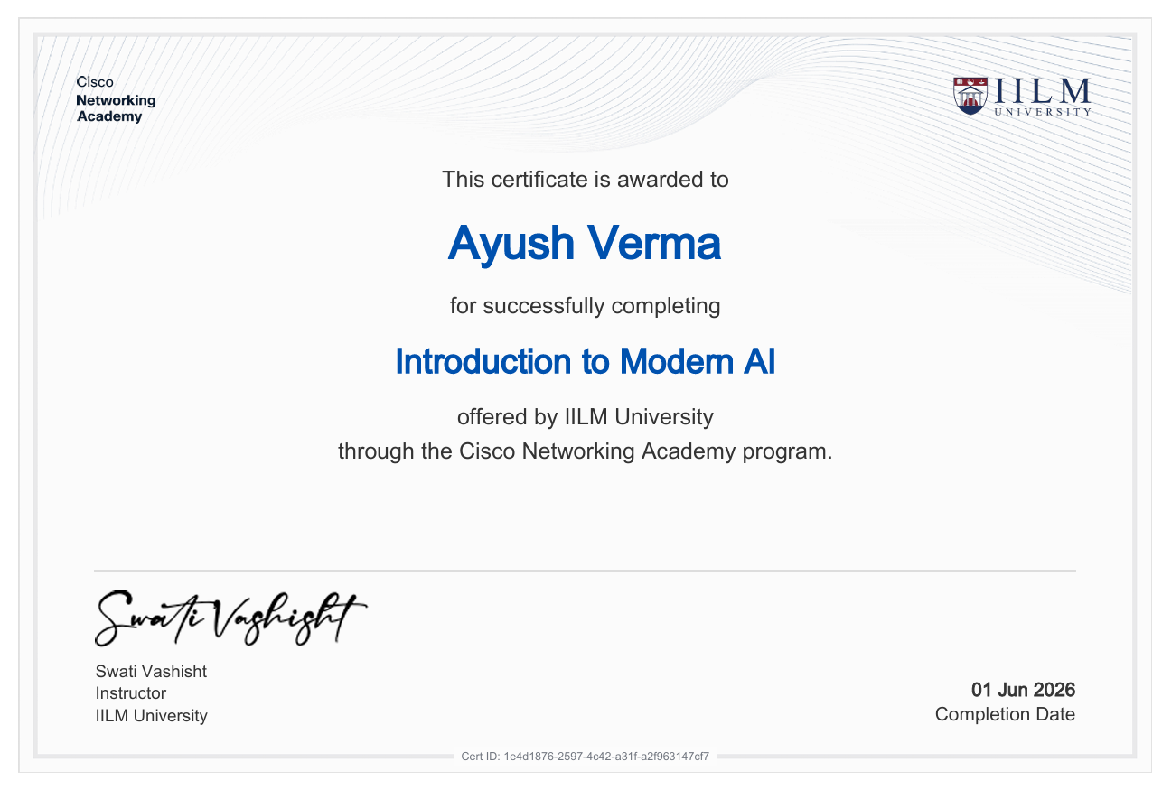
Certificate of Completion — Introduction to Modern AI, Cisco Networking Academy, IILM University

Field | Details
Recipient | Ayush Verma
Course | Introduction to Modern AI
Offered by | IILM University
Delivered through | Cisco Networking Academy
Instructor | Swati Vashisht
Completion Date | 01 June 2026
Certificate ID | 1e4d1876-2597-4c42-a31f-a2f963147cf7

1. Introduction
Artificial Intelligence has moved from being a specialised research subject to a set of everyday tools that shape how people search for information, communicate, create images, and make decisions. For an undergraduate engineering student, building even a foundational understanding of how these systems work, what they do well, and where they fall short is an increasingly essential part of technical literacy.
This report documents a structured learning experience I completed through the course “Introduction to Modern AI”, offered by IILM University and delivered through the Cisco Networking Academy program. The course was designed to introduce learners to the core ideas behind modern Artificial Intelligence — including machine learning, computer vision, machine translation, chatbots, and generative AI — without assuming a prior background in the field.
For me, the course was a chance to step outside the mathematics-heavy treatment of AI that formal coursework often emphasises, and instead build an applied, intuitive sense of how these systems are used in practice, and how to use them responsibly.

2. About the Learning Program

2.1 IILM University
IILM University is the host institute for this Bachelor of Technology programme and facilitates access to industry-aligned learning platforms, including the Cisco Networking Academy, so that students can supplement their core curriculum with recognised, self-paced courses in emerging technology areas.

2.2 Cisco Networking Academy
Cisco Networking Academy is Cisco's global IT skills and career-building program, offering self-paced online courses across networking, cybersecurity, programming, and, increasingly, foundational Artificial Intelligence literacy. Courses on the platform combine short instructional content with interactive checkpoints and conclude with a verifiable certificate of completion.

2.3 Course Overview — Introduction to Modern AI
“Introduction to Modern AI” is organised around one core instructional module covering the building blocks of modern AI systems, followed by a second, open-ended project module intended to let learners apply the concepts to a topic of their choice. The core module spans the following broad areas of study:
- AI, Machine Learning, and Models — foundational definitions and how the three ideas relate.
- Computer Vision — object detection, similarity search, image segmentation, and optical character recognition (OCR).
- Machine Translation — how word order, context, and meaning interact when translating between languages.
- Chatbots — how chatbots generate responses, their limitations, and effective ways of using them.
- Generative AI and multimodal prompting — image generation and combined image-and-text interaction.
- Skill Stacking — combining AI literacy with other skills to increase one's overall value in a professional setting.

The curriculum also lists an Open Ended Project component, intended for learners to apply the course concepts to a self-directed project. As no supporting evidence of a completed project is available at the time of writing, this report does not claim completion of that component; it is mentioned here only as part of the overall course design. The report that follows is based on the core instructional module, together with the completion certificate issued for the course.

3. Learning Objectives
On completion of the course, the intended learning objectives were to be able to:
- Define Artificial Intelligence, Machine Learning, and Models, and explain how the three concepts relate to one another.
- Describe the major tasks within computer vision, including object detection, image segmentation, similarity search, and OCR.
- Explain the role of word order and context in machine translation, and why literal translation often fails to preserve meaning.
- Describe how chatbots generate responses, including the phenomenon of hallucination and the limits of chatbot memory.
- Apply practical techniques for writing effective prompts and for verifying chatbot output before relying on it.
- Identify a range of everyday and professional use cases for chatbots, beyond simple question-answering.
- Explain the concept of generative AI and multimodal prompting, and how these capabilities extend text-based chatbots.
- Understand the idea of skill stacking, and how AI literacy complements other technical and professional skills.

Note on Scope
This report distinguishes clearly between concepts introduced in the course and any activity personally undertaken by the author. Claims describing something the author built, implemented, or produced are supported by the certificate and course material referenced in this report; all other content reflects conceptual understanding gained through the course.

4. Artificial Intelligence, Machine Learning and Models
The course opened by establishing precise definitions for three terms that are frequently used interchangeably in popular discussion, but which describe distinct layers of the same field.
Artificial Intelligence is the broad discipline concerned with building systems that exhibit intelligent behaviour — behaviour that would ordinarily be associated with human reasoning, perception, or judgement. Machine Learning is a specific approach to building AI systems: rather than being explicitly programmed with fixed rules, a machine learning system learns patterns directly from data. A Model is the concrete, trained artefact that results from this process — it is what actually receives an input and produces a prediction or output.
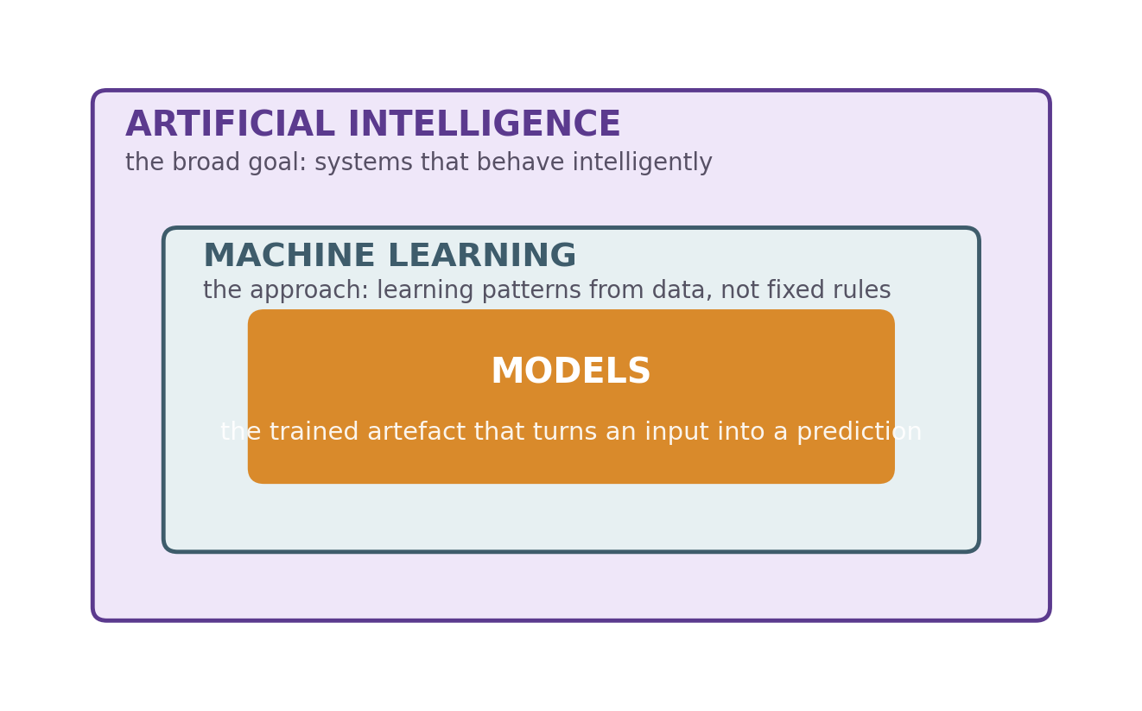
Fig. 1 — How AI, Machine Learning and Models relate
This layered relationship matters because it clarifies what is actually happening when a system is described as “using AI”. In most modern applications, a specific trained model — built using machine learning techniques — is the component doing the work, while “AI” describes the overall goal the system is designed to achieve.
The course also introduced intelligence itself as a useful lens: rather than treating intelligence as a single, all-or-nothing property, it is more useful to think of it as a collection of capabilities — perception, reasoning, language understanding, and decision-making — that different AI systems exhibit to varying degrees.

5. Computer Vision
Computer vision is the branch of AI concerned with enabling systems to interpret and act on visual information — images and video — in ways that approximate human visual understanding. The course covered four representative tasks within this field.
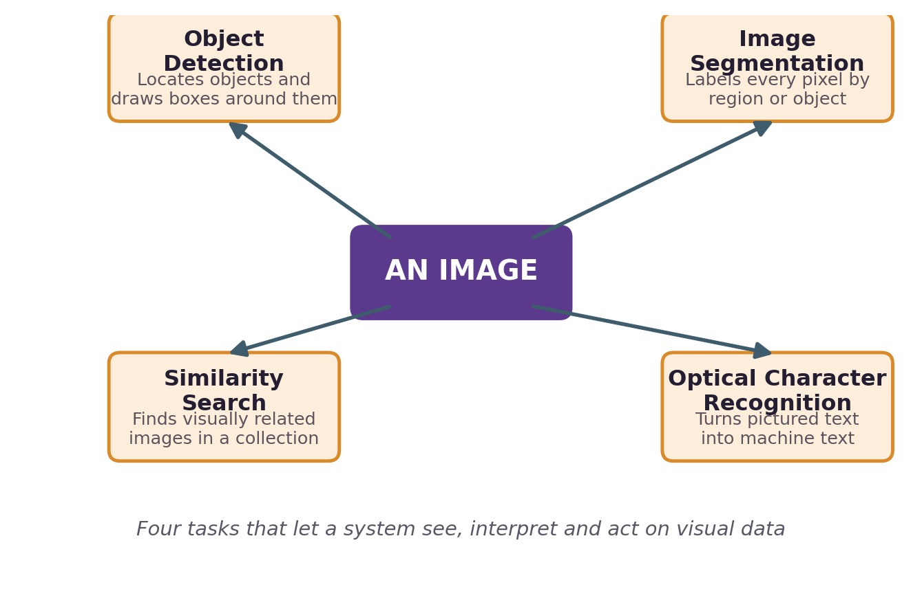
Fig. 2 — The computer vision landscape

5.1 Object Detection
Object detection involves identifying the presence and location of specific objects within an image, typically by drawing a bounding box around each detected object and assigning it a label. It underlies applications such as autonomous-vehicle perception, retail shelf monitoring, and security systems.

5.2 Similarity Search
Similarity search involves finding images within a large collection that are visually similar to a given query image. Rather than matching exact pixels, it compares learned representations of images, which allows it to surface visually or semantically related results — a capability widely used in reverse image search and visual product recommendation.

5.3 Image Segmentation
Image segmentation divides an image into distinct, meaningful regions — for example, separating a foreground subject from its background, or identifying every pixel belonging to a particular object class. This is more granular than object detection, since it operates at the pixel level rather than producing a single bounding box.

5.4 Optical Character Recognition (OCR)
OCR converts text that appears within an image — such as a scanned document, a street sign, or a photograph of a printed page — into machine-readable text data. It is a foundational technology behind document digitisation, automated form processing, and accessibility tools.

Why It Matters
These four tasks solve different sub-problems but are frequently combined: a mobile shopping assistant, for instance, might use object detection to locate a product in a photo and similarity search to find visually matching items for sale.

6. Machine Translation
Machine translation is the task of automatically converting text from one language into another while preserving its intended meaning. The course framed this as considerably harder than a word-for-word substitution problem, for several reasons.
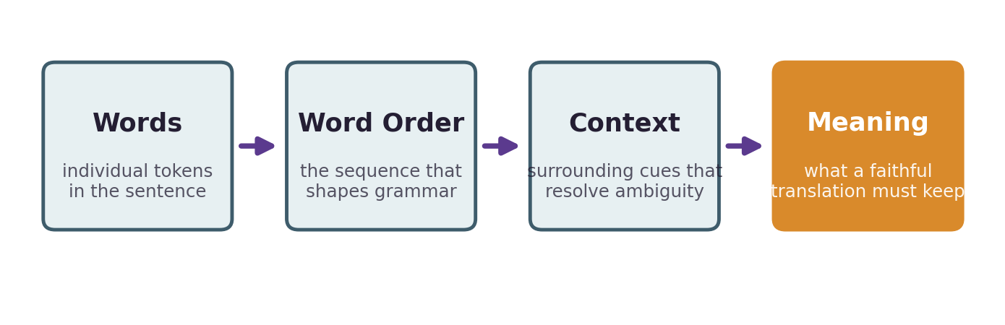
Fig. 3 — From words to meaning in machine translation

6.1 Words and Word Order
Different languages order their words differently — subject, verb, and object can appear in different sequences across languages — so a translation system must restructure a sentence, not merely substitute individual words.

6.2 Context
The correct translation of a word or phrase often depends on the surrounding context. A word with multiple possible meanings must be resolved using the sentence, and sometimes the broader conversation, around it.

6.3 Idiomatic vs Literal Translation
Idiomatic expressions rarely translate correctly on a word-by-word basis; a literal translation frequently produces a grammatically valid but meaningless or misleading sentence in the target language. Effective machine translation systems are therefore built to prioritise preserving meaning over preserving literal word choice.

6.4 Distance Between Two Words
The course also introduced the idea of measuring how “close” or “distant” two words or phrases are in meaning — a concept that underlies how modern translation and language models represent words numerically, and use those representations to find the closest appropriate translation among many candidates.

7. Chatbots: Capabilities and Limitations
A significant portion of the course was devoted to chatbots — conversational AI systems capable of responding to natural-language prompts. The course explained the underlying mechanism at a conceptual level: a chatbot generates a response by repeatedly predicting the most likely next word, based on the prompt and everything it has generated so far.

7.1 Hallucinations
Because a chatbot generates plausible-sounding text rather than retrieving verified facts from a database, it can produce statements that sound confident and coherent but are factually incorrect — a phenomenon referred to as hallucination. The course emphasised that this is an inherent limitation of how these systems work, not merely an occasional bug.

7.2 Memory
Chatbots have a limited working memory: they can only take into account a finite amount of prior conversation when generating a response, and typically do not retain information between separate, unconnected sessions unless a platform explicitly stores it.

7.3 Level of Difficulty and Using Multiple Chatbots
The course noted that different chatbots vary in capability, and that some tasks are better suited to one chatbot than another. Comparing responses from multiple chatbots, and choosing the one best suited to the task, was presented as a practical strategy for getting better results.

7.4 Test It Before You Rely on It
Given the risk of hallucination, the course stressed a discipline of verification: chatbot output, particularly on factual matters, should be checked against a reliable source before it is relied upon or shared further.

7.5 Writing Effective Prompts
The quality of a chatbot's response depends heavily on how a prompt is written. The course covered practical prompting techniques — being specific about the desired output, providing relevant context, and iterating on a prompt when the first response falls short.
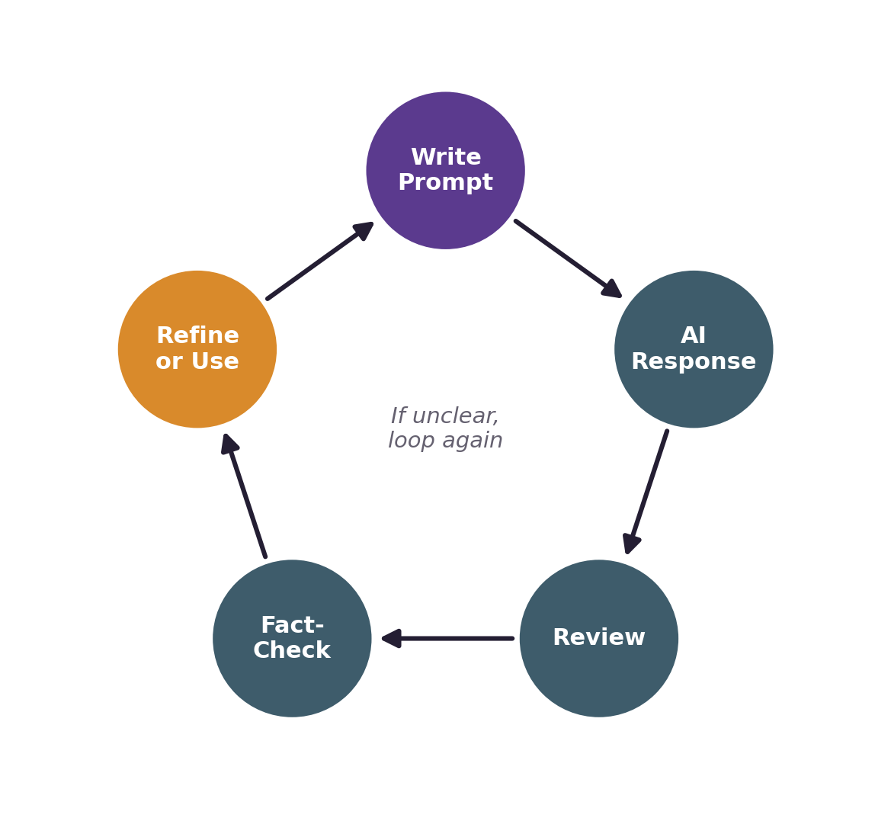
Fig. 4 — A disciplined chatbot interaction cycle
Taken together, these ideas point to a disciplined way of working with chatbots: write a clear prompt, review the response critically, verify any factual claims, and refine the prompt if the result is incomplete or unclear, rather than accepting the first response at face value.

8. Effective Ways to Use Chatbots
Beyond basic question-answering, the course surveyed a wide range of practical applications for chatbots, which can be grouped into a small number of broad categories.
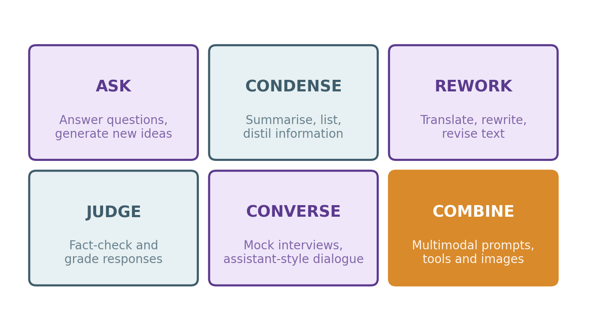
Fig. 5 — Six practical ways to work with a chatbot
- Answering questions and generating new ideas for a task or project.
- Summarising, listing, and organising information from longer material.
- Translating, rewriting, and revising text for tone or clarity.
- Fact-checking and providing qualitative or grading-style feedback on a piece of work.
- Holding a conversation — including simulated mock interviews — or having two chatbots collaborate on a task.
- Working with images and text together (multimodal prompting), and using chatbots as a personal assistant for everyday tasks.

The course framed this diversity of uses as a reason to treat chatbots as general-purpose tools whose value depends on the skill of the person directing them, rather than as tools with one narrow purpose.

9. Generative AI and Multimodal AI
Generative AI refers to systems that produce new content — text, images, audio, or code — rather than simply classifying or analysing existing content. The course covered the vocabulary commonly used to discuss generative systems, and situated chatbots as one specific, text-based application of the broader generative AI category.
Within this theme, the course introduced image generation as a capability offered by many modern AI tools, in which a written description is used to produce a new image — presented conceptually, as one of the ways chatbots and related tools can be used, rather than as a system built during the course. It also introduced multimodal prompting: interacting with an AI system using more than one type of input at once, such as providing an image together with a text instruction and receiving a response that draws on both. This was framed as an extension of the conversational chatbot model into richer, mixed forms of input and output.
Understanding these concepts is useful because a growing share of everyday AI tools are multimodal by default, and combining images and text effectively in a single prompt is an increasingly practical skill.

10. Skill Stacking and Modern AI Workflows
The final conceptual theme of the course was skill stacking — the idea that combining AI literacy with an existing domain skill (such as writing, design, engineering, or business analysis) produces more value than either skill alone. Rather than viewing AI as a replacement for a specific skill, the course encouraged viewing it as an amplifier that increases the output and reach of a person who already understands their field.
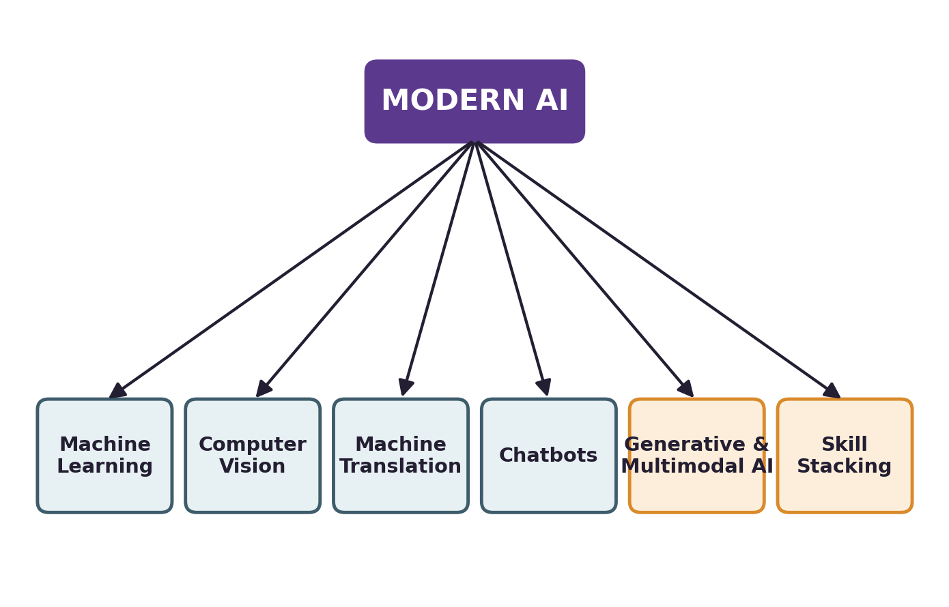
Fig. 6 — Concept map of the Modern AI topics covered
This concept map summarises how the individual topics covered in the course — machine learning, computer vision, machine translation, chatbots, generative and multimodal AI, and skill stacking — relate back to the single, broader theme of Modern AI introduced at the start of the course.

11. Learning Journey and Methodology
The course was completed in a self-paced, online format through the Cisco Networking Academy platform. Learning was organised around a single instructional module, broken into a sequence of short topics, each combining explanatory content with brief interactive checkpoints designed to reinforce understanding before moving to the next topic.

Topic | Focus Area
1.0 | AI, Machine Learning, and Models
1.1 | Computer Vision
1.2 | Machine Translation
1.3 | Chatbots Overview
1.4 | Ways to Use Chatbots
1.5 | Generative AI and Other Vocabulary

The curriculum also includes a second module, an Open Ended Project, intended for learners to apply the course concepts to a self-directed project of their choice. As no supporting evidence of a completed project was available at the time of writing, this report does not claim completion of that component; it is noted here only as part of the overall course design.
This report is based on the core instructional module described above, together with the completion certificate issued for the course.

12. Skills and Learning Outcomes
On completing the course, I developed a foundational, working understanding of the following areas:
- The distinction between Artificial Intelligence, Machine Learning, and Models, and how the three relate.
- The major categories of computer vision tasks — object detection, similarity search, image segmentation, and OCR — and where each is used.
- The linguistic challenges underlying machine translation, including word order, context, and idiomatic meaning.
- How chatbots generate responses, why hallucinations occur, and the practical implications of limited chatbot memory.
- A set of concrete techniques for writing effective prompts and for verifying chatbot output before relying on it.
- A broad set of practical, everyday and professional use cases for chatbots beyond simple question-answering.
- The concepts of generative AI and multimodal prompting, and how they extend text-based chatbot interaction.
- The principle of skill stacking, and how AI literacy can be combined with an existing domain skill.

Learning Takeaway
The most practically useful outcome of the course was not a single technique, but a habit of mind: treating AI tools as capable but fallible assistants, whose output is most valuable when it is critically reviewed, verified, and refined rather than accepted automatically.

13. Real-World Applications of the Concepts
The concepts covered in the course connect directly to widely used, real-world AI applications. Object detection and image segmentation underpin autonomous-vehicle perception and medical image analysis. Similarity search powers reverse image search and visual product recommendation on e-commerce platforms. OCR is used in document digitisation, automated data entry, and accessibility tools for visually impaired users.
Machine translation underlies real-time translation features in messaging and browser applications, enabling communication across language barriers. Chatbots, built on the same next-word-prediction principle covered in the course, now serve as customer support agents, coding assistants, and personal productivity tools across industries. Generative AI and multimodal systems extend this further into content creation, design assistance, and tools that combine visual and textual understanding in a single interaction.
As a Computer Science and Engineering student, these applications illustrate why foundational AI literacy is increasingly relevant across roles that are not themselves AI research positions — from software development to product design and technical analysis.

14. Reflection
During the learning experience, the most valuable shift for me was moving from viewing AI systems as opaque “black boxes” to understanding, at a conceptual level, why they behave the way they do — including why they sometimes produce confident but incorrect answers, and why the quality of a prompt materially affects the quality of a response.
I found the sections on chatbot limitations and prompting particularly relevant to my day-to-day use of AI tools as a student, since they gave me a more disciplined framework for verifying information rather than accepting it at face value. The course helped me understand computer vision and machine translation not as isolated topics, but as specific instances of a common underlying idea: systems that learn patterns from data rather than following fixed, hand-written rules.
Looking ahead, I intend to build on this foundation through more technical, hands-on coursework in machine learning as part of my Computer Science and Engineering programme, using the conceptual vocabulary from this course as a starting point.

15. Conclusion
This report has documented my completion of “Introduction to Modern AI”, a course offered by IILM University through the Cisco Networking Academy program, and summarised the conceptual understanding I developed across its core areas — Artificial Intelligence and Machine Learning fundamentals, computer vision, machine translation, chatbots, generative and multimodal AI, and skill stacking.
The course achieved its intended purpose of building foundational AI literacy without requiring prior technical background, and provided a practical, applied vocabulary for engaging with AI tools responsibly. This foundation is expected to be valuable both in further academic study and in the increasingly AI-integrated professional environments that Computer Science and Engineering graduates will enter.

16. References
Cisco Networking Academy, “Introduction to Modern AI” course curriculum, IILM University.
Certificate of Completion, Cisco Networking Academy, Certificate ID: 1e4d1876-2597-4c42-a31f-a2f963147cf7, issued 01 June 2026.
Cisco Networking Academy — official course catalogue, netacad.com.
IILM University — School of Computer Science and Engineering, iilm.edu.

