**Chapter 1**

**Introduction**

**1.1 Introduction-**

The report is about the project ‘Face Detection System’. This report tries to give a brief overview of the libraries used, code results and the problem it resolves.

Face detection is an [artificial intelligence](https://www.techtarget.com/searchenterpriseai/definition/AI-Artificial-Intelligence) (AI) based computer technology used to find and identify human faces in digital images. Face detection technology can be applied to various fields - including security, [biometrics](https://www.techtarget.com/searchsecurity/definition/biometrics), law enforcement, entertainment and personal safety - to provide surveillance and tracking of people in real time.

Face detection has progressed from rudimentary [computer vision](https://www.techtarget.com/searchenterpriseai/definition/machine-vision-computer-vision) techniques to advances in machine learning ([ML](https://www.techtarget.com/searchenterpriseai/definition/machine-learning-ML)) to increasingly sophisticated artificial neural networks ([ANN](https://www.techtarget.com/searchenterpriseai/definition/neural-network)) and related technologies; the result has been continuous performance improvements. It now plays an important role as the first step in many key applications -- including face tracking, face analysis and [facial recognition](https://www.techtarget.com/searchenterpriseai/definition/facial-recognition). Face detection has a significant effect on how sequential operations will perform in the application.

In face analysis, face detection helps identify which parts of an image or video should be focused on to determine age, gender and emotions using facial expressions. In a facial recognition system -- which maps an individual's facial features mathematically and stores the data as a face print -- face detection data is required for the [algorithms](https://www.techtarget.com/whatis/definition/algorithm) that discern which parts of an image or video are needed to generate a face print. Once identified, the new face print can be compared with stored face prints to determine if there is a match.

**1.2 Why there is need of face detection system-**

In the current scenario, when identity theft is widespread, face recognition technology can play a significant role in preventing identity fraud. According to a report of 2019, 3.2 million fraud cases were reported to the [FTC](https://en.wikipedia.org/wiki/Federal_Trade_Commission) (Federal Trade Commission), out of which, [20.33%](https://www.ftc.gov/system/files/documents/reports/consumer-sentinel-network-data-book-2019/consumer_sentinel_network_data_book_2019.pdf) of cases were identity-related. Modern [AI](https://en.wikipedia.org/wiki/Artificial_intelligence)-enabled facial recognition technology offers a high level of accuracy and can match even the unique characteristics of a human face. Businesses and organizations of different types can leverage this technology to minimize the risk of identity theft to a great extent.

Below are some benefits of biometric face recognition solutions to businesses include:

* Better Security -A biometric facial recognition solution can help businesses identify [burglars](https://dictionary.cambridge.org/dictionary/english/burglar?q=burglars), [trespassers](https://dictionary.cambridge.org/dictionary/english/trespasser), and other criminals. Businesses can use it as a security tool to minimize [identity theft](https://en.wikipedia.org/wiki/Identity_theft).
* Quicker Processing- It takes a facial recognition system second or less to recognize a face. In the era of [cyber-attacks](https://en.wikipedia.org/wiki/Cyberattack) and hacking, the businesses need this type of rapid technology to keep their systems secure.
* Seamless Integration- Most facial recognition solutions are compatible with the existing [software](https://en.wikipedia.org/wiki/Software), which means companies won’t need to spend additional money on integration.

**1.3 Problem Statement-**

This project introduces an involuntary attendance marking system, devoid of any kind of interference with the normal teaching procedure.

The system can be also implemented during exam sessions or in other teaching activities where attendance is highly essential. This system eliminates classical student identification such as calling name of the student, or checking respective identification cards of the student, which can not only interfere with the ongoing teaching process, but also can be stressful for students during examination sessions. In addition, the students have to register in the database to be recognized. The enrolment can be done on the spot through the user-friendly interface. Thus, face recognition attendance system is proposed in order to replace the manual signing of the presence of students which are burdensome and causes students get distracted in order to sign for their attendance.

**Chapter 2**

**Literature Survey**

**2.1 A Approach to Attendance System using Machine Learning**

**Techniques-**

In this project, the idea of two technologies namely Face detection system and Student Attendance system has been implemented with a machine learning approach. This system automatically detects the student face and maintains the student’s attendance with their name, arrival time and departure time. Therefore the attendance of the student can be made available by recognizing the face. On recognizing, the attendance details of the student is obtained.

**2.2 Automated Attendance System Using Face Recognition-**

Automated Attendance System using Face Recognition proposes that the system is based on face detection and recognition algorithms, which is used to automatically detects the student face when he/she enters the class and the system is capable to marks the attendance by recognizing him. Viola-Jones Algorithm has been used for face detection which detect human face using cascade classifier and PCA algorithm for feature selection and SVM for classification. When it is compared to traditional attendance marking this system saves the time and also helps to monitor the students.

**2.3 Existing Recognition Systems-**

**2.3.1 Fingerprint Based recognition system**- In the Fingerprint based existing attendance system, a portable fingerprint device need to be configured with the students fingerprint earlier. Later either during the lecture hours or before, the student needs to record the fingerprint on the configured device to ensure their attendance for the day. The problem with this approach is that during the lecture time it may distract the attention of the students.

**2.3.2 RFID(Radio Frequency Identification) Based recognition system**- In the RFID based existing system, the student needs to carry a Radio Frequency Identity Card with them and place the ID on the card reader to record their presence for the day. The system is capable of to connect to RS232 and record the attendance to the saved database. There are possibilities for the fraudulent access may occur. Some are students may make use of other students ID to ensure their presence when the particular student is absent or they even try to misuse it sometimes.

**Chapter 3**

**Methodology**

**3.1 Flowchart**

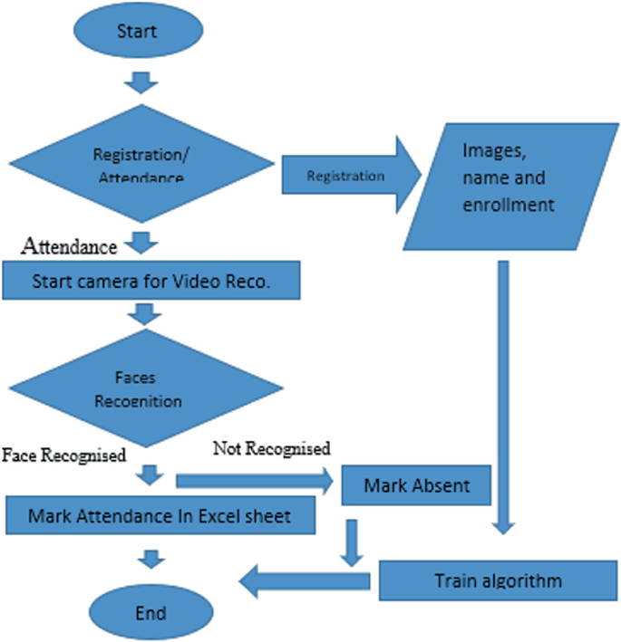

**Fig 3.1**

**3.2 Steps for facial recognition–**

**3.2.1 Face Detection and Extraction-** Face detection is important as the image taken through the camera given to the system, face detection algorithm applies to identify the human faces in that image, the number of image processing algorithms are introduce to detect faces in an images and also the location of that detected faces. We have used HOG method to detect human faces in given image.

**3.2.2 Face Positioning-** There are 68 specific points in a human face. In other words we can say 68 face landmarks. The main function of this step is to detect landmarks of faces and to position the image. A python script is used to automatically detect the face landmarks and to position the face as much as possible without distorting the image.

**3.2.3 Face Encoding-** Once the faces are detected in the given image, the next step is to extract the unique identifying facial feature for each image. Basically whenever we get localization of face, the 128 key facial point are extracted for each image given input which are highly accurate and these 128-d facial points are stored in data file for face recognition.

**3.2.4 Face matching-** This is last step of face recognition process. We have used the one of the best learning technique that is deep metric learning which is highly accurate and capable of outputting real value feature vector. Our system ratifies the faces, constructing the 128- d embedding (ratification) for each. Internally compare faces function is used to compute the Euclidean distance between face in image and all faces in the dataset. If the current image is matched with the 60% threshold with the existing dataset, it will move to attendance marking.

**3.2.5 Attendance Marking**- Once the face is identify with the image stored in file, python generates attendance table which includes the name, arrival time and departure time . And then passes the data to python to store the table into an excel sheet automatically. Each sheet is saved according to the subjects which already entered by the administrator, for example when system generates excel sheet by sending the compiled sheet in an array to python, the python first checks whether there exit any excel sheet of that date, if yes then it create separate worksheet by subject id, so that attendance is differentiated for different subjects.

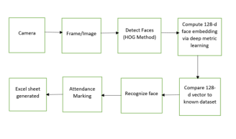

**Fig 3.2 Block Diagram**

**Chapter 4**

**Result and Discussion**

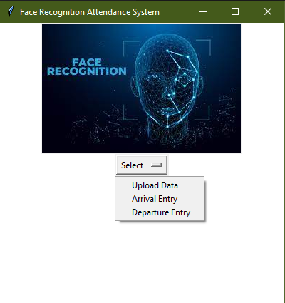

**Fig 4.1 Main Window of GUI**

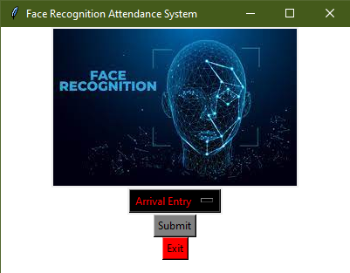

**Fig 4.2.1 Selection when there is arrival**

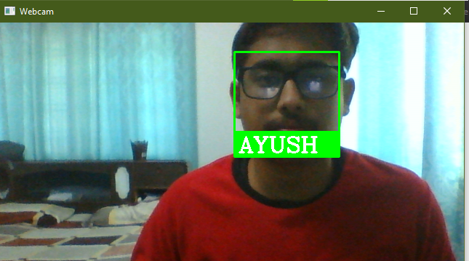

**Fig 4.2.2 Identification of the face**

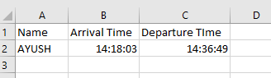

**Fig4.2.3 Excel sheet of present students**



**Fig 4.3 Uploading new data**

**Chapter 5**

**Conclusion and Future Work**

Face recognition systems are part of facial image processing applications and their significance as a research area are increasing recently. Implementations of system are crime prevention, video surveillance, person verification, and similar security activities. The face recognition system implementation can be part of Universities. Face Recognition Based Attendance System has been envisioned for the purpose of reducing the errors that occur in the traditional (manual) attendance taking system. The aim is to automate and make a system that is useful to the organization such as an institute. The efficient and accurate method of attendance in the office environment that can replace the old manual methods. This method is secure enough, reliable and available for use. Proposed algorithm is capable of detect multiple faces, and performance of system has acceptable good results.

With advances in digital technology, the quality of facial verification in face recognition attendance systems has improved, and the acceptance rate is relatively high. Face recognition attendance systems’ appeal is enhanced further by their fast image processing time and ease of integration. The facial recognition attendance app improves employee attendance tracking while cutting costs. A system like this also provides an additional layer of protection to the workplace. If your company is still using a manual or fingerprint biometric attendance system, it’s time to switch to a facial recognition attendance system.

**References**

 [1] Smart Attendance Management System Using Face Recognition Kaneez Laila Bhatti1,* , Laraib Mughal1 , Faheem Yar Khuhawar1 , Sheeraz Ahmed Memon1 1Dept. of Telecommunication Engineering, MUET, Jamshoro, PK.(https://eudl.eu/pdf/10.4108/eai.13-7-2018.159713#:~:text=Methodology&text=The%20system%20calculate%20the%20attendance,the%20given%20image%20or%20not.)

 [2] https://www.kaspersky.com/resource-center/definitions/what-is-facial-recognition