**Table of Contents**

|  |  |  |
| --- | --- | --- |
| **Chapter No.** | **Description** | **Page No.** |
| Chapter 1 | Introduction | **1** |
| Chapter 2 | Literature Survey | **3** |
| Chapter 3 | Methodology | **4** |
| Chapter 4 | Result and Discussion | **6** |
| Chapter 5 | Conclusion and Future Work | **10** |
|  | References | **10** |

**Chapter 1**

**Introduction**

**1.1 Introduction-**

The report is about the project ‘Online Auction System’. This report tries to give a brief overview of the libraries used, code results and the problem it resolves.

The global reach of online auction market places allows for the buyers and sellers to overcome geographical constraints and purchase products anytime from anywhere over the internet. The online auction market provides the consumers with great advantages of low prices, greater product selection and greater efficiency compared to the usual traditional offline markets.

The online auction system is a model where we participate in a bid for products and service. This auction is made easier by using online software which can regulate processes involved. There are several different auction methods or types and one of the most popular methods is English auction system. This system has been designed to be highly-scalable and capable of supporting large numbers of bidders in an active auction.

Online Auction System has several other names such as e-Auctions, electronic auction etc. The requirement for online auction or online bidding can be more accurately specified by the client. It should be healthy and will be a good practice when it is made more transparent as a matter of fact. Online Bidding has become more wide spread in all sorts of industrial usage. It not only includes the product or goods to be sold, it also has services which can be provided. Due to their low cost this expansion made the system to grow. Online bidding has become a standard method for procurement process. Bidders can be maintained in a single database according to the preference, and they can be monitored. User's data can be maintained in a confidential way for validity and integrity of contractual documentation. Neat reporting reduces paperwork, postage, photocopying and time beneficial. Multiple bidders can be communicated with a great ease. This system allows multiple bids by single users.

**1.2 Why there is need of Online Auction system-**

At present people need to go to the auction place where auction is held, to buy product by bidding. This type of manual system is time consuming and participation of general public is very limited. Moreover in the traditional system people have to stay physically when auction is held. Now a day internet users are increasing day by day of our country. Considering this situation, we have built an online auction system.

**1.3 Problem Statement-**

The online auction system is software, which helps the user to perform following:

•The user can register and can login by his/her credentials.

•The user can take part on current bid and can enter the amount.

•The user can sell his/her product.

•The user can see the result of past bidding.

**Chapter 2**

**Literature Survey**

**2.1 Approach to Online Auction System using PHP**

**Techniques-**

In this project, the idea of Online Auction System is implemented with help of PHP. This system takes the input from the user and then show it in the upcoming bid section.

**2.2 Automated manipulation of bids using PHP-**

In automated manipulation firstly the data is present in the upcoming bids section and when the start time and start date crosses today date and current time then it automatically get deleted from the upcoming bid section and go to current bid section where we can bring change to the base value of the product. When the end time and end date reached then bid data got deleted from current bid section and go to result and then a mail is sent to the user.

**2.3 Existing Systems-**

**2.3.1 Manual bidding system** – In this system the bidding in done by humans and the user have to present physically there for entire duration of the bidding.

**Chapter 3**

**Methodology**

**3.1 Flowchart**

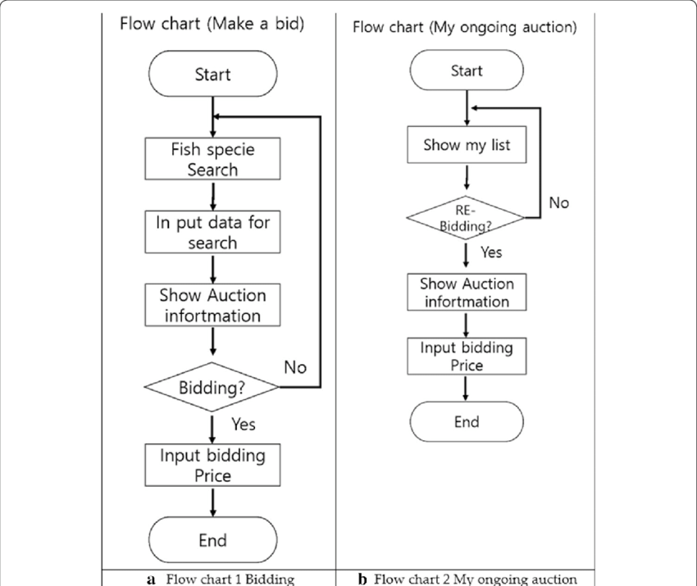

**Fig 3.1**

**3.2 Steps for Online auction System–**

* Login with the credentials for the security of the user and the user which are not registered can register themselves by verifying themselves.
* Users can upload the details of the bid using upload form which will be shown in upcoming bid till the start date and time reached.
* After the current date and time reached the start date and time then it will be shown in current bid section.
* Users can see the ongoing bids and can take part on it by entering the amount of the bid if that amount is greater than the current amount then the user can submit his/her bid.
* After the current date and time becomes greater than end date and time then it will be deleted from current bid section and go to result section.
* Users can also see the result of the past bidding and the winner of the bid will be notified by mail.

**Chapter 4**

**Result and Discussion**

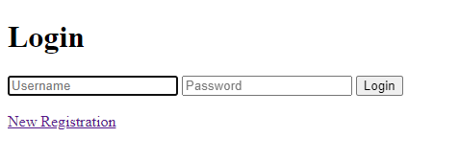

**Fig 4.1: Login Page**

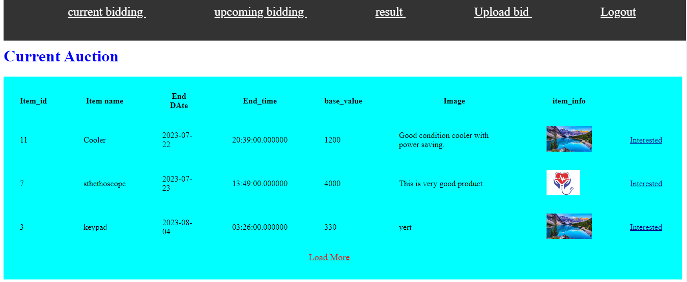

**Fig 4.2: Current Bid Section**

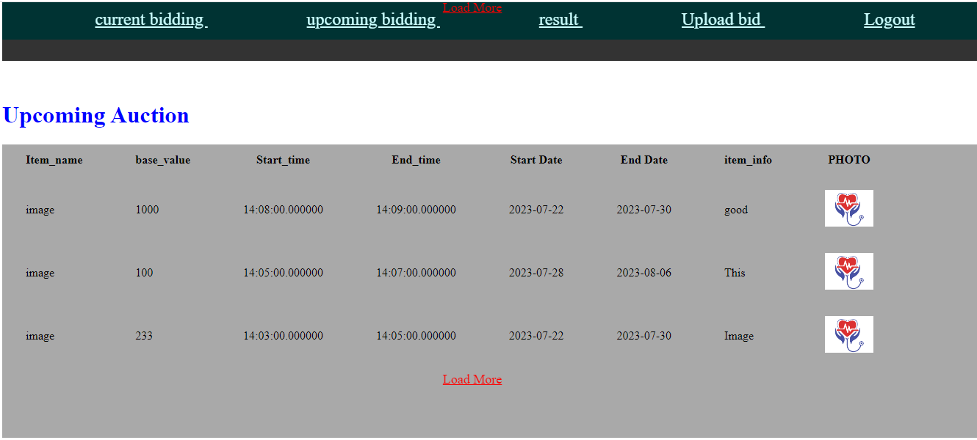

**Fig 4.3: Upcoming Bid Section**

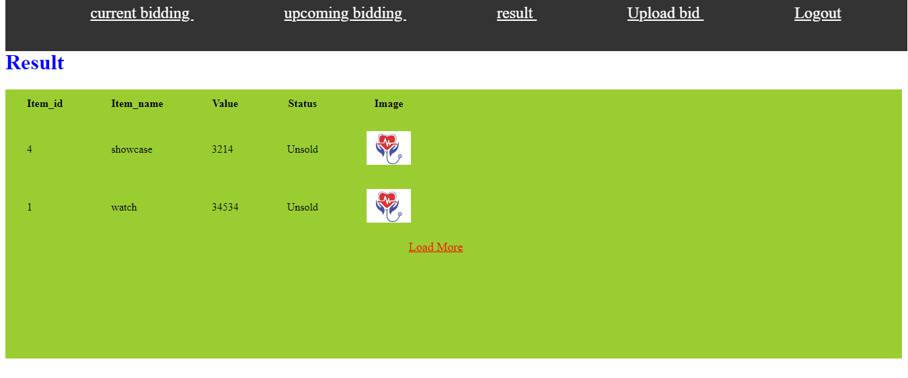

**Fig 4.4: Result Section**

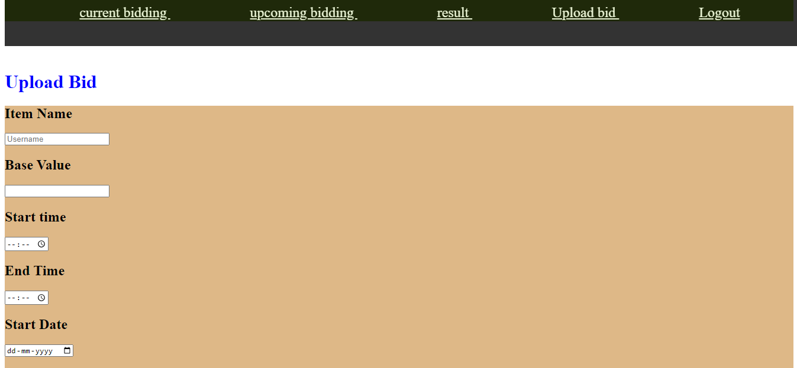



**Fig 4.5: Upload Bid Section**

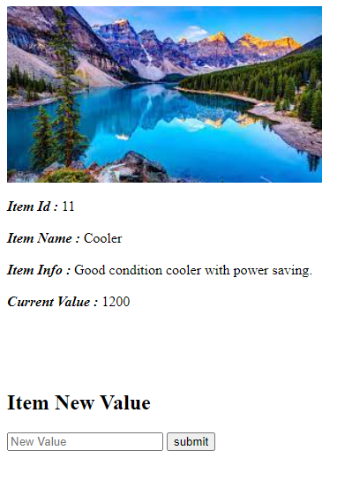

**Fig 4.6: Enter new value of the product**

**Chapter 5**

**Conclusion and Future Work**

Online Auction System is used to make bid online using PHP. The proposed system can be more improved by involvement of Artificial Intelligence in the field which can predict the market value and compare it with the base value and suggest is it worth buying or not.

**References**

 [1] https://en.wikipedia.org/wiki/Online_auction

 [2] <https://www.academia.edu/11582907/TITLE_ONLINE_AUCTION_SYSTEM_1_1_Introduction>

[3] https://www.academia.edu/22801737/Online_auctions