

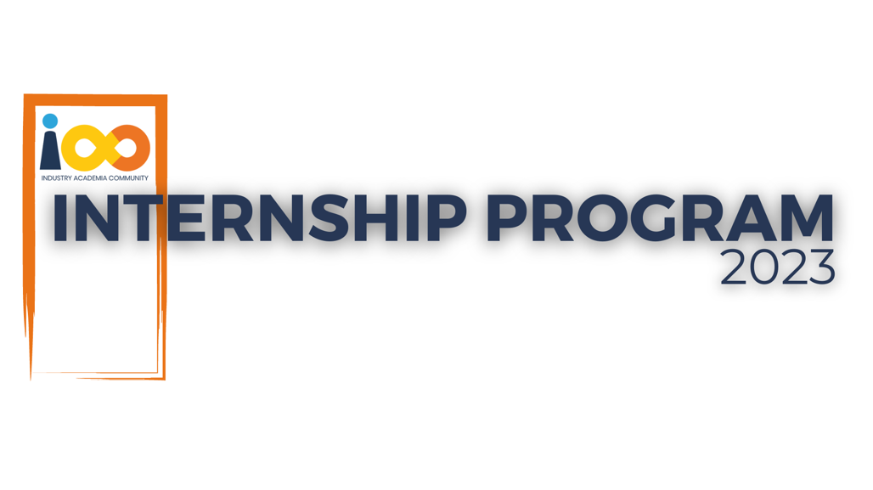

PROJECT REPORT

Data Science  
  
Prediction of Placement Status

and Calculating Passing Year

|  |  |  |  |
| --- | --- | --- | --- |
| **Created By:** | Ayush Nautiyal | **Approved By:** | Harshada Topale |
| **Created On:** | 15-Sept-2020 | **Approved On:** | DD-MMM-YYYY |

Page left blank intentionally

**INDEX**

**1** **PROJECT DETAILS** 2

**2** **SUMMARY** 2

**3** **INTRODUCTION** 2

3.1 Background 2

3.2 Stakeholders 2

3.3 Objectives 2

**4** **METHODOLOGY** 2

4.1 Considerations & Assumption 3

4.2 Approach 3

4.3 Activities 3

**5** **TARGETTED V/S ACHIEVED OUTPUT** 3

**6** **CONCLUSION** 3

**7** **APPENDICES** 4

7.1 Appendix A – Title 4

# **PROJECT DETAILS**

|  |  |  |  |
| --- | --- | --- | --- |
| **Project Name** | Prediction of Placement Status and calculation of Passing Year. | | |
| **Project Sponsor** | Tushar Topale | | |
| **Project Manager** | Harshada Topale | | |
| **Start Date** | 01-08-2023 | **Completion Date** | 15-09-2023 |

# **SUMMARY**

*To make the most of available resources provide timely support and guarantee excellent academic and career outcomes it is crucial to know when the student will graduate and whether they will receive a placement.*

# **INTRODUCTION**

## Background

*Lack of academic planning and career advice is the root cause of not knowing of when they are going to graduate and not receive a placement. Students may face problem with their workflow when they do not get their timeline when they are going to graduate. Furthermore, one can face difficulties in job market without knowing job relevant skills.*

## Stakeholders

*Process owner – Harshada Topale,*

*Key Stakeholders – Harshada Topale,*

*End Customers – Cloud Counselage Pvt. Ltd.*

## Objectives

*The solution involves developing predictive model for student placement and calculation for year of graduation which accurately forecasts whether students secure placement and when students will graduate.*

# **METHODOLOGY**

## Considerations & Assumption

*The dataset details are correct.*

*Assuming that the degree program is of 4 years duration.*

## Approach

* *To solve the problem of finding the year of graduation we simply merge two columns academic year and current academic year and applying the specific constrains we apply the formula “current year +(4 – given year)”.*
* *To solve the placement status problem the steps which are taken are:*

1. Clean the data to remove the duplicates entities in the dataset and remove Nan values.
2. Split the dataset into train and test dataset by 20% ratio.
3. Make Pipeline so that we do not have to clean or change the value for test data and new coming data.
4. Comparing all the classification models and got RandomForestClassifer performing well in this scenario.
5. Testing the test dataset with it.
6. Applying that to the new coming data.

## Activities

*Requirement Analysis and Specifications.*

Design and Specifications.

Coding and Testing.

Integration.

# **TARGETTED V/S ACHIEVED OUTPUT**

*The objective is successfully achieved after performing the steps defined in approach section.*

# **CONCLUSION**

*The objective is achieved.*

# **APPENDICES**

## Appendix A – Cloud Counselage https://cloudcounselage.graphy.com/