Ayush Venkatesh – SEC01 (NUID 001348315)

Big Data System Engineering with Scala  
Spring 2022   
Assignment No. 5



**-List of Tasks Implemented:**

Github link: <https://github.com/ayushVenkatesh/CSYE7200-Ayush>

Implemented functions as asked in the question. Edited files function.scala and movie.scala

**-Code (Please scroll below to next page)**

**Please check repo**



**-Unit tests**

**MovieSpec.scala**

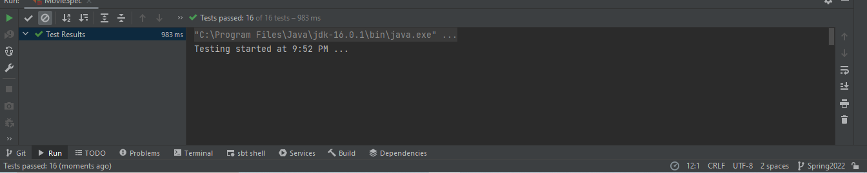

**FunctionSpec.scala**

