Ayush Venkatesh – SEC01 (NUID 001348315)

Big Data System Engineering with Scala  
Spring 2022   
Assignment No. 6



**-List of Tasks Implemented:**

Github link: <https://github.com/ayushVenkatesh/CSYE7200-Ayush>

Implemented functions as asked in the question. Edited files WebCrawler.scala and MonadOps.scala

**-Code**

**Please check repo**

**-Unit tests**

**MonadOpsSpec.scala**

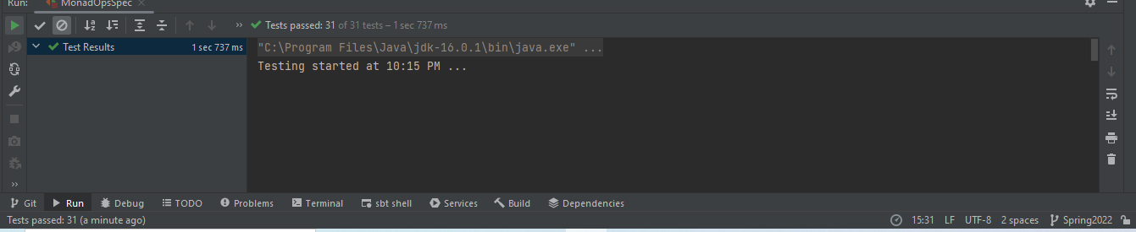

**WebCrawlerSpec.scala**

