Ayush Venkatesh – SEC01 (NUID 001348315)

Big Data System Engineering with Scala  
Spring 2022   
Assignment No. 6



**-List of Tasks Implemented:**

Github link: <https://github.com/ayushVenkatesh/CSYE7200>

Under the spark-csv module, created two new files called AnalyzeMovieRating under scala folder and AnalyzeMovieRatingTest under test folder.

**-Code**

**AnalyzeMovieRating**

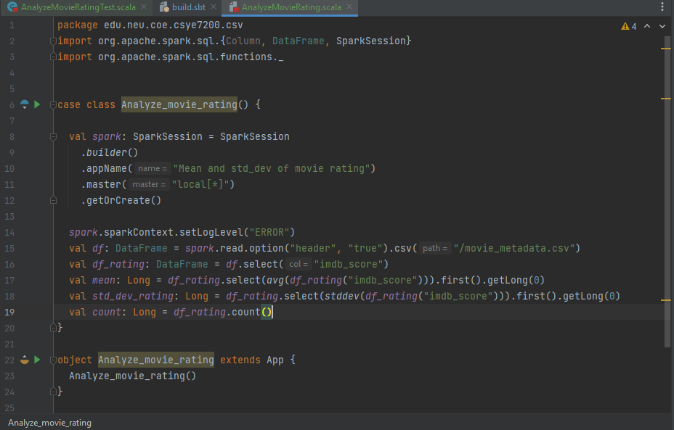

**(Continued below)**

**Line AnalyzeMovieRatingTest**

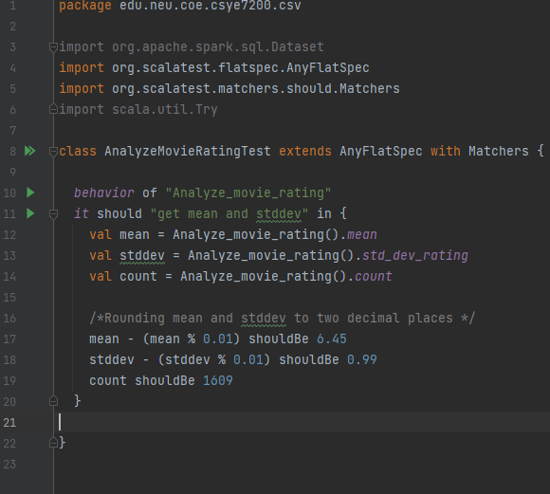

**(Continued below)**

**-Unit tests**

**Failed, was not sure how to resolve.**

