Software Part Needs to Be Figured Out , Planned!!!

1. Using Ultasonic Sensor , get some kind of localisation
Thinking of getting the distance and radius and mapping it to it and then plot it in the graph and make it more smooth , kind of first idea. Use mpu and encoders also

2. Make Multiple Ros Nodes and make them independent to each other
Thinking of using ROS1 but might can shift to ROS2 if needed.

3. Peforme some cv algorithms to detect some features about my Surrounding

4. Thinking of making the camera movable so that it mobves 60 degree each side on my command.

5. Power management always read the battert voltage and suggest if it becomes very low.

6. Autonomous navigation. Look how A* works and how Dijikstra works , use grid cells for looking.

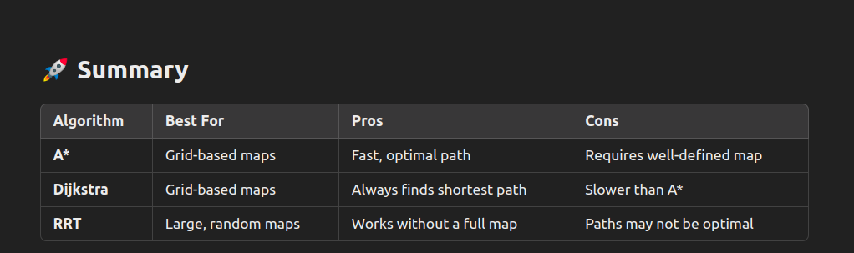
7.

