# 📌 Phase 2: Org Setup & Configuration

In this phase, we prepared the Salesforce development environment and configured the basic organizational settings required for the Education Institute CRM.

## Salesforce Editions

We worked on a Developer Edition Org, which provides full functionality for building and testing CRM features like Lead Management, Enrollments, and Course Tracking.

## Company Profile Setup

The company profile was configured with details of the coaching institute, including the organization name and default currency set to INR.

## Business Hours & Holidays

Default business hours were set to IST (Indian Standard Time), ensuring accurate follow-up tracking and counselor availability. Holidays can be added (like national holidays or exam dates) to avoid scheduling tasks or follow-ups on non-working days.



## Fiscal Year Settings

Standard fiscal year was adopted for reporting on student admissions and revenue tracking.

## User Setup & Licenses

Multiple users were created to represent different roles in the institute:  
o **Counselor** (to manage student inquiries, leads, and follow-ups)  
o **Manager** (to oversee counselor performance and reports)  
o **Admin** (to configure and manage the CRM)  
Each user was assigned a Salesforce license.

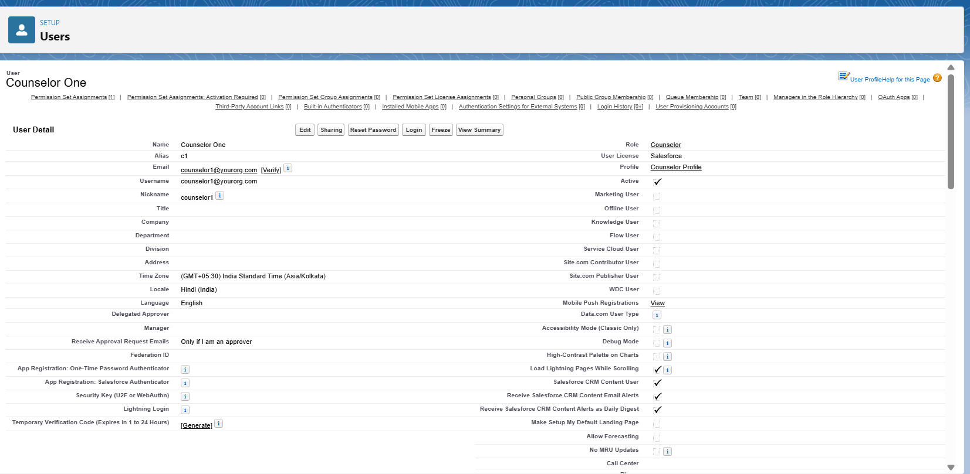



## Profiles

A Counselor Profile was created by cloning the Standard User profile. It was configured with object-level permissions: Leads, Contacts, and Enrollments were editable, while Courses and Batches were read-only.

## 

## 

## Roles

A simple role hierarchy was set up to control record access:  
Admin → Manager → Counselor.  
This ensures managers automatically see counselors’ leads and enrollments if sharing is private.

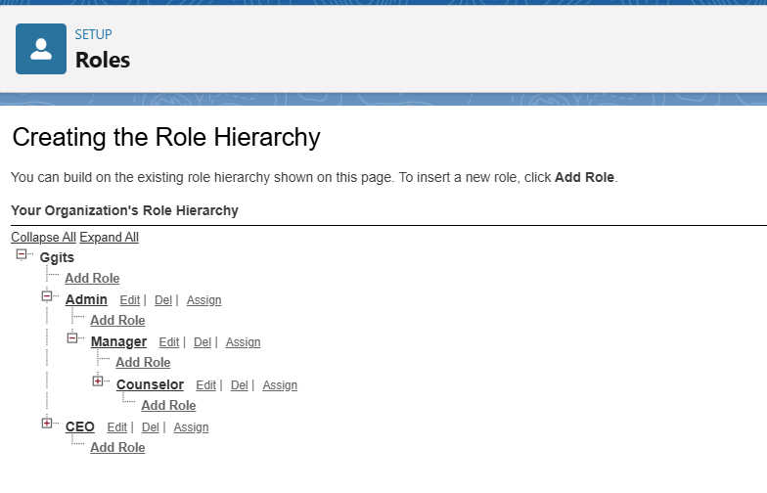

## Permission Sets

Special permission sets can be created for extra access. For example, a Report Access permission set allows counselors or managers to run detailed reports without changing their base profile.

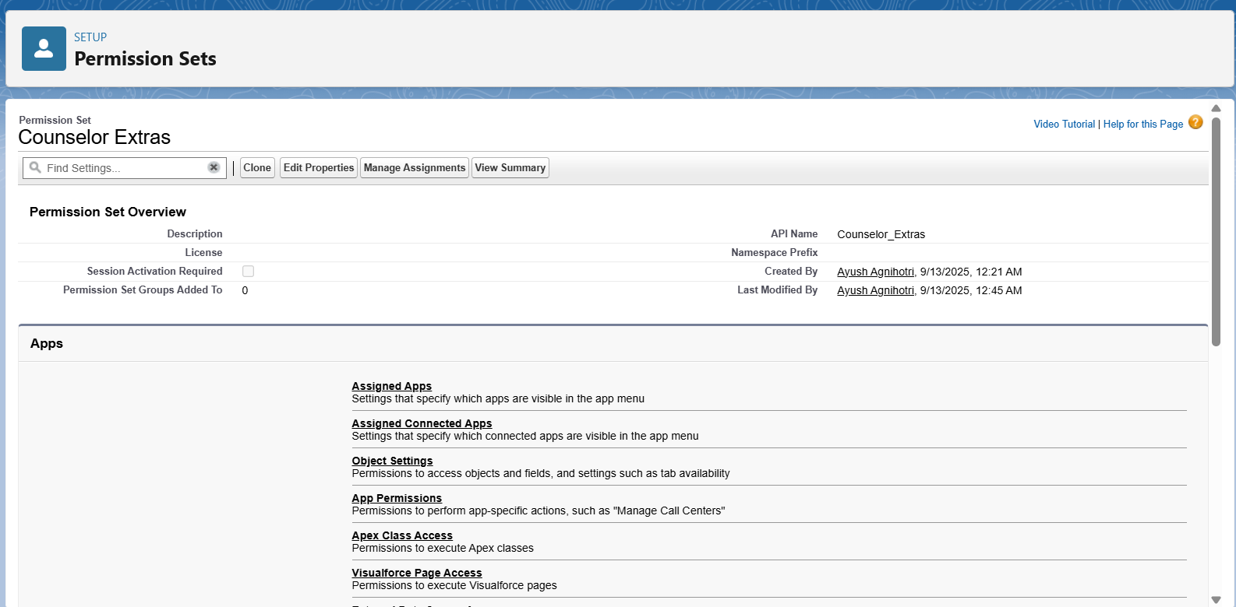

## OWD (Org-Wide Defaults)

Organization-Wide Defaults were kept Private for Leads to ensure each counselor sees only their own leads, while Contacts were controlled by parent (account/lead owner). Courses and Batches were kept public read-only for transparency.

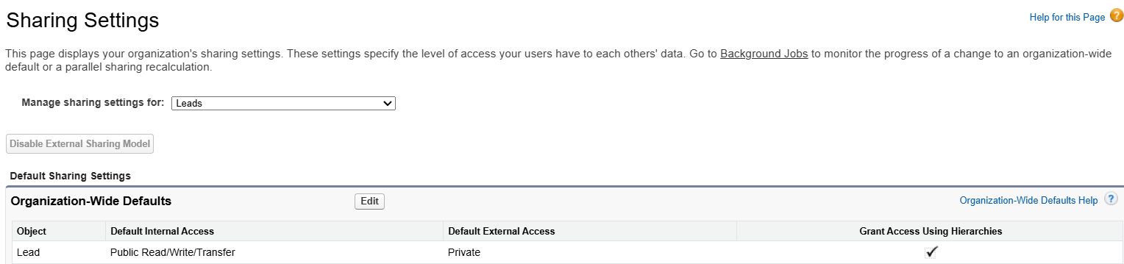







## Sharing Rules

Could be applied if managers or senior staff need visibility into all counselors’ records. For example, a sharing rule can allow managers to access all Leads owned by counselors.

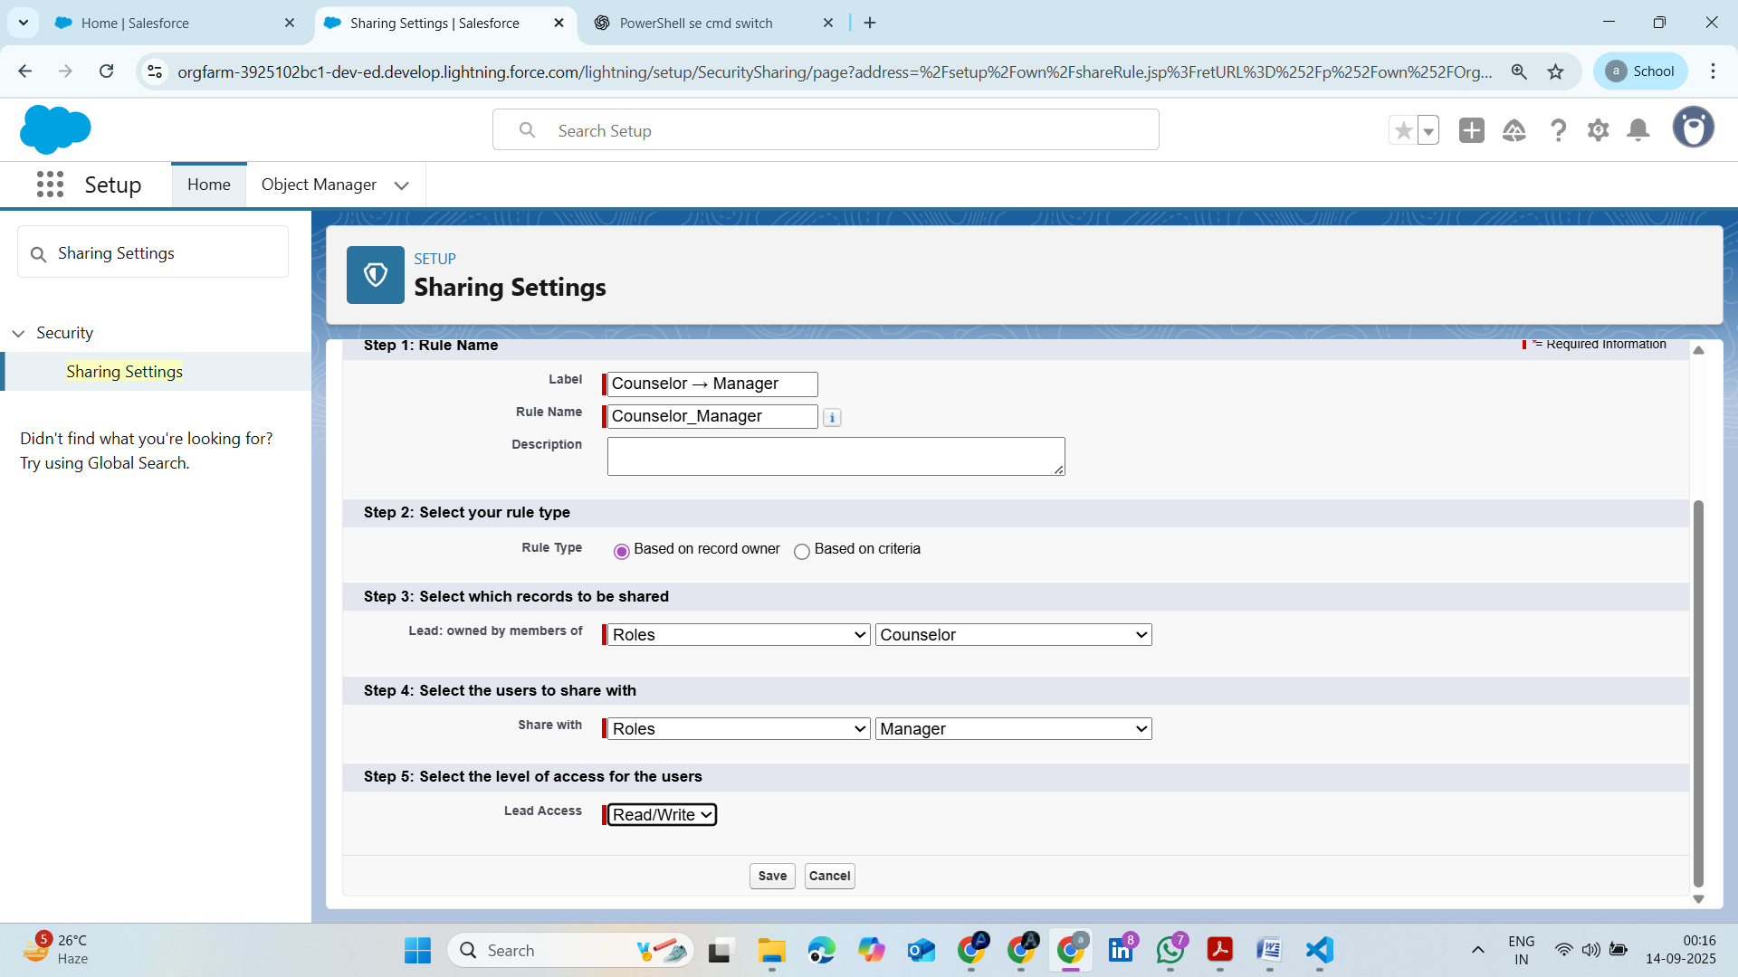

## Login Access Policies

Configured to enforce secure logins with IP restrictions and session timeouts for institute staff.

## Dev Org Setup

The Developer Org served as the main environment for building this project.

## Sandbox Usage & Deployment Basics

For this academic project, sandbox wasn’t mandatory. However, deployment concepts like Change Sets and VS Code with SFDX CLI were explored for migrating changes between environments.

👉 Overall, Phase 2 ensured the Education Institute CRM environment was ready with appropriate users, access controls, and security configurations before implementing the main business processes.