# 📌 Phase 3: Data Modeling & Relationships

In this phase, the data model for our Salesforce project was designed using a mix of standard and custom objects to handle the business processes.

## Standard Objects

We used Salesforce’s core CRM objects: Leads, Accounts, Contacts, Opportunities, and Cases.

• Leads → to capture and qualify new prospects.

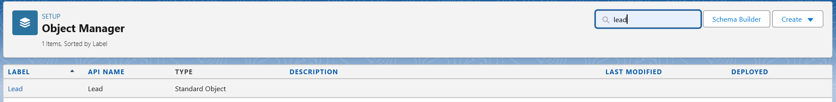

• Accounts & Contacts → to manage organizations and individuals.





• Opportunities → to track deals and revenue.

• Cases → to log and resolve customer issues.



## Custom Objects

To extend the functionality beyond standard CRM, custom objects were created:

• Course_Enrollment__c → to manage student/course enrollment (fields: Enrollment Date, Status, Payment Status, Course lookup, Student lookup).

• Counselor_Assignment__c → to track which counselor is assigned to which student/lead (fields: Counselor [User lookup], Lead lookup, Assignment Date).

• Feedback__c → to capture feedback from students/leads (fields: Rating, Comments, Counselor lookup, Lead/Account lookup).







## Fields

Different field types were used:

• Picklists: e.g., Enrollment Status (Pending, Active, Completed), Payment Status (Pending, Paid, Overdue).

• Lookup fields: to link Leads → Counselor, Enrollment → Course.

• Currency: for payment amount.

• Date: Enrollment Date, Due Date.

• Long Text Area: for detailed feedback.

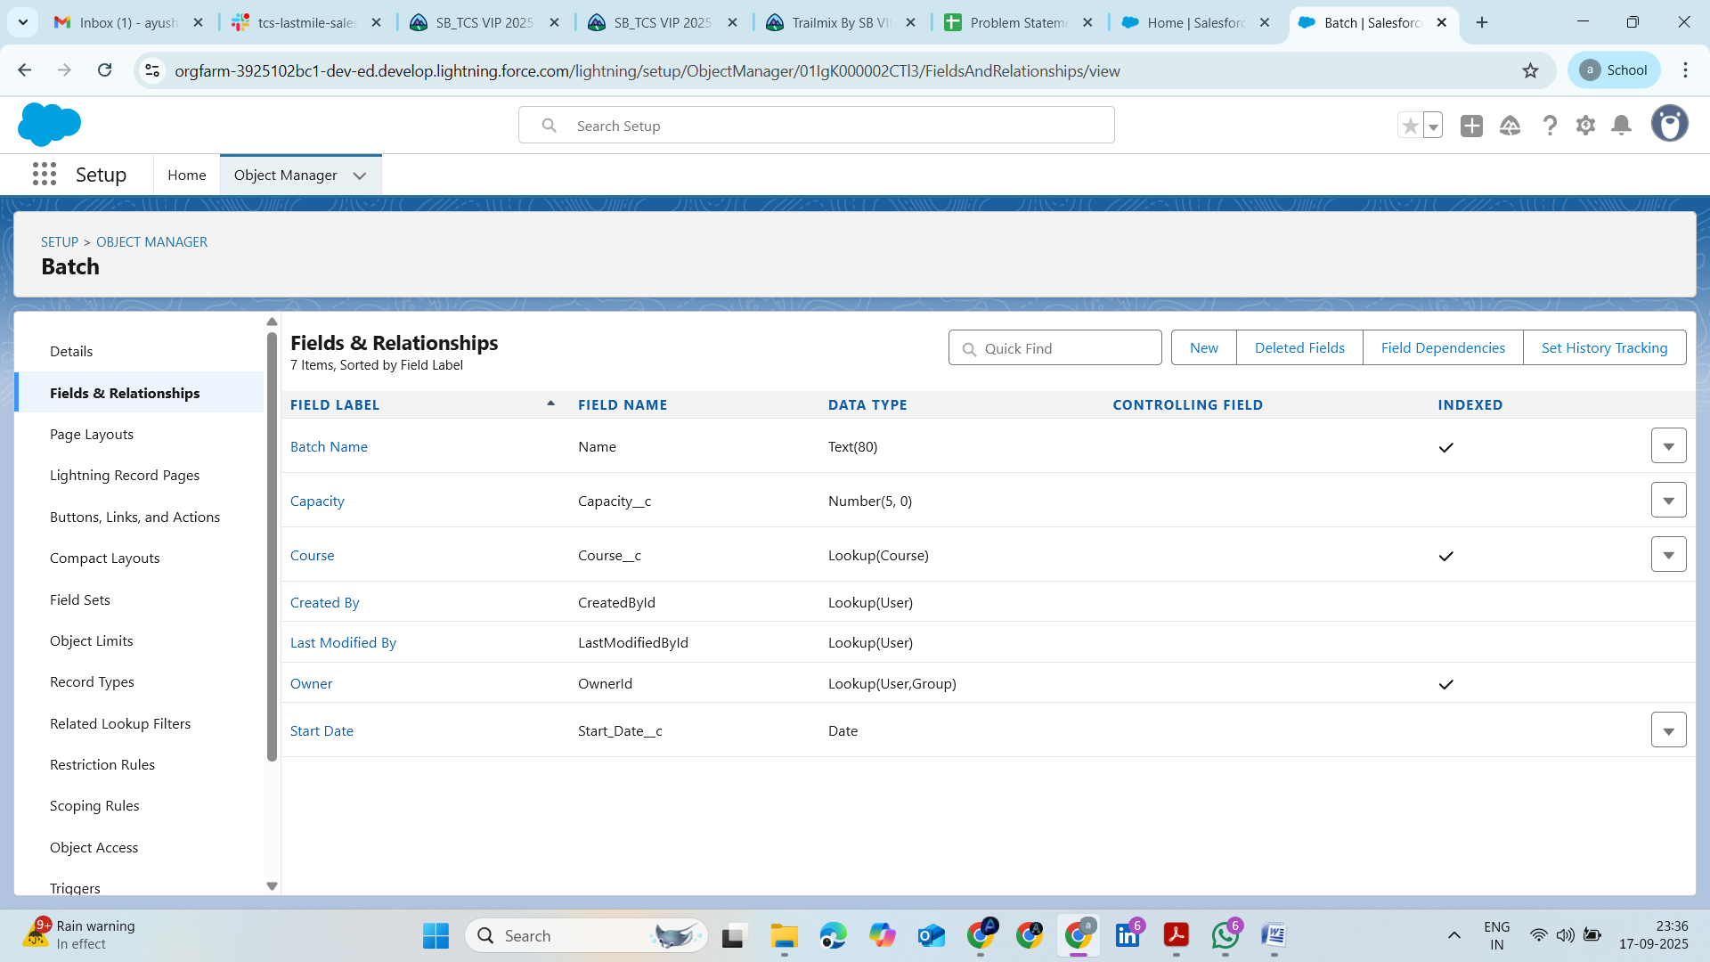

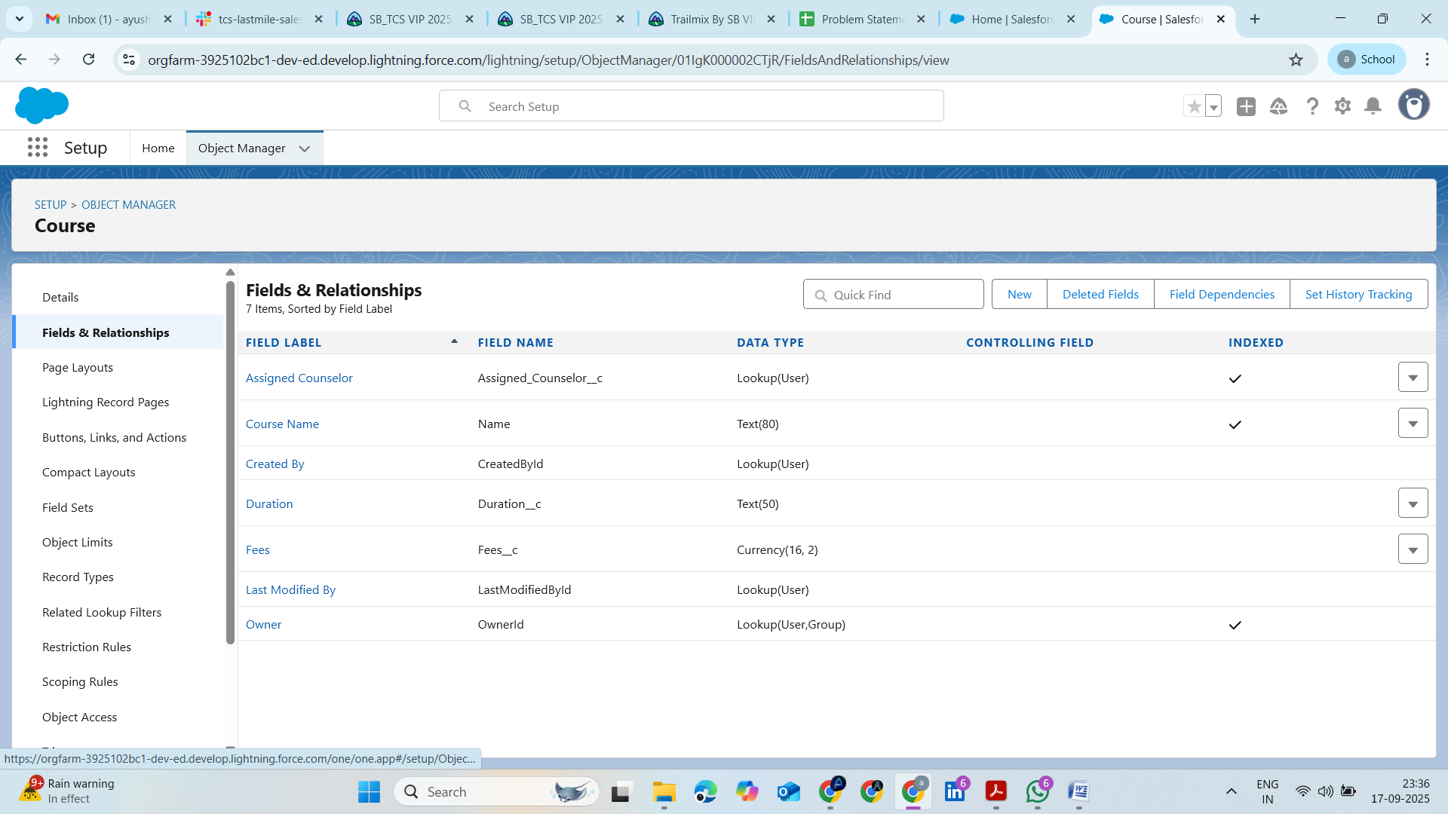

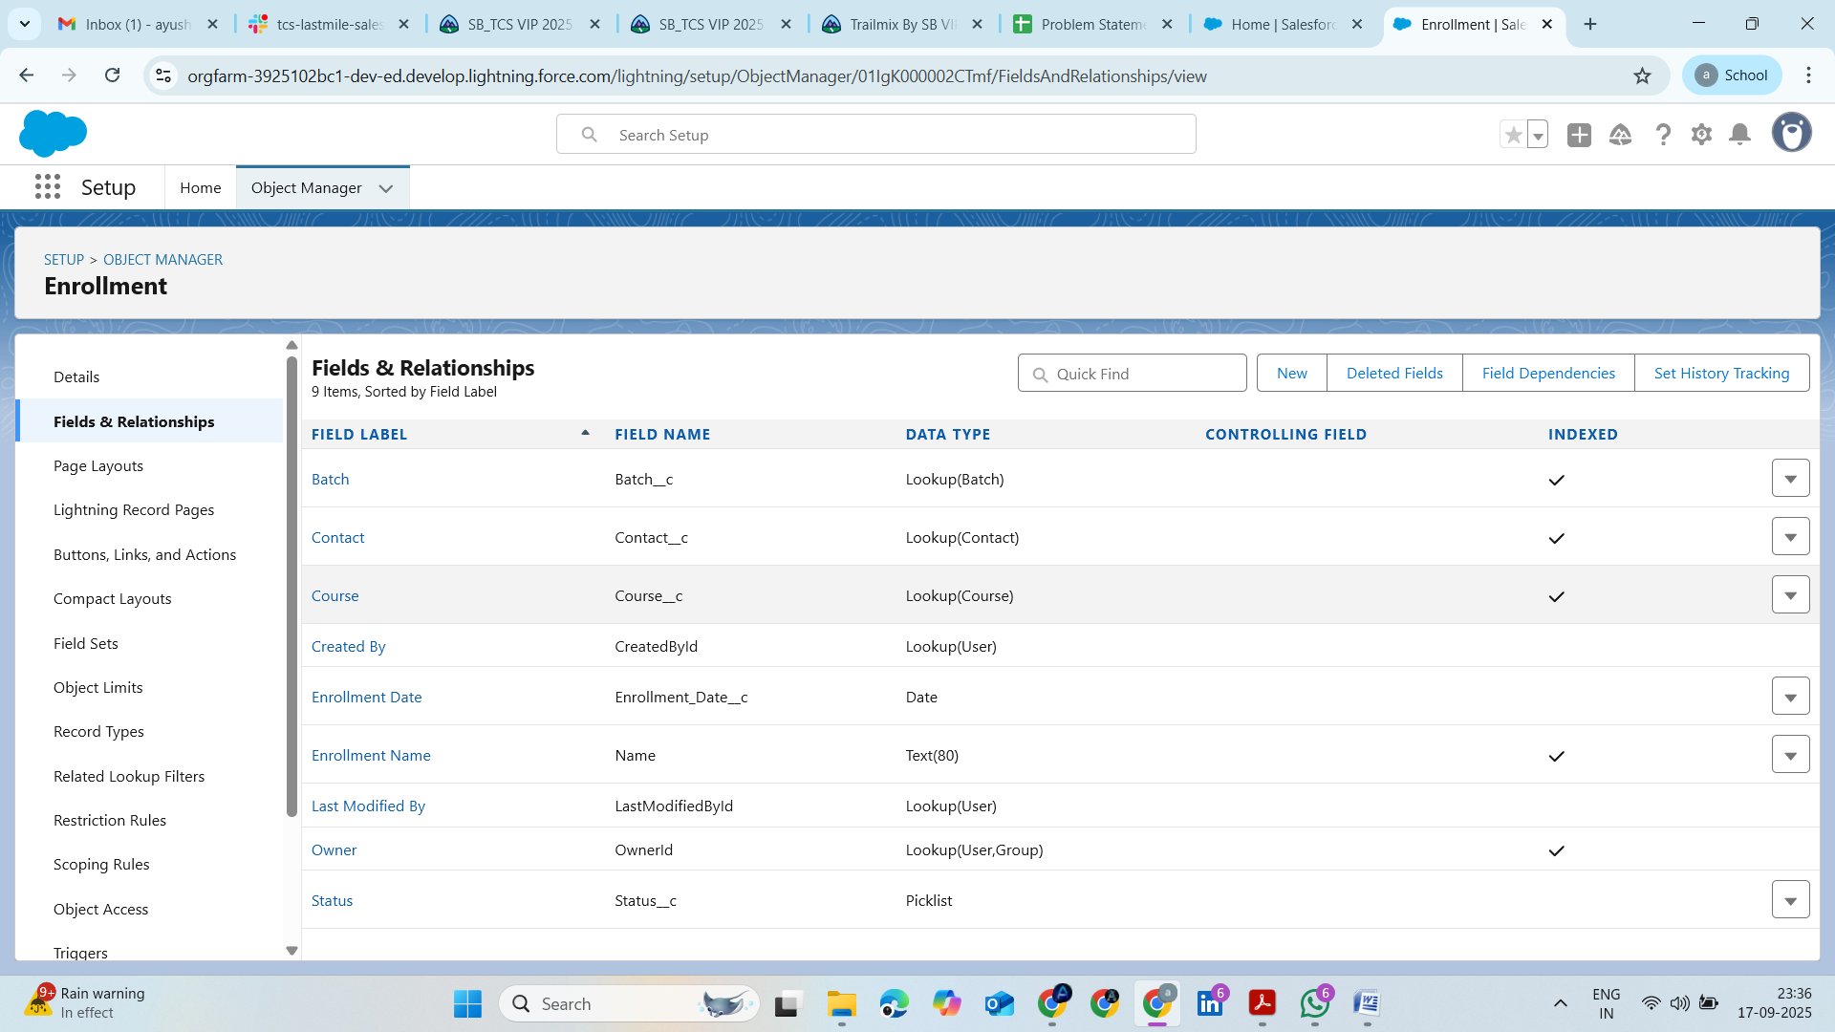

## Record Types

Record types can be used to separate Student Enrollments vs Corporate Enrollments, each with different layouts and business processes.

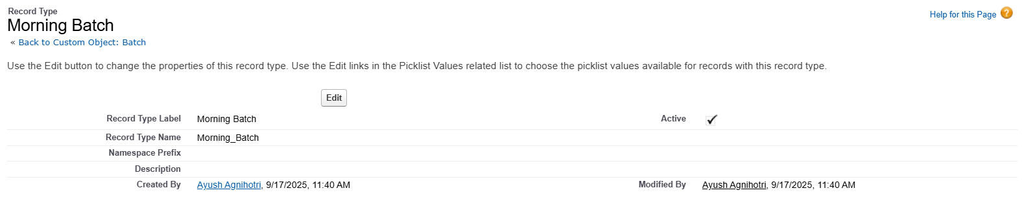

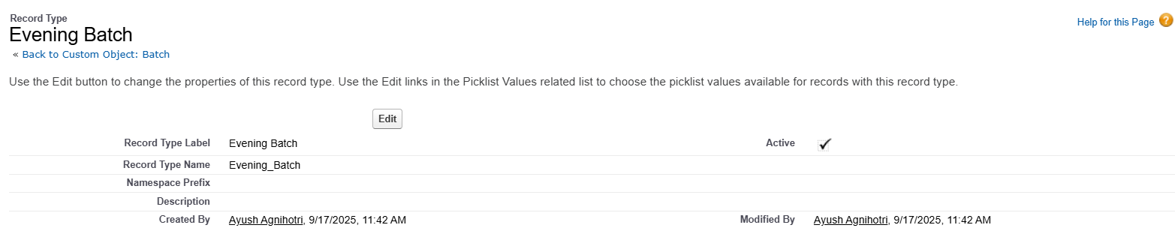

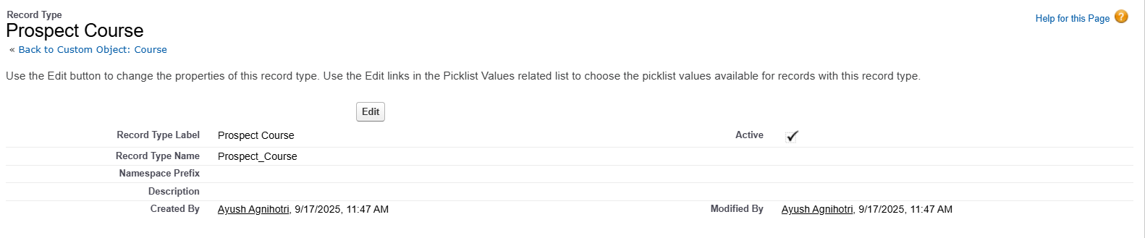

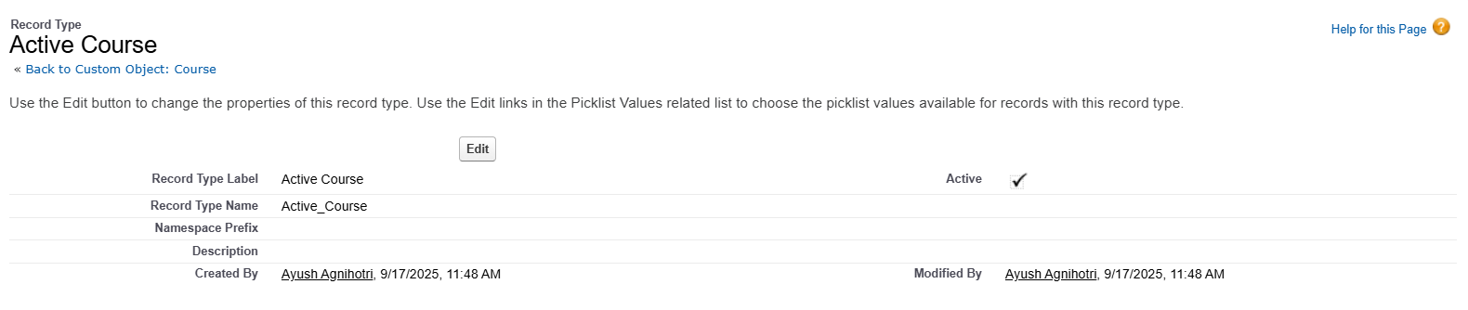

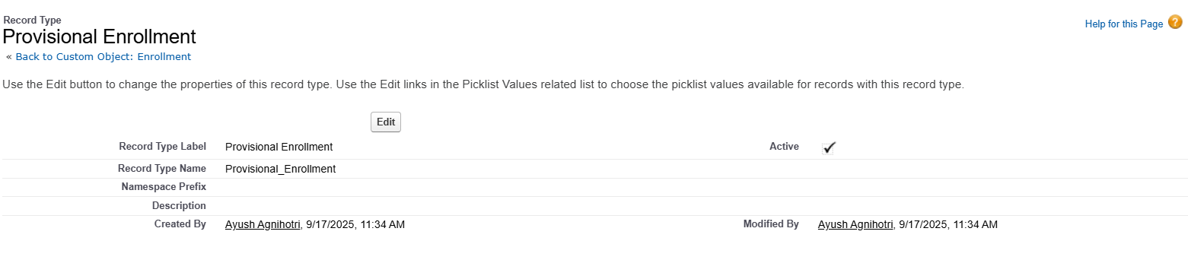

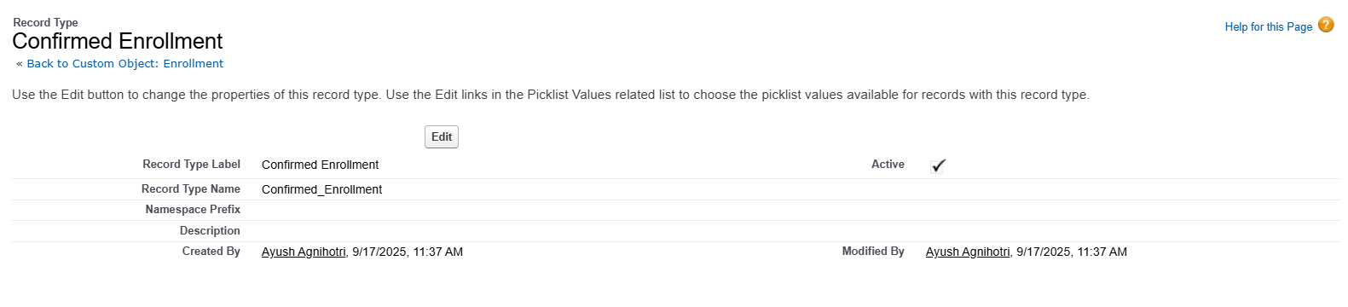

## Page Layouts

Customized layouts were prepared:

• Lead layout: shows basic lead info (Name, Phone, Email, Preferred Course).

• Enrollment layout: shows Course, Payment Status, Enrollment Status, Due Date.

• Feedback layout: shows Rating and Comments clearly.

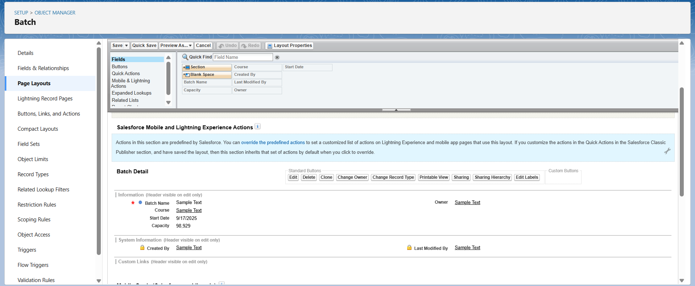

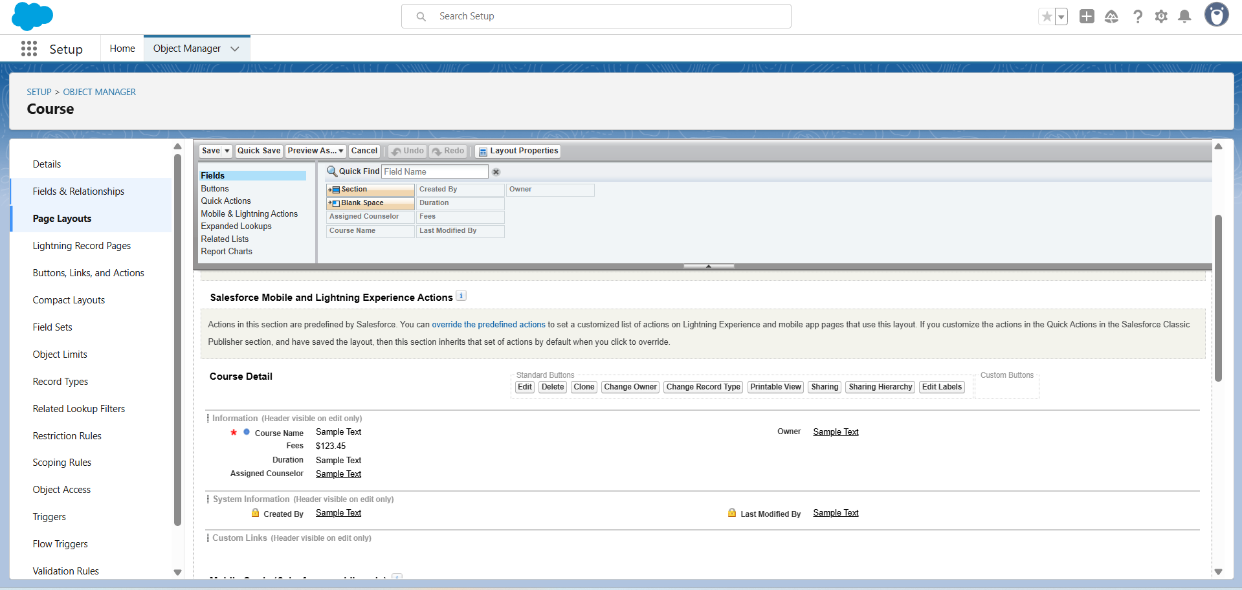

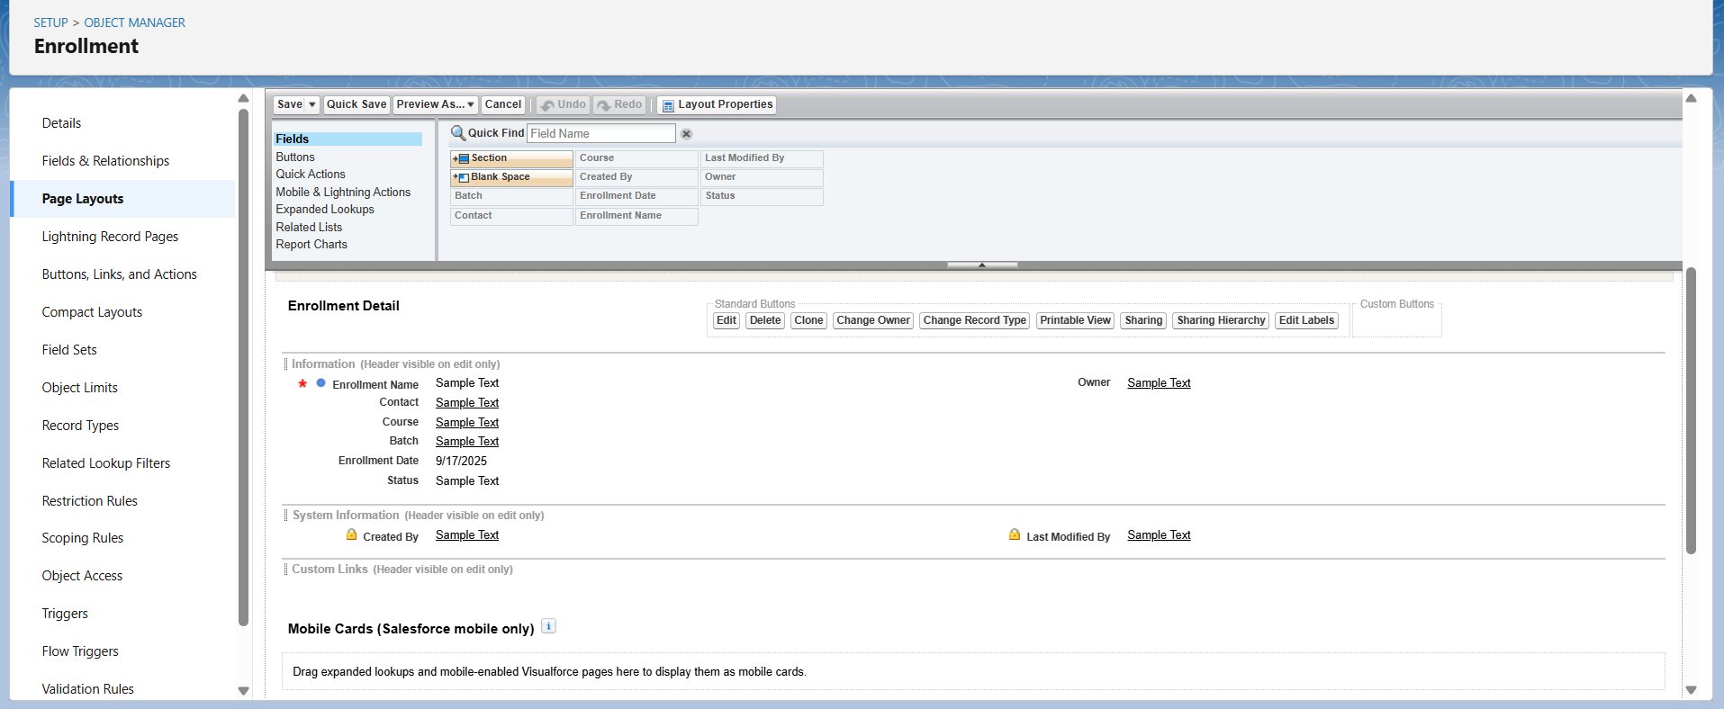

## Compact Layouts

Key fields were highlighted for quick view:

• Lead: Name, Status, Phone, Email.

• Enrollment: Course, Status, Due Date.

• Feedback: Rating, Counselor.

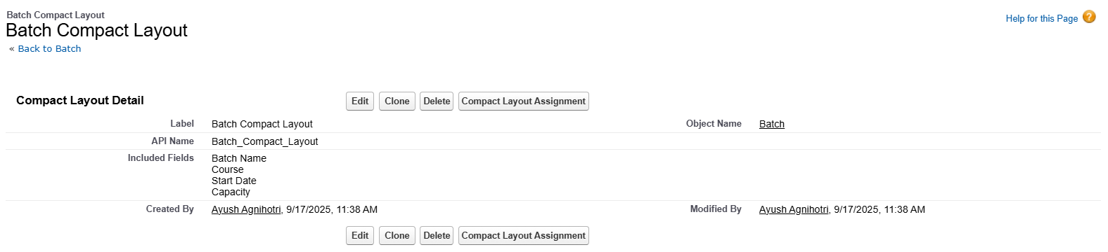

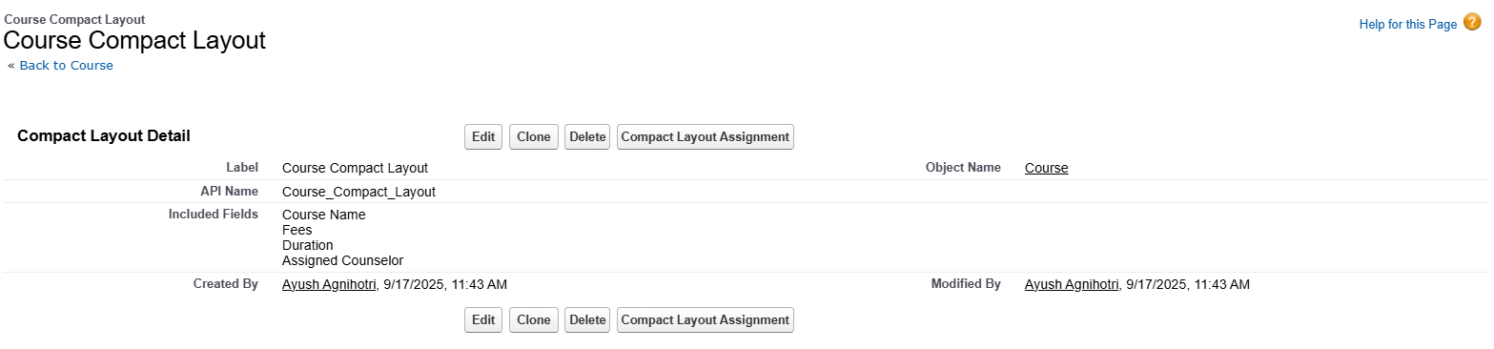

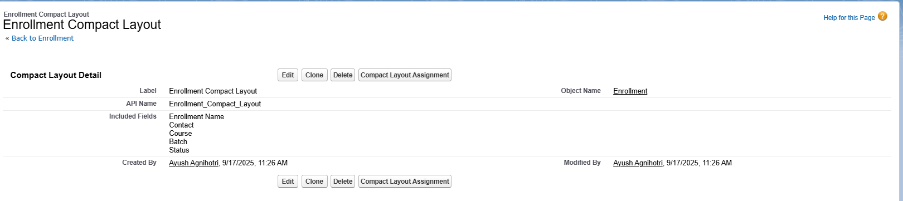

## Schema Builder

Salesforce Schema Builder was used to visualize object relationships:

• Lead ↔ Counselor_Assignment__c

• Lead/Account ↔ Enrollment__c

• Enrollment__c ↔ Feedback__c

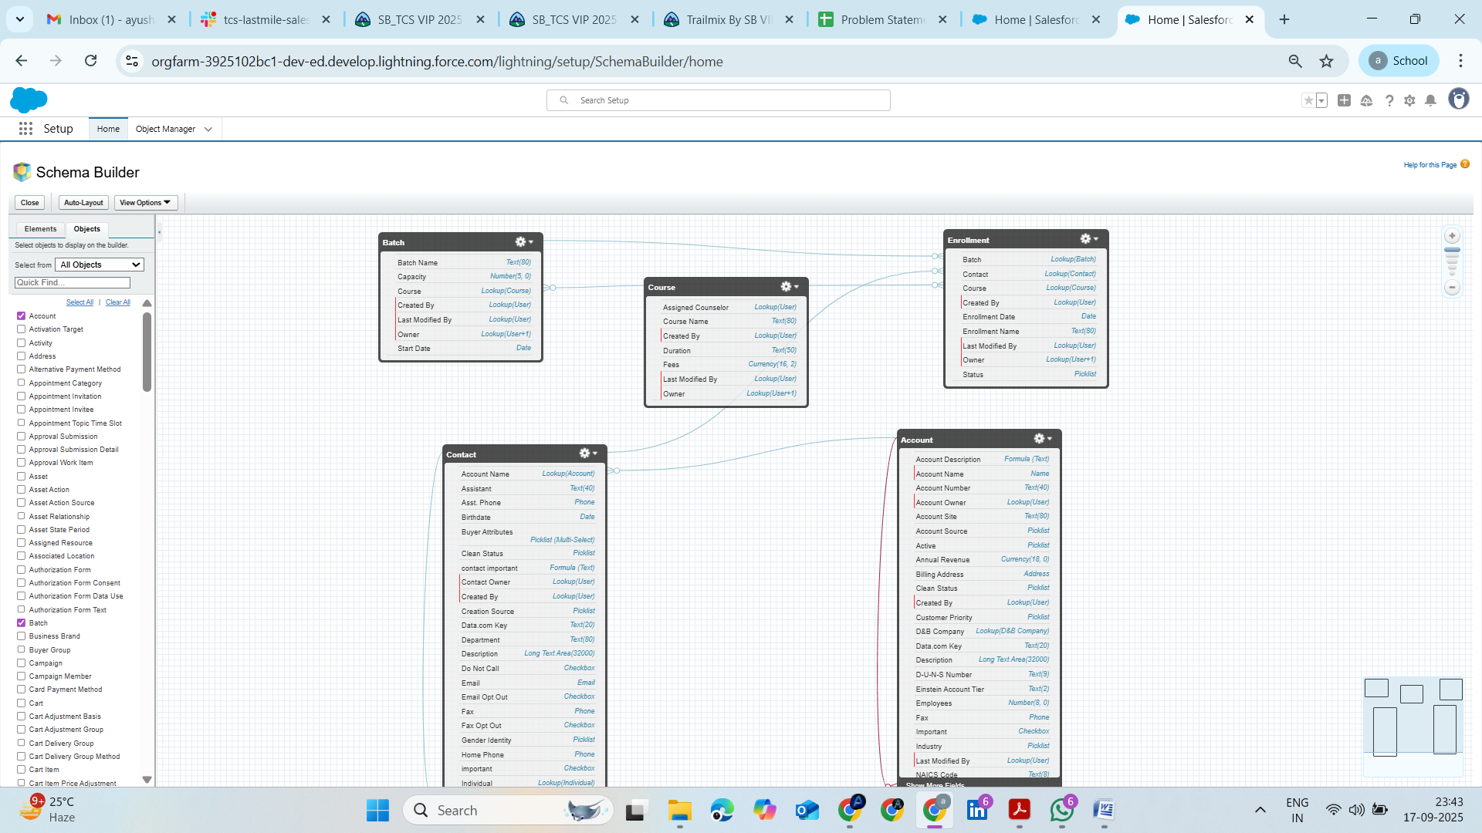

## Lookup vs Master-Detail vs Hierarchical Relationships

• Lookup: used mostly (e.g., Lead → Counselor, Enrollment → Course).

• Master-Detail: not used, since independent ownership and sharing rules were required.

• Hierarchical: not relevant except for User object.

## Junction Objects

Not required in current scope. Could be used in the future (e.g., multiple counselors linked to multiple leads).

## External Objects

Not used in this phase, but Salesforce provides them for integrating with external systems (like Payment Gateways or LMS in the future).

👉 Phase-3 delivered a flexible and scalable data model where standard CRM functionality (Leads, Accounts, Opportunities) was extended with education-specific entities like Course Enrollments, Counselor Assignments, and Feedback.