# Phase 4: Process Automation (Admin)

In this phase, we automated the key business processes of the Education Institute CRM using Salesforce declarative tools. The goal was to reduce manual work for counselors and managers and ensure timely follow-ups, email notifications, and record updates.

## 1) Validation Rules

Use: Ensure data quality before records are saved.  
Implementation in Project:  
  
Rule on Lead: At least one of Phone or Email must be provided when the Lead Status = New.  
  
Formula:  
  
AND(  
 ISPICKVAL(Status, "New"),  
 ISBLANK(Phone),  
 ISBLANK(Email)  
)  
  
Result: Counselors cannot save incomplete leads.

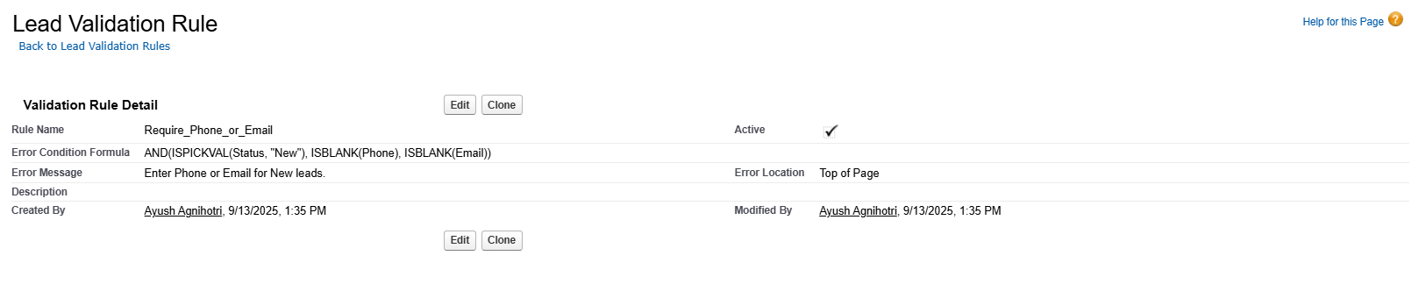

## 2) Workflow Rules

Use: Legacy tool to automate actions like email alerts, field updates, and tasks.  
Implementation in Project:  
  
Created Workflow Rule on Lead:  
  
Criteria: When a Lead is created with Status = New.  
  
Immediate Action: Trigger New Lead Email Alert.  
  
Result: Ensures counselor/lead owner immediately gets notified.

## 3) Process Builder

Use: Automates processes with point-and-click (now mostly replaced by Flow).  
Implementation in Project:  
  
Not used extensively since Flow is more powerful.  
  
But for learning: Created a Process Builder process to auto-update a custom field (e.g., Lead Source = “Website” if created via web form).  
  
Result: Demonstrated understanding but replaced by Flow for production.

## 4) Approval Process

Use: Standardize approvals before a record can proceed.  
Implementation in Project:  
  
Created an Approval Process for Discount Requests on Course Fees.  
  
Steps:  
  
Counselor submits discount request on Enrollment.  
Approval goes to Manager.  
If approved → Discount field updated. If rejected → Enrollment status updated as Rejected.  
  
Result: Prevents unauthorized discounts.

## 5) Flow Builder (Screen, Record-Triggered, Scheduled, Auto-launched)

Use: Modern automation tool for Salesforce.  
Implementation in Project:  
  
Record-Triggered Flow:  
  
On Lead creation → Creates Follow-up Task for Counselor.

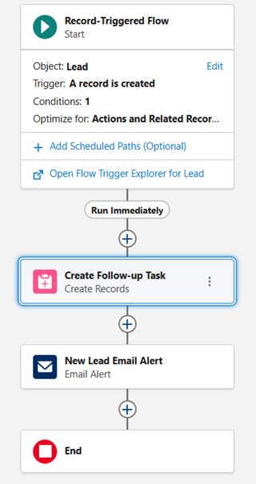

On Lead creation/update → Auto-assigns Counselor based on Preferred Course.

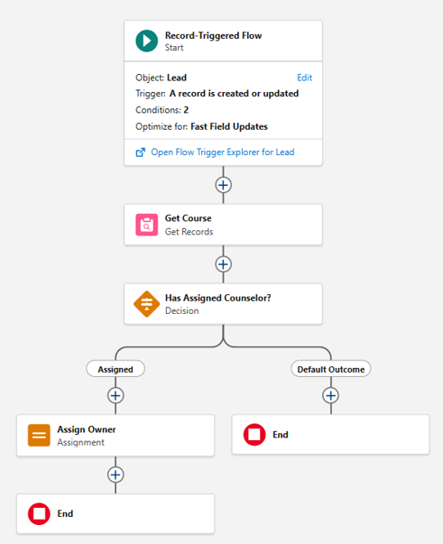

Auto-launched Flow: Integrated with Email Alert for notifications.  
  
(Optional Screen Flow): Can be used by counselor for guided Lead capture.  
  
Result: End-to-end automation of lead handling without manual steps.

## 6) Email Alerts

Use: Automatically notify users of key events.  
Implementation in Project:  
  
Created Lightning/Classic Email Template (Lead_New_Notification).

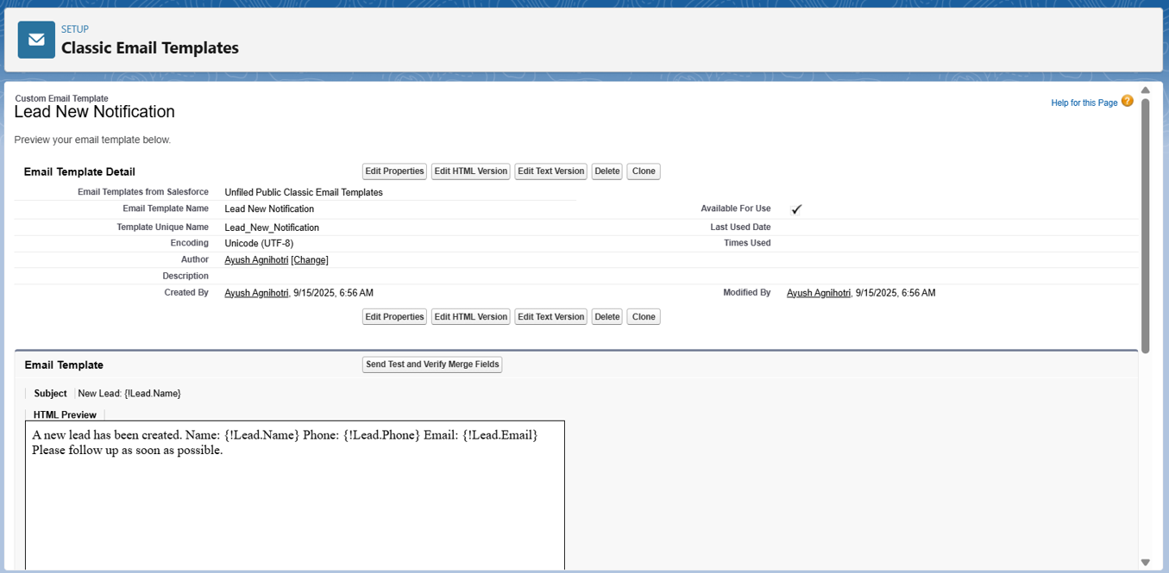  
  
Created New Lead Email Alert using the template.

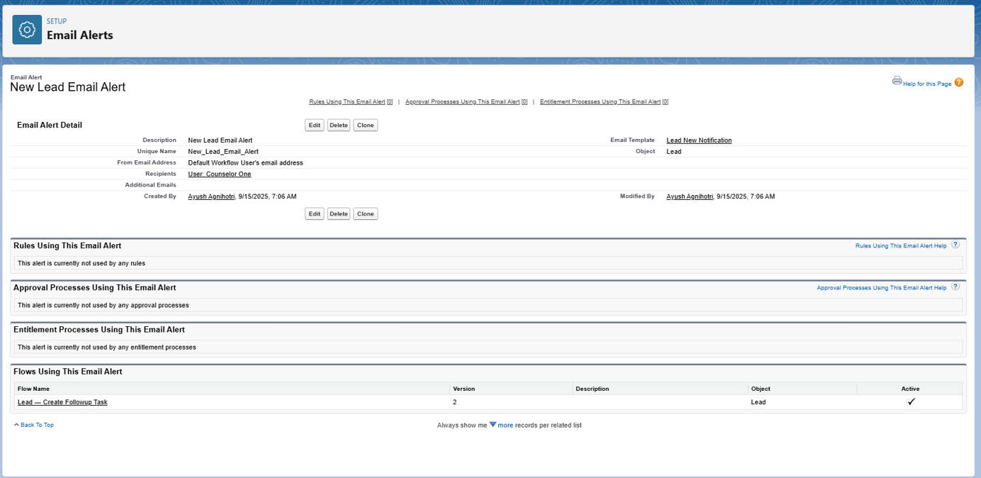  
Connected via Workflow Rule and Flow.  
  
Result: Lead Owner gets instant email when a new lead is created.

## 7) Field Updates

Use: Auto-update record fields.  
Implementation in Project:  
  
Example Workflow Field Update: When Enrollment is Approved, set Status = Confirmed.  
  
Result: Saves time, ensures consistent data.

## 8) Tasks

Use: Assign work automatically to users.  
Implementation in Project:  
  
Flow creates a Follow-up Task for counselor whenever a Lead is created.  
  
Task Fields:  
  
Subject = “Follow up: {Lead Name}”  
Due Date = Next Day  
Owner = Lead Owner  
  
Result: Counselors never miss a follow-up.

## 9) Custom Notifications

Use: Send in-app and push notifications instead of email.  
Implementation in Project:  
  
Configured a Custom Notification Type for “New Lead Alert”.  
  
Flow Action: Send custom notification to Counselor on new Lead creation.  
  
Result: Real-time alerts inside Salesforce (and mobile app).

## Overall Result:

Phase 4 ensures smooth automation of student lead management. Counselors are guided by system-generated tasks and notifications, managers approve critical requests, and duplicate or incomplete data is prevented.