National Public School Koramangala

Computer Science

Project Report

Airline Reservation System (AIRS)

*By: Ayush Agrawal*

*Rajat Agarwal*

*Pavan Bykampadi*

# Index

Introduction

Algorithm

Flow Charts

Source Code

Screenshots

Acknowledgement

# Introduction

The Airline Reservation System (AIRS) is an interface for users and airlines to interact and connect to each other. It makes it convenient for both airlines and consumers to discover each other, providing a single platform for users to book flights across airlines. As a result, it is a one-stop program for a consumers who wish to book air travel tickets to and from their favorite destinations. Moreover, it also helps airlines manage their flight logistics and schedules across destinations.

Consumers can search for flights to and from their required destinations, getting instant results. They can then pick and choose which flight they want to book, enter the number of seats, fill in their payment details and complete their booking. If they wish to, they can view or cancel it at a later date.

Similarly, airlines can list their flights on to the platform, making it available for consumers to book. They can also view their old listings, and delete them if they wish. Thus, it is a convenient platform for them to work on.

# Algorithm:

***General Algorithm:***

1. Start
2. Enter login details
3. Go to user or admin menu based on login details
4. Check if user wants to log out
5. If yes, stop
6. If no, go to step 4

***User:***

1. Start
2. Menu displayed: book flights, view current bookings, exit.
3. If user chooses book flight
   1. Input search criteria
   2. Display results
   3. Confirm, book and pay
4. If user chooses view booking status
   1. Displays current bookings
   2. If user wants to cancel booking, booking is cancelled
   3. If user wants to exit cancellation menu, program returns to step 2
5. If user wants to exit program, program stops

***Algorithm if admin:***

1. Start
2. Menu displayed: Add flight, delete flight, display all flights, logout.
3. If admin chooses to add flight
   1. Flight details are input
   2. A resulting flight is created
4. If admin chooses to delete flight
   1. All flights are displayed
   2. Serial number of flight to be deleted is taken as an input
   3. Corresponding flight is deleted
5. If admin wants to logout, program stops

# Flow Charts:

*General Flow:*

**Enter log in credentials**

**User or Admin**

**User menu and functions**

**Admin menu and functions**

**Log out?**

**START**

**STOP**

User

Admin

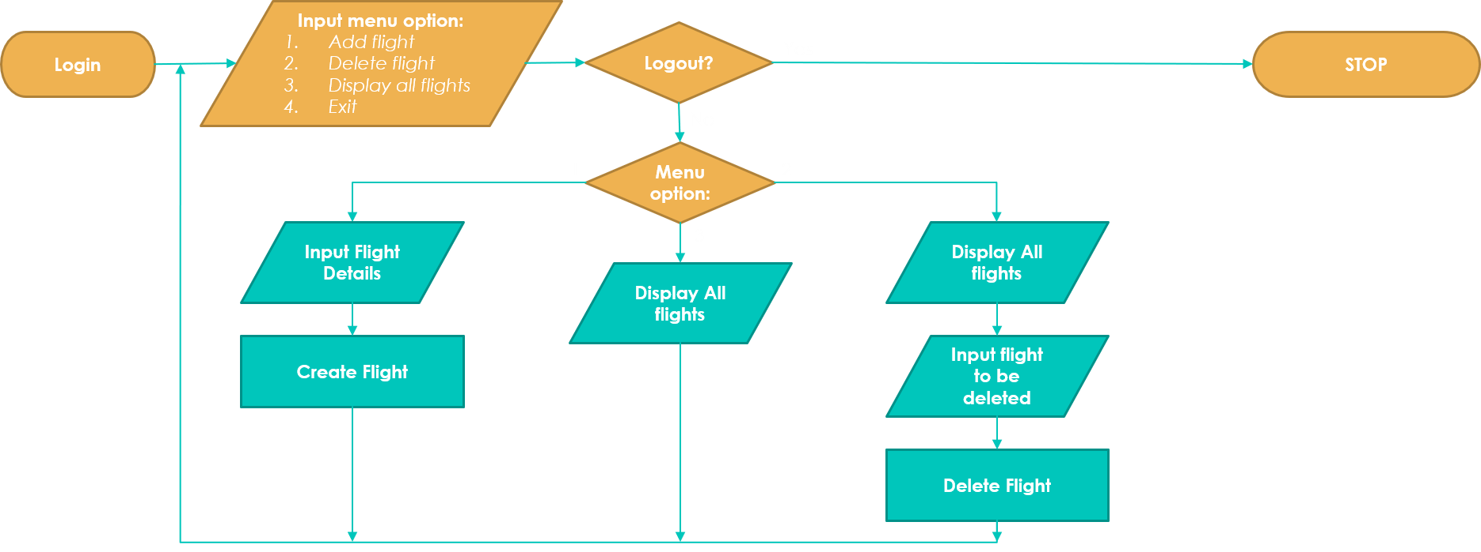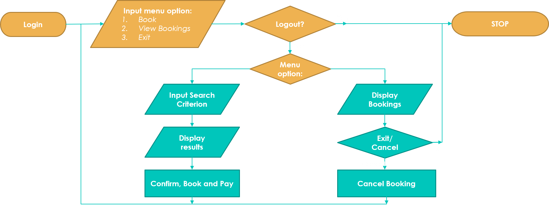*User Flow*

*Admin Flow*

# Screen-shots:

# 

# Acknowledgements:

We would like to thank our Computer Science teachers Chandita Ma’am and Kavitha Ma’am for giving us the opportunity to work on this project and showcase our talents. The project would not have been possible without their continued guidance and support.