Beyond Keyword Matching: A Three-Layer, Evidence-Weighted ATS Scorer for Job Seekers with a Reproducible Audit
Ayush Anand
Guide: Dr. Heena Kalim
Department of Computer Science and Engineering
Manipal University Jaipur, Jaipur, Rajasthan, India
ayushanandchoudhary543@gmail.com

Abstract—Applicant tracking systems (ATSs) sit between almost every job seeker and a human recruiter, yet candidates cannot see how their resumes are parsed, matched, or ranked. This paper presents ResumeMatch, an open-source, candidate-facing ATS simulator. It scores a resume against a job description (JD) with a deterministic layer of 14 structure and formatting checks and a skill layer that combines exact, alias, and MiniLM sentence-embedding matches, and it explains every point it awards. We then audit the scorer on 1,759 labelled resume–JD pairs using tie-aware ranking metrics, leakage-free distractors, within-JD AUC, and stronger lexical (BM25) and dense (BGE-small) baselines. Skill-based scores agree only weakly with the fit labels (pooled AUC 0.552, within-JD 0.610). The hybrid appears to improve Hit@1 by about 21% over keyword-only matching when ties are counted as misses, but the gain disappears once ties are broken fairly (MRR 0.436 vs. 0.432). A whole-document BGE-small embedding is the strongest signal (AUC 0.625, within-JD 0.727, MRR 0.486). Embedding-based skill matching adds only 11.4% of matches at the deployed threshold, and appending the JD’s skill list to a No-Fit resume raises the deployed score from 37.3 to 86.8. We propose evidence-weighted credit (EWC), which withholds credit from skills that appear only in lists or templated sentences. With full discounting, EWC removes the score inflation caused by pasted skill lists and cuts that of templated skill sentences by about 90%, at a cost of 0.035 MRR on clean data. We then implement these findings in ResumeMatch v2, which adds a chunked whole-document BGE-small layer, evidence-weighted credit, a direction-aware semantic blocklist, and a corrected fallback rule. On the same data, v2 raises pooled ROC-AUC from 0.542 to 0.610, within-JD AUC from 0.626 to 0.699, and MRR from 0.443 to 0.490, and it cuts the score gained by pasting a JD skill list into a No-Fit resume from +49.1 to +16.6 points (mean 86.8 to 56.4). We close with design recommendations for transparent resume feedback that is harder to game.
Index Terms—applicant tracking system, resume screening, person–job fit, semantic similarity, Sentence-BERT, keyword stuffing, explainable AI, algorithmic hiring
I. Introduction
Automated screening now mediates most applications to large employers. Jobscan’s 2026 audit detected an applicant tracking system on the career sites of 487 of the Fortune 500 companies (97.4%), a share that has stayed between 97% and 99% since 2018; Workday alone serves more than 40% of them [1]. In the Harvard Business School and Accenture “Hidden Workers” survey, more than 90% of employers that used a recruiting management system relied on it to filter or rank candidates initially, and 88% agreed that qualified high-skills applicants were screened out because they did not match the exact criteria in a job description [2].
Screening is also moving from keyword filters to learned scores. Workday’s HiredScore module, for example, grades each applicant from A to D according to how well the resume matches the required and preferred qualifications of the posting [3]. This shift has drawn legal scrutiny: a U.S. federal court allowed an age-discrimination claim against Workday’s screening tools to proceed as a nationwide collective action [4]; New York City requires bias audits of automated employment decision tools, although a state audit found its enforcement weak [5]; and the EU AI Act classifies AI used for recruitment as high-risk, with obligations now due from December 2027 [6], [7].
For the candidate, the problem is opacity. A resume can fail because the parser cannot read a two-column layout, because a section is titled “Work History” rather than “Experience,” or because the candidate wrote “ML” where the posting says “machine learning.” Commercial resume checkers report a match rate but do not publish how it is computed [8], and most academic matching systems are built for recruiters and evaluated on small or synthetic test sets [9]–[11]. A candidate-facing tool must also face a problem recruiter tools can ignore: whatever it rewards, users will learn to produce. If it rewards literal keyword overlap, it teaches keyword stuffing.
This paper describes ResumeMatch [12], a candidate-facing ATS scorer we built to make these mechanics visible, and audits it as critically as we would audit someone else’s system. We ask four research questions:
- RQ1. How well do the scorer’s components agree with human fit labels, compared with standard lexical and dense retrieval baselines?
- RQ2. Does combining structure, keyword, and semantic signals help rank the resume that actually fits a JD above other resumes?
- RQ3. How much does embedding-based skill matching add beyond exact and alias matching, and how accurate are the matches it adds?
- RQ4. How easily can the scores be inflated by keyword stuffing, and can a simple evidence rule prevent that without hurting accuracy?
- RQ5. Do the changes suggested by the audit improve the deployed system on the same data?
Our contributions are:
- An open, deterministic, explainable scorer that runs offline on a CPU with a 22M-parameter encoder and reports per-check reasons, a keyword placement map, skill gaps, and ranked fixes, with an optional large language model (LLM) rewriter whose output is re-scored.
- A reproducible audit protocol for candidate-facing scorers: pooled and within-JD AUC, tie-aware ranking with leakage-free distractors, threshold analysis with manual inspection of semantic matches, and four keyword-stuffing attacks.
- Negative and corrective findings, including a ranking gain that was an artifact of tie handling, a fallback rule that inflates scores when no JD skills are extracted, and low precision of embedding-only skill matches.
- Evidence-weighted credit (EWC), a lightweight rule that withholds credit from skills supported only by list-like or templated text, evaluated against non-adaptive and adaptive stuffing.
- ResumeMatch v2, the deployed result of the audit: a three-layer score (20% structure, 40% evidence-weighted skills, 40% whole-document context), JD requirement checks, writing-quality checks, and a stuffing warning, with measured gains over v1 on the same 1,759 pairs.
Section II explains how industry ATSs screen resumes, and Section III reviews the research literature. Section IV describes ResumeMatch, Section V the experimental setup, and Section VI the results. Section VII discusses implications, limitations, and ethics, and Section VIII concludes. Section IV-G describes ResumeMatch v2 and Section VI-E evaluates it.
II. Background: How Industry ATSs Screen Resumes
A. The Screening Pipeline
An ATS is a workflow system for requisitions, applications, and communication; screening is one stage within it. A typical application passes through four steps: (i) capture, where the candidate uploads a file and answers form questions; (ii) parsing, where the file is converted into structured fields such as contact details, employers, dates, education, and skills; (iii) screening, where knock-out rules, searches, or scores order or filter the pool; and (iv) human review of the shortlist. The market is concentrated. Among Fortune 500 companies Workday leads with more than 40% and SAP SuccessFactors follows with about 12%, while across more than 13,000 companies of all sizes Greenhouse (19.0%), Workday (17.5%), Lever (15.6%), and iCIMS (14.4%) lead [1].
B. Parsing and Skill Taxonomies
Parsing errors propagate to every later step. Multi-column layouts, text inside tables, headers and footers, icons, and images are the usual sources of loss, because extraction tools read text in an order that does not match the visual layout. After parsing, skills are normalized against a taxonomy. Public examples include the European ESCO classification, with 13,939 skills and 3,039 occupations in 28 languages [13], and commercial taxonomies such as Lightcast’s, which lists more than 34,000 skills and is updated monthly [14]. As Section VI shows, taxonomy coverage bounds what any skill-based scorer can see.
C. Matching Mechanisms
Table I summarizes the mechanisms candidates face. Knock-out questions on work authorization, licences, or location are the most common automatic filter; in a small interview study by a resume-tool vendor, all 25 recruiters used them, while 23 said their ATS did not auto-reject on resume content [15]. That study is small and commercially motivated, so it shows that practice varies rather than that keyword screening is a myth. Recruiter keyword search remains common and can be strict: Jobscan reports that Taleo’s Boolean search does not match “project manager” to “project management” or an acronym to its expansion, and that Taleo workflows can reject candidates automatically on knock-out criteria or a low score [16]. Newer modules score structured fields with machine learning (Oracle’s 0–3 star ratings for profile, education, experience, and skills [16]) or grade candidates against the posting’s qualifications (Workday HiredScore’s A–D grades [3]). On the candidate side, Jobscan computes a match rate that weights hard skills most heavily and recommends at least 75% [8].
TABLE I
Screening mechanisms candidates face
Mechanism | Example | Reads | Candidate lever
Knock-out questions | Recruiter-set eligibility questions [15], [16] | Form answers | Answer accurately; not resume text
Keyword / Boolean search | Taleo recruiter search [16] | Parsed text; exact terms | Mirror JD wording; give acronym and expansion
Field-level ML match | Oracle 0–3 star criteria [16] | Parsed fields | Parseable layout, standard headers
Qualification grading | Workday HiredScore A–D [3] | Resume vs. required and preferred qualifications | Visible evidence for each requirement
Candidate match rate | Jobscan, ≥ 75% advised [8] | Resume vs. JD keywords | Keyword coverage, hard skills first

D. Regulation and Accountability
Regulators increasingly treat screening tools as consequential decisions. New York City’s Local Law 144 requires an annual independent bias audit, a public summary of results, and notice to candidates; a December 2025 audit by the State Comptroller found that the city identified one likely violation among 32 employers reviewed where auditors found 17 potential ones [5]. The EU AI Act lists recruitment and candidate evaluation among high-risk uses [6], and the 2026 Digital Omnibus moved those obligations to 2 December 2027 [7]. In India, where this work was done, resumes are personal data under the Digital Personal Data Protection Act, 2023, operationalized by rules notified in November 2025 with phased implementation [17]. These rules govern employers and vendors rather than candidates, but they raise the bar for transparency and data minimization that a candidate-facing tool should meet as well.
III. Related Work
A. Lexical Retrieval
Classical screening treats resumes and JDs as bags of words and ranks them by TF-IDF cosine similarity [18] or by the probabilistic BM25 function [19]. Lexical methods are fast, transparent, and hard to beat on exact technical terms, but they miss paraphrases (“built statistical models” versus “machine learning”) and reward repetition, which makes them easy to game.
B. Learned Person–Job Fit
Person–job fit research learns matching functions from historical hiring outcomes. PJFNN encodes resumes and JDs with convolutional networks trained on recruiter decisions [20], and APJFNN adds attention over individual requirements to identify which abilities a candidate satisfies [21]. ConFit addresses sparse interaction data with paraphrase-based augmentation and contrastive learning, improving nDCG@10 by up to 31 points over baselines that include BM25 [22]. Surveys organize the field around challenges such as data sparsity, two-sided preferences, and fairness [23], [24]. All of these models require large proprietary interaction logs, which an individual job seeker does not have, and their scores are not designed to be explained to candidates.
C. Resume Parsing and Skill Extraction
Resume parsing has moved from rules to neural sequence labelling [25]. Skill extraction from job postings is now a research area with its own datasets: SkillSpan annotates more than 12,500 hard- and soft-skill spans in English postings [26], and a 2024 survey maps the methods, datasets, and taxonomies used for skill extraction and classification [27]. A recurring finding is that skills are expressed as long, varied spans that dictionary lookup misses, which matches the coverage gap we measure in Section VI.
D. Sentence Embeddings
Sentence-BERT made it practical to compare texts by the cosine similarity of pooled transformer embeddings [28], and MiniLM distillation made such encoders small enough for CPU use [29]. The MTEB benchmark showed that no single embedding model dominates across tasks [30], and newer general-purpose models such as BGE were trained with large contrastive corpora and instructions [31]. In recruitment, conSultantBERT fine-tuned SBERT on more than 270,000 consultant-labelled resume–vacancy pairs [32], and a 2025 thesis found SBERT ahead of TF-IDF on MRR and nDCG in a candidate-centric job recommender, at higher latency [33].
E. Hybrid and Explainable Screening Tools
Several recent systems combine lexical and semantic signals. ResumeMatch Pro AI scores MiniLM document similarity, lists matched and missing skills, and is demonstrated on two role scenarios [9]. A government-hiring framework fuses TF-IDF and SBERT scores, typically weighting the semantic part at 65% [10]. Others pair SBERT with section-wise skill analysis and an identity-removal fairness check [34], combine SBERT, DeBERTa, and Jaccard skill overlap [35], or build an explainable extraction-and-matching pipeline [36]. A simulation study argues that keyword screening causes excess false-negative rejections that semantic matching reduces [11]. Table II compares these systems with ours. Two gaps stand out: almost all target the recruiter, and none tests whether its score can be inflated by stuffing, which is exactly the behaviour a candidate-facing tool may encourage.
TABLE II
Comparison with related resume–JD matching systems
System | User | Signals | Fmt. | Expl. | Evaluation | Stuff.
PJFNN / APJFNN [20], [21] | Recr. | Learned | – | Partial | Proprietary logs | –
ConFit [22] | Both | Learned, contrastive | – | – | Two real datasets | –
conSultantBERT [32] | Recr. | Fine-tuned SBERT | – | – | 270k labelled pairs | –
ResumeMatch Pro AI [9] | Recr. | MiniLM doc. + skills | – | Yes | Two cases | –
Hussain et al. [10] | Recr. | TF-IDF + SBERT | – | Partial | 1,000 unlabelled pairs | –
Tayade et al. [34] | Recr. | SBERT + skills | – | Yes | Comparative tests | –
Bala & Quadhari [35] | Recr. | SBERT, DeBERTa, Jaccard | – | – | Test cases | –
Smart-Hiring [36] | Recr. | NER + embeddings | – | Yes | Real CVs | –
Jobscan [8] | Cand. | Keywords | Yes | Partial | Not published | –
ResumeMatch (ours) | Cand. | Exact, alias, MiniLM | 14 checks | Yes | 1,759 labelled pairs | Yes
Recr. = recruiter-facing; Cand. = candidate-facing; Fmt. = formatting/parseability checks; Expl. = explanations to the user; Stuff. = robustness to keyword stuffing tested. Entries summarize what each paper reports; “–” means not reported.
F. LLM Screening, Bias, and Manipulation
LLMs are now used directly for screening; one framework classifies, grades, and summarizes resumes 11 times faster than manual review [37]. Audits show why caution is needed. Bias in hiring predates AI: a field experiment found that resumes with White-sounding names received 50% more callbacks than identical resumes with Black-sounding names [38], and Amazon abandoned an experimental recruiting model that penalized resumes mentioning women’s organizations [39]. Embedding-based retrieval favoured White-associated names in 85.1% of tests and female-associated names in only 11.1% [40]. GPT scoring of about 361,000 resumes gave lower scores to Black male candidates with comparable qualifications [41], and GPT-3.5 reproduced occupational stereotypes in both scoring and resume generation [42]. Vendors’ bias-mitigation claims are often hard to verify [43]. Manipulation is the other risk. Resumes can hide instructions in white or zero-size text: an analysis of about 200,000 real resumes found that roughly 1% contained hidden prompt injections, a share that is rising [44]. Injection success varies widely across models and prompting defences [45], and separating candidate content from trusted instructions is an effective architectural defence [46]. Keyword stuffing is the pre-LLM version of the same problem, and it is the attack our scorer must withstand.
IV. System Design
Fig. 1 shows the pipeline of the deployed system (v2). Sections IV-A to IV-F describe the original design and the EWC rule that the audit motivated; Section IV-G describes how v2 combines them. ResumeMatch separates scoring from content generation: parsing, structuring, and all scoring layers are deterministic and local, the LLM rewriter is opt-in, and documents are rendered from templates. The front end is a Next.js 14 application over a FastAPI service.
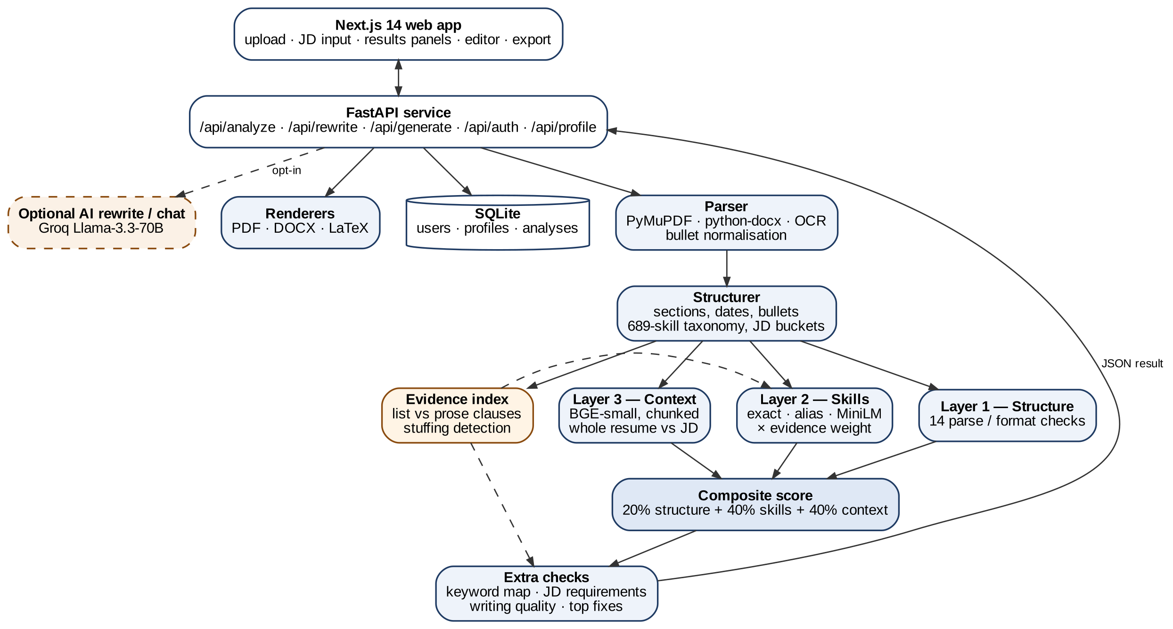
Fig. 1. ResumeMatch v2 architecture. Solid boxes run locally and deterministically. The evidence index feeds Layer 2 and the stuffing warnings, Layer 3 reads the whole resume and JD, and the composite combines the three layers. The dashed rewriter is opt-in, and its output passes through the same pipeline so the user sees a before/after score.
A. Parsing and Structuring
PDFs are read with PyMuPDF, which reorders text blocks column by column so that a sidebar’s “Skills” header stays next to its content. DOCX files are read with python-docx, and scanned PDFs fall back to Tesseract OCR when the extracted text fails a quality check. A rule-based structurer then detects section headers, contact fields, experience entries, bullets, and date ranges, and estimates total experience by merging overlapping date intervals. Skills are found by word-boundary matching against a curated taxonomy of 653 skills (689 in v2), with stricter boundaries for ambiguous short names such as C, R, and Go. For a JD, the structurer strips leading company boilerplate, assigns skills to required or preferred using section cues (“nice to have,” “preferred”) and keyword proximity, extracts the minimum years of experience, and drops context-dependent false positives such as the verbs “go” and “make” when no technical context is present.
B. Layer 1: Structure and Formatting
Layer 1 implements the parseability advice that ATS vendors and career services give (Section II-B) as 14 weighted checks (Table III). Continuous signals are graded rather than pass/fail, so a resume with half of its bullets quantified earns half the weight. The Layer 1 score is the weighted fraction earned:
S₁ = 100 · Σ_{i} w_{i} f_{i} / Σ_{i} w_{i} (1)
where w_{i} is the weight of check i and f_{i} ∈ [0, 1] is the fraction achieved. Parse quality is graded linearly between an alphanumeric ratio of 0.50 and 0.85, and skills breadth reaches full credit at ten skills. Every check returns a human-readable reason, and failed checks become ranked “top fixes.”
TABLE III
Layer 1 checks and weights
Check | Weight | Type
Contact email | 10 | Binary
Phone or LinkedIn/GitHub link | 5 | Binary
Core sections (Experience, Education, Skills) | 20 | Binary
Summary or Projects section | 5 | Binary
Length 100–1,200 words | 15 | Binary
Parse quality (alphanumeric ratio) | 15 | Graded
Quantified bullets | 15 | Graded
Skills breadth | 15 | Graded
Single-column layout | 10 | Binary
No table-based layout | 8 | Binary
Standard section headers | 10 | Binary
Consistent date formats | 7 | Binary
“Present” for ongoing roles | 5 | Binary
Decorative symbols < 2% of characters | 5 | Binary

C. Keyword Map
To mirror literal ATS search (Section II-C), each JD skill k is searched in the resume with word-boundary regular expressions. An exact match earns m(k) = 1.0, a match through a curated alias group (for example “ML” and “machine learning,” or “K8s” and “Kubernetes”) earns 0.8, and no match earns 0. Required skills carry weight ω_{k} = 2 and preferred skills ω_{k} = 1:
K = 100 · Σ_{k} ω_{k} m(k) / Σ_{k} ω_{k} (2)
The module also records where each keyword appears (summary, skills, or experience) and warns when a keyword occurs four or more times, following the common advice of one to three natural uses. K is displayed to the user but, in the deployed version, does not enter the composite score.
D. Layer 2: Semantic Skill Matching
Layer 2 embeds every JD skill s and every resume skill r, expanded with its aliases, using all-MiniLM-L6-v2 [28], [29]. A JD skill counts as matched when its best cosine similarity reaches a threshold τ = 0.6:
match(s) = 1[ max_{r} cos(e(s), e(r)) ≥ τ ] (3)
S₂ is the required/preferred-weighted share of matched JD skills, defined like (2) with binary credit. If the JD yields no extractable skills, Layer 2 is reported as not applicable. Layer 2 also notes an experience gap when the resume’s estimated years fall below the JD minimum.
E. Composite Score, Rewriting, and Rendering
With a JD that yields skills, the core score is S = 0.35 S₁ + 0.65 S₂. Otherwise S = S₁, so the tool still works as a general ATS hygiene check. The optional rewriter sends one request to Llama-3.3-70B through the Groq API with hard rules that forbid inventing metrics, employers, dates, titles, or credentials, and asks it to mirror JD terminology only where truthful and to write acronyms with their expansions. The returned JSON passes through the full pipeline, so the user sees a score delta and a change log before exporting. Resumes are rendered to PDF (WeasyPrint), DOCX, or LaTeX from single-column templates. The system also offers user accounts (PBKDF2 password hashing and JWT sessions in SQLite), a reusable master profile for one-click tailoring, and optional Langfuse tracing of LLM calls.
F. Evidence-Weighted Credit
Both K and S₂ give full credit for a skill wherever it appears, so a pasted skill list earns as much as a skill demonstrated in a project. EWC changes only the credit for each matched skill. The resume text is cut into clauses at sentence ends, line breaks, and bullet symbols. A clause is list-like when its comma-, semicolon-, slash-, or pipe-separated items have a median length of at most 3 tokens (e.g., “Python, SQL, Power BI”). To block the obvious workaround of one templated sentence per skill, a clause is also treated as list-like when, once skill mentions are masked, it is identical to another clause that names different skills (e.g., “Built features using Python.” and “Built features using SQL.”); exact duplicate bullets are exempt. Any mention outside list-like clauses is prose evidence. A matched skill s then receives an evidence factor
v(s) = 1 if s has prose evidence, else λ (4)
and its contribution to (2) or to S₂ is multiplied by v(s). With λ = 1 EWC reproduces the deployed scores exactly (verified on all 1,759 pairs). Smaller λ rewards skills that are demonstrated in sentences over skills that are only listed. EWC needs no model and no training data, and it can explain itself (“SQL appears only in your skills list”).
G. ResumeMatch v2: Applying the Audit
Version 2 adopts the changes that the audit in Section VI supports. (i) Layer 3, contextual fit. The resume is split into overlapping chunks of 180 words (step 150) so that nothing is truncated, each chunk and the JD are embedded with BGE-small-en-v1.5 [31], the chunk vectors are mean-pooled, and the cosine similarity c with the JD vector is mapped to a score by a fixed linear calibration:
S₃ = 100 · clip((c − 0.60) / (0.80 − 0.60), 0, 1) (5)
The calibration points are the 5th and 95th percentiles of c on the public test split. (ii) Evidence-weighted Layer 2. Matched skills are weighted by EWC with λ = 0.5, so that skills that are only listed keep half credit and are shown as “listed only” with a prompt to add a bullet that uses them. We chose λ = 0.5 rather than 0 because λ = 0 lowered within-JD AUC on clean resumes (Section VI-D), and Layer 3 supplies a second, independent check on content. A warning is raised when one list holds at least 70% of the JD’s skills and at least 70% of those appear nowhere else. (iii) Direction-aware semantic matching. Embedding-only matches receive 0.75 credit, and a blocklist removes the false equivalences found by the manual audit (for example CSS and HTML, or “Machine Learning” for “Deep Learning”). (iv) Fallback fix. When a JD yields no skills, the composite is 0.4 S₁ + 0.6 S₃ instead of silently reusing S₁. The v2 composite is therefore
S = 0.20 S₁ + 0.40 S₂* + 0.40 S₃ (6)
where S₂* is the evidence-weighted skill score, and it falls back to the v1 weights (0.35, 0.65) only when the contextual model is disabled for low-memory hosts. Without a JD, S = S₁. (v) Searchability and writing checks. Because commercial scanners also test whether the exact job title, the degree level, the years of experience, and acronyms in both forms are present, v2 reports these as JD requirement checks. A separate writing-quality panel scores action verbs, weak duty phrases, first-person pronouns, clichés, and bullet length; it is shown to the user but does not enter the ATS score. (vi) Parser fixes. Word-exported PDFs encode bullets as private-use glyphs (U+F0B7) that earlier versions did not recognise, so most such resumes showed no bullets; v2 normalises bullet glyphs, joins wrapped lines, and handles DOCX list paragraphs, Indian mobile numbers, and letter-spaced names.
V. Experimental Setup
A. Dataset
We use the test split of the public resume-job-description-fit dataset [47]: 1,759 resume–JD pairs labelled No Fit (857), Potential Fit (444), or Good Fit (458). The split contains 477 unique resumes and 71 unique JDs, and its JDs do not overlap with the training split. The repository has no dataset card, so the labelling procedure and inter-annotator agreement are unknown. Resume text in the dataset has most line breaks removed (median four newlines per resume) and a median length of 618 words. This affects the line-based structurer: it detected an Experience section in only about 1% of resumes, which depresses Layer 1 and limits skill extraction relative to real uploads.
B. Methods Compared
We score each pair with Layer 1 (S₁), the keyword map (K), Layer 2 (S₂), the deployed core (S), and an equal-weight K + S₂ combination, all using the unmodified repository code. Baselines that ignore skill extraction are TF-IDF cosine (English stop words, sublinear term frequency) [18], [48], BM25 (Okapi, used for ranking only because its scores are not comparable across queries) [19], whole-document all-MiniLM-L6-v2 cosine (input truncated at 256 word pieces), and whole-document BGE-small-en-v1.5 cosine (truncated at 512 tokens) [31]. Fusions average a skill score rescaled to [0, 1] with a document cosine. EWC is evaluated for λ ∈ {0.5, 0.25, 0}.
C. Protocols and Metrics
- E1 – label agreement (RQ1). Spearman ρ with the ordinal label; ROC-AUC for Good vs. No Fit and for Fit (Good or Potential) vs. No Fit with 1,000-sample bootstrap 95% confidence intervals [49]; and within-JD AUC, the mean AUC over the 61 JDs that have both classes. Within-JD AUC removes differences in score scale between JDs and matches how a recruiter ranks applicants for one posting.
- E2 – ranking (RQ2). For each of the 430 Good-Fit pairs whose JD yields skills, the true resume is ranked against nine distractors drawn from resumes that are not identical to it and are not labelled Fit for that JD. Because keyword scores tie often, we report the expected Hit@1, Hit@3, and MRR under uniformly random tie-breaking, averaged over five seeds; confidence intervals resample queries. Random ranking gives 0.100, 0.300, and 0.293.
- E3 – semantic contribution (RQ3). For every JD skill we record whether it is matched exactly or by alias, only by embedding, or not at all, for τ ∈ {0.5, 0.55, 0.6, 0.65, 0.7, 0.8}. We also manually classified every distinct embedding-only pair at τ = 0.6.
- E4 – stuffing (RQ4). For 200 random No-Fit pairs whose JD yields skills, we add the JD’s extracted skill list to the resume: appended once (A1), appended five times (A5), prepended once (P1), or appended as one templated sentence per skill (T1, “Built production features using s.”). We report the share of resumes whose score reaches the median score of all Good-Fit pairs under the same method, and the mean score change in units of that method’s standard deviation.
- E5 – latency. Parsing, structuring, and scoring time on 200 random pairs with an empty embedding cache.
- E6 – v1 versus v2 (RQ5). The released script evaluate_dataset.py re-implements the v1 formula and scores all 1,759 pairs with both versions using the final code: pooled and within-JD ROC-AUC (Fit vs. No Fit), the 1-of-10 ranking protocol of E2 (430 queries), and the A1 stuffing attack on 200 No-Fit resumes against the median Good-Fit score of each version.
All experiments ran on a 2-vCPU cloud machine without a GPU, using Python 3.13, sentence-transformers, scikit-learn, and rank-bm25. The evaluation scripts and per-pair scores are released with the paper.
VI. Results
A. RQ1: Agreement with Fit Labels
Table IV and Fig. 2 show that every score is only weakly aligned with the dataset labels. Layer 1 is at chance (pooled AUC 0.508), which is expected because formatting hygiene says nothing about fit. K and S₂ reach about 0.551 and are nearly interchangeable (Pearson r = 0.965). The deployed core is lower (0.540), but not because Layer 1 dilutes it: on the 1,632 pairs whose JD yields skills, the core reaches 0.550, the same as S₂, and varying the Layer 1 weight from 0 to 0.5 leaves AUC unchanged. The drop comes from the fallback rule. For the 127 pairs from 4 JDs with no extractable skills, S falls back to S₁, whose mean (61.9) is far above the typical core score (39.9), so a candidate who pastes such a JD sees an inflated score.
TABLE IV
Agreement with fit labels (n = 1,759)
Method | ρ | AUC Good/No | AUC Fit/No [95% CI] | Within-JD AUC
Layer 1, S₁ | 0.008 | 0.502 | 0.508 [0.481, 0.535] | 0.545
Keyword, K | 0.082 | 0.548 | 0.551 [0.526, 0.576] | 0.608
Layer 2, S₂ | 0.081 | 0.548 | 0.552 [0.526, 0.578] | 0.610
K + S₂ (equal) | 0.084 | 0.550 | 0.553 [0.529, 0.578] | 0.610
Deployed core, S | 0.052 | 0.527 | 0.540 [0.514, 0.567] | 0.627
TF-IDF cosine | 0.114 | 0.572 | 0.569 [0.542, 0.595] | 0.641
MiniLM document | 0.108 | 0.555 | 0.581 [0.554, 0.608] | 0.679
BGE-small document | 0.185 | 0.607 | 0.625 [0.598, 0.649] | 0.727
S₂ + MiniLM document | 0.102 | 0.556 | 0.571 [0.545, 0.596] | 0.667
K, EWC λ = 0.5 | 0.090 | 0.553 | 0.557 [0.531, 0.581] | 0.618
S₂, EWC λ = 0.5 | 0.093 | 0.554 | 0.560 [0.531, 0.585] | 0.620
K, EWC λ = 0 | 0.089 | 0.548 | 0.556 [0.529, 0.580] | 0.599
S₂, EWC λ = 0 | 0.102 | 0.557 | 0.563 [0.537, 0.588] | 0.601
Within-JD AUC is the mean over 61 JDs with both classes. EWC = evidence-weighted credit (Section IV-F).
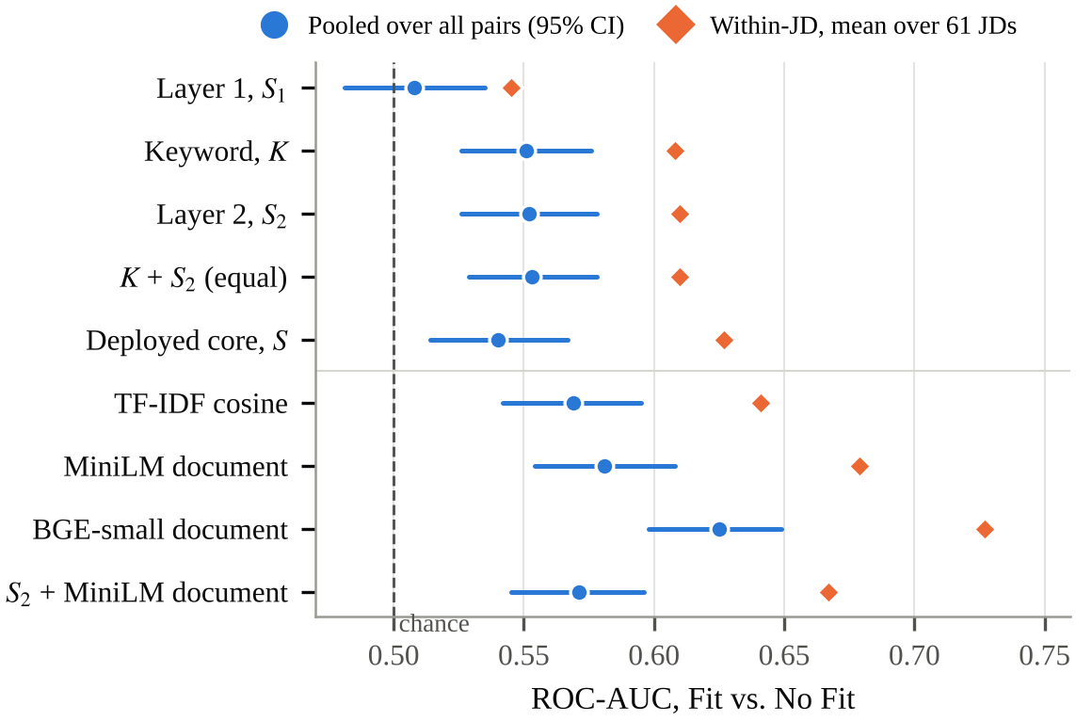
Fig. 2. ROC-AUC for Fit vs. No Fit. Circles are pooled over all pairs with bootstrap 95% confidence intervals; diamonds are within-JD means. The dashed line marks chance (0.5).
Two baselines that ignore skill extraction do better. TF-IDF reaches 0.569 and MiniLM document similarity 0.581, but the clear winner is BGE-small document similarity, with pooled AUC 0.625 [0.598, 0.649] and within-JD AUC 0.727; its interval does not overlap those of the skill-based scores. Within-JD AUC is higher than pooled AUC for every method, by about 0.06 for the skill scores and 0.10 for BGE, which shows that part of the weak pooled agreement reflects score scales that differ between JDs rather than poor ordering of candidates for the same JD. The 629 pairs (35.8%) with S₂ = 0 or not applicable show the coverage limit: the structurer found 6.3 JD skills and 15.9 resume skills per pair on average.
B. RQ2: Ranking the Right Resume
Ranking is closer to how a candidate uses the tool: does the score prefer the resume that actually fits a JD? Table V and Fig. 3 give the answer. Under fair tie-breaking, the deployed core and keyword-only score perform the same (MRR 0.436 vs. 0.432; paired difference +0.004 [−0.007, +0.015]). Our preliminary evaluation reported a 27% Hit@1 gain for the hybrid. That gain came from the evaluation, not the scorer: it counted any tie with a distractor as a miss, and K ties with 2.3 of the nine distractors on average while the core almost never ties, because Layer 1 adds a resume-specific constant. With that convention on our cleaned distractor set, Hit@1 rises from 0.188 for K to 0.228 for the core (+21%), a gain of similar size; with expected tie-breaking the two are equal. Layer 1 alone is close to random (MRR 0.321).
TABLE V
1-of-10 ranking of the true Good-Fit resume (430 queries × 5 seeds)
Method | Hit@1 | Hit@3 | MRR | Tied distractors
Random | 0.100 | 0.300 | 0.293 | 9.00
Layer 1, S₁ | 0.116 | 0.357 | 0.321 | 0.10
Keyword, K | 0.234 | 0.504 | 0.432 | 2.33
Layer 2, S₂ | 0.225 | 0.503 | 0.428 | 2.15
Deployed core, S | 0.229 | 0.523 | 0.436 | 0.06
TF-IDF cosine | 0.228 | 0.486 | 0.425 | 0.00
BM25 | 0.212 | 0.467 | 0.412 | 0.00
MiniLM document | 0.227 | 0.517 | 0.432 | 0.00
BGE-small document | 0.281 | 0.593 | 0.486 | 0.00
S₂ + MiniLM doc. | 0.238 | 0.516 | 0.443 | 0.00
S + MiniLM doc. | 0.241 | 0.527 | 0.447 | 0.00
S₂ + BGE doc. | 0.254 | 0.541 | 0.458 | 0.00
K, EWC λ = 0.5 | 0.229 | 0.503 | 0.430 | 1.94
S₂, EWC λ = 0.5 | 0.220 | 0.496 | 0.423 | 1.73
K, EWC λ = 0 | 0.201 | 0.458 | 0.399 | 3.32
S₂, EWC λ = 0 | 0.193 | 0.453 | 0.393 | 3.10
Expected values under random tie-breaking, averaged over five seeds. MRR 95% CIs (resampling the 430 queries) are about ±0.027; e.g., BGE-small [0.459, 0.515], core [0.410, 0.464].
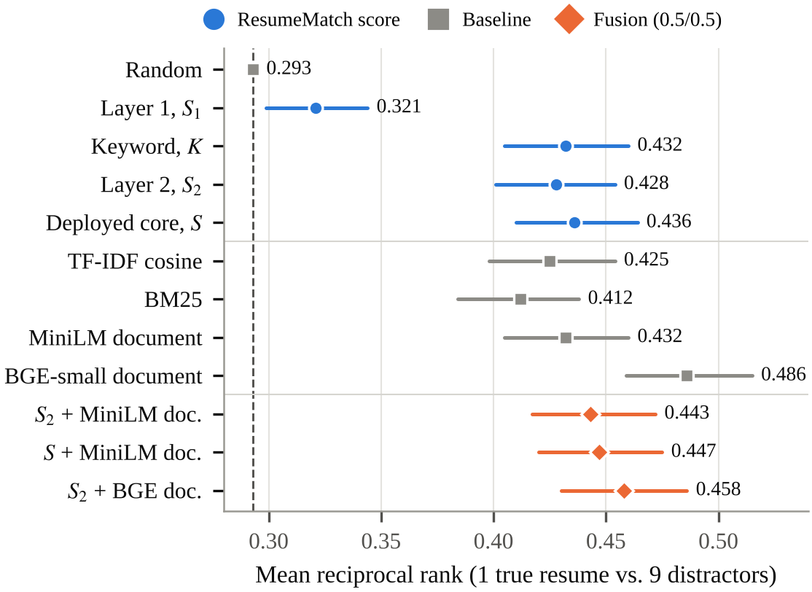
Fig. 3. Mean reciprocal rank of the true Good-Fit resume among ten candidates, with 95% confidence intervals. The dashed line is random ranking.
Document-level signals again help most. BGE-small reaches MRR 0.486 and Hit@1 0.281, ahead of the core by +0.050 [+0.019, +0.080]. Adding MiniLM document similarity to S₂ improves it by +0.015 [+0.004, +0.026], so free-text semantics carries information that the taxonomy-bound skill layer misses. Fusing S₂ with BGE, however, scores below BGE alone (0.458 vs. 0.486; −0.028 [−0.054, −0.002]), so equal-weight fusion with a weak signal can hurt a strong one. BM25 and TF-IDF are close to the skill scores, which is plausible because distractors in this dataset often come from similar technical domains.
C. RQ3: How Much Is Really Semantic?
Across all pairs, 2,330 JD-skill instances were matched exactly or by alias. At the deployed τ = 0.6, embeddings added only 300 more (11.4% of matches), while 7,771 (74.7%) stayed unmatched (Fig. 4). The threshold is sensitive: τ = 0.5 more than doubles semantic matches to 721, and τ = 0.7 nearly eliminates them (39).
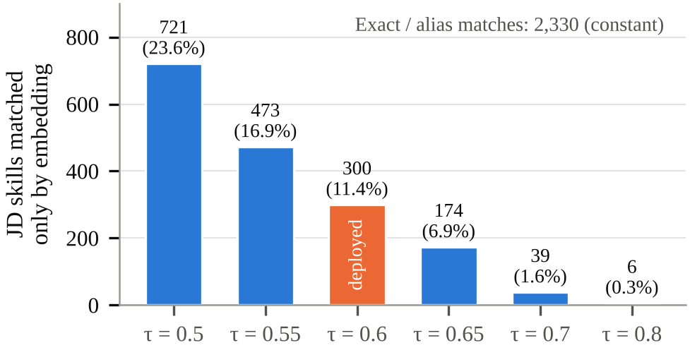
Fig. 4. JD skills matched only through embedding similarity as the threshold τ varies (share of all matches in parentheses). Exact and alias matches are unaffected by τ.
We classified all 39 distinct embedding-only pairs at τ = 0.6 by hand (Table VI). Only 11 were valid, meaning the resume skill is a synonym of the JD skill or implies it (“JavaScript” required, “jQuery” listed). Seven were direction-reversed: the resume shows a broader or neighbouring skill that does not imply the specific one required (“Deep Learning” required, only “Machine Learning” listed). Thirteen were related but not equivalent, and eight were false equivalences, such as “Unit Testing” matched to “Performance Testing” or “CloudWatch” to “google cloud.” Cosine similarity is symmetric, but skill implication is not. At τ = 0.5 errors become more blatant, e.g., “C++” matched to “Java” and “AWS” to “Salesforce.”
TABLE VI
Manual classification of the distinct embedding-only skill matches at τ = 0.6
Category | Count | Examples (JD skill ~ resume skill, cosine)
Valid (synonym or implied) | 11 | JavaScript ~ jQuery (0.67); SQL ~ MySQL (0.69); Agile ~ Scrum (0.69); Git ~ GitHub (0.76)
Direction-reversed | 7 | Deep Learning ~ Machine Learning (0.69); jQuery ~ JavaScript (0.67); Scrum ~ Agile (0.69)
Related, not equivalent | 13 | Business Analysis ~ Data Analysis (0.68); Linux ~ Unix (0.69); API Design ~ REST API (0.61)
False equivalence | 8 | Unit Testing ~ Performance Testing (0.66); CSS ~ HTML (0.60); System Design ~ Design Systems (0.72)

D. RQ4: Robustness to Keyword Stuffing
Appending the JD’s skill list once to a No-Fit resume raised mean K from 21.5 to 100.0, S₂ from 24.1 to 99.6, and the core from 37.3 to 86.8. Every stuffed resume then scored at or above the median Good-Fit resume, against 45% before stuffing (Table VII, Fig. 5). Five repetitions gave identical scores because matching is set-based; they did trigger density warnings on 100% of resumes, against 28% for a single list. The density check therefore catches crude repetition, but one tidy skills list defeats both layers.
TABLE VII
Share of 200 No-Fit resumes reaching the median Good-Fit score
Method | Clean | A1 | A5 | P1 | T1 | Δ (SD), A1
Keyword, K | 47% | 100% | 100% | 100% | 100% | +3.00
Layer 2, S₂ | 49% | 100% | 100% | 100% | 100% | +2.74
Deployed core, S | 45% | 100% | 100% | 100% | 100% | +2.69
K, EWC λ = 0.5 | 45% | 100% | 100% | 100% | 100% | +1.70
S₂, EWC λ = 0.5 | 44% | 100% | 100% | 100% | 100% | +1.53
K, EWC λ = 0 | 38% | 38% | 38% | 38% | 47% | +0.00
S₂, EWC λ = 0 | 39% | 38% | 38% | 38% | 46% | −0.06
TF-IDF cosine | 42% | 68% | 84% | 68% | 69% | +0.63
MiniLM document | 48% | 48% | 48% | 65% | 48% | +0.00
BGE-small document | 37% | 38% | 38% | 55% | 38% | +0.01
A1/A5 = JD skill list appended once/five times; P1 = prepended once; T1 = one templated sentence per skill appended. Δ = mean score change under A1 in units of the method’s standard deviation over all pairs.
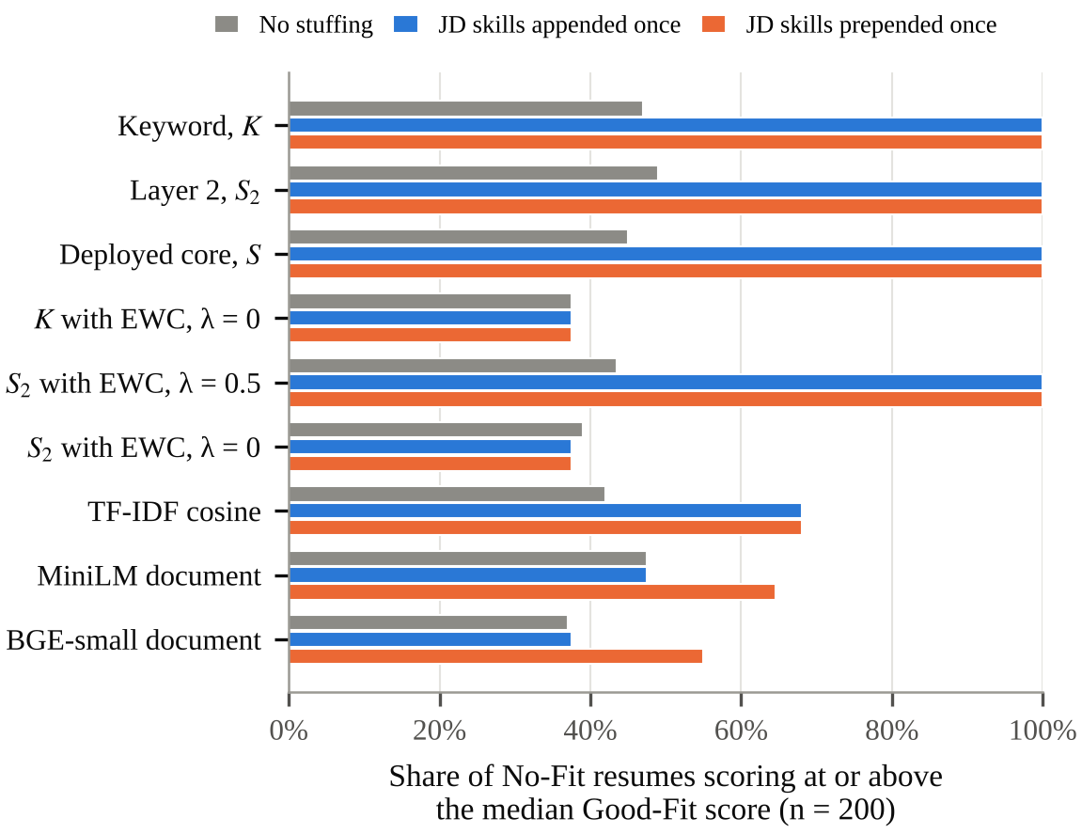
Fig. 5. Share of No-Fit resumes reaching the median Good-Fit score before stuffing, after appending the JD skill list once, and after prepending it once.
The document embeddings look robust to appended lists (MiniLM Δ = 0.00 SD, BGE 0.01 SD), but that robustness is an artifact of truncation: a typical resume exceeds the encoders’ input limits, so appended text is never read. Prepending the same list moves both (MiniLM 48% to 65%, BGE 37% to 55% reaching the Good-Fit median). Prior robustness claims for embedding scorers should therefore state where the attack text was placed. TF-IDF is moderately affected and, unlike the set-based scores, rewards repetition (68% after A1, 84% after A5).
EWC addresses the failure directly (Table VII). With λ = 0.5 the A1 inflation of K falls from 3.0 to 1.7 standard deviations, which still lets every stuffed resume pass. With λ = 0, skills that appear only in lists earn nothing, so the A1, A5, and P1 attacks leave K and S₂ unchanged (pass rate 37.5% before and after). The templated attack T1 keeps a residual gain of 0.29 SD for K, about a tenth of the undefended 3.0 SD, raising the pass rate to 47.0%. The residual comes from cases the template rule cannot see, such as JDs with a single extracted skill, which yield a single sentence. On clean data, λ = 0.5 slightly raises pooled AUC (0.560 vs. 0.552 for S₂) with no significant change in MRR (−0.004 [−0.013, +0.004]). λ = 0 keeps pooled AUC (0.563) but lowers within-JD AUC to 0.601 and MRR by −0.035 [−0.055, −0.015], because genuine candidates whose skills appear only in a skills section also lose credit. The template rule fired on only 3 of 477 clean resumes. The choice of λ is therefore a policy choice between rewarding listed skills and resisting stuffing; Section VII-D gives our recommendation.
E. RQ5: The Deployed v2
Table VIII and Fig. 6 compare v1 and v2 on the same pairs. Pooled AUC rises from 0.542 to 0.610 and within-JD AUC from 0.626 to 0.699. Ranking improves from MRR 0.443 to 0.490 and from Hit@1 0.243 to 0.292. These gains come mainly from Layer 3: used alone, the chunked BGE score reaches pooled AUC 0.624, within-JD AUC 0.723, and MRR 0.471, while the evidence-weighted skill score alone (0.559, 0.618) is close to the original skill score (0.554, 0.613). The composite is not better than its best part on AUC, but it keeps the explainable skill view and, as shown next, is much harder to inflate.
TABLE VIII
ResumeMatch v1 versus v2 on 1,759 labelled pairs
Metric | v1 | v2
ROC-AUC, Fit vs. No Fit (pooled) | 0.542 | 0.610
ROC-AUC within the same JD | 0.626 | 0.699
MRR, true resume among 10 | 0.443 | 0.490
Hit@1, true resume among 10 | 0.243 | 0.292
Mean score of No-Fit resumes, before pasting JD skills | 37.7 | 39.8
Mean score after pasting the JD skill list (A1) | 86.8 | 56.4
No-Fit resumes reaching the Good-Fit median, after A1 | 100% | 84%
Ranking values are expected values under random tie-breaking. The v1 values differ slightly from Section VI because the script draws its own distractors and stuffing sample and v2 includes the larger taxonomy (689 skills).
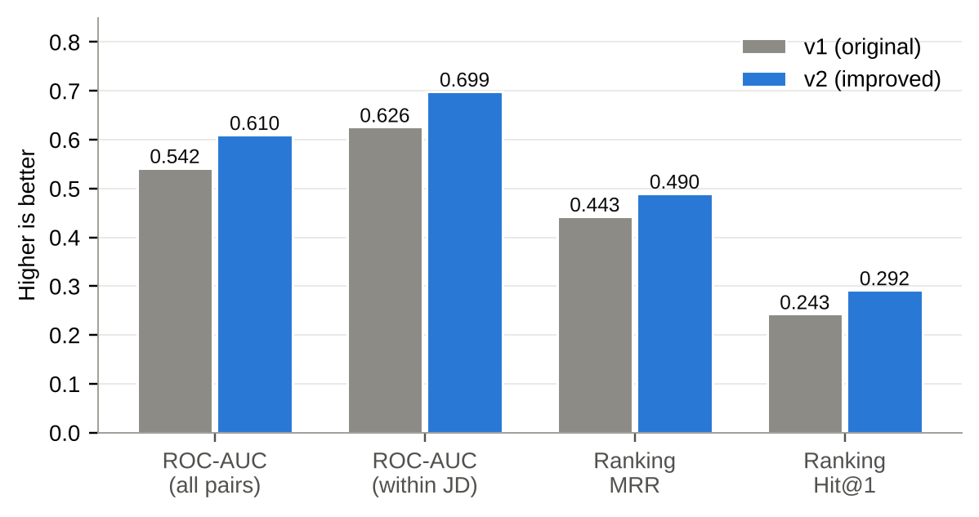
Fig. 6. ResumeMatch v1 versus v2 on 1,759 labelled resume–JD pairs (higher is better). Ranking metrics are expected values under random tie-breaking.
The stuffing result is the clearest change. Pasting the JD’s skill list into a No-Fit resume raised the v1 score by 49.1 points on average, to 86.8, and every stuffed resume then passed the Good-Fit median. In v2 the same attack raises the score by 16.6 points, to 56.4, because listed-only skills earn half credit and Layer 3 reads the resume as a whole; 84% still pass, since λ = 0.5 and the shared vocabulary of the JD still help, so v2 mitigates stuffing but does not eliminate it. It also warns the user, and the interface lists every skill as demonstrated or listed only. In a controlled demonstration with two fictional resumes that list the same JD skills, plain keyword matching scores both at 80.6, whereas v2 scores the resume that uses the skills in bullets at 84.1 and the pasted-list resume at 41.7 with a stuffing warning. The test suite of 17 offline tests covers the evidence rule, the template rule, the semantic blocklist, the composite modes, the requirement and writing checks, and the API.
F. Latency
Parsing and structuring took 182.1 ms per pair on average (95th percentile 289.2 ms), and the three scoring modules together took 11.4 ms (95th percentile 30.5 ms) on two CPU cores, after a one-time model download of about 90 MB. This supports an interactive edit-and-rescore loop without a GPU or a paid API.
VII. Discussion
A. What the Score Measures
ResumeMatch is designed as an ATS simulator, not a hiring-fit oracle. Its job is to tell a candidate how literal and taxonomy-based screens are likely to read a resume, and those screens are themselves imperfect predictors of fit [2], [11]. The weak label agreement should also be read against the dataset: labels of unknown provenance, flattened text that defeats section detection, and a ceiling suggested by the fact that even the strongest baseline reaches only 0.625 pooled AUC. Still, the gap between the skill scores and BGE-small is large enough to change the design. A candidate tool should report document-level similarity alongside the explainable skill view rather than presenting the skill score as the whole picture.
B. Why Skill-Level Semantics Adds Little
Layer 2 compares taxonomy-extracted skill names, not free text, so it can connect only skills that the structurer already recognized. This explains why it correlates at 0.965 with keyword matching, why it adds 11.4% of matches, and why paraphrases such as “built statistical models” never reach the embedding step. Skill names are also short, so cosine similarity between them mostly reflects co-occurrence (CSS and HTML) rather than substitutability, and it ignores the direction of implication. A larger taxonomy, such as ESCO’s [13], together with span-level skill extraction [26], [27], would raise coverage more than tuning τ.
C. Lessons for Evaluating Resume Scorers
Three pitfalls, all of which affected our own preliminary evaluation, are likely to recur in similar work. First, coarse scores tie, and a metric that counts ties as losses rewards any method that breaks ties, even at random; expected tie-aware metrics fix this. Second, a distractor resume can be identical to the target or labelled as fitting the same JD, so distractors must be filtered. Third, apparent robustness of embedding scorers can come from input truncation, so attacks should be placed at the start as well as the end of the document. We also recommend reporting within-JD AUC, which separates ordering quality from cross-JD score calibration.
D. Design Recommendations
Version 2 implements the first four recommendations below in a simplified form (EWC at λ = 0.5, the fallback fix, a chunked BGE term with a fixed 0.4 weight, and a semantic blocklist), and Section VI-E shows their effect.
- Adopt EWC. Use λ = 0 for the score that is used to compare against the JD, and show the listed-only skills separately as “claimed but not demonstrated,” so candidates are told to add evidence rather than more keywords.
- Fix the fallback. When a JD yields no skills, report “skill match unavailable” instead of substituting S₁ into the JD score.
- Add a document-level term. A stronger encoder (BGE-small here), with the resume chunked to avoid truncation, should complement the skill layer, using a learned or validated fusion weight rather than a fixed 50/50 average.
- Make semantic matching directional and category-aware. Replace one global τ with skill-pair rules from a taxonomy hierarchy (child implies parent) and a negative list for sibling technologies.
- Grow the taxonomy from JD corpora or ESCO to reduce the 74.7% of JD skills that are never matched.
- Keep Layer 1 separate. Parseability feedback is useful, but it carries no fit signal and should be shown as its own score.
E. Threats to Validity
Internal: the manual classification of semantic matches was done by one annotator; the EWC parameters (three-token items, exact template matching) were chosen before the stuffing experiment and not tuned, but an adaptive attacker who varies each sentence would defeat the template rule. External: the dataset has flattened text, undocumented labels, and mostly technical roles, and we did not compare against commercial ATS engines, whose ranking logic is proprietary. Construct: agreement with fit labels is a proxy; the outcome that matters to candidates, being shortlisted, was not observed. The LLM rewriter’s truthfulness was not evaluated.
F. Ethics, Fairness, and Privacy
A candidate-facing optimizer can help people present real skills in the vocabulary screens expect, but it can also teach gaming. Publishing the stuffing results and adopting EWC are steps toward rewarding demonstrated skills rather than keyword dumps. ResumeMatch does not use names, photos, or demographic fields, yet the audits above show that embedding models and LLMs can encode name-based and intersectional bias [40]–[42]. The document-level encoder we recommend should therefore be audited for such effects before deployment, for example by name-swap tests in the style of [38]. The optional rewriter is an LLM that reads untrusted resume text, so it inherits prompt-injection risks [44], [45]; its inputs should be passed as data in a separate channel [46]. Finally, all scoring is local, and no resume leaves the machine unless the user opts into LLM features, which suits data-minimization principles such as those in India’s DPDP Act [17].
VIII. Conclusion and Future Work
We built ResumeMatch, a transparent, offline, candidate-facing ATS scorer, and audited it on public labelled data. The audit changed our conclusions. The hybrid composite does not rank fitting resumes better than keyword matching once ties are handled fairly; embedding-based skill matching adds few matches and many questionable ones; a fallback rule inflates scores; and a single pasted skill list lifts a No-Fit resume above the median Good-Fit resume. Two changes help: a stronger document-level encoder improves agreement and ranking, and evidence-weighted credit removes the inflation from pasted skill lists, and most of it from templated sentences, at a small ranking cost. We implemented these changes in ResumeMatch v2, which improves pooled AUC from 0.542 to 0.610, within-JD AUC from 0.626 to 0.699, and MRR from 0.443 to 0.490, and reduces the score inflation from pasting a skill list from 49.1 to 16.6 points. Remaining gaps are a fixed λ and fixed layer weights, a skill taxonomy of 689 entries, and a labelled dataset of unknown provenance. Future work will tune the layer weights on recruiter labels, grow the taxonomy from ESCO, build a recruiter-labelled benchmark from real PDF resumes, compare outputs with commercial ATS parsers, measure whether LLM rewrites preserve factual content, run name-swap fairness audits, and test EWC against adaptive, paraphrasing attackers.
Code and Data Availability
The system source code is available at [12]. The dataset is public [47]. The evaluation scripts (including the tie-aware ranking protocol, EWC, and the stuffing attacks), raw per-pair scores, and result files accompany this paper as supplementary material.
References
[1] Jobscan, “2026 applicant tracking system (ATS) usage report: Key shifts and strategies for job seekers,” Jobscan Blog, 2026. [Online]. Available: https://www.jobscan.co/blog/fortune-500-use-applicant-tracking-systems/
[2] J. B. Fuller, M. Raman, E. Sage-Gavin, and K. Hines, “Hidden workers: Untapped talent,” Harvard Business School Project on Managing the Future of Work and Accenture, Sep. 2021. [Online]. Available: https://www.hbs.edu/managing-the-future-of-work/Documents/research/hiddenworkers09032021.pdf
[3] Workday, “Reference: Candidate grades,” Workday HiredScore Documentation, 2026. [Online]. Available: https://doc.workday.com/hiredscore/en-us/workday-hiredscore/recruiter-productivity-/reference--candidate-grades.html
[4] Mobley v. Workday, Inc., No. 3:23-cv-00770 (N.D. Cal. May 16, 2025) (order granting preliminary collective certification); see Holland & Knight, “Federal court allows collective action lawsuit over alleged AI hiring bias,” May 2025. [Online]. Available: https://www.hklaw.com/en/insights/publications/2025/05/federal-court-allows-collective-action-lawsuit-over-alleged
[5] Office of the New York State Comptroller, “DiNapoli: New Yorkers deserve transparent hiring process when artificial intelligence is used to vet their applications” (audit of NYC DCWP enforcement of Local Law 144), Dec. 2, 2025. [Online]. Available: https://www.osc.ny.gov/press/releases/2025/12/dinapoli-new-yorkers-deserve-transparent-hiring-process-when-artificial-intelligence-used-vet-their
[6] Regulation (EU) 2024/1689 of the European Parliament and of the Council of 13 June 2024 laying down harmonised rules on artificial intelligence (Artificial Intelligence Act), Off. J. Eur. Union, Jul. 12, 2024.
[7] Orrick, Herrington & Sutcliffe, “EU AI Act update: Digital Omnibus finalizes 8 compliance changes,” Jul. 29, 2026. [Online]. Available: https://www.orrick.com/en/Insights/2026/07/EU-AI-Act-Update-Digital-Omnibus-Finalizes-8-Compliance-Changes
[8] Jobscan, “Jobscan tutorial,” 2026. [Online]. Available: https://www.jobscan.co/jobscan-tutorial
[9] K. Bhuvaneswari and V. Vijayalakshmi, “ResumeMatch Pro AI: A transformer-based semantic matching engine for intelligent recruitment support,” Int. J. Informative & Futuristic Res., vol. 13, no. 8, pp. 1214–1221, Apr. 2026, doi: 10.64672/IJIFR/26.04.13.08.041.
[10] M. M. M. Hussain, H. A. A. Ghanim, I. M. A. Ali, and R. A. B. M. Kier, “An intelligent text mining framework for decision support in government hiring,” Int. J. Transdiscipl. Res. Perspect., vol. 2, no. 1, Jan. 2026.
[11] I. D. Fofanah, “Quantifying algorithmic friction in automated resume screening systems,” arXiv:2602.04087, Feb. 2026.
[12] A. Anand, “ResumeMatch (ats-checker): ATS scorer, AI rewriter and multi-format resume generator,” GitHub repository, 2026. [Online]. Available: https://github.com/ayushanand27/ats-checker
[13] European Commission, “What is ESCO” (ESCO v1.2.1), 2025. [Online]. Available: https://esco.ec.europa.eu/en/about-esco/what-esco
[14] Lightcast, “Our taxonomies,” 2026. [Online]. Available: https://lightcast.io/our-taxonomies
[15] Enhancv, “The 75% ATS rejection myth shattered: 92% of recruiters confirm applicant tracking systems do not auto-reject resumes,” press release, Aug. 31, 2026. [Online]. Available: https://www.wboc.com/online_features/press_releases/the-75-ats-rejection-myth-shattered-92-of-recruiters-confirm-applicant-tracking-systems-do-not/article_f141f112-dc9e-5082-9be5-1ea7b6444456.html
[16] Jobscan, “How Taleo ranks job applications,” Jobscan Blog, Apr. 2026. [Online]. Available: https://www.jobscan.co/blog/taleo-popular-ats-ranks-job-applications/
[17] Government of India, The Digital Personal Data Protection Act, 2023 (Act No. 22 of 2023); see Hogan Lovells, “India's Digital Personal Data Protection Act 2023 brought into force,” Nov. 2025. [Online]. Available: https://ca.hoganlovells.com/en/publications/indias-digital-personal-data-protection-act-2023-brought-into-force-
[18] G. Salton and C. Buckley, “Term-weighting approaches in automatic text retrieval,” Inf. Process. Manage., vol. 24, no. 5, pp. 513–523, 1988.
[19] S. Robertson and H. Zaragoza, “The probabilistic relevance framework: BM25 and beyond,” Found. Trends Inf. Retr., vol. 3, no. 4, pp. 333–389, 2009.
[20] C. Zhu, H. Zhu, H. Xiong, C. Ma, F. Xie, P. Ding, and P. Li, “Person-job fit: Adapting the right talent for the right job with joint representation learning,” ACM Trans. Manage. Inf. Syst., vol. 9, no. 3, Art. no. 12, 2018.
[21] C. Qin, H. Zhu, T. Xu, C. Zhu, L. Jiang, E. Chen, and H. Xiong, “Enhancing person-job fit for talent recruitment: An ability-aware neural network approach,” in Proc. 41st Int. ACM SIGIR Conf. Res. Develop. Inf. Retrieval, 2018, doi: 10.1145/3209978.3210025.
[22] X. Yu, J. Zhang, and Z. Yu, “ConFit: Improving resume-job matching using data augmentation and contrastive learning,” in Proc. 18th ACM Conf. Recommender Syst. (RecSys), 2024, doi: 10.1145/3640457.3688108.
[23] Y. Mashayekhi, N. Li, B. Kang, J. Lijffijt, and T. De Bie, “A challenge-based survey of e-recruitment recommendation systems,” ACM Comput. Surv., vol. 56, no. 10, pp. 1–33, 2024.
[24] C. de Ruijt and S. Bhulai, “Job recommender systems: A review,” arXiv:2111.13576, 2021.
[25] V. Bhatia, P. Rawat, A. Kumar, and R. R. Shah, “End-to-end resume parsing and finding candidates for a job description using BERT,” arXiv:1910.03089, 2019.
[26] M. Zhang, K. N. Jensen, S. D. Sonniks, and B. Plank, “SkillSpan: Hard and soft skill extraction from English job postings,” in Proc. NAACL-HLT, 2022, pp. 4962–4984.
[27] E. Senger, M. Zhang, R. van der Goot, and B. Plank, “Deep learning-based computational job market analysis: A survey on skill extraction and classification from job postings,” in Proc. 1st Workshop Natural Lang. Process. Human Resources (NLP4HR), 2024, pp. 1–15.
[28] N. Reimers and I. Gurevych, “Sentence-BERT: Sentence embeddings using Siamese BERT-networks,” in Proc. EMNLP-IJCNLP, 2019, pp. 3982–3992.
[29] W. Wang, F. Wei, L. Dong, H. Bao, N. Yang, and M. Zhou, “MiniLM: Deep self-attention distillation for task-agnostic compression of pre-trained transformers,” in Proc. NeurIPS, 2020.
[30] N. Muennighoff, N. Tazi, L. Magne, and N. Reimers, “MTEB: Massive text embedding benchmark,” in Proc. 17th Conf. Eur. Chapter Assoc. Comput. Linguistics (EACL), 2023, pp. 2014–2037.
[31] S. Xiao, Z. Liu, P. Zhang, N. Muennighoff, D. Lian, and J.-Y. Nie, “C-Pack: Packed resources for general Chinese embeddings,” in Proc. 47th Int. ACM SIGIR Conf., 2024; arXiv:2309.07597.
[32] D. Lavi, V. Medentsiy, and D. Graus, “conSultantBERT: Fine-tuned Siamese Sentence-BERT for matching jobs and job seekers,” in Proc. Workshop Recommender Syst. Human Resources (RecSys in HR), 2021; arXiv:2109.06501.
[33] A. Power, “Comparative evaluation of resume-job matching using transformer-based semantic similarity and TF-IDF,” M.Sc. thesis, School of Computing, National College of Ireland, Dublin, 2025. [Online]. Available: https://norma.ncirl.ie/9765/
[34] E. Tayade, P. Pagare, D. Aher, and S. Chaudhari, “A hybrid explainable framework for resume screening and candidate-job matching using semantic similarity,” Open Access Int. J. Sci. Eng., vol. 9, no. 5, pp. 38–53, 2026, doi: 10.65521/oaijse.v9i5.3186.
[35] M. M. Bala and F. S. Quadhari, “A hybrid NLP framework for resume parsing and job description matching in recruitment leveraging NLP and DeBERTa,” in Intelligent Computing and Communication (ICICC 2025), LNNS, vol. 1839. Cham, Switzerland: Springer, 2026, pp. 207–225, doi: 10.1007/978-3-032-18349-1_22.
[36] K. Khelkhal and D. Lanasri, “Smart-Hiring: An explainable end-to-end pipeline for CV information extraction and job matching,” arXiv:2511.02537, Nov. 2025.
[37] C. Gan, Q. Zhang, and T. Mori, “Application of LLM agents in recruitment: A novel framework for automated resume screening,” J. Inf. Process., vol. 32, pp. 881–893, 2024, doi: 10.2197/ipsjjip.32.881.
[38] M. Bertrand and S. Mullainathan, “Are Emily and Greg more employable than Lakisha and Jamal? A field experiment on labor market discrimination,” Amer. Econ. Rev., vol. 94, no. 4, pp. 991–1013, 2004.
[39] J. Dastin, “Amazon scraps secret AI recruiting tool that showed bias against women,” Reuters, Oct. 10, 2018.
[40] K. Wilson and A. Caliskan, “Gender, race, and intersectional bias in resume screening via language model retrieval,” in Proc. AAAI/ACM Conf. AI, Ethics, Soc. (AIES), vol. 7, no. 1, 2024, pp. 1578–1590.
[41] J. An, D. Huang, C. Lin, and M. Tai, “Measuring gender and racial biases in large language models: Intersectional evidence from automated resume evaluation,” PNAS Nexus, 2025, Art. no. pgaf089, doi: 10.1093/pnasnexus/pgaf089.
[42] L. Armstrong, A. Liu, S. MacNeil, and D. Metaxa, “The silicon ceiling: Auditing GPT’s race and gender biases in hiring,” in Proc. ACM Conf. Equity Access Algorithms, Mechanisms, Optim. (EAAMO), 2024, doi: 10.1145/3689904.3694699.
[43] M. Raghavan, S. Barocas, J. Kleinberg, and K. Levy, “Mitigating bias in algorithmic hiring: Evaluating claims and practices,” in Proc. Conf. Fairness, Accountability, Transparency (FAT∗), 2020, pp. 469–481.
[44] M. Zhang, Y. Jia, Z. Tan, S. Jiang, N. Z. Gong, T. Chen, and D. Song, “Measuring real-world prompt injection attacks in LLM-based resume screening,” arXiv:2605.28999, May 2026.
[45] A. Akdemir and J. H. Levy, “Understanding and defending against resume-based prompt injections in HR AI,” in Proc. 5th Workshop Recommender Syst. Human Resources (RecSys in HR), CEUR-WS, 2025.
[46] J. Barach, “ResumeShield: Channel separation and an open benchmark for indirect prompt injection in AI resume screening,” arXiv:2609.20188, 2026.
[47] cnamuangtoun, “resume-job-description-fit” [Dataset], Hugging Face, Jul. 2024. [Online]. Available: https://huggingface.co/datasets/cnamuangtoun/resume-job-description-fit
[48] F. Pedregosa et al., “Scikit-learn: Machine learning in Python,” J. Mach. Learn. Res., vol. 12, pp. 2825–2830, 2011.
[49] B. Efron and R. J. Tibshirani, An Introduction to the Bootstrap. New York, NY, USA: Chapman & Hall, 1993.

