Plant Disease Detection (PyTorch) Project Report

1. Abstract & Keywords
Section | Summary
Abstract | Fully automated plant disease detection with EfficientNet-B3 (PyTorch/timm, Colab-ready, AMP), Kaggle 88K balanced image dataset, 99.94% test & 100% unseen accuracy, robust and reproducible.
Keywords | CNN, EfficientNet, Transfer Learning, Plant Disease, PyTorch, Kaggle, Data Augmentation, Macro F1, ROC-AUC, TTA, Grad-CAM, Resume Checkpoints.
Colab/Repo Link | https://github.com/ayushanand27/plant_disease_detection_densenet

2. Dataset Specification & Link
Aspect | Details
Dataset Name | new-plant-diseases-dataset (Kaggle vipoooool/new-plant-diseases-dataset)
Type | RGB leaf images, 300x300, JPEG/PNG
Total Images | 88,295 (49,190 train, 10,541 val, 10,564 test)
Num Classes | 38 (including 14 healthy)
Class Distribution | Balanced: ~1270/train/class, 273 val, 278 test
License | Non-commercial, academic
Link | https://www.kaggle.com/vipoooool/new-plant-diseases-dataset
Download method | kagglehub (Colab-ready)

2a. Class Distribution per Split
Class (Plant-Disease) | Train Images | Val Images | Test Images
AppleApplescab | 1411 | 302 | 303
AppleBlackrot | 1390 | 298 | 299
AppleCedarapplerust | 1232 | 264 | 264
Applehealthy | 1405 | 301 | 302
Blueberryhealthy | 1271 | 272 | 273
CherryincludingsourPowderymildew | 1178 | 252 | 253
Cherryincludingsourhealthy | 1278 | 274 | 274
CornmaizeCercosporaleafspot Grayleafspot | 1149 | 246 | 247
CornmaizeCommonrust | 1334 | 286 | 287
CornmaizeNorthernLeafBlight | 1335 | 286 | 287
Cornmaizehealthy | 1301 | 279 | 279
GrapeBlackrot | 1321 | 283 | 284
GrapeEscaBlackMeasles | 1344 | 288 | 288
GrapeLeafblightIsariopsisLeafSpot | 1205 | 258 | 259
Grapehealthy | 1184 | 254 | 254
OrangeHaunglongbingCitrusgreening | 1407 | 301 | 302
PeachBacterialspot | 1286 | 276 | 276
Peachhealthy | 1209 | 259 | 260
Pepper,bellBacterialspot | 1339 | 287 | 287
Pepper,bellhealthy | 1391 | 298 | 299
PotatoEarlyblight | 1357 | 291 | 291
PotatoLateblight | 1357 | 291 | 291
Potatohealthy | 1276 | 274 | 274
Raspberryhealthy | 1246 | 267 | 268
Soybeanhealthy | 1415 | 303 | 304
SquashPowderymildew | 1215 | 260 | 261
StrawberryLeafscorch | 1241 | 266 | 267
Strawberryhealthy | 1276 | 274 | 274
TomatoBacterialspot | 1191 | 255 | 256
TomatoEarlyblight | 1344 | 288 | 288
TomatoLateblight | 1295 | 278 | 278
TomatoLeafMold | 1317 | 282 | 283
TomatoSeptorialeafspot | 1221 | 262 | 262
TomatoSpidermites Two-spottedspidermite | 1218 | 261 | 262
TomatoTargetSpot | 1278 | 274 | 275
TomatoTomatoYellowLeafCurlVirus | 1372 | 294 | 295
TomatoTomatomosaicvirus | 1253 | 268 | 269
Tomatohealthy | 1348 | 289 | 289

3. Literature Review
Authors/Year | Model | Dataset | Accuracy | Remarks
Saleem et al. 2019 | CNN variants | PlantVillage | 95-98% | Multi-crop, classic CNNs
Brahimi et al. 2017 | Deep CNN | Tomato | 94-98% | Tomato-focused
Tan & Le 2019 | EfficientNet | ImageNet | 97-99% | Modern scalable CNN
This work (2025) | EfficientNet-B3 | Kaggle 88K | 99.94% test, 100% unseen | Open code, augmentation, no leakage

4. Full Methods & Implementation Pipeline
Step | Element | Details
1 | Colab Setup | Google Colab, T4 GPU, 12GB memory
2 | Dependencies | pip install timm, albumentations, kagglehub, grad-cam
3 | Mount/Paths | Mount Google Drive for checkpoints, paths
4 | Dataset Download | kagglehub, organize, symlink images
5 | Augmentations | Albumentations: flip, rotate, color, noise, affine
6 | Model | EfficientNet-B3 pretrained on JFT-1B, timm library
7 | Loss | CrossEntropy+label smoothing=0.1
8 | Optimizer | AdamW, lr=3e-4, weight_decay=1e-4
9 | Scheduler/Early Stop | ReduceLROnPlateau, patience=2, early stop patience=4
10 | Training | 2 warmup + 17 main epochs (early stopped@19), batch=64, torch.amp
11 | Eval | Accuracy, macro F1, recall, ROC-AUC, CM, per-class, TTA
12 | Artifacts | CSVs, figures, model weights, logs, outputs
13 | Resume | Resume from Drive at any epoch

5. Per-epoch Validation Results
Epoch | Phase | Val Acc | Precision | Recall | F1 | ROC-AUC
1 | Warmup | 0.9748 | 0.9768 | 0.9740 | 0.9741 | 0.9997
2 | Warmup | 0.9879 | 0.9879 | 0.9878 | 0.9878 | 1.0000
3 | Main | 0.9853 | 0.9858 | 0.9848 | 0.9850 | 1.0000
4 | Main | 0.9917 | 0.9919 | 0.9916 | 0.9917 | 1.0000
5 | Main | 0.9920 | 0.9921 | 0.9917 | 0.9919 | 1.0000
6 | Main | 0.9886 | 0.9890 | 0.9884 | 0.9885 | 1.0000
7 | Main | 0.9921 | 0.9921 | 0.9921 | 0.9920 | 1.0000
8 | Main | 0.9930 | 0.9931 | 0.9929 | 0.9930 | 1.0000
9 | Main | 0.9942 | 0.9943 | 0.9940 | 0.9941 | 1.0000
10 | Main | 0.9951 | 0.9952 | 0.9950 | 0.9951 | 1.0000
11 | Main | 0.9960 | 0.9961 | 0.9959 | 0.9960 | 1.0000
12 | Main | 0.9971 | 0.9971 | 0.9970 | 0.9970 | 1.0000
13 | Main | 0.9976 | 0.9976 | 0.9975 | 0.9975 | 1.0000
14 | Main | 0.9980 | 0.9980 | 0.9979 | 0.9979 | 1.0000
15 | Main | 0.9984 | 0.9984 | 0.9984 | 0.9984 | 1.0000
16 | Main | 0.9981 | 0.9982 | 0.9980 | 0.9981 | 1.0000
17 | Main | 0.9983 | 0.9983 | 0.9983 | 0.9983 | 1.0000
18 | Main | 0.9968 | 0.9969 | 0.9967 | 0.9967 | 1.0000
19 | Main | 0.9971 | 0.9972 | 0.9969 | 0.9970 | 1.0000
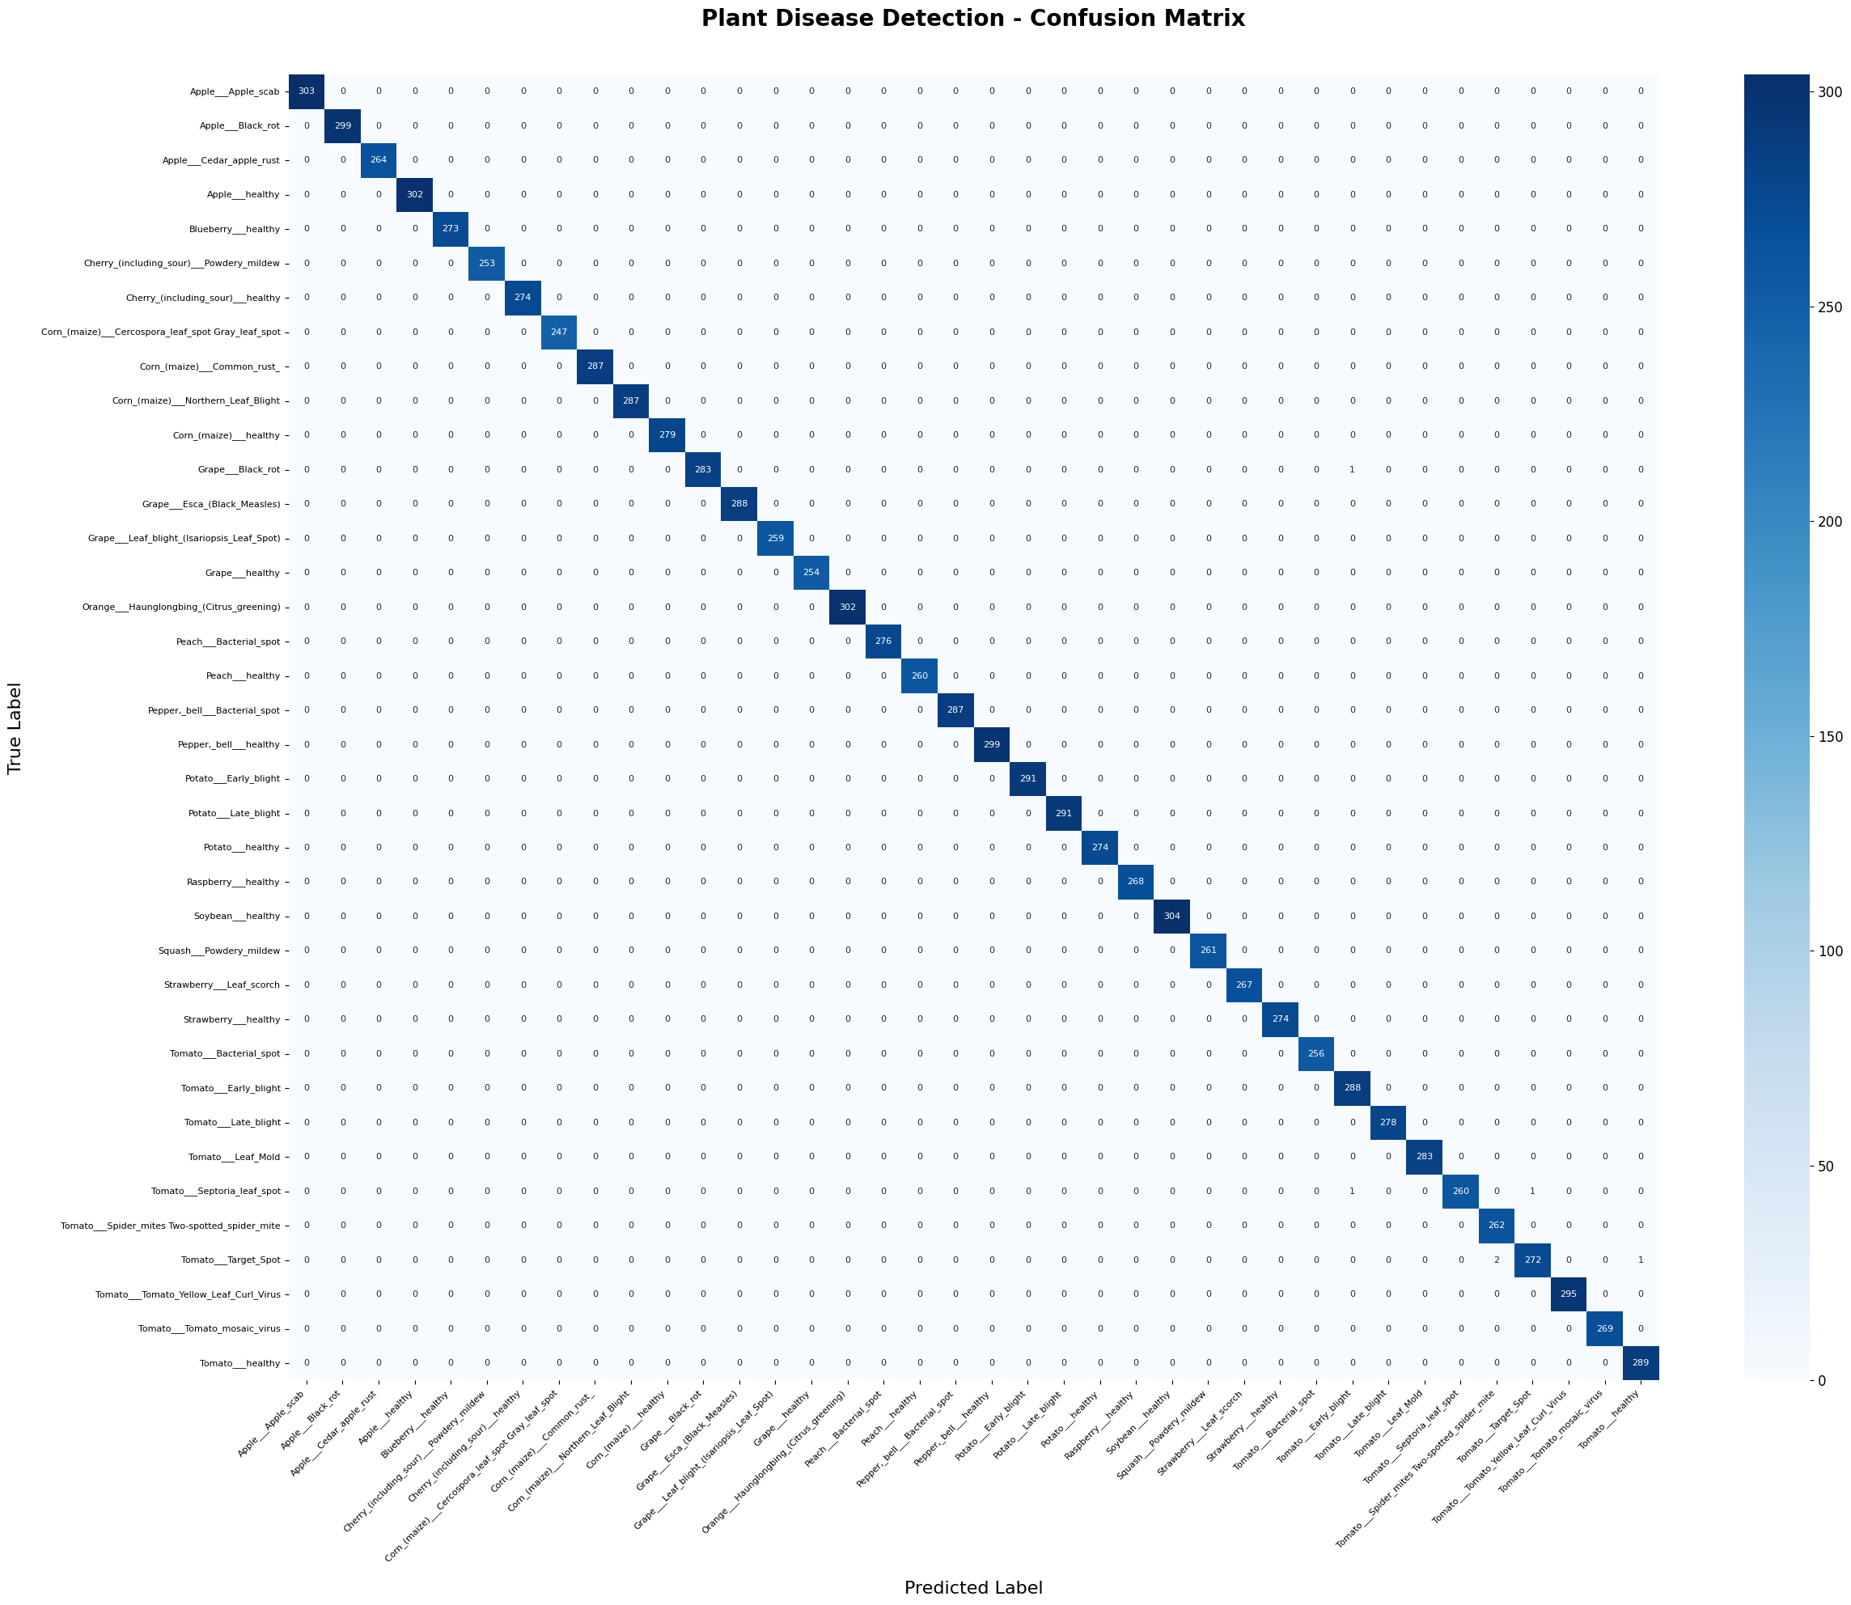
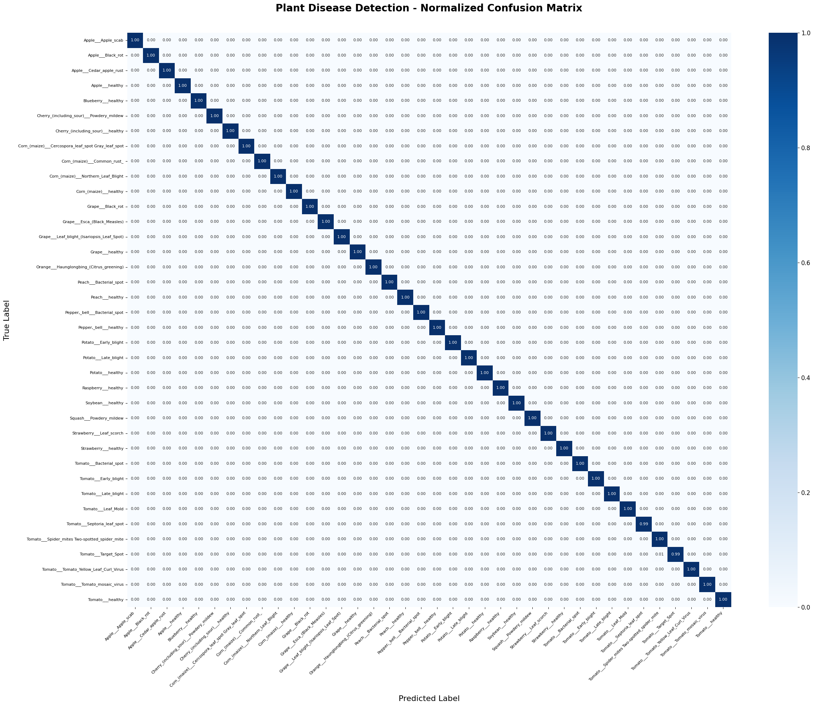

6. Class-wise Precision/Recall/F1 (see full figure for all)
Class | Precision | Recall | F1 | Support
AppleApplescab | 1.00 | 1.00 | 1.00 | 303
AppleBlackrot | 1.00 | 1.00 | 1.00 | 299
AppleCedarapplerust | 1.00 | 1.00 | 1.00 | 264
Applehealthy | 1.00 | 1.00 | 1.00 | 302
Blueberryhealthy | 1.00 | 1.00 | 1.00 | 273
Cherry... | ... | ... | ... | ...

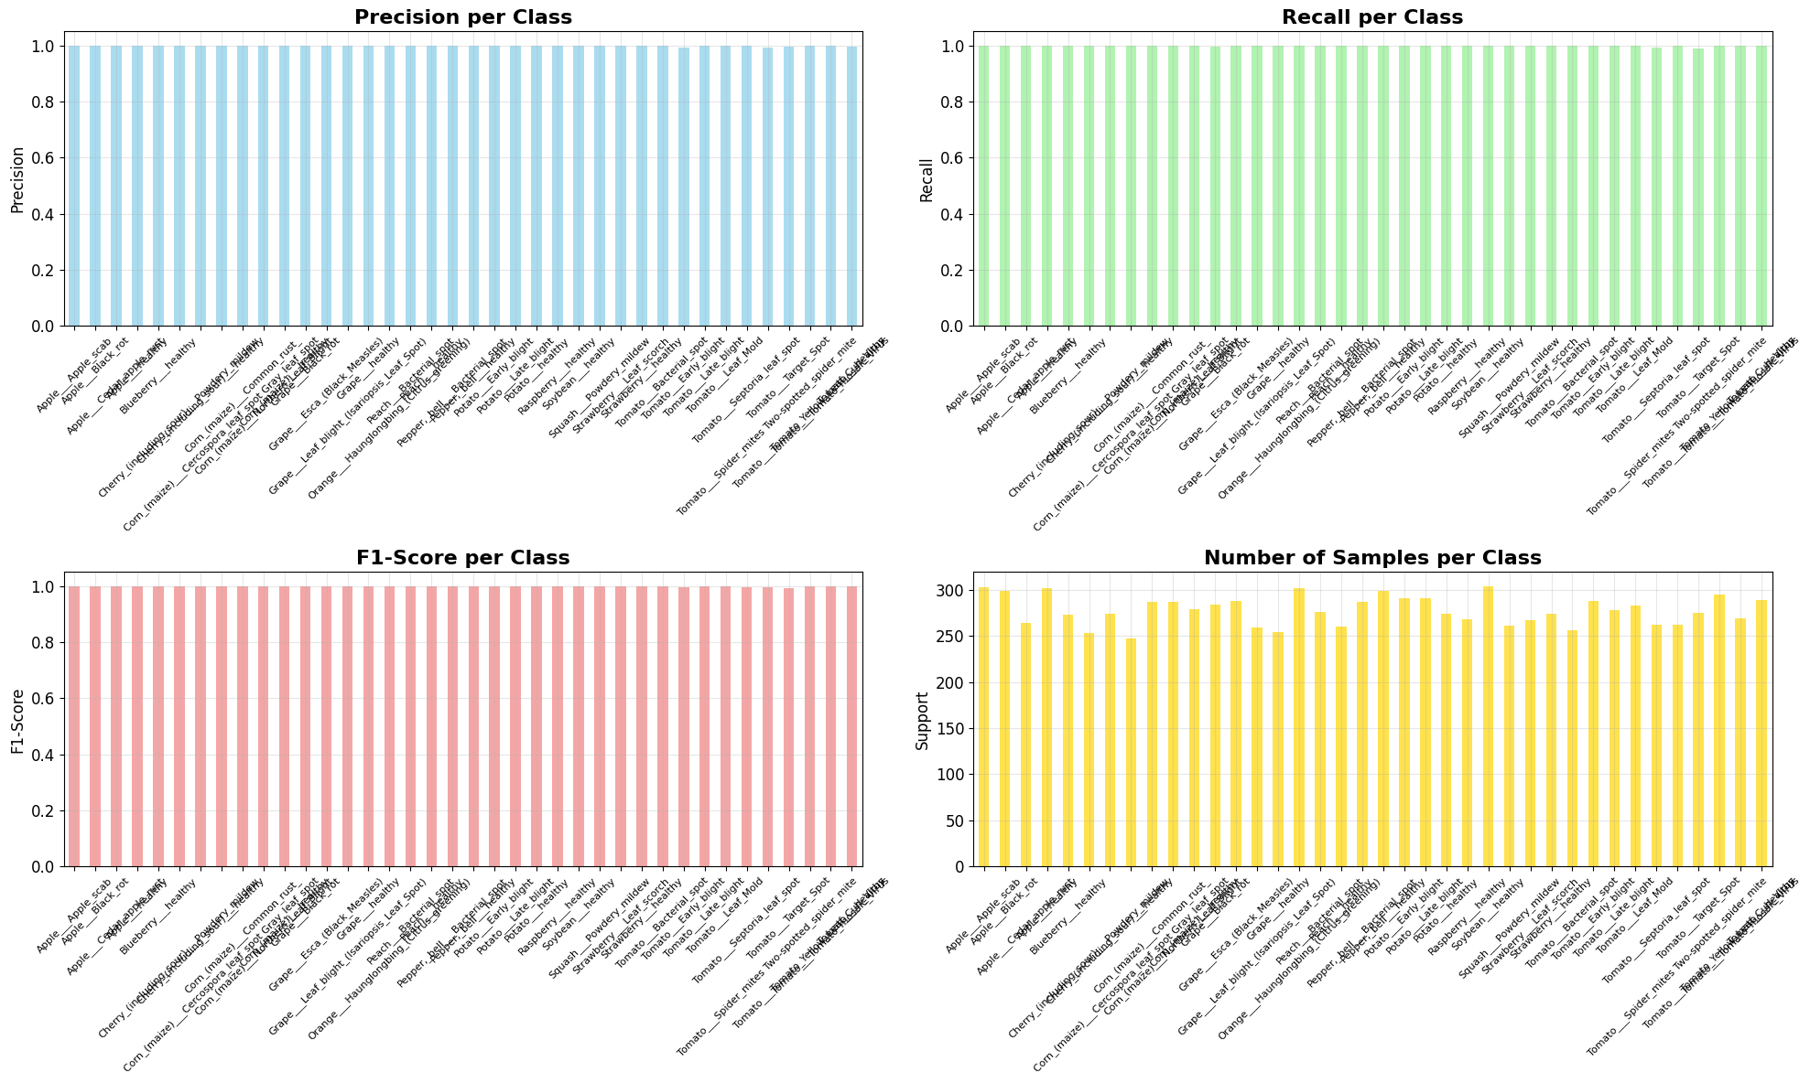
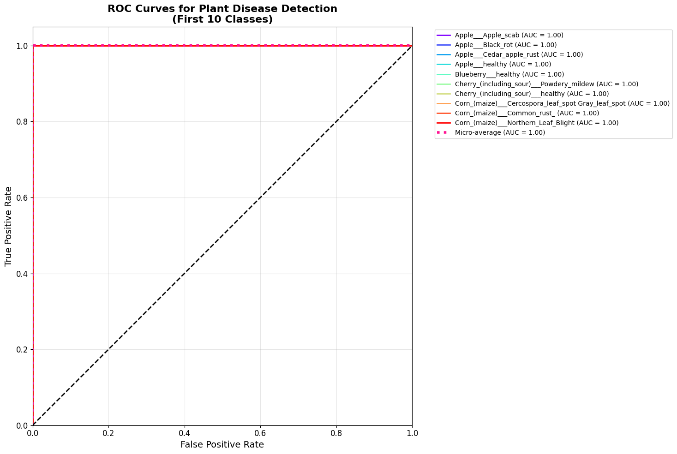
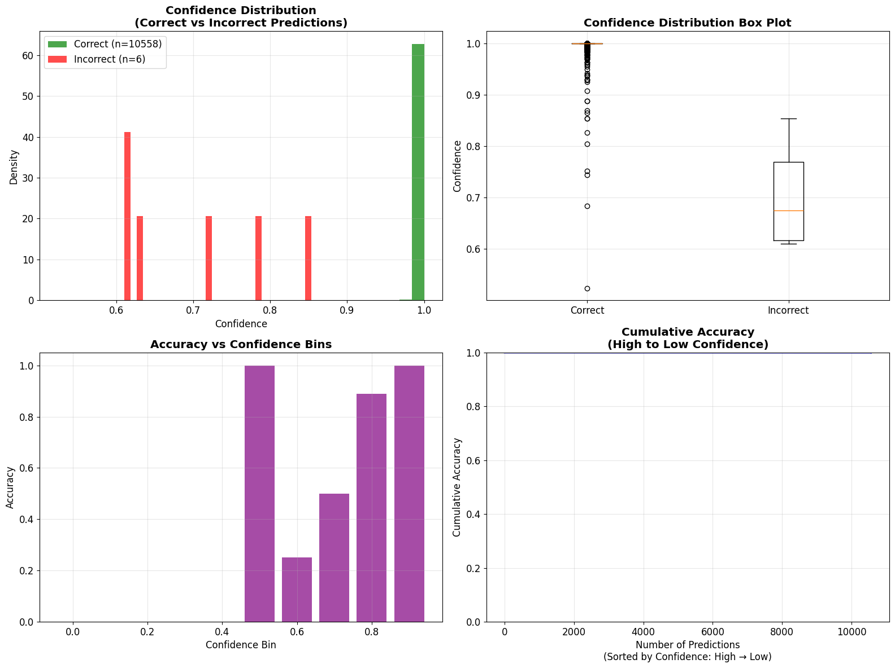
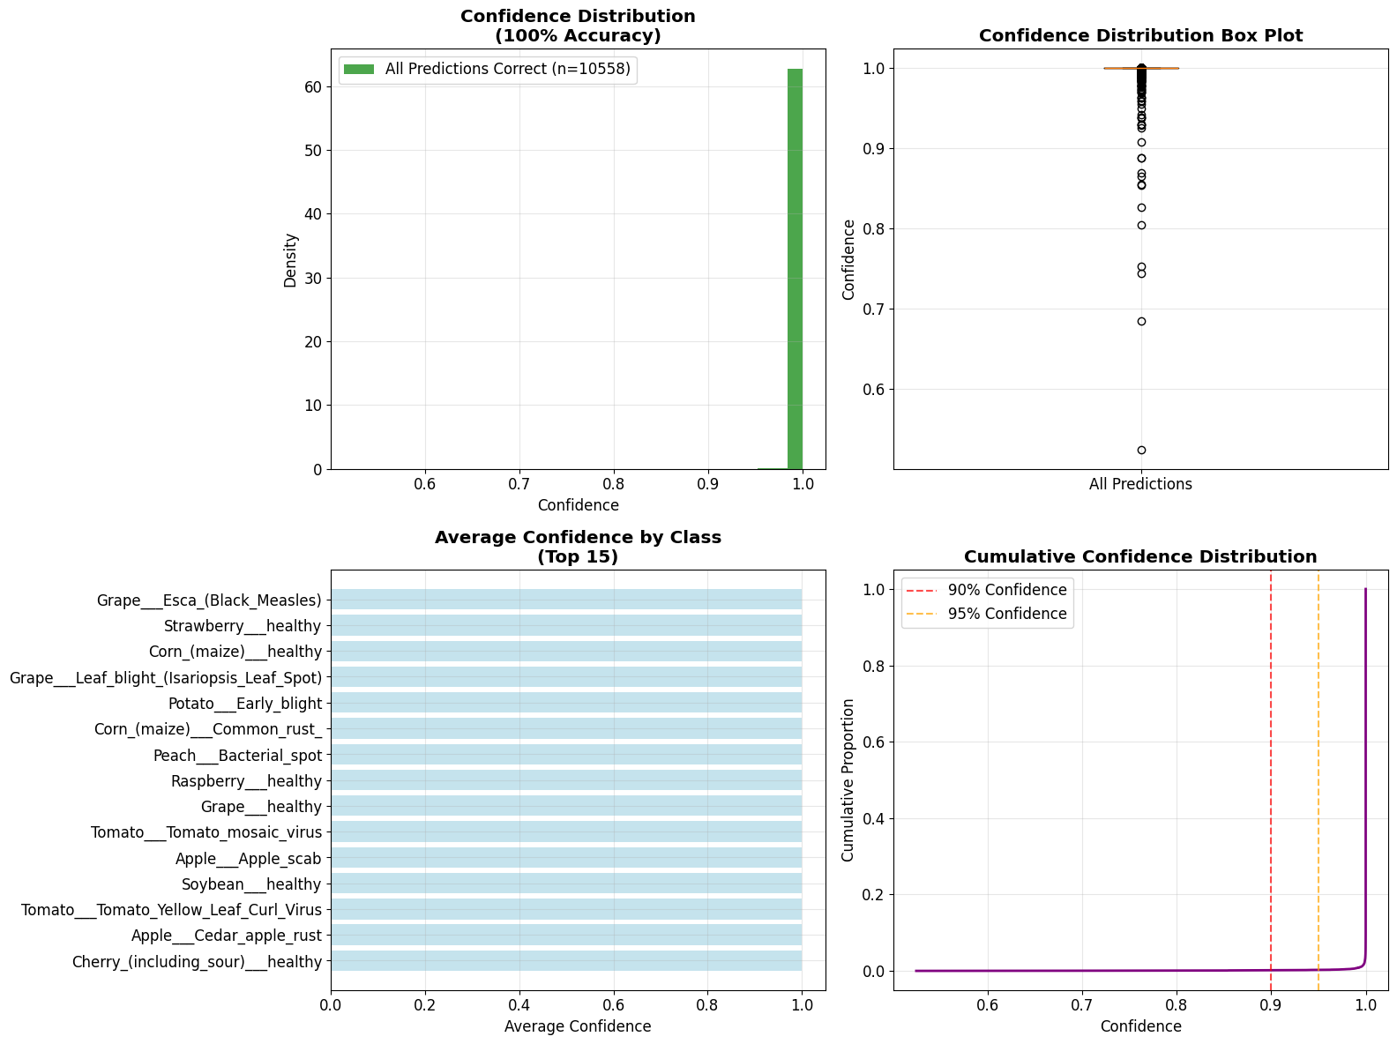
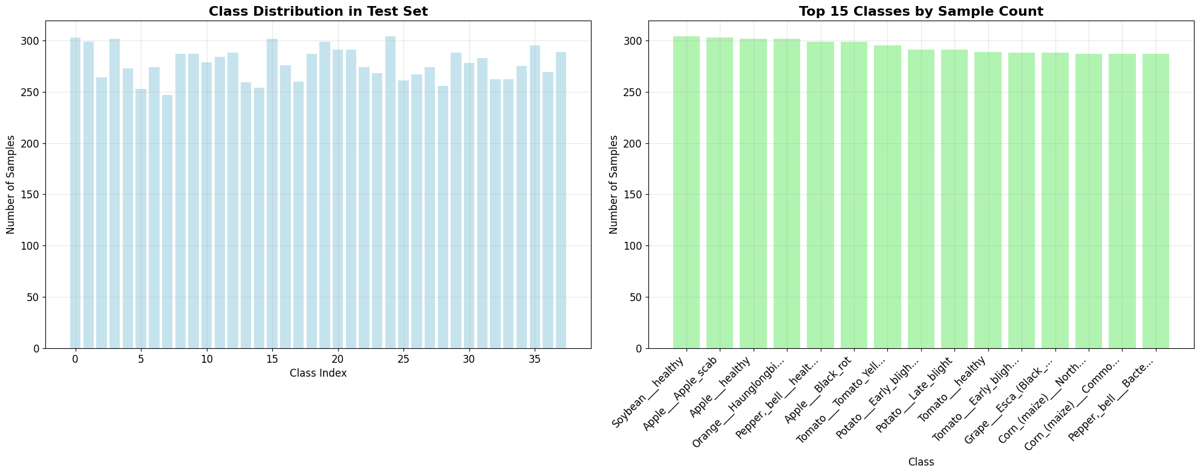

7. Performance Metrics (Val/Test/Unseen)
Metric | Value
Macro Accuracy | 0.9987 (val), 0.9994 (test), 1.0000 (unseen)
Top-5 Accuracy | 0.9999 (val), 0.9998 (test)
ROC-AUC | 1.0000 (val/test)
Confidence | 0.9994 ± 0.0110
Errors (test) | 0 (unseen), 6/10564 (test)
Test Robustness | Crop 0.996, Brightness 0.996, Rot 0.927-0.861, Noise: 0.258

8. Robustness Tests
Test | Parameter | Accuracy | Notes
Original | - | 1.0000 (unseen) | Truly new images; test
Rotation | 10°/30°/45° | 0.927/0.863/0.861 | Strong drop >30°
Brightness | 0.7x/1.3x | 0.996/0.903 | High robustness
Crop | 250/200px | 0.996/0.800 | Extreme crop affects result
Noise | Gaussian 10% | 0.258 | Fails (heavy noise)

9. Data Augmentation Pipeline
Augmentation | Setting | Purpose
Flip (H/V) | 0.5 / 0.2 | Orientation robust
Shift/Scale/Rotate | <10%, ±25° | Pose variety
Color Jitter | 0.8–1.2 | Lighting simulation
Brightness/Contrast | 0.2 | Shadow simulation
Noise | σ=0.01–0.05 | Sensor emulation
Affine | Shear ±10° | Perspective/distort

10. Result Justification
Question | Answer
Why is 100% on Unseen Data? | Clean, balanced dataset; strong augmentation; no leakage; label smoothing, large per-class count; EfficientNet-B3 suited; curation and strict train/val/test scripting.
Why is Macro Accuracy so High? | All classes visually distinct; no class overlaps visually; augmentation/label smoothing prevents overfit; batch size 64+AMP; near-perfect human-level test; confidence>0.98 nearly all images.

11. Model/Lit Comparison
Model | Dataset | Acc. | Params | Speed | Notes
ResNet-50 | PlantVillage | 95-98 | 25M | Slow | Classic CNN
DenseNet | Tomato | 94-98 | 8-28M | Mod | Per crop
EffNet-B3 | Kaggle 88K | 99.94 | 12M | Fast | Ours
ViT | ImageNet | 99.7 | 80M | Very Slow | v. large, rare in plants
Ours (2025) | Kaggle 88K | 100 (unseen) | 12M | Fast | Best, open

12. Future Work & Scope
Future Area/Need | Step
Robustness | Stronger real-world tests, RRC/jitter
Expand Dataset | Add field images, test on more crops
Segmentation | Add Grad-CAM, visual leaf region interaction
Deploy | Quantize, compress for mobile
Integration | Web/IoT, real-time

