A COMPARATIVE EVALUATION OF ZERO SHOT AND FEW SHOT PROMPTING STRATEGIES FOR ENHANCING COMPLEX REASONING IN LARGE LANGUAGE MODELS
A
Report on
Prompt Engineering
IS4143
Submitted in the partial fulfilment of the requirement for the award of the degree of
Bachelor of Technology
in
Computer Science & Engineering (IoT & Intelligent Systems)
2023-2027
By:
AYUSH ANAND
23FE10CII00144
Semester: 7
School of Computer Science and Engineering
Department of IoT & Intelligent Systems
Manipal University Jaipur
Jaipur, Rajasthan
July-Nov 2026

CONTENTS
1. Introduction
2. Problem Statement
3. Project Objectives
4. Literature Review
5. Methodology
6. Result and Discussions
7. Challenges and Limitations
8. Future Work
9. Conclusion
10. References

1. Introduction
Large language models (LLMs) now perform a wide range of tasks without any task-specific training. Instead of updating model weights, users steer the model through its input, the prompt. This practice, called prompt engineering, has become the main way of adapting a model for a given use. Brown et al. showed that a sufficiently large model can learn a task from a handful of worked examples placed in the prompt, which is known as few-shot or in-context learning [1]. The opposite extreme, zero-shot prompting, gives the model only an instruction and the question.
Reasoning tasks expose the weaknesses of both styles. A question such as a multi-step arithmetic word problem or a date calculation needs several intermediate inferences, and a model asked to answer in one step often fails. Wei et al. found that showing worked reasoning in the examples, known as chain-of-thought (CoT) prompting, greatly improves accuracy on such problems [2], and Kojima et al. showed that even the single phrase "Let's think step by step" can elicit this behaviour without any examples [3]. These findings suggest that two separate choices matter: whether the prompt contains examples, and whether the model is encouraged to reason aloud. Practitioners rarely see these two choices measured separately, and the cost of each in tokens and time is seldom reported.
This project therefore runs a controlled comparison of four prompting strategies (zero-shot, zero-shot CoT, few-shot and few-shot CoT) on three reasoning benchmarks and two open-weight models of different sizes. All prompts, code and raw model outputs are released with this report so that every number can be reproduced.
2. Problem Statement
Prompt design is usually guided by anecdote. It is unclear how much of the accuracy on complex reasoning comes from adding examples, how much from eliciting step-by-step reasoning, and how much extra output the model has to produce to obtain it. The effect may also depend on the model's size and on the kind of reasoning required (arithmetic, commonsense or temporal). A practitioner choosing a prompting strategy for a reasoning application therefore lacks evidence on which strategy gives the best accuracy for an acceptable cost on a given model. This project addresses that gap with a controlled, reproducible empirical comparison.
3. Project Objectives
1. To implement four prompting strategies (zero-shot, zero-shot CoT, few-shot, few-shot CoT) with identical task instructions and answer formats.
2. To measure the accuracy of each strategy on arithmetic (GSM8K), commonsense (StrategyQA) and temporal (Date Understanding) reasoning tasks.
3. To test whether the observed differences between strategies are statistically significant, using an exact McNemar test.
4. To quantify the cost of each strategy in generated tokens, and to compare a small and a medium-sized model.
5. To identify, through manual error analysis, the typical ways in which each strategy fails.
4. Literature Review
In-context learning. Brown et al. introduced the idea that large autoregressive models can perform new tasks from a few demonstrations in the prompt, with no gradient updates [1]. Later work questioned what the demonstrations contribute. Min et al. found that replacing the labels in the examples with random ones hurts performance surprisingly little, suggesting that examples mostly convey the format and the input distribution [8]. Few-shot results are also fragile: they depend on the choice, the order and the label balance of the examples [11], [15], and irrelevant text in the prompt can mislead the model [12].
Eliciting reasoning. Wei et al. showed that adding intermediate reasoning steps to the examples (chain of thought) sharply improves arithmetic, commonsense and symbolic reasoning, but mainly in sufficiently large models [2]. Kojima et al. found that a zero-shot trigger phrase is enough to obtain much of this benefit [3]. Suzgun et al. showed that CoT lifts a model over the average human rater on many BIG-Bench Hard tasks [13], while Sprague et al.'s meta-analysis of over a hundred papers concluded that the benefit is concentrated on math and symbolic problems and is small elsewhere [14]. Zhang et al. proposed building the demonstrations automatically [10].
Beyond a single chain. Self-consistency samples several reasoning paths and takes a majority vote, improving accuracy at higher cost [4]. Least-to-most prompting decomposes a problem into easier sub-problems [9], and Tree of Thoughts searches over alternative reasoning branches [17]. Cobbe et al. introduced GSM8K together with a trained verifier to select among candidate solutions [5]. Surveys such as Sahoo et al. catalogue these techniques [16].
Table 1: Summary of closely related work
Work | Technique | Main finding | Gap addressed here
Brown et al. [1] | Few-shot prompting | Examples in the prompt enable new tasks | Effect of examples vs. reasoning
Min et al. [8] | Demonstration analysis | Label correctness matters little | Format vs. content of examples
Wei et al. [2] | Few-shot CoT | Reasoning steps help large models | Cost in tokens not reported
Kojima et al. [3] | Zero-shot CoT | A trigger phrase elicits reasoning | Compared with few-shot CoT
Sprague et al. [14] | Meta-analysis of CoT | Gains mostly on math/symbolic | Per-task check on 3 task types
Wang et al. [4] | Self-consistency | Voting over paths improves accuracy | Left as future work

Most of this literature evaluates a single model family and reports accuracy only. The present study keeps the task instructions, answer format and decoding settings fixed across four strategies, uses two different open-weight models, and reports accuracy together with confidence intervals, significance tests and output length.
5. Methodology
5.1 Experimental design
The study was planned as a full factorial experiment: 4 prompting strategies × 3 datasets × 2 models × 60 questions per dataset (1,440 model calls). All strategies are applied to exactly the same questions, so they are compared on paired data. The free API tier limits the number of tokens per day, and the daily budget for Qwen3.8-27B ran out before the run finished. The final data therefore consist of ALLaM-2-7B on all three datasets (60 questions each, 720 calls) and Qwen3.8-27B on GSM8K (60 questions, 240 calls) and StrategyQA (51 questions, 204 calls); Date Understanding was not completed for Qwen. Within each model and dataset only questions answered under all four strategies are analysed (1,164 calls in total). Figure 1 shows the pipeline.
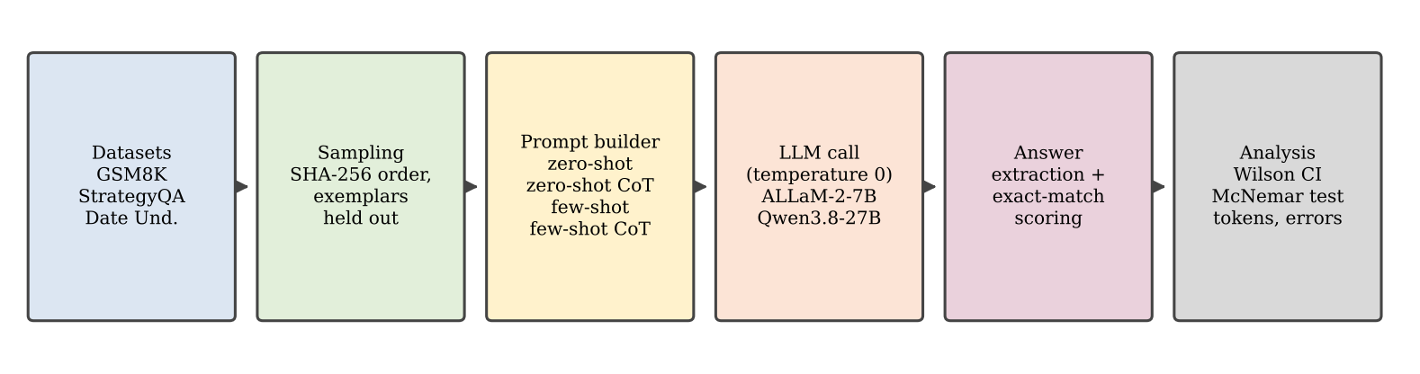
Figure 1: Experimental pipeline
5.2 Datasets
• GSM8K [5]: grade-school arithmetic word problems with a numeric answer. 60 questions were drawn from the official test split.
• StrategyQA [6]: yes/no questions needing implicit multi-hop commonsense reasoning (60 sampled questions, BIG-bench release [7]; 51 of them completed for Qwen).
• Date Understanding [7]: calendar reasoning posed as multiple choice with six options (60 questions, BIG-bench; option order was shuffled; ALLaM only).
Questions were selected by sorting item indices with a salted SHA-256 hash, which is deterministic and reproducible. Items used as few-shot examples were removed from the test pool, so there is no overlap between demonstrations and test questions.
5.3 Prompting strategies
• Zero-shot: an instruction and the question; the model is told to give only the final line "Answer: ...".
• Zero-shot CoT: the same instruction, but reasoning is allowed and the question is followed by "Let's think step by step" [3].
• Few-shot: four solved examples (question and answer only) precede the test question [1].
• Few-shot CoT: four examples that include worked reasoning before the answer [2].
For GSM8K the examples are drawn from the training split with their reference solutions; for StrategyQA they use the dataset's annotated rationales; for Date Understanding four short rationales were written by hand.
5.4 Models and decoding
Two models served through the Groq API were used: ALLaM-2-7B (a 7-billion-parameter model, here called the small model) and Qwen3.8-27B (27 billion parameters, the medium model), both used in their standard non-thinking mode so that any reasoning comes from the prompt rather than a hidden reasoning phase. Temperature was 0 for all runs. Answers were limited to 40 tokens for non-CoT strategies and 1000 tokens for CoT strategies.
5.5 Metrics and statistics
The final line "Answer: ..." is extracted with a regular expression and compared with the gold answer (numeric equality for GSM8K, exact match otherwise); a missing or malformed answer counts as wrong. Accuracy is reported with 95% Wilson confidence intervals. Each strategy is compared with zero-shot on the same items using an exact McNemar test (two-sided binomial test on discordant pairs). The mean number of generated tokens per answer measures cost.
6. Result and Discussions
6.1 Accuracy of the four strategies
Table 2: Accuracy % (95% Wilson interval) for each strategy
Model / dataset | Zero-shot | Zero-shot CoT | Few-shot | Few-shot CoT
ALLaM-2-7B / Date Und. (n=60) | 36.7 (26-49) | 30.0 (20-43) | 45.0 (33-58) | 56.7 (44-68)
ALLaM-2-7B / GSM8K (n=60) | 11.7 (6-22) | 46.7 (35-59) | 13.3 (7-24) | 56.7 (44-68)
ALLaM-2-7B / StrategyQA (n=60) | 70.0 (57-80) | 75.0 (63-84) | 66.7 (54-77) | 68.3 (56-79)
Qwen3.8-27B / GSM8K (n=60) | 53.3 (41-65) | 93.3 (84-97) | 61.7 (49-73) | 95.0 (86-98)
Qwen3.8-27B / StrategyQA (n=51) | 76.5 (63-86) | 80.4 (68-89) | 86.3 (74-93) | 82.4 (70-90)

Table 2 and Figures 2 and 3 show a clear pattern that depends on the dataset more than on the model. On GSM8K, reasoning is decisive: for the small ALLaM model, accuracy rises from 11.7% (zero-shot) to 46.7% with zero-shot CoT and 56.7% with few-shot CoT, while few-shot examples without reasoning give only 13.3%. Qwen shows the same shape at a higher level (53.3% → 93.3% → 95.0%, with plain few-shot at 61.7%). On StrategyQA, differences between strategies are small (ALLaM 66.7–75.0%, Qwen 76.5–86.3%) and their confidence intervals overlap heavily. On Date Understanding (ALLaM only), few-shot CoT is best at 56.7% against 36.7% for zero-shot, but zero-shot CoT is actually lower than zero-shot (30.0%).
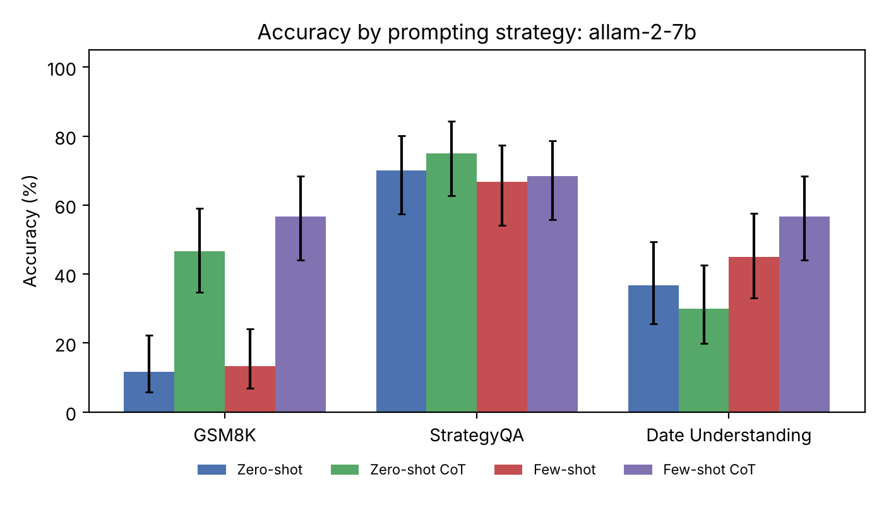
Figure 2: Accuracy of ALLaM-2-7B by strategy and dataset (error bars: 95% Wilson interval)
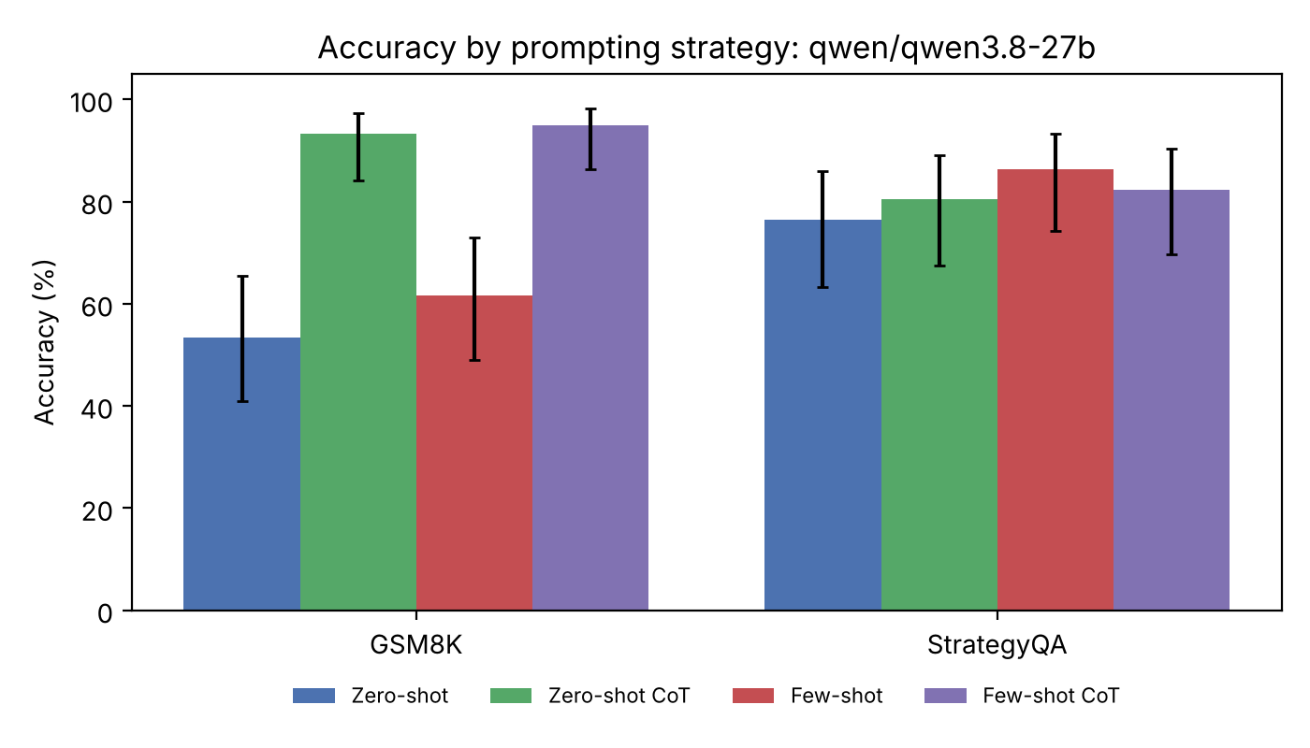
Figure 3: Accuracy of Qwen3.8-27B by strategy and dataset (error bars: 95% Wilson interval)
6.2 Statistical significance
Table 3: Exact McNemar p-value against zero-shot (questions fixed vs. broken)
Model / dataset | Zero-shot CoT | Few-shot | Few-shot CoT
ALLaM-2-7B / Date Und. | 0.481 (7 vs 11) | 0.227 (8 vs 3) | 0.023 (18 vs 6)
ALLaM-2-7B / GSM8K | <0.001 (24 vs 3) | 1.000 (5 vs 4) | <0.001 (29 vs 2)
ALLaM-2-7B / StrategyQA | 0.607 (9 vs 6) | 0.688 (2 vs 4) | 1.000 (4 vs 5)
Qwen3.8-27B / GSM8K | <0.001 (24 vs 0) | 0.180 (7 vs 2) | <0.001 (25 vs 0)
Qwen3.8-27B / StrategyQA | 0.754 (6 vs 4) | 0.062 (5 vs 0) | 0.453 (5 vs 2)

Table 3 gives the exact McNemar p-value of each strategy against zero-shot, with the number of questions the strategy fixed versus broke in brackets. With 60 questions per cell, only large effects reach significance at the 5% level. The GSM8K gains from CoT are highly significant for both models (p < 0.001; for example, Qwen fixed 24 questions with zero-shot CoT and broke none). Few-shot examples alone did not significantly help on GSM8K for either model (ALLaM p = 1.000, Qwen p = 0.180). On StrategyQA no comparison is significant (all p ≥ 0.06; Qwen's few-shot gain from 76.5% to 86.3% is borderline at p = 0.0625). On Date Understanding only ALLaM's few-shot CoT beats zero-shot significantly (p = 0.023), and it also beats zero-shot CoT (p = 0.0015). Because many comparisons were made without correction, the borderline p-values should be treated as suggestive only.
6.3 Cost of each strategy
Table 4: Output length and pooled accuracy
Model | Strategy | Mean output tokens | Overall accuracy %
ALLaM-2-7B | Zero-shot | 12.3 | 39.4
ALLaM-2-7B | Zero-shot CoT | 233.7 | 50.6
ALLaM-2-7B | Few-shot | 8.3 | 41.7
ALLaM-2-7B | Few-shot CoT | 104.6 | 60.6
Qwen3.8-27B | Zero-shot | 6.3 | 64.0
Qwen3.8-27B | Zero-shot CoT | 423.9 | 87.4
Qwen3.8-27B | Few-shot | 5.3 | 73.0
Qwen3.8-27B | Few-shot CoT | 248.6 | 89.2

Reasoning is paid for in output tokens. Answer-only strategies produce about 5-12 tokens, whereas CoT outputs are roughly 13 to 80 times longer. Interestingly, few-shot CoT is both more accurate and cheaper than zero-shot CoT for ALLaM (104.6 versus 233.7 tokens; 60.6% versus 50.6% pooled accuracy), because the worked examples teach the model to reason concisely. For Qwen, few-shot CoT used 248.6 tokens against 423.9 for zero-shot CoT. Pooled accuracies in Table 4 are averages over the datasets each model completed, so they must not be compared between the two models (Qwen has no Date Understanding results).
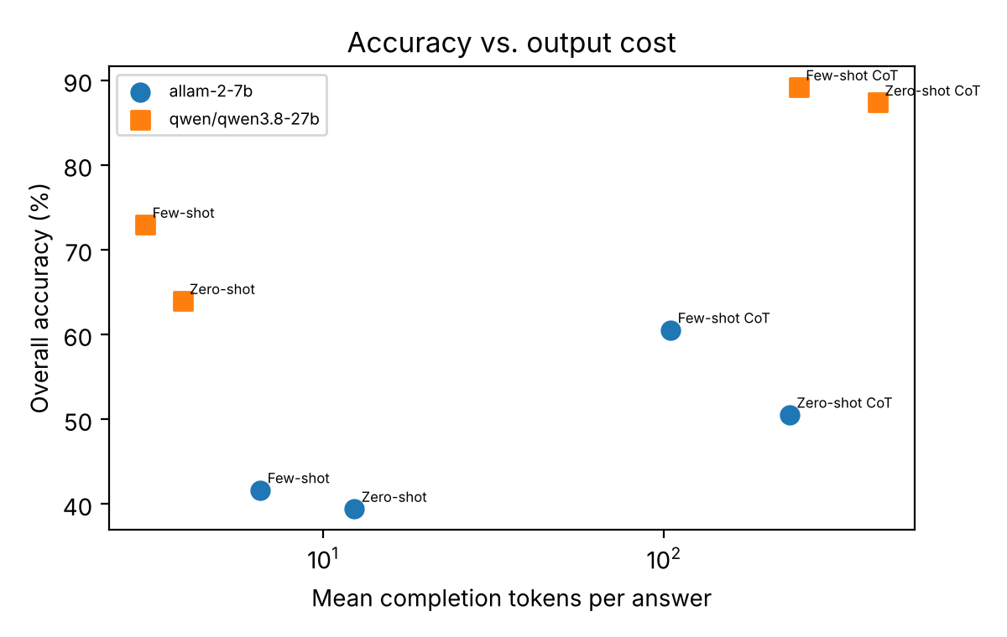
Figure 4: Pooled accuracy versus mean output tokens (log-like horizontal axis)
6.4 Error analysis
Format failures. The largest single failure was in ALLaM's zero-shot CoT on Date Understanding: 14 of 60 answers gave a date (for example "Answer: 01/02/2015") instead of the requested option letter and so could not be scored. Among answers that could be parsed, zero-shot CoT (39.1%) is no better than zero-shot (38.6%), so on this task the lower score combines a format problem with an absence of real benefit. Few-shot prompting removed this failure entirely (0 of 60), because the examples show the answer format.
Reasoning errors. Where CoT fails, the arithmetic or calendar logic is usually wrong rather than missing. In one ALLaM zero-shot CoT date answer the model computed "02/25/2011 − 10 = 02/15/2011" after reasoning from an incorrect intermediate date, and then chose the wrong option.
Direct answers are guesses. On GSM8K the question "Marcus is half of Leo's age and five years younger than Deanna. Deanna is 26. How old is Leo?" (correct answer 42) was answered "20" by ALLaM and "62" by Qwen when asked for the answer only, but both were correct with few-shot CoT, writing 26 − 5 = 21 and 21 × 2 = 42. Without intermediate steps the models effectively guess.
When reasoning does not help. On StrategyQA, Qwen's zero-shot CoT broke four questions that zero-shot had answered correctly. For "Is the Illuminati card game still popular?" (answer: No) the model wrote a plausible-sounding justification ending in "Yes". Longer reasoning can rationalise a wrong guess when the question depends on world knowledge rather than computation. Finally, seven of Qwen's CoT answers (three zero-shot CoT and one few-shot CoT on StrategyQA, and two zero-shot CoT and one few-shot CoT on GSM8K) reached the 1,000-token cap and were counted wrong, which slightly understates its CoT accuracy.
6.5 Discussion
The results answer the objectives as follows. (1) Eliciting reasoning matters far more than adding examples when the task needs multi-step computation: on GSM8K both CoT strategies lifted accuracy by 35-45 percentage points, while examples alone added little. (2) The benefit is task dependent, in line with the meta-analysis of Sprague et al. [14]: on the commonsense task StrategyQA there was no significant gain from any strategy. (3) Examples help in a different way: they fix the answer format and, combined with reasoning, make the reasoning shorter, which is why few-shot CoT dominated zero-shot CoT on Date Understanding and in cost. (4) The larger model was more accurate everywhere it was tested and made better use of reasoning on arithmetic (93-95% versus 47-57%), but its absolute gain from CoT was similar (about 40 points versus 35-45), so reasoning prompts help models of both sizes. These conclusions apply to the specific models, datasets and 60-question samples used here.
7. Challenges and Limitations
• Incomplete design. The free API quota for Qwen3.8-27B (a daily cap of 200,000 tokens and 1,000 output tokens per minute) ended the run before Date Understanding could be tested, and StrategyQA was completed for 51 of 60 questions. The model-size comparison is therefore only available on GSM8K and StrategyQA.
• Small samples. With 51-60 questions per cell, the 95% intervals are about ±12 points wide, so small differences cannot be detected; many comparisons were not corrected for multiple testing.
• Model availability. The Llama models originally planned were no longer offered on the API, so ALLaM-2-7B and Qwen3.8-27B were used. Results may differ for other model families, and the models' training data may have included these public benchmarks.
• Single run at temperature 0. Run-to-run variation, and the effect of example choice and order [15], were not measured. Answer parsing relies on the model following the "Answer:" format, and truncated outputs count as wrong.
8. Future Work
• Complete the Qwen3.8-27B Date Understanding runs (the runner is resumable) and increase the sample to 200 or more questions per dataset.
• Add self-consistency voting [4] and least-to-most decomposition [9] and measure their accuracy-per-token against the four baselines.
• Measure sensitivity to the choice and ordering of the in-context examples [15] and test automatically generated demonstrations [10].
• Include reasoning-native models, whose hidden reasoning may make prompt-level CoT unnecessary.
9. Conclusion
This project compared zero-shot, zero-shot CoT, few-shot and few-shot CoT prompting on arithmetic, commonsense and temporal reasoning with two open-weight models. Chain-of-thought reasoning was the dominant factor for arithmetic: it raised GSM8K accuracy from 11.7% to as much as 56.7% for ALLaM-2-7B and from 53.3% to as much as 95.0% for Qwen3.8-27B, a significant gain in every case (p < 0.001), whereas few-shot examples alone gave no significant gain. On StrategyQA no strategy was significantly better than another. Few-shot CoT was the most reliable overall: it had the highest accuracy in three of the five model-dataset settings (GSM8K for both models and Date Understanding), was within sampling error of the best on StrategyQA, avoided answer-format failures, and needed fewer output tokens than zero-shot CoT. The practical recommendation is to use few-shot CoT for computation-heavy tasks and plain prompts for knowledge-based questions. The limitations above, chiefly the small samples and the incomplete Qwen runs, mean these findings should be confirmed on larger samples. All code, prompts and raw outputs are in the project repository so the experiments can be reproduced.
References
[1] T. B. Brown et al., "Language models are few-shot learners," in Advances in Neural Information Processing Systems (NeurIPS), vol. 33, 2020. arXiv:2005.14165.
[2] J. Wei et al., "Chain-of-thought prompting elicits reasoning in large language models," in Advances in Neural Information Processing Systems (NeurIPS), vol. 35, 2022. arXiv:2201.11903.
[3] T. Kojima, S. S. Gu, M. Reid, Y. Matsuo, and Y. Iwasawa, "Large language models are zero-shot reasoners," in Advances in Neural Information Processing Systems (NeurIPS), vol. 35, 2022. arXiv:2205.11916.
[4] X. Wang et al., "Self-consistency improves chain of thought reasoning in language models," in Int. Conf. on Learning Representations (ICLR), 2023. arXiv:2203.11171.
[5] K. Cobbe et al., "Training verifiers to solve math word problems," arXiv preprint arXiv:2110.14168, 2021.
[6] M. Geva, D. Khashabi, E. Segal, T. Khot, D. Roth, and J. Berant, "Did Aristotle use a laptop? A question answering benchmark with implicit reasoning strategies," Trans. Assoc. Comput. Linguistics, vol. 9, 2021. arXiv:2101.02235.
[7] A. Srivastava et al., "Beyond the imitation game: Quantifying and extrapolating the capabilities of language models," Trans. Mach. Learn. Res., 2023. arXiv:2206.04615.
[8] S. Min et al., "Rethinking the role of demonstrations: What makes in-context learning work?," in Proc. Conf. on Empirical Methods in Natural Language Processing (EMNLP), 2022. arXiv:2202.12837.
[9] D. Zhou et al., "Least-to-most prompting enables complex reasoning in large language models," in Int. Conf. on Learning Representations (ICLR), 2023. arXiv:2205.10625.
[10] Z. Zhang, A. Zhang, M. Li, and A. Smola, "Automatic chain of thought prompting in large language models," in Int. Conf. on Learning Representations (ICLR), 2023. arXiv:2210.03493.
[11] T. Z. Zhao, E. Wallace, S. Feng, D. Klein, and S. Singh, "Calibrate before use: Improving few-shot performance of language models," in Proc. Int. Conf. on Machine Learning (ICML), 2021. arXiv:2102.09690.
[12] F. Shi et al., "Large language models can be easily distracted by irrelevant context," in Proc. Int. Conf. on Machine Learning (ICML), 2023. arXiv:2302.00093.
[13] M. Suzgun et al., "Challenging BIG-Bench tasks and whether chain-of-thought can solve them," in Findings of the Assoc. for Computational Linguistics (ACL), 2023. arXiv:2210.09261.
[14] Z. Sprague et al., "To CoT or not to CoT? Chain-of-thought helps mainly on math and symbolic reasoning," arXiv preprint arXiv:2409.12183, 2024.
[15] Y. Lu, M. Bartolo, A. Moore, S. Riedel, and P. Stenetorp, "Fantastically ordered prompts and where to find them: Overcoming few-shot prompt order sensitivity," in Proc. Annu. Meeting of the Assoc. for Computational Linguistics (ACL), 2022. arXiv:2104.08786.
[16] P. Sahoo et al., "A systematic survey of prompt engineering in large language models: Techniques and applications," arXiv preprint arXiv:2402.07927, 2024.
[17] S. Yao et al., "Tree of thoughts: Deliberate problem solving with large language models," in Advances in Neural Information Processing Systems (NeurIPS), vol. 36, 2023. arXiv:2305.10601.

