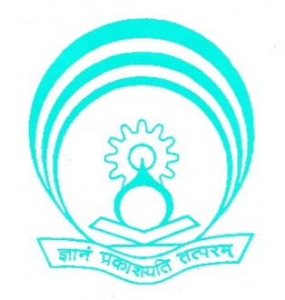
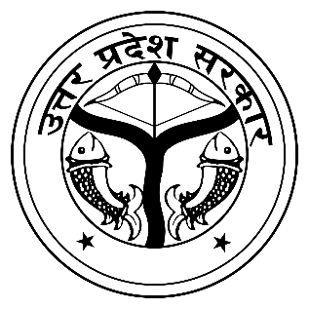
Department of Technical Education, U.P. Govt.
Institute of Research Development & Training, U.P., Kanpur

Ref No.: {{certificate no}}
CERTIFICATE

This is to certify that Mr./Ms./Smt. {{name of staff}}, {{designation}}, {{branch}} of {{institute name}} has successfully completed the Short-Term Course on “AUTO-CAD” organised by Institute of Research Development & Training, U.P., Kanpur from 14th October 2024 to 18th October 2024.




(Kunwer Mritunjay Singh) (Shyam Lal) (F. R. Khan)
Training Officer Training Coordinator Director

