**Name: Ayush Kushwaha**

**Lab: 1**

**Roll No:** CH.EN.U4CSE22077

------------------------------------------------------------------------------------------------

**Basic Lex Programs**

**1.Title:** Write a program to check if a given number is prime or not.

**Code:**

%{

#include <stdio.h>

#include <stdlib.h>

#include <math.h>

%}

%%

[0-9]+ {

int num = atoi(yytext);

if(num <= 1) {

printf("%d is not prime.\n", num);

} else {

int i, flag = 1;

int limit = (int)sqrt(num);

for(i = 2; i <= limit; i++) {

if(num % i == 0) {

flag = 0;

break;

}

}

if(flag)

printf("%d is prime.\n", num);

else

printf("%d is not prime.\n", num);

}

}

\n ; // ignore new lines

. ; // ignore other characters

%%

int main() {

printf("Enter a number: ");

yylex();

return 0;

}

int yywrap() {

return 1;

}

**Output:**

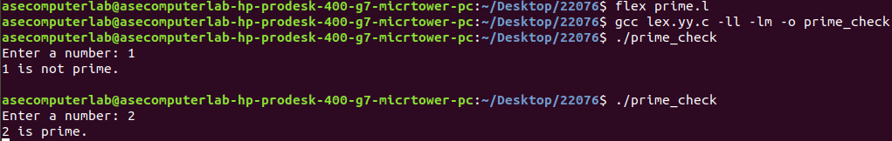

**2.Title:** Write a program to reverse a string without using built-in functions.

**Code:**

%{

#include <stdio.h>

void reverse(char *str, int length) {

int i;

for(i = 0; i < length / 2; i++) {

char temp = str[i];

str[i] = str[length - 1 - i];

str[length - 1 - i] = temp;

}

}

%}

%%

.*\n {

// yytext contains the whole line including newline

int length = 0;

// Calculate length excluding newline

while(yytext[length] != '\n' && yytext[length] != '\0') {

length++;

}

// Reverse the string in yytext (modifying in place)

reverse(yytext, length);

// Add newline back manually

yytext[length] = '\n';

yytext[length+1] = '\0';

printf("Reversed string: %s", yytext);

return 0; // Stop after processing one line

}

%%

int main() {

printf("Enter a string: ");

yylex();

return 0;

}

int yywrap() {

return 1;

}

**Output:**



**3.Title:** Write a program to find the factorial of a number using recursion.

**Code:**

%{

#include <stdio.h>

// Recursive factorial function

long long factorial(int n) {

if (n <= 1)

return 1;

else

return n * factorial(n - 1);

}

%}

%%

[0-9]+ {

int num = atoi(yytext);

printf("Factorial of %d is %lld\n", num, factorial(num));

return 0; // Stop after processing one number

}

\n ; // ignore newline

. ; // ignore any other characters

%%

int main() {

printf("Enter a number: ");

yylex();

return 0;

}

int yywrap() {

return 1;

}

**Output:**

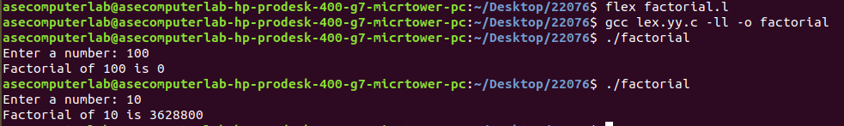

**4.Title:** Write a program to find the largest and smallest element in an array.

**Code:**

%{

#include <stdio.h>

#include <limits.h>

int largest = INT_MIN;

int smallest = INT_MAX;

%}

%%

[0-9]+ {

int num = atoi(yytext);

if (num > largest)

largest = num;

if (num < smallest)

smallest = num;

}

[\n\t ]+ ; // Ignore whitespace including newlines, tabs, spaces

. ; // Ignore any other characters

%%

int main() {

printf("Enter numbers separated by space (Ctrl+D or Ctrl+Z to end input):\n");

yylex();

printf("Largest element: %d\n", largest);

printf("Smallest element: %d\n", smallest);

return 0;

}

int yywrap() {

return 1;

}

**Output:**

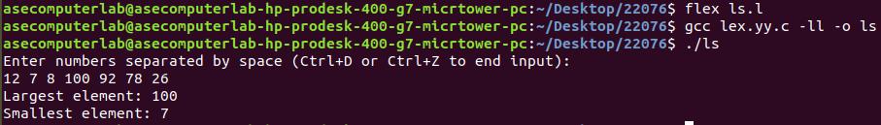

**5.Title:** Write a program to find the sum of digits of a given number.

**Code:**

%{

#include <stdio.h>

%}

%%

[0-9]+ {

int sum = 0;

char *p = yytext;

while (*p) {

sum += (*p - '0'); // convert char digit to int and add

p++;

}

printf("Sum of digits in %s is %d\n", yytext, sum);

return 0; // stop after processing one number

}

\n ; // ignore newlines

. ; // ignore other characters

%%

int main() {

printf("Enter a number: ");

yylex();

return 0;

}

int yywrap() {

return 1;

}

**Output:**

