Name: AYUSH KUSHWAHA

Reg No.: CH.EN.U4CSE22077

Date: 28-07-2025

-----------------------------------------------------------------------------------  
  **LAB – 4**  
  
**Aim:** To implement LL(1) parsing using C program.  
**Code:**  
  
**Parser.c**  
  
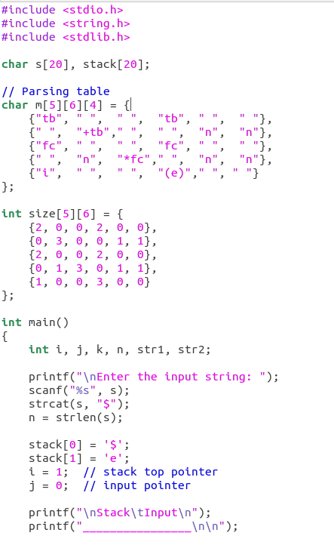

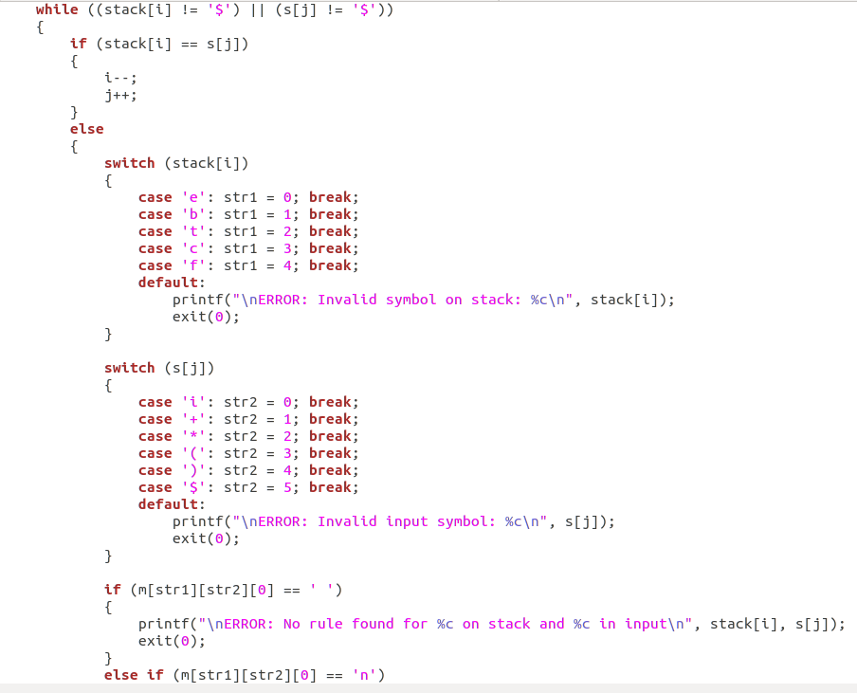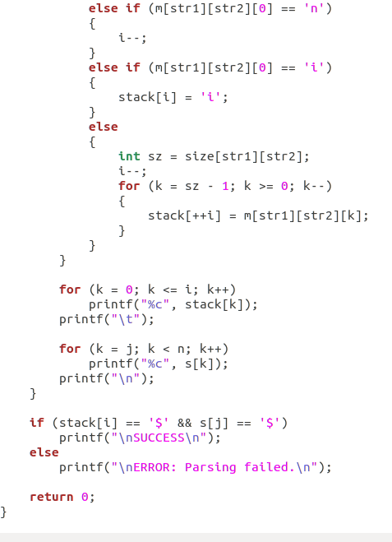

**Output:**

