**Name:** Ayush Kushwaha  
**Roll No:** CH.EN.U4CSE22077

------------------------------------------------------------------------------------------------

**Lab-5**

**Title:** To write a program in YACC for parser generation.

Algorithm:

* Get the input from the user and Parse it token by token.
* First identify the valid inputs that can be given for a program.
* Define the precedence and the associativity of various operators like +,-,/,* etc. Write codes for saving the answer into memory and displaying the result on the screen.
* Write codes for performing various arithmetic operations.
* Display the possible Error message that can be associated with this calculation. Display the output on the screen else display the error message on the screen

**Code:**

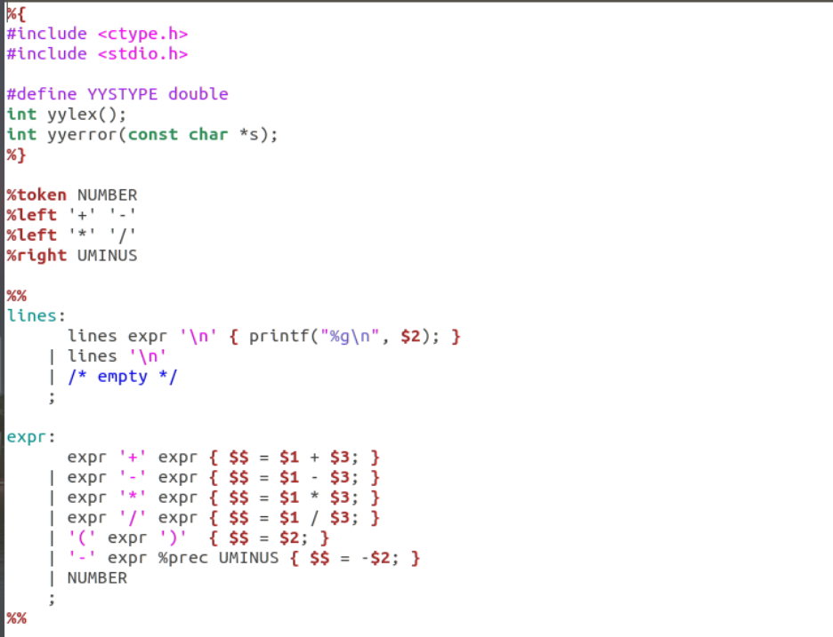

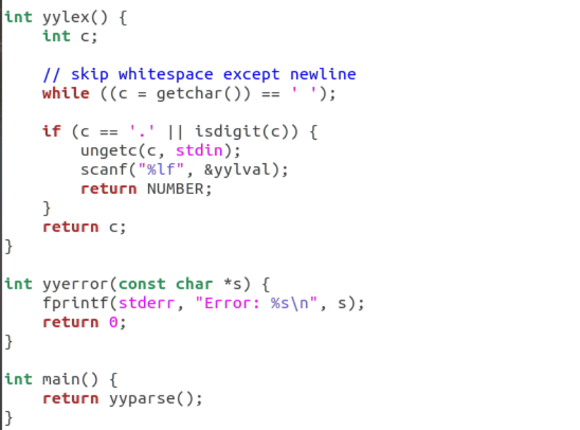

**Output:**

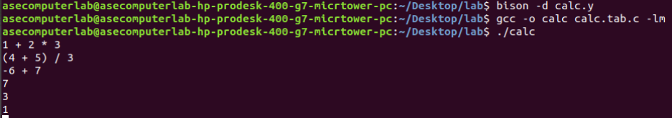

Result: Hence, parser generation for YACC has been successfully executed.