**Name:** Ayush Kushwaha  
**Roll No:** CH.EN.U4CSE22077

------------------------------------------------------------------------------------------------

**Lab-7**

**Title:** Implementation of intermediate code generation.

**Algorithm:**

* Take the parse tree tokens from the syntax analyser.
* Generate intermediate code using temp variable
* Assign the final temp variable to initial variable

**Code:**

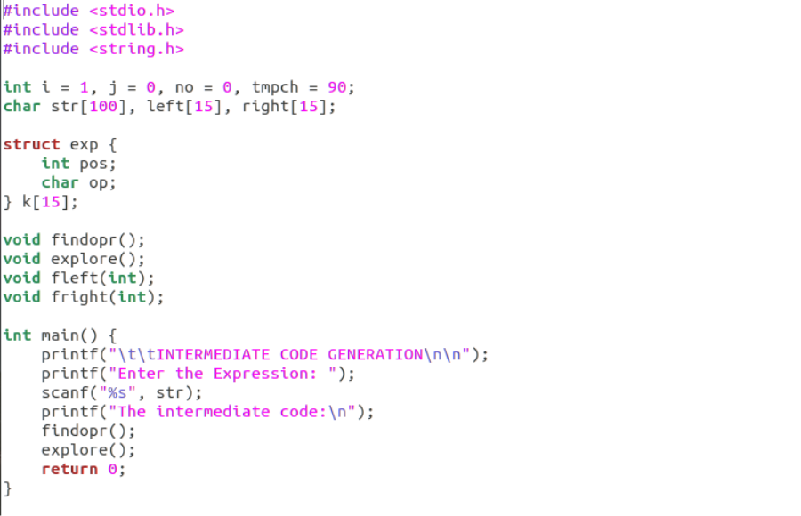

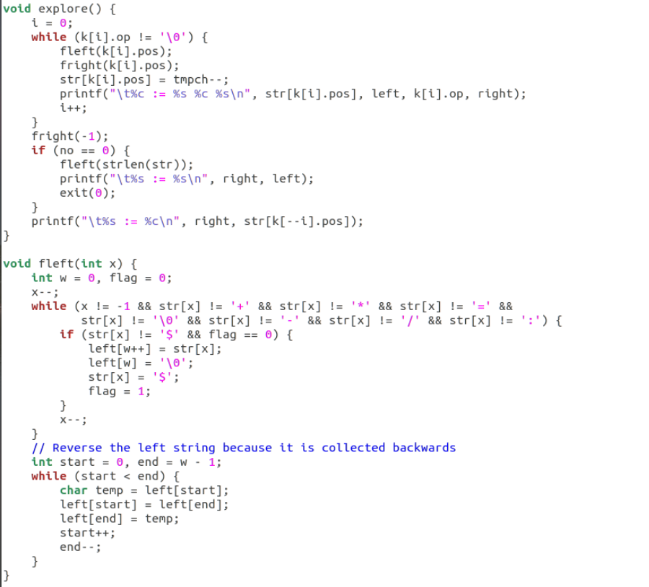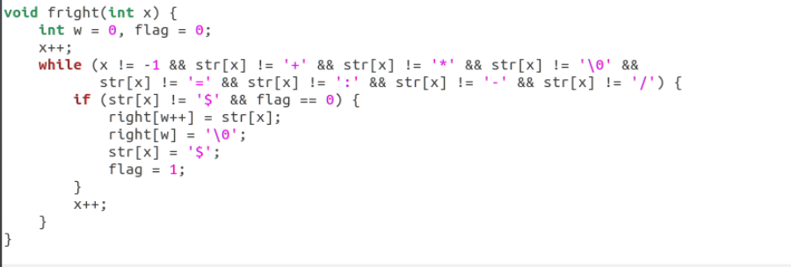

**Output:**

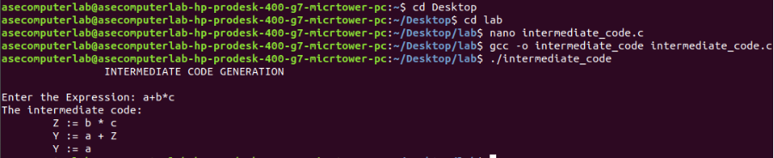

**Result:** Hence, implementation of intermediate code generation has been successfully executed.