**Name:** Ayush Kushwaha  
**Roll No:** CH.EN.U4CSE22077

------------------------------------------------------------------------------------------------

**Lab-8**

**Title: I**mplementation of Code Optimization Techniques.

Algorithm:

* Start the program
* Declare the variables and functions.
* Enter the expression and state it in the variable a, b, c. 24
* Calculate the variables b & c with ‘temp’ and store it in f1 and f2.
* If(f1=null && f2=null) then expression could not be optimized.
* Print the results.
* Stop the program.

**Code:**

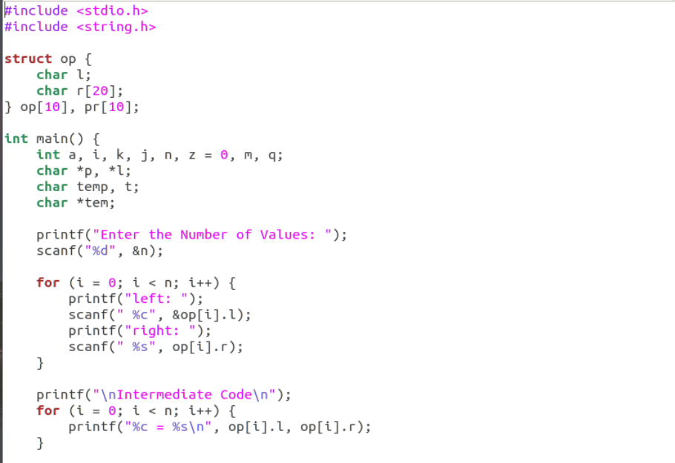

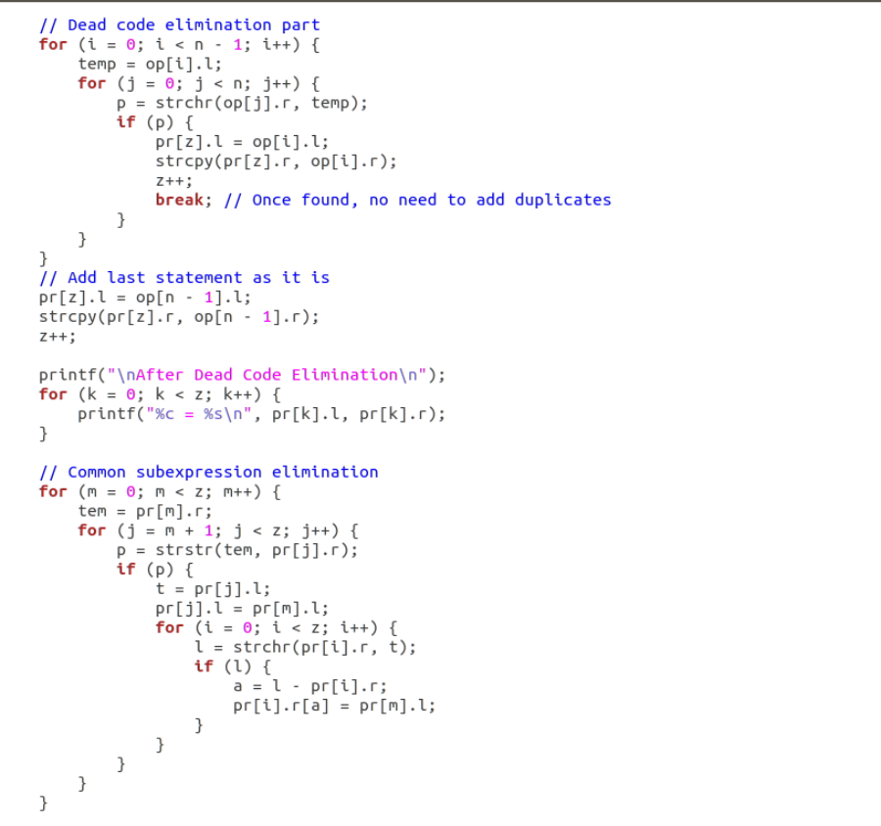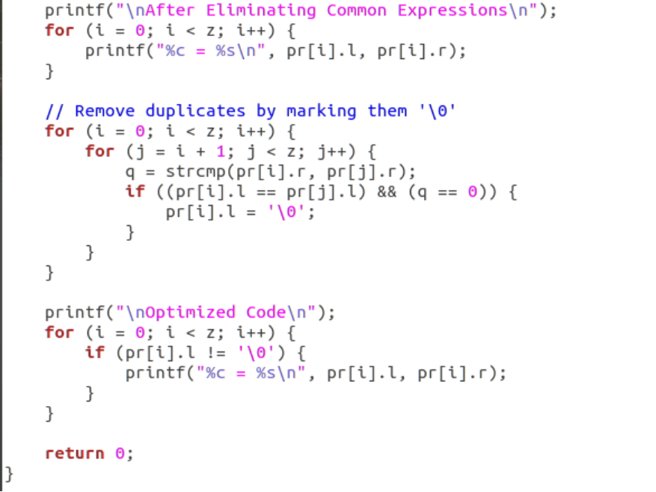

**Output:**

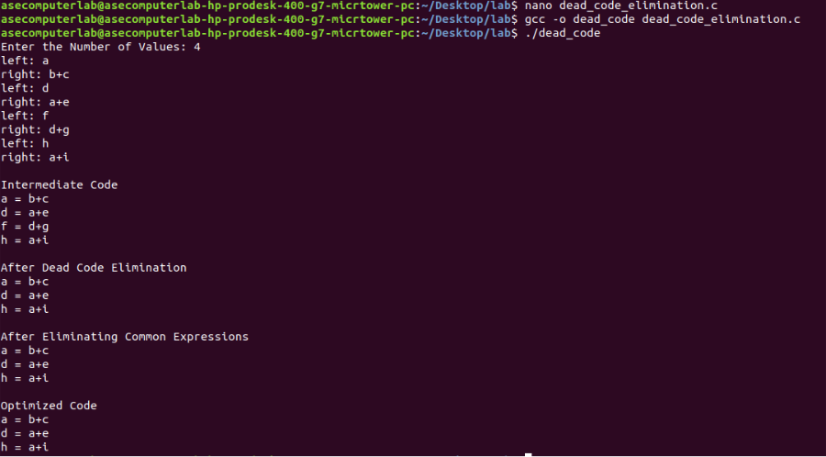**Result:** Hence, implementation of code optimization technique has been successfully executed.