Name: AYUSH KUSHWAHA
Reg No.: CH.EN.U4CSE22077
Date: 08-09-2025
-----------------------------------------------------------------------------------
LAB – 5 (Symbol Table)
Aim: To implement Symbol table using C program.
Code:
SymbolTable.c
#include <stdio.h>
#include <ctype.h>
#include <stdlib.h>
int main() {
int i = 0, n = 0;
char c;
char expression[100]; // buffer for input expression

printf("Input the expression ending with $ sign: ");
while ((c = getchar()) != '$' && i < 99) {
expression[i++] = c;
}
n = i; // number of characters read

printf("\nGiven Expression: ");
for (i = 0; i < n; i++) {
printf("%c", expression[i]);
}

printf("\n\nSymbol Table display\n");
printf("Symbol \t Address \t Type\n");

for (i = 0; i < n; i++) {
c = expression[i];
if (isalpha(c)) {
// Identifier
printf("%c \t %p \t identifier\n", c, (void*)&expression[i]);
} else if (c == '+' || c == '-' || c == '*' || c == '=') {
// Operator
printf("%c \t %p \t operator\n", c, (void*)&expression[i]);
}
// You can add more checks here (digits, delimiters, etc.)
}

return 0;
}

Output:
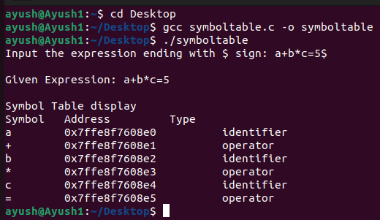
Hence, symbol table using C programming has been successfully executed.

