Q1.

package assignments1;

public class Prblm1 {

public static void main(String[] args) {

//Q 1 Java program to print welcome message

System.***out***.println("Hello Welcome to Java World");

}

}

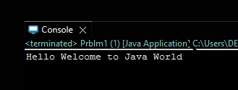

Q2.

package assignments1;

import java.util.Scanner;

public class Prblm2 {

public static void main(String [] args) {

Scanner input = new Scanner(System.***in***);

//Q 2 Java program to print sum of three float numbers

System.***out***.println("Enter First Number : ");

float x = input.nextFloat();

System.***out***.println("Enter Second Number : ");

float y = input.nextFloat();

System.***out***.println("Enter Third Number : ");

float z = input.nextFloat();

float a = x+y+z;

System.***out***.println("Sum of Number = " + a);

}

}

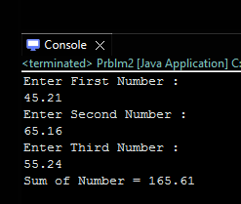

Q3.

package assignments1;

import java.util.Scanner;

public class Prblm3 {

public static void main(String[] args) {

Scanner sc = new Scanner(System.***in***);

//Q 3 Java Program to Swap Two Numbers

System.***out***.println("Enter First input : ");

int a=sc.nextInt();

System.***out***.println("Enter Second input : ");

int b=sc.nextInt();

a = a+b;

b = a-b;

a = a-b;

System.***out***.println(" first input = " + a +

" second input = " + b)

}

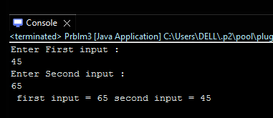

Q4.

package assignments1;

import java.util.Scanner;

public class Prblm4 {

public static void main(String[] args) {

Scanner sc = new Scanner(System.***in***);

//Q 4 Wap to check if number is even or odd

System.***out***.println("Enter your input : ");

int a = sc.nextInt();

if (a%2==0) {

System.***out***.println("NUMBER IS EVEN");

}else {

System.***out***.println("NUMBER IS ODD");

}

}

}

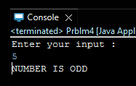

Q5.

package assignments1;

import java.util.Scanner;

public class Prblm5 {

public static void main(String[] args) {

Scanner sc = new Scanner (System.***in***);

/*Q 5 wap to check from three given number that whether a number is greater than or equal to

20 and less than other numbers .print appropriate message .*/

System.***out***.println("ENTER 1ST NUMBER : ");

int num1 = sc.nextInt();

System.***out***.println("ENTER 2ND NUMBER : ");

int num2 = sc.nextInt();

System.***out***.println("ENTER 3RD NUMBER : ");

int num3 = sc.nextInt();

if (num1 >=20&&(num1<num2&&num1<num3)) {

System.***out***.println("number is greater than or equal to 20 and less than other numbers = "+num1);

}else if (num2 >= 20 && (num2<num3&&num2<num1)){

System.***out***.println("number is greater than or equal to 20 and less than other numbers = "+num2);

}else if (num3 >= 20 && (num3<num1&&num3<num2)) {

System.***out***.println("number is greater than or equal to 20 and less than other numbers = "+num3);

}

}

}

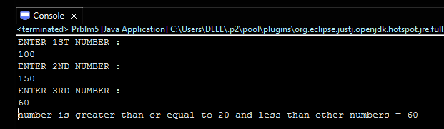

Q7.

package assignments1;

import java.util.Scanner;

public class Prblm7 {

public static void main(String[] args) {

Scanner sc =new Scanner(System.***in***);

/*Q 7 wap to check if sales of a person is greater than 10000 then eligible for bonus

else not eligible calculate bonus as 20% of sales .*/

System.***out***.println("INPUT SALE AMOUNT : ");

int sales =sc.nextInt();

if (sales>10000) { float bonus = (float)(20.0/100.0)*sales;

System.***out***.println(" ELIGIBLE FOR BONUS " + " & AMOUNT ="+bonus );

}else

System.***out***.println("NOT ELIGIBLE FOR BONUS");

}

}

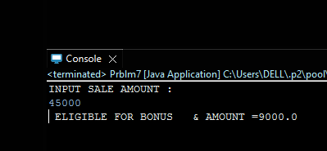

Q8.

package assignments1;

import java.util.Scanner;

public class Prblm8 {

public static void main(String[] args) {

Scanner sc = new Scanner(System.***in***);

//Q 8 wap to check if two given integer value is in range of 18 and 100 print eligible for voting else not eligible .

System.***out***.println("FIRST INPUT : ");

int A = sc.nextInt();

System.***out***.println("SECOND INPUT : ");

int B = sc.nextInt();

if (A>=18 && A<=100 && B>=18 && B<=100) {System.***out***.println("ELIGIBLE FOR VOTE");}

else {System.***out***.println(" NOT ELIGIBLE FOR VOTE");}

}

}

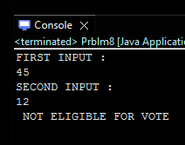

Q9.

import java.util.Scanner;

public class Prblm9 {

public static void main(String[] args) {

Scanner sc = new Scanner(System.***in***);

//Q 9 wap to print average of given five subjects marks of student and check if average >=40 print Pass else print fail

System.***out***.println("1st SUBJECT MARKS : ");

int sub1 = sc.nextInt();

System.***out***.println("2nd SUBJECT MARKS : ");

int sub2 = sc.nextInt();

System.***out***.println("3rd SUBJECT MARKS : ");

int sub3 = sc.nextInt();

System.***out***.println("4th SUBJECT MARKS : ");

int sub4 = sc.nextInt();

System.***out***.println("5th SUBJECT MARKS : ");

int sub5 = sc.nextInt();

int Average = (sub1+sub2+sub3+sub4+sub5)/5;

if (Average>=40)

System.***out***.println("PASS");

else

System.***out***.println("FAIL");

}

}

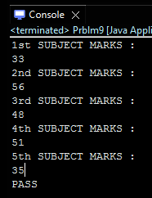

Q10.

package assignments1;

import java.util.Scanner;

public class Prblm10 {

public static void main(String[] args) {

//Q10 WAP to ask name ,age and salary of an employee and print on console.

Scanner sc = new Scanner(System.***in***);

System.***out***.println("ENTER YOUR NAME : ");

String name =sc.nextLine();

System.***out***.println("ENTER YOUR AGE : ");

int age =sc.nextInt();

System.***out***.println("ENTER YOUR SALARY : ");

int salary =sc.nextInt();

System.***out***.println("NAME : "+ name);

System.***out***.println("AGE : "+ age);

System.***out***.println("SALARY : "+ salary );

}

}

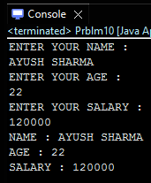

Q11.

package assignments1;

import java.util.Scanner;

public class Prblm11 {

public static void main(String[] args) {

Scanner sc = new Scanner(System.***in***) ;

//Q 11 wap that ask two numbers from user and print greater number among two

System.***out***.println("ENTER 1ST NUMBER : ");

int num1 = sc.nextInt();

System.***out***.println("ENTER 2nd NUMBER : ");

int num2 = sc.nextInt();

if (num1 > num2) {

System.***out***.println("GREATEST NUMBER = " + num1);

}else

System.***out***.println("GREATEST NUMBER = " + num2);

}

}

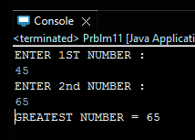

Q12.

package assignments1;

import java.util.Scanner;

public class Prblm12 {

public static void main(String[] args) {

Scanner sc = new Scanner(System.***in***);

/*Q 12 wap to ask product name and price of product from user and calculate discount i.e

if price > 2000 then discount is 10 percent of price

else discount is 7 % of price*/

System.***out***.println("NAME OF PRODUCT : ");

String name = sc.nextLine();

System.***out***.println("PRICE OF PRODUCT : ");

int price = sc.nextInt();

if (price > 2000) {float disc1 =(float)(0.1)*price;

System.***out***.println("DISCOUNT IS 10% = " + disc1);

}else {float disc2 = (float)(7.0/100.0)*price;

System.***out***.println("DISCOUNT IS 7% = " + disc2);

}}

}

