Full Season Pitching Report for Jared Shuster

Ayush Arora

9/19/2019

*WAKE FOREST BASEBALL*

#setwd("~/Desktop/WFU Baseball")  
#Spec_SP1 <- read.csv("~/Desktop/WFU Baseball/WakeFull20191.csv")  
Spec_SP1 <- read.csv("~/Documents/WakeFull2019.csv")  
list = list("Cusick, Ryan", "Shuster, Jared", "Fleming, William", "Menendez, Antonio", "Hearn, Bobby", "Witt, Ty", "Muntz, Shane", "McNamee, Cole")  
##################################################################  
Spec_SP2 <- subset(Spec_SP1, Spec_SP1$Pitcher == "Shuster, Jared")  
Spec_SP <- Spec_SP2[-c(1,2,3,4,5,7,8,9,10,11,13,28,47,48,49,50,51,52,53,54,55,56,57,69,70,71,72,73,74,75,77,78,83,84,85,86)]  
Spec_SP <- na.omit(Spec_SP)  
  
fastball <- subset(Spec_SP, Spec_SP$TaggedPitchType == "Fastball")  
FB_Up <- subset(fastball, fastball$PlateLocHeight> 2.55)  
FB_Down <- subset(fastball, fastball$PlateLocHeight < 2.55)  
FB_Right <- subset(fastball, fastball$PlateLocSide > 0)  
FB_Left <- subset(fastball, fastball$PlateLocSide < 0)  
slider <- subset(Spec_SP, Spec_SP$TaggedPitchType == "Slider")  
changeup <- subset(Spec_SP, Spec_SP$TaggedPitchType == "ChangeUp")

## Warning in strikeFX(noswing, model = m, layer = x): pitchRx assumes the  
## height of each batter is recorded as 'b_height'. Since there is no such  
## column, we will assume each batter has a height of 6'2''

## Conditioning on: stand == Right

## Warning in strikeFX(kmiss, model = n, layer = r): pitchRx assumes the  
## height of each batter is recorded as 'b_height'. Since there is no such  
## column, we will assume each batter has a height of 6'2''

## Conditioning on: stand == Right

## Warning in strikeFX(kmiss_sl, model = n_sl, layer = r): pitchRx assumes  
## the height of each batter is recorded as 'b_height'. Since there is no such  
## column, we will assume each batter has a height of 6'2''

## Conditioning on: stand == Left

## Warning in strikeFX(kmiss_ch, model = n_ch, layer = r): pitchRx assumes  
## the height of each batter is recorded as 'b_height'. Since there is no such  
## column, we will assume each batter has a height of 6'2''

## Conditioning on: stand == Right

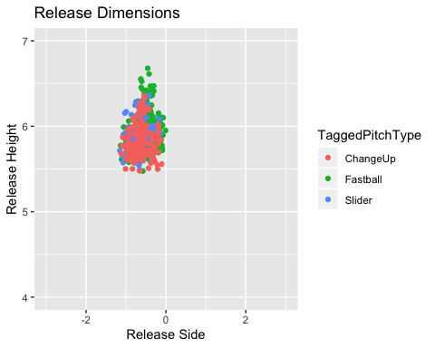

**Mechanics**

*Fastball, by Location*

**Fastball Up**

|  |  |  |  |
| --- | --- | --- | --- |
|  | FB Up Mean | FB Up Range- | FB Up Range+ |
| FB Up Velo | 89.9 | 88.9 | 91.0 |
| FB Up Spin Rate | 2098.2 | 1996.7 | 2199.6 |
| FB Up Induced Vert. Break | 18.4 | 14.8 | 22.0 |
| FB Up Vertical Break | -15.7 | -19.4 | -12.1 |
| FB Up Horizontal Break | -10.3 | -13.0 | -7.7 |
| FB Up Vert. Approach Angle | -4.4 | -5.1 | -3.6 |
| FB Up Effective Velocity | 89.7 | 88.5 | 90.9 |

**Fastball Down**

|  |  |  |  |
| --- | --- | --- | --- |
|  | FB Down Mean | FB Down Range- | FB Down Range+ |
| FB Down Velo | 90.1 | 89.0 | 91.2 |
| FB Down Spin Rate | 2107.0 | 1999.2 | 2214.8 |
| FB Down Induced Vert. Break | 17.3 | 14.5 | 20.1 |
| FB Down Vertical Break | -16.6 | -19.6 | -13.6 |
| FB Down Horizontal Break | -10.9 | -13.4 | -8.3 |
| FB Down Vert. Approach Angle | -6.1 | -6.7 | -5.4 |
| FB Down Effective Velocity | 90.0 | 88.7 | 91.2 |

**Fastball Left**

|  |  |  |  |
| --- | --- | --- | --- |
|  | FB Left Mean | FB Left Range- | FB Left Range+ |
| FB Left Velo | 89.8 | 88.8 | 90.9 |
| FB Left Spin Rate | 2095.9 | 1994.9 | 2196.8 |
| FB Left Induced Vert. Break | 17.9 | 14.7 | 21.0 |
| FB Left Vertical Break | -16.3 | -19.6 | -13.1 |
| FB Left Horizontal Break | -10.9 | -13.5 | -8.4 |
| FB Left Vert. Approach Angle | -5.1 | -6.3 | -4.0 |
| FB Left Effective Velocity | 89.6 | 88.4 | 90.8 |

**Fastball Right**

|  |  |  |  |
| --- | --- | --- | --- |
|  | FB Right Mean | FB Right Range- | FB Right Range+ |
| FB Right Velo | 90.2 | 89.2 | 91.3 |
| FB Right Spin Rate | 2108.5 | 2000.9 | 2216.1 |
| FB Right Induced Vert. Break | 17.9 | 14.5 | 21.3 |
| FB Right Vertical Break | -16.0 | -19.4 | -12.5 |
| FB Right Horizontal Break | -10.3 | -13.0 | -7.6 |
| FB Right Vert. Approach Angle | -5.2 | -6.3 | -4.1 |
| FB Right Effective Velocity | 90.0 | 88.8 | 91.3 |
| *Offspeed* |  |  |  |

**Slider**

|  |  |  |  |
| --- | --- | --- | --- |
|  | SL Mean | SL Range- | SL Range+ |
| SL Velo | 81.1 | 79.5 | 82.7 |
| SL Spin Rate | 2019.0 | 1862.9 | 2175.0 |
| SL Induced Vert. Break | 1.8 | -2.9 | 6.4 |
| SL Vertical Break | -40.3 | -45.8 | -34.8 |
| SL Horizontal Break | 2.7 | -0.5 | 6.0 |
| SL Vert. Approach Angle | -8.0 | -9.1 | -6.9 |
| SL Speed Drop | 6.4 | 5.7 | 7.1 |

## Warning: Removed 6561 rows containing missing values (geom_rect).

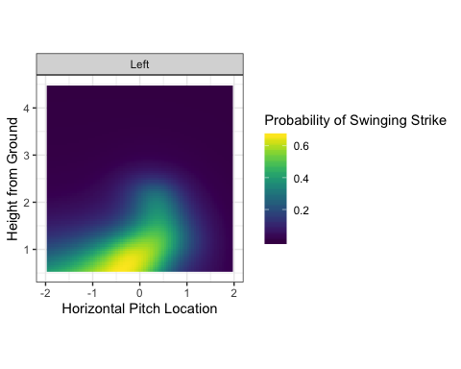

**Changeup**

|  |  |  |  |
| --- | --- | --- | --- |
|  | ch Mean | ch Range- | ch Range+ |
| CH Velo | 77.1 | 75.5 | 78.7 |
| CH Spin Rate | 1515.5 | 1365.7 | 1665.2 |
| CH Induced Vert. Break | 11.8 | 7.7 | 16.0 |
| CH Vertical Break | -34.0 | -38.1 | -29.8 |
| CH Horizontal Break | -5.5 | -9.9 | -1.2 |
| CH Vert. Approach Angle | -7.8 | -9.0 | -6.7 |
| CH Speed Drop | 6.5 | 5.9 | 7.2 |

**Contact Visualizations**

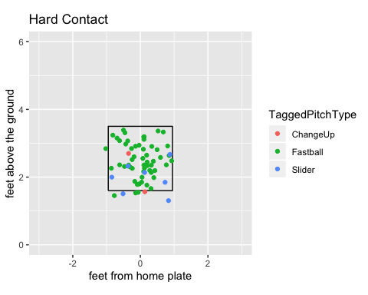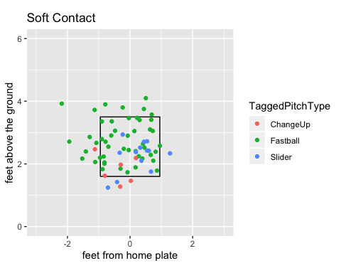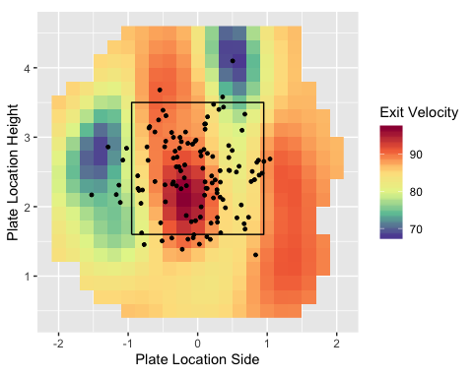

p3fb

## Warning: Removed 6561 rows containing missing values (geom_rect).

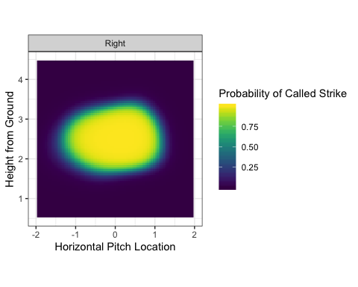

p5b

## Warning: Removed 6561 rows containing missing values (geom_rect).

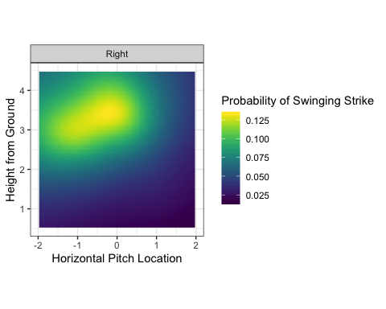

**Swinging Strike Visuals**

p5

## Warning: Removed 1 rows containing missing values (geom_point).

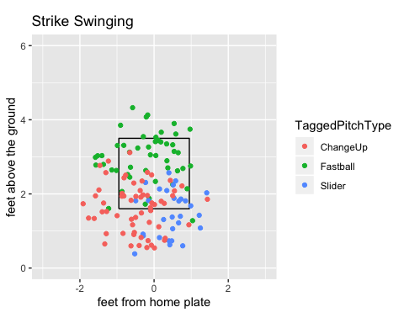

p5b

## Warning: Removed 6561 rows containing missing values (geom_rect).



**Release Point Breakdown** 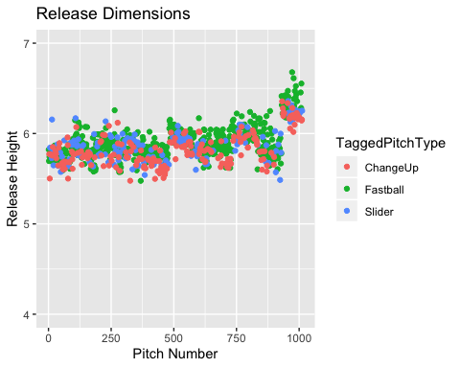

**Movement/Spin Axis**

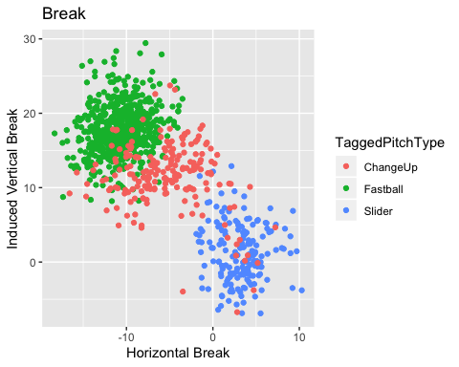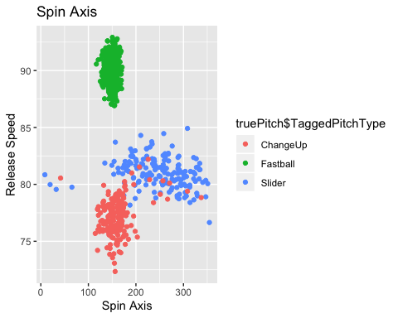

**Release/Approach Angles**

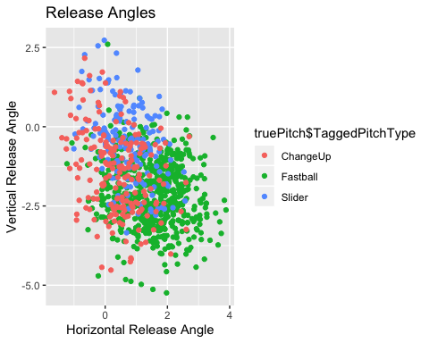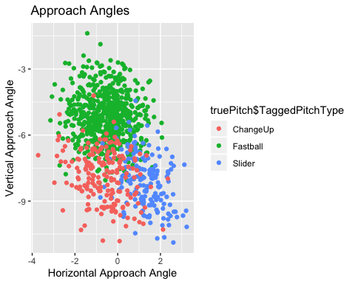

**Tunneling**

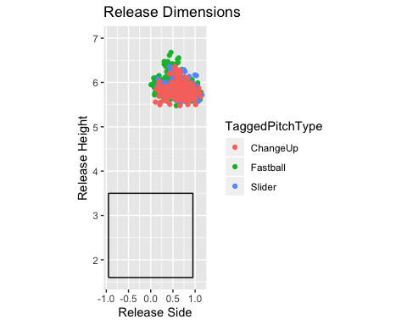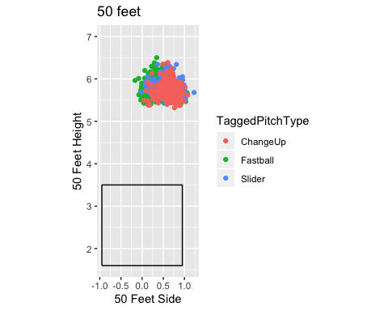

*Discipline Metrics*

kable(discipline_r, digits = 2, align = "lccc", position= "c")

|  |  |  |  |  |  |  |  |  |
| --- | --- | --- | --- | --- | --- | --- | --- | --- |
|  | InZone% | OutZone% | SwStr% | CallStr% | FoulBall% | Con% | IzSw% | OzSw% |
| FB | 0.46 | 0.54 | 0.08 | 0.18 | 0.18 | 0.17 | 0.68 | 0.23 |
| BB | 0.45 | 0.55 | 0.17 | 0.20 | 0.11 | 0.15 | 0.56 | 0.32 |
| CH | 0.25 | 0.75 | 0.32 | 0.09 | 0.05 | 0.07 | 0.75 | 0.33 |

kable(discipline_l, digits = 2, align = "lccc", position= "c")

|  |  |  |  |  |  |  |  |  |
| --- | --- | --- | --- | --- | --- | --- | --- | --- |
|  | InZone% | OutZone% | SwStr% | CallStr% | FoulBall% | Con% | IzSw% | OzSw% |
| FB | 0.54 | 0.46 | 0.08 | 0.19 | 0.15 | 0.20 | 0.67 | 0.17 |
| BB | 0.39 | 0.61 | 0.18 | 0.21 | 0.06 | 0.16 | 0.57 | 0.30 |
| CH | 0.21 | 0.79 | 0.36 | 0.07 | 0.07 | 0.07 | 0.67 | 0.45 |