Spray Charts

AA

9//2019

library(dplyr)

##   
## Attaching package: 'dplyr'

## The following objects are masked from 'package:stats':  
##   
## filter, lag

## The following objects are masked from 'package:base':  
##   
## intersect, setdiff, setequal, union

library(ggplot2)

Deacons = read.csv('Wake4Ayush.csv')  
head(Deacons)

## PitchNo Date Time PAofInning PitchofPA Pitcher  
## 1 1 2/15/19 3:59:41 PM 1 1 McSweeney, Morgan  
## 2 2 2/15/19 3:59:47 PM 1 2 McSweeney, Morgan  
## 3 3 2/15/19 4:00:01 PM 1 3 McSweeney, Morgan  
## 4 4 2/15/19 4:00:17 PM 1 4 McSweeney, Morgan  
## 5 5 2/15/19 4:00:30 PM 1 5 McSweeney, Morgan  
## 6 6 2/15/19 4:00:45 PM 1 6 McSweeney, Morgan  
## PitcherId PitcherThrows PitcherTeam Batter BatterId BatterSide  
## 1 8889973 Right WAK_DEA Brown, Elijah 1000009864 Left  
## 2 8889973 Right WAK_DEA Brown, Elijah 1000009864 Left  
## 3 8889973 Right WAK_DEA Brown, Elijah 1000009864 Left  
## 4 8889973 Right WAK_DEA Brown, Elijah 1000009864 Left  
## 5 8889973 Right WAK_DEA Brown, Elijah 1000009864 Left  
## 6 8889973 Right WAK_DEA Brown, Elijah 1000009864 Left  
## BatterTeam PitcherSet Inning Top.Bottom Outs Balls Strikes  
## 1 SAC_PIO Windup 1 Top 0 0 0  
## 2 SAC_PIO Windup 1 Top 0 1 0  
## 3 SAC_PIO Windup 1 Top 0 2 0  
## 4 SAC_PIO Windup 1 Top 0 3 0  
## 5 SAC_PIO Windup 1 Top 0 3 1  
## 6 SAC_PIO Windup 1 Top 0 3 2  
## TaggedPitchType AutoPitchType PitchCall KorBB HitType  
## 1 Fastball Undefined BallCalled Undefined Undefined  
## 2 Slider Slider BallCalled Undefined Undefined  
## 3 Fastball Fastball BallCalled Undefined Undefined  
## 4 Fastball Fastball StrikeCalled Undefined Undefined  
## 5 Fastball Fastball StrikeSwinging Undefined Undefined  
## 6 Fastball Fastball StrikeSwinging Strikeout Undefined  
## PlayResult OutsOnPlay RunsScored Notes RelSpeed VertRelAngle  
## 1 Undefined 0 0 NA NA NA  
## 2 Undefined 0 0 NA 84.23255 -1.07554267  
## 3 Undefined 0 0 NA 91.24500 0.04251552  
## 4 Undefined 0 0 NA 91.70311 -0.73245058  
## 5 Undefined 0 0 NA 92.49611 -1.22112645  
## 6 Undefined 0 0 NA 94.17915 -1.51985608  
## HorzRelAngle SpinRate SpinAxis Tilt RelHeight RelSide Extension  
## 1 NA NA NA NA NA NA  
## 2 -2.4082987 NA 107.4561 9:30 5.363378 1.4306846 5.807304  
## 3 -1.8569801 2276.630 203.3535 12:45 5.713891 1.0314675 6.815261  
## 4 -1.6009266 2237.017 210.8246 1:00 5.620063 0.9932288 6.380104  
## 5 -1.4310439 2267.922 195.8120 12:30 5.732850 1.0605666 6.377935  
## 6 -0.6918148 2331.157 192.9460 12:30 5.825744 0.8281148 6.555522  
## VertBreak InducedVertBreak HorzBreak PlateLocHeight PlateLocSide  
## 1 NA NA NA NA NA  
## 2 -37.09043 2.69200 -8.679746 1.271444 -1.53323598  
## 3 -16.33617 15.93592 6.893841 4.391347 -0.08863144  
## 4 -20.04495 12.31245 7.365015 3.275624 0.13402503  
## 5 -13.44873 18.75863 5.320979 3.488333 0.18734415  
## 6 -13.33719 17.25967 3.974200 3.320536 0.52503720  
## ZoneSpeed VertApprAngle HorzApprAngle ZoneTime ExitSpeed Angle  
## 1 NA NA NA NA NA NA  
## 2 76.82715 -8.013761 -4.04342834 0.4539596 NA NA  
## 3 83.24440 -3.084015 -0.53689821 0.4088698 NA NA  
## 4 84.13951 -4.523856 -0.20493189 0.4094099 NA NA  
## 5 83.69065 -3.783252 -0.41563677 0.4084596 NA NA  
## 6 85.99173 -4.056418 0.06587855 0.3981162 NA NA  
## Direction HitSpinRate PositionAt110X PositionAt110Y PositionAt110Z  
## 1 NA NA NA NA NA  
## 2 NA NA NA NA NA  
## 3 NA NA NA NA NA  
## 4 NA NA NA NA NA  
## 5 NA NA NA NA NA  
## 6 NA NA NA NA NA  
## Distance LastTrackedDistance Bearing HangTime pfxx pfxz  
## 1 NA NA NA NA NA NA  
## 2 NA NA NA NA 3.932144 1.785654  
## 3 NA NA NA NA -4.372070 8.879298  
## 4 NA NA NA NA -4.469719 6.950318  
## 5 NA NA NA NA -3.369747 10.699430  
## 6 NA NA NA NA -2.391925 9.968472  
## x0 y0 z0 vx0 vy0 vz0 ax0 ay0  
## 1 NA NA NA NA NA NA NA NA  
## 2 -1.2282559 50 5.253366 5.415470 -122.3920 -3.4448931 5.897945 26.67305  
## 3 -0.9146614 50 5.710412 4.120804 -132.9554 -0.3511608 -7.812245 28.97271  
## 4 -0.8815745 50 5.557973 3.508234 -133.5775 -2.3209700 -8.102538 27.88170  
## 5 -0.9600926 50 5.638732 3.200605 -134.6087 -3.2800027 -6.117431 32.10180  
## 6 -0.7822145 50 5.715353 1.536813 -137.1880 -4.0420673 -4.551081 30.80908  
## az0 HomeTeam AwayTeam Stadium Level League  
## 1 NA WAK_DEA SAC_PIO GeneHooksField NCAA ACC  
## 2 -29.49569 WAK_DEA SAC_PIO GeneHooksField NCAA ACC  
## 3 -16.30805 WAK_DEA SAC_PIO GeneHooksField NCAA ACC  
## 4 -19.57478 WAK_DEA SAC_PIO GeneHooksField NCAA ACC  
## 5 -12.75033 WAK_DEA SAC_PIO GeneHooksField NCAA ACC  
## 6 -13.20718 WAK_DEA SAC_PIO GeneHooksField NCAA ACC  
## GameID PitchUID  
## 1 20190215-GeneHooksField-1 71bff009-b321-4ebf-88b9-9abbd8bb23f1  
## 2 20190215-GeneHooksField-1 9c80222c-3164-11e9-b163-94b86dcc8dae  
## 3 20190215-GeneHooksField-1 a5353673-3164-11e9-b163-94b86dcc8dae  
## 4 20190215-GeneHooksField-1 ae64338f-3164-11e9-b163-94b86dcc8dae  
## 5 20190215-GeneHooksField-1 b756074a-3164-11e9-b163-94b86dcc8dae  
## 6 20190215-GeneHooksField-1 bec9716e-3164-11e9-b163-94b86dcc8dae  
## EffectiveVelo MaxHeight MeasuredDuration SpeedDrop PitchLastMeasuredX  
## 1 NA NA NA NA NA  
## 2 83.03025 NA NA 7.405399 0.1334805  
## 3 92.18674 NA NA 8.000594 -2.9384282  
## 4 92.06513 NA NA 7.563601 -2.4791753  
## 5 92.27934 NA NA 8.805466 -2.3971002  
## 6 94.67681 NA NA 8.187424 -2.2078163  
## PitchLastMeasuredY PitchLastMeasuredZ ContactPositionX ContactPositionY  
## 1 NA NA NA NA  
## 2 1.088123 1.6244612 NA NA  
## 3 4.145192 0.1245896 NA NA  
## 4 2.956380 -0.1241326 NA NA  
## 5 3.228866 -0.1625542 NA NA  
## 6 3.057067 -0.5311217 NA NA  
## ContactPositionZ GameUID  
## 1 NA c26c5ad2-3162-11e9-b163-94b86dcc8dae  
## 2 NA c26c5ad2-3162-11e9-b163-94b86dcc8dae  
## 3 NA c26c5ad2-3162-11e9-b163-94b86dcc8dae  
## 4 NA c26c5ad2-3162-11e9-b163-94b86dcc8dae  
## 5 NA c26c5ad2-3162-11e9-b163-94b86dcc8dae  
## 6 NA c26c5ad2-3162-11e9-b163-94b86dcc8dae  
## outside.of.zone.top.or.Bottom outside.of.zone.in.or.out outside.of.zone  
## 1 1 0 1  
## 2 1 1 1  
## 3 1 0 1  
## 4 1 0 1  
## 5 1 0 1  
## 6 1 0 1  
## in.zone swing swing.out swing.in Contact contact.out contact.in F.Strike  
## 1 0 0 0 0 0 0 0 0  
## 2 0 0 0 0 0 0 0 0  
## 3 0 0 0 0 0 0 0 0  
## 4 0 0 0 0 0 0 0 0  
## 5 0 1 1 0 0 0 0 0  
## 6 0 1 1 0 0 0 0 0  
## Swing.and.miss Plate.Appearences In.zone.2.0 Top.Right Top.Center  
## 1 0 1 0 0 0  
## 2 0 0 0 0 0  
## 3 0 0 0 0 0  
## 4 0 0 0 0 0  
## 5 1 0 0 0 0  
## 6 1 0 0 0 0  
## Top.Left Middle.Left Middle.Center Middle.Right Bottom.Right  
## 1 0 0 0 0 0  
## 2 0 0 0 0 0  
## 3 0 0 0 0 0  
## 4 0 0 0 0 0  
## 5 0 0 0 0 0  
## 6 0 0 0 0 0  
## Bottom.Center Bottom.Left Far.Bottom.Far.Left Far.Bottom.Left  
## 1 0 0 0 0  
## 2 0 0 1 0  
## 3 0 0 0 0  
## 4 0 0 0 0  
## 5 0 0 0 0  
## 6 0 0 0 0  
## Far.Bottom.Center Far.Bottom.Right Far.Bottom.Far.Right Bottom.Far.Left  
## 1 1 0 0 0  
## 2 0 0 0 0  
## 3 0 0 0 0  
## 4 0 0 0 0  
## 5 0 0 0 0  
## 6 0 0 0 0  
## Bottom.Far.Right Center.Far.Left Center.far.Right High.Far.Left  
## 1 0 0 0 0  
## 2 0 0 0 0  
## 3 0 0 0 0  
## 4 0 0 0 0  
## 5 0 0 0 0  
## 6 0 0 0 0  
## High.Far.Right Far.High.Far.Left Far.High.Left Far.High.Center  
## 1 0 0 0 0  
## 2 0 0 0 0  
## 3 0 0 0 1  
## 4 0 0 0 1  
## 5 0 0 0 1  
## 6 0 0 0 0  
## Far.High.Right Far.High.Far.Right X_Zone_Axis Hit.Location.Bin.X  
## 1 0 0 0 0.00  
## 2 0 0 2 0.00  
## 3 0 0 2 3.25  
## 4 0 0 4 0.00  
## 5 0 0 3 4.00  
## 6 1 0 0 0.00  
## Hit.Location.Bin.Y Y_Zone_Axis X0.0 X1.0 X0.1 X1.1 X1.2 X0.2 X2.0 X2.1  
## 1 0 5 1 0 0 0 0 0 0 0  
## 2 0 3 0 1 0 0 0 0 0 0  
## 3 3 2 0 0 0 0 0 0 1 0  
## 4 0 3 0 0 0 0 0 0 0 0  
## 5 4 4 0 0 0 0 0 0 0 0  
## 6 0 4 0 0 0 0 0 0 0 0  
## X2.2 X3.0 X3.1 X3.2 Fastball.0.0 ChangeUp.0.0 Curveball.0.0 Slider.0.0  
## 1 0 0 0 0 1 0 0 0  
## 2 0 0 0 0 0 0 0 0  
## 3 0 0 0 0 1 0 0 0  
## 4 0 1 0 0 0 0 0 1  
## 5 0 0 1 0 0 0 0 0  
## 6 0 0 0 1 1 0 0 0  
## Cutter.0.0 Sinker.0.0 Splitter.0.0 Knuckleball Fastball.1.0 Changeup.1.0  
## 1 0 0 0 0 0 0  
## 2 0 0 0 0 1 0  
## 3 0 0 0 0 0 0  
## 4 0 0 0 0 0 0  
## 5 0 0 0 0 0 0  
## 6 0 0 0 0 0 0  
## Curveball.1.0 Slider.1.0 Cutter.1.0 Sinker.1.0 Splitter.1.0  
## 1 0 0 0 0 0  
## 2 0 0 0 0 0  
## 3 0 0 0 0 0  
## 4 0 0 0 0 0  
## 5 0 0 0 0 0  
## 6 0 0 0 0 0  
## Knuckleball.1.0 Fastball Changeup Curveball Slider Cutter Sinker  
## 1 0 1 0 0 0 0 0  
## 2 0 1 0 0 0 0 0  
## 3 0 1 0 0 0 0 0  
## 4 0 0 0 0 1 0 0  
## 5 0 1 0 0 0 0 0  
## 6 0 1 0 0 0 0 0  
## Splitter Knuckleball2 Previous.Pitch.Type Previous.Pitch.Location  
## 1 0 0   
## 2 0 0 Fastball 0,5  
## 3 0 0   
## 4 0 0   
## 5 0 0 Fastball 4,3  
## 6 0 0   
## Pitch.Location PitchCount Pitch Pitches_Thrown Game.Type  
## 1 0,5 C 0-0 1 1 Game  
## 2 2,3 C 1-0 1 2 Game  
## 3 2,2 C 0-0 1 3 Game  
## 4 4,3 C 0-0 1 4 Game  
## 5 3,4 C 0-1 1 5 Game  
## 6 0,4 C 0-0 1 6 Game

Deacons %>%  
 select(PitchCall, Direction, Distance) %>%  
 head()

## PitchCall Direction Distance  
## 1 BallCalled NA NA  
## 2 BallCalled NA NA  
## 3 BallCalled NA NA  
## 4 StrikeCalled NA NA  
## 5 StrikeSwinging NA NA  
## 6 StrikeSwinging NA NA

unique(Deacons$PitchCall)

## [1] BallCalled StrikeCalled StrikeSwinging InPlay   
## [5] FoulBall HitByPitch BallIntentional  
## 7 Levels: BallCalled BallIntentional FoulBall HitByPitch ... StrikeSwinging

Deacons_BIP = Deacons %>%  
 filter(PitchCall == 'InPlay')  
  
Deacons_BIP %>%  
 select(PitchCall, Direction, Distance) %>%  
 head()

## PitchCall Direction Distance  
## 1 InPlay 10.448479 123.27025  
## 2 InPlay -6.416404 288.41910  
## 3 InPlay 27.467616 290.48318  
## 4 InPlay 22.250037 182.72104  
## 5 InPlay -12.201070 265.79181  
## 6 InPlay 17.951385 69.13891

summary(Deacons_BIP$Direction)

## Min. 1st Qu. Median Mean 3rd Qu. Max. NA's   
## -65.326 -19.567 -2.606 -1.758 14.581 142.879 310

summary(Deacons_BIP$Distance)

## Min. 1st Qu. Median Mean 3rd Qu. Max. NA's   
## 1.418 26.686 167.402 168.345 291.632 458.935 315

Deacons_BIP$hc_x = tan((Deacons_BIP$Direction)*(pi/180)) * Deacons_BIP$Distance  
Deacons_BIP$hc_y = Deacons_BIP$Distance  
  
  
summary(Deacons_BIP$hc_x)

## Min. 1st Qu. Median Mean 3rd Qu. Max. NA's   
## -278.609 -34.799 -1.847 -5.283 21.939 267.435 315

summary(Deacons_BIP$hc_y)

## Min. 1st Qu. Median Mean 3rd Qu. Max. NA's   
## 1.418 26.686 167.402 168.345 291.632 458.935 315

ggplot(Deacons_BIP, aes(x = hc_x, y = hc_y, color = PlayResult))+  
 geom_point()

## Warning: Removed 315 rows containing missing values (geom_point).

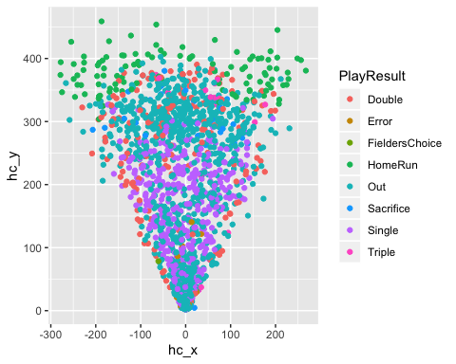

Adjust Name for updated Spray Charts:

LC = subset(Deacons_BIP, Batter == 'Lanzilli, Chris')  
  
colnames(LC)

## [1] "PitchNo" "Date"   
## [3] "Time" "PAofInning"   
## [5] "PitchofPA" "Pitcher"   
## [7] "PitcherId" "PitcherThrows"   
## [9] "PitcherTeam" "Batter"   
## [11] "BatterId" "BatterSide"   
## [13] "BatterTeam" "PitcherSet"   
## [15] "Inning" "Top.Bottom"   
## [17] "Outs" "Balls"   
## [19] "Strikes" "TaggedPitchType"   
## [21] "AutoPitchType" "PitchCall"   
## [23] "KorBB" "HitType"   
## [25] "PlayResult" "OutsOnPlay"   
## [27] "RunsScored" "Notes"   
## [29] "RelSpeed" "VertRelAngle"   
## [31] "HorzRelAngle" "SpinRate"   
## [33] "SpinAxis" "Tilt"   
## [35] "RelHeight" "RelSide"   
## [37] "Extension" "VertBreak"   
## [39] "InducedVertBreak" "HorzBreak"   
## [41] "PlateLocHeight" "PlateLocSide"   
## [43] "ZoneSpeed" "VertApprAngle"   
## [45] "HorzApprAngle" "ZoneTime"   
## [47] "ExitSpeed" "Angle"   
## [49] "Direction" "HitSpinRate"   
## [51] "PositionAt110X" "PositionAt110Y"   
## [53] "PositionAt110Z" "Distance"   
## [55] "LastTrackedDistance" "Bearing"   
## [57] "HangTime" "pfxx"   
## [59] "pfxz" "x0"   
## [61] "y0" "z0"   
## [63] "vx0" "vy0"   
## [65] "vz0" "ax0"   
## [67] "ay0" "az0"   
## [69] "HomeTeam" "AwayTeam"   
## [71] "Stadium" "Level"   
## [73] "League" "GameID"   
## [75] "PitchUID" "EffectiveVelo"   
## [77] "MaxHeight" "MeasuredDuration"   
## [79] "SpeedDrop" "PitchLastMeasuredX"   
## [81] "PitchLastMeasuredY" "PitchLastMeasuredZ"   
## [83] "ContactPositionX" "ContactPositionY"   
## [85] "ContactPositionZ" "GameUID"   
## [87] "outside.of.zone.top.or.Bottom" "outside.of.zone.in.or.out"   
## [89] "outside.of.zone" "in.zone"   
## [91] "swing" "swing.out"   
## [93] "swing.in" "Contact"   
## [95] "contact.out" "contact.in"   
## [97] "F.Strike" "Swing.and.miss"   
## [99] "Plate.Appearences" "In.zone.2.0"   
## [101] "Top.Right" "Top.Center"   
## [103] "Top.Left" "Middle.Left"   
## [105] "Middle.Center" "Middle.Right"   
## [107] "Bottom.Right" "Bottom.Center"   
## [109] "Bottom.Left" "Far.Bottom.Far.Left"   
## [111] "Far.Bottom.Left" "Far.Bottom.Center"   
## [113] "Far.Bottom.Right" "Far.Bottom.Far.Right"   
## [115] "Bottom.Far.Left" "Bottom.Far.Right"   
## [117] "Center.Far.Left" "Center.far.Right"   
## [119] "High.Far.Left" "High.Far.Right"   
## [121] "Far.High.Far.Left" "Far.High.Left"   
## [123] "Far.High.Center" "Far.High.Right"   
## [125] "Far.High.Far.Right" "X_Zone_Axis"   
## [127] "Hit.Location.Bin.X" "Hit.Location.Bin.Y"   
## [129] "Y_Zone_Axis" "X0.0"   
## [131] "X1.0" "X0.1"   
## [133] "X1.1" "X1.2"   
## [135] "X0.2" "X2.0"   
## [137] "X2.1" "X2.2"   
## [139] "X3.0" "X3.1"   
## [141] "X3.2" "Fastball.0.0"   
## [143] "ChangeUp.0.0" "Curveball.0.0"   
## [145] "Slider.0.0" "Cutter.0.0"   
## [147] "Sinker.0.0" "Splitter.0.0"   
## [149] "Knuckleball" "Fastball.1.0"   
## [151] "Changeup.1.0" "Curveball.1.0"   
## [153] "Slider.1.0" "Cutter.1.0"   
## [155] "Sinker.1.0" "Splitter.1.0"   
## [157] "Knuckleball.1.0" "Fastball"   
## [159] "Changeup" "Curveball"   
## [161] "Slider" "Cutter"   
## [163] "Sinker" "Splitter"   
## [165] "Knuckleball2" "Previous.Pitch.Type"   
## [167] "Previous.Pitch.Location" "Pitch.Location"   
## [169] "PitchCount" "Pitch"   
## [171] "Pitches_Thrown" "Game.Type"   
## [173] "hc_x" "hc_y"

LC %>%  
 select(PitchCall, Direction, Distance) %>%  
 head()

## PitchCall Direction Distance  
## 11 InPlay -21.962144 8.634593  
## 20 InPlay -44.057490 8.902690  
## 31 InPlay -36.691469 373.899232  
## 41 InPlay 1.608335 30.282774  
## 66 InPlay -10.124818 8.040641  
## 82 InPlay 6.203708 353.527536

unique(LC$PitchCall)

## [1] InPlay  
## 7 Levels: BallCalled BallIntentional FoulBall HitByPitch ... StrikeSwinging

LC_BIP = LC %>%  
 filter(PitchCall == 'InPlay')  
  
LC_BIP %>%  
 select(PitchCall, Direction, Distance) %>%  
 head()

## PitchCall Direction Distance  
## 1 InPlay -21.962144 8.634593  
## 2 InPlay -44.057490 8.902690  
## 3 InPlay -36.691469 373.899232  
## 4 InPlay 1.608335 30.282774  
## 5 InPlay -10.124818 8.040641  
## 6 InPlay 6.203708 353.527536

summary(LC_BIP$hc_x)

## Min. 1st Qu. Median Mean 3rd Qu. Max. NA's   
## -278.6093 -63.3284 -14.1119 -30.4738 -0.2667 189.7384 21

summary(LC_BIP$hc_y)

## Min. 1st Qu. Median Mean 3rd Qu. Max. NA's   
## 2.738 40.431 195.562 186.653 314.984 421.441 21

LC_R = subset(LC_BIP, PitcherThrows == 'Right')  
LC_L = subset(LC_BIP, PitcherThrows == 'Left')  
  
LC_R_FB = subset(LC_R, TaggedPitchType == 'Fastball')  
LC_R_CB = subset(LC_R, TaggedPitchType == 'Curveball')  
LC_R_SL = subset(LC_R, TaggedPitchType == 'Slider')  
LC_R_CH = subset(LC_R, TaggedPitchType == 'ChangeUp')  
  
LC_L_FB = subset(LC_L, TaggedPitchType == 'Fastball')  
LC_L_CB = subset(LC_L, TaggedPitchType == 'Curveball')  
LC_L_SL = subset(LC_L, TaggedPitchType == 'Slider')  
LC_L_CH = subset(LC_L, TaggedPitchType == 'ChangeUp')  
  
spray_chart = function(...){  
 ggplot(...) +   
 geom_curve(x = -225, xend = 225, y = 310, yend = 300, curvature = -0.45) +   
 geom_segment(x = -225, xend = 0, y = 310, yend = 0) +  
 geom_segment(x = 225, xend = 0, y = 300, yend = 0) +   
 geom_curve(x = -65, xend = 65, y = 95, yend = 95, curvature = -0.50, linetype = "dotted") +  
 coord_fixed() +  
 scale_x_continuous(NULL, limits = c(-300,300)) +   
 scale_y_continuous(NULL, limits = c(-25,500))  
}  
  
all_spray_chart = spray_chart(LC_BIP, aes(x = hc_x, y = hc_y, color = PlayResult)) +  
 geom_point() +  
 scale_color_hue()+  
 ggtitle('Spray Chart vs All')  
  
  
spray_chart = function(...){  
 ggplot(...) +   
 geom_curve(x = -225, xend = 225, y = 310, yend = 300, curvature = -0.45) +   
 geom_segment(x = -225, xend = 0, y = 310, yend = 0) +  
 geom_segment(x = 225, xend = 0, y = 300, yend = 0) +   
 geom_curve(x = -65, xend = 65, y = 95, yend = 95, curvature = -0.50, linetype = "dotted") +  
 coord_fixed() +  
 scale_x_continuous(NULL, limits = c(-300,300)) +   
 scale_y_continuous(NULL, limits = c(-25,500))  
}  
spray_chart_right = spray_chart(LC_R, aes(x = hc_x, y = hc_y, color = PlayResult)) +  
 geom_point() +  
 scale_color_hue()+  
 ggtitle('Spray Chart vs Right')  
  
spray_chart = function(...){  
 ggplot(...) +   
 geom_curve(x = -225, xend = 225, y = 310, yend = 300, curvature = -0.45) +   
 geom_segment(x = -225, xend = 0, y = 310, yend = 0) +  
 geom_segment(x = 225, xend = 0, y = 300, yend = 0) +   
 geom_curve(x = -65, xend = 65, y = 95, yend = 95, curvature = -0.50, linetype = "dotted") +  
 coord_fixed() +  
 scale_x_continuous(NULL, limits = c(-300,300)) +   
 scale_y_continuous(NULL, limits = c(-25,500))  
}  
  
spray_chart_left = spray_chart(LC_L, aes(x = hc_x, y = hc_y, color = PlayResult)) +  
 geom_point() +  
 scale_color_hue()+  
 ggtitle('Spray Chart vs Left')  
  
spray_chart_R_FB = spray_chart(LC_R_FB, aes(x = hc_x, y = hc_y, color = PlayResult)) +  
 geom_point() +  
 scale_color_hue()+  
 ggtitle('Spray Chart vs Righty Fastballs')  
  
spray_chart_R_CB = spray_chart(LC_R_CB, aes(x = hc_x, y = hc_y, color = PlayResult)) +  
 geom_point() +  
 scale_color_hue()+  
 ggtitle('Spray Chart vs Righty Curveballs')  
  
spray_chart_R_SL = spray_chart(LC_R_SL, aes(x = hc_x, y = hc_y, color = PlayResult)) +  
 geom_point() +  
 scale_color_hue()+  
 ggtitle('Spray Chart vs Righty Sliders')  
  
spray_chart_R_CH = spray_chart(LC_R_CH, aes(x = hc_x, y = hc_y, color = PlayResult)) +  
 geom_point() +  
 scale_color_hue()+  
 ggtitle('Spray Chart vs Righty Changeups')  
  
spray_chart_L_FB = spray_chart(LC_L_FB, aes(x = hc_x, y = hc_y, color = PlayResult)) +  
 geom_point() +  
 scale_color_hue()+  
 ggtitle('Spray Chart vs Lefty Fastballs')  
  
spray_chart_L_CB = spray_chart(LC_L_CB, aes(x = hc_x, y = hc_y, color = PlayResult)) +  
 geom_point() +  
 scale_color_hue()+  
 ggtitle('Spray Chart vs Lefty Curveballs')  
  
spray_chart_L_SL = spray_chart(LC_L_SL, aes(x = hc_x, y = hc_y, color = PlayResult)) +  
 geom_point() +  
 scale_color_hue()+  
 ggtitle('Spray Chart vs Lefty Sliders')  
  
spray_chart_L_CH = spray_chart(LC_L_CH, aes(x = hc_x, y = hc_y, color = PlayResult)) +  
 geom_point() +  
 scale_color_hue()+  
 ggtitle('Spray Chart vs Lefty Changeups')  
  
  
  
  
  
all_spray_chart

## Warning: Removed 21 rows containing missing values (geom_point).

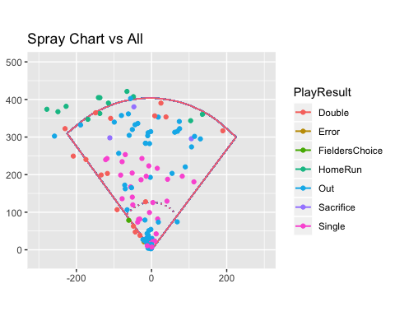

spray_chart_right

## Warning: Removed 14 rows containing missing values (geom_point).

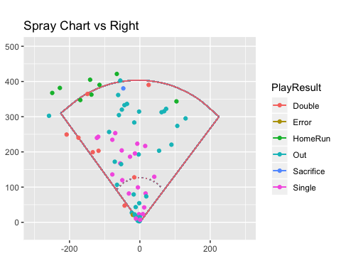

spray_chart_left

## Warning: Removed 7 rows containing missing values (geom_point).

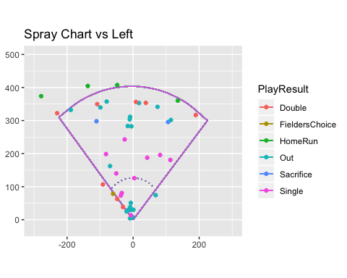

spray_chart_R_FB

## Warning: Removed 8 rows containing missing values (geom_point).

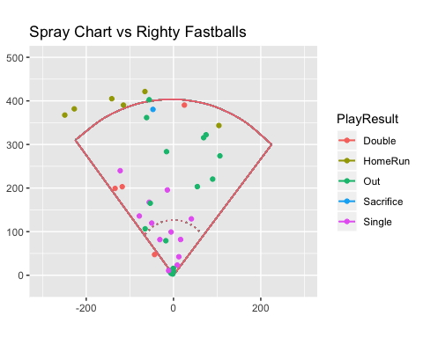

spray_chart_R_CB

## Warning: Removed 2 rows containing missing values (geom_point).

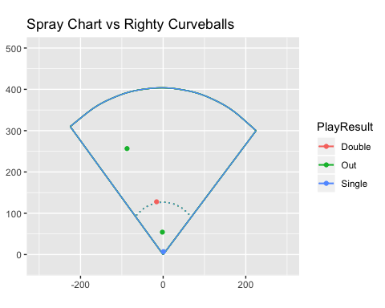

spray_chart_R_SL

## Warning: Removed 3 rows containing missing values (geom_point).

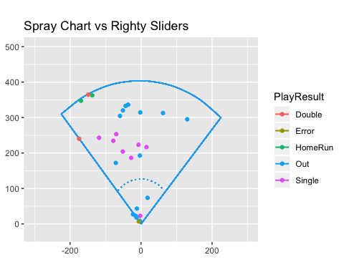

spray_chart_R_CH

## Warning: Removed 1 rows containing missing values (geom_point).

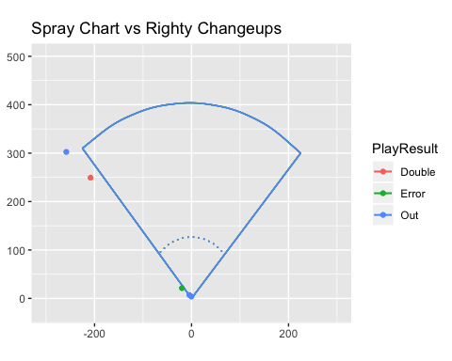

spray_chart_L_FB

## Warning: Removed 5 rows containing missing values (geom_point).

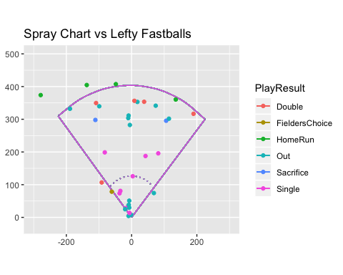

spray_chart_L_CB

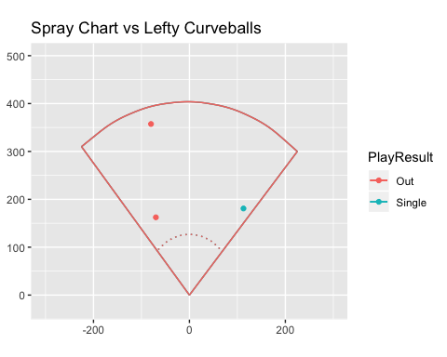

spray_chart_L_SL

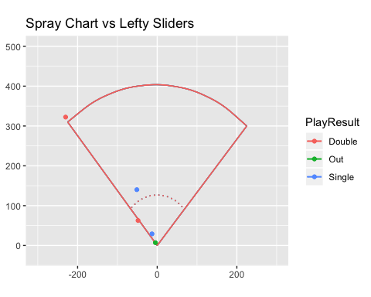

spray_chart_L_CH

## Warning: Removed 1 rows containing missing values (geom_point).

