**Details of environment:**

Computer Architecture : Intel® Core™ i5-3210M CPU @ 2.50GHz × 4

Ram : 8GB

OS: Ubuntu 14.04 LTS

Compiler : GNU CC Compiler (Option : -std=c99)

Language : C

Number of Experiment Runs : 1000

**Source of the code:**

<http://geeksquiz.com/mergesort>

<http://geeksquiz.com/insertion-sort/>

**Results:**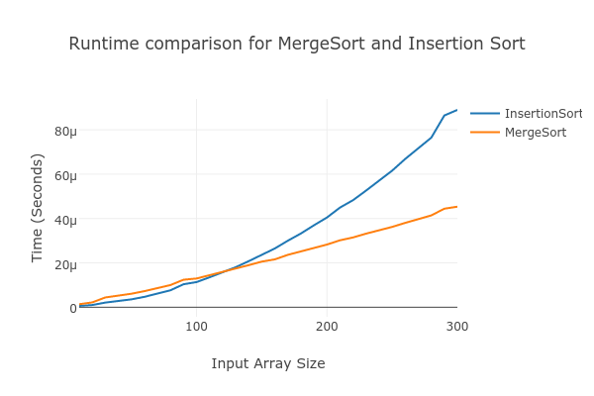

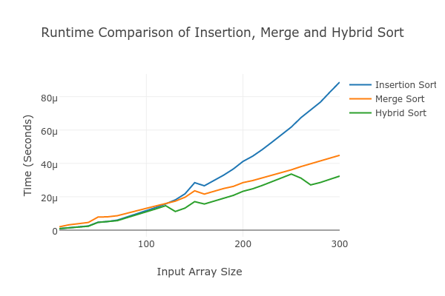

**Conclusion:**

The insertion sort algorithm was found to perform better until the array size of 130 while above that merge sort performs better which is clearly depicted in graph above. The cross over point in this experiment run is array size of 130 elements.

However, a hybrid algorithm was implemented in which the merge sort switched to insertion sort if the size of sub array is below or equal to the crossover point. Until the cross over point, the hybrid algorithm and insertion sort algorithm perform equally. But, above the cross over point hybrid algorithm performs better then both insertion and hybrid sort.