**Details of environment:**

Computer Architecture : Intel® Core™ i5-3210M CPU @ 2.50GHz × 4

Ram : 8GB

OS: Ubuntu 14.04 LTS

Compiler : GNU CC Compiler (Option : -std=c99)

Language : C

Number of Experiment Runs : 20

**Results:**

In this assignment, the value of binomial coefficient was calculated using three different approaches: divide and conquer, dynamic programming and memoized. The runtime for value of C(n,k) was compared for various experiments. In this experiment, the value of 'n' was changed increasingly with 10 until 100, while value of k was kept constant at 5. For each calculation the experiment was repeated 20 times and the run time was averaged for twenty experiments. The running time was written to a file (result.csv) that has been submitted along with the assignment. The results obtained are depicted in the graph below:

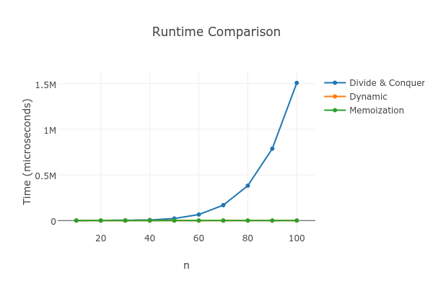

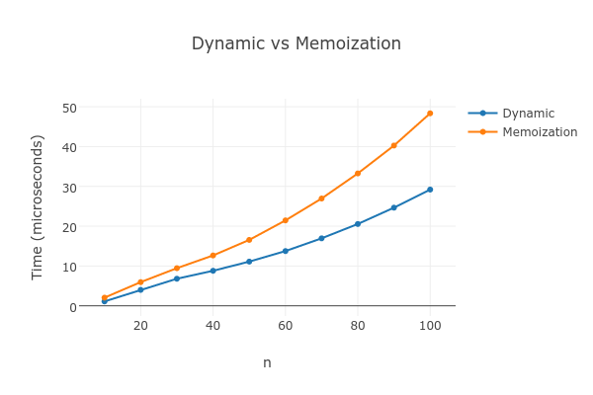

**Conclusion**

The divide and conquer algorithm was found to take very high amount of time compared to other two approaches. The higher amount of time clearly depicted that in case of divide and conquer algorithms all the subproblems were solved, due to which the number of function calls is high and so is the run time. The other two programming approaches, dynamic (bottom up) and top down (memoized) were significantly faster. However, the performance of dynamic programming algorithm was slightly better compared to the memoized version when the value of N was higher. The usage of dynamic memory allocation in memoized version could also be one of the reason for slight increase in running time.