e-YSIP 2022

Title of the Project

Intern 1 Name

Intern 2 Name

Mentor Name

Duration of Internship: 06*/*06*/*2022 − 23*/*07*/*2022

*2022, e-Yantra Publication*

# Project Name

## Abstract

Give the brief introduction and overview of the project

### Completion status

Give details for work/project completed successfully. If work is not complete, mention the details till which task is done.

## 1.1 Hardware parts

* List of hardware
* Detail of each hardware: Datasheet, page 5, Vendor link,
* Connection diagram

## 1.2 Software used

* List of software used
* Detail of software: version, [download link,](http://www.amazon.com/)
* Installation steps

## 1.3 Assembly of hardware

Circuit diagram and Steps of assembly of hardware with pictures for each

step

1

1.4. SOFTWARE AND CODE

**Circuit Diagram**

In our internship one of our task was to completely design a working PCB to assemble all the hardware used in our software on one board. Designing of PCB was Task 2 of our project. For that the timeline that we followed for making PCB was initially making Schematics, then

**Step 1 – Schematic Design of Board for Agriculture Applications**

This board consists of STM32-L073 Series chip suitable for low powered applications as is our case of agriculture applications which requires minimal computation capabilities, low power, and network independence. The STM32 L Series microcontroller address all these will help to speed up development time. The STM32 L0 Series is a 32-bit ultra-low-power MCUs designed to achieve an outstandingly low power consumption level. The result is a genuine ultra-low-power MCU with the world’s lowest power consumption at 125 °C.

The schematic designs consists of decoupling capacitors, Crystal Oscillator of 16MHz, External Pins for UART, I2C, Serial Wire JTAG Connection(for Serial Wire Debug). There is an external filter for analog signals using ferrite bead of 120 Ohm because analog signals need extra filtering.

There is a switch attached to BOOT0 Pin which is in RUN Mode at default. In this mode the stm32 will either run the code that is already uploaded on the chip or can be flashed using USB. But when the switch is turned to 3 i.e. High then the chip comes in FLASH mode and can be flashed using Serial Wire Debug.

This board also has a USB C Type plug along with AMS 117 voltage regulator which gives an output of 3.3V suitable for all our purposes. Calculation of Capacitance to be used with oscillator is done using the formula:

CL=2*(CL0-Cs)=2*(10-5)pF=10pF(as provided in the datasheet) Where CL = Capacitance to be used with oscillator is CL0 = Capacitance of capacitor inside oscillator CS = Stray Capacitance

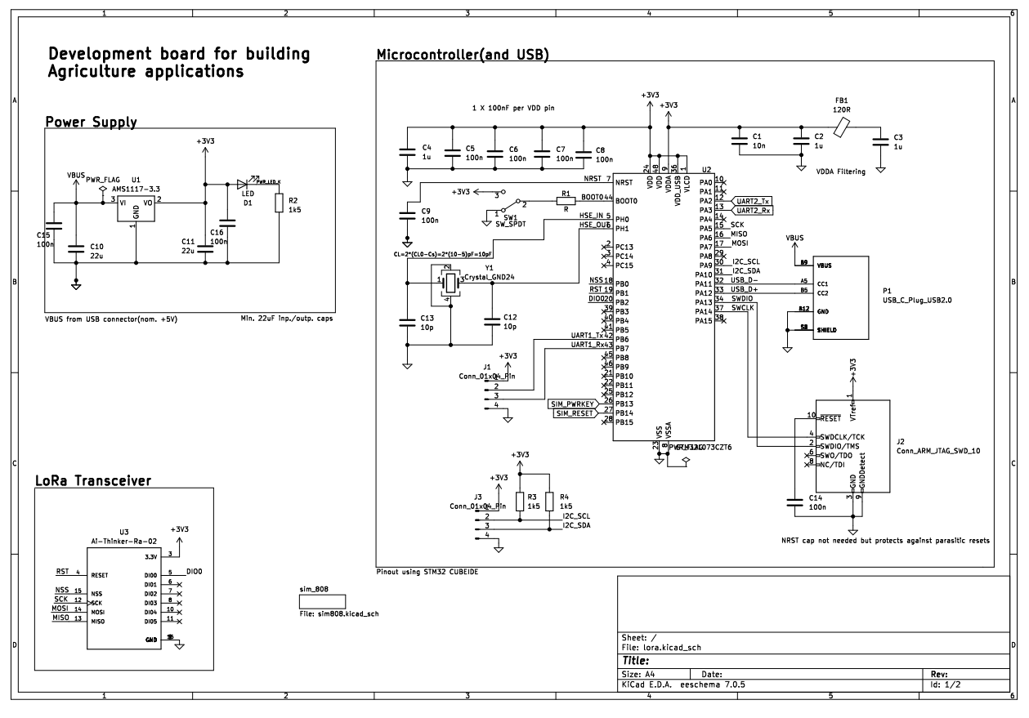

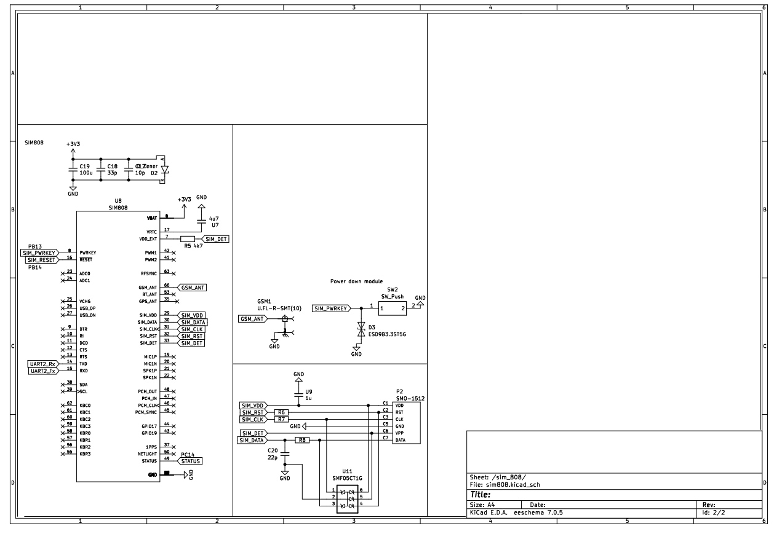

Fig – Schematic Design of Development Of Agricultural board

**Step 2 - PCB Layout Design**:

**Step 3**

Steps for assembling part 3

## 1.4 Software and Code

[Github link](http://www.github.com/) for the repository of code

Brief explanation of various parts of code

## 1.5 Use and Demo

Final Setup Image

User Instruction for demonstration

[Youtube Link](http://www.youtube.com/) of demonstration video

**1.6 Future Work**

What can be done to take this work ahead in future as projects.

## 1.7 Bug report and Challenges

Any issues in code and hardware.

Any failure or challenges faced during project

[www.e-yantra.org](http://www.e-yantra.org/) 2

# Bibliography

[1] Ad Kamerman and Leo Monteban, *WaveLAN-II: A High-Performance Wireless LAN for the Unlicensed band*, 1997.

3