**A PROJECT REPORT**

**ON**

**“WEB DEVELOPMENT – YEAR 1”**

**CSY1018 (NAMI)**

**“PERSONAL PORTFOLIO DEVELOPMENT”**

BY

NAME: **AYUSH BHUSAL**

NILE ID:**17439840**

NAYA AAYAM MULTIDISIPLINARY INSTITUTE

INTRODUCTION

The purpose of this project is to make students build a simple yet complete CV/Portfolio page, which could help in turn for our employability.

The aim of this project is to create a portfolio page with HTML and CSS coding to test the student’s capability to code for web, while also creating a decent aesthetically pleasing design.

The goals of the project are to create a home page introducing myself, a bio page with a biography of my own, a CV page for people to view my certifications and skills and a contact page for people to message/e-mail or follow me through social medias.

Project development methodology

A simple procedural development methodology was adopted for this project. Plans on how to develop the project was made beforehand. This project went through three different phases, which are:

1. Planning of the web page: After thoroughly reading through the Assignment brief and checklist a detailed understanding was gathered. Some notes were made about what contents will be written onto the web pages and what graphics or styles are to be used with them. A work log was developed to create a sequential workflow, and also to make myself work within a time constraint. This helped me create a good foundation of the project.
2. Development of the web page: All the outputs and prototypes were made during the development stage. Wireframe’s were developed, font styles, design scheme and the final prototype were obtained as asked by the project brief.
3. Finalization of the web pages: web pages were validated to see if they worked as were intended, Designs were finalized and the designs concepts were kept to testing to family members to check If the designs weren’t ambiguous or complex to understand.

Finally, a website was ready, with all errors corrected and was working as was intended.

Constraints

A small constraint was built for the webpage to adopt in design.

1. The webpage should be minimalistic.
2. It should follow googles material design.
3. Should be clear, Unambiguous and Aesthetically Pleasing.

Comparable websites

My website was not solely made by my own imagination. To create a good-looking websites research was done. I compared different websites with each other and analyzed how some feature made the website look good and more compelling to use. Analyzed finding were recorded for future use. I divided pros and cons of some website, and adopted some of the features or designs on my website. Although I have taken ideas from other websites but the final output was improvised to match my web scheme.

So, ideas were shared but not copied.

Findings

Fonts used

Google web font’s API was used to find good web fonts for the webpage. Since the webpage is directed towards simplicity and minimal design four fonts were selected. No handwritten fonts were used because it could confuse or may be hard to read, depending on the viewer. For the fonts to be selected they had to pass few tests, which are as follows:

1. The fonts shouldn’t be ambiguous, that is, no two fonts should look the same. For example, the letter ”I” might look similar to alphabet 1 or capital “I” and lower case “I” might look similar. This could confuse the user
2. Sans-serif fonts or monospace fonts were selected because serif fonts which have ending strokes might not look minimal.

With all these points in mind these fonts were selected:

Montserrat(Sans-Serif)

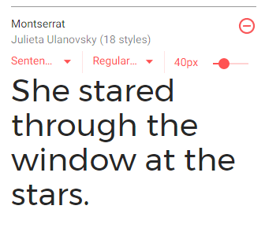

Open Sans(Sans-serif)

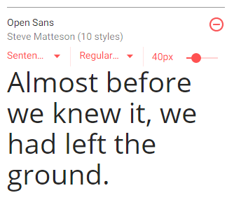

Cutive Mono(Monospace)

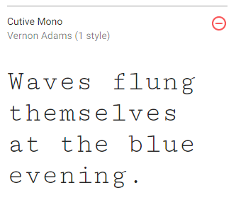

Color Schemes

For choosing the color scheme a physiological approach was used. After comparing different colors and their uses, I selected “Blue”.” Blue” because it signifies sky, sea and calmness in a person’s mind. This color Slows and eases the viewers’ attention. Since, only one color was not enough I went with the shades of blue. Four, Blue shades were selected and a monochromatic palette was made.

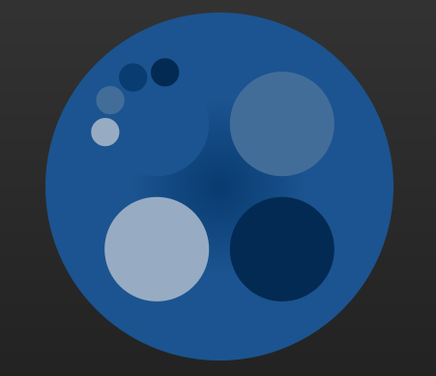

Planning’s

Wireframes

The website wasn’t built on the go. Mockups/wireframes were created to let me visualize what has to be on the websites. Although the website may not look as exact as the wireframes because some contents may be improvised, while others may be simplified as I was not capable to build such content.

1. Home page

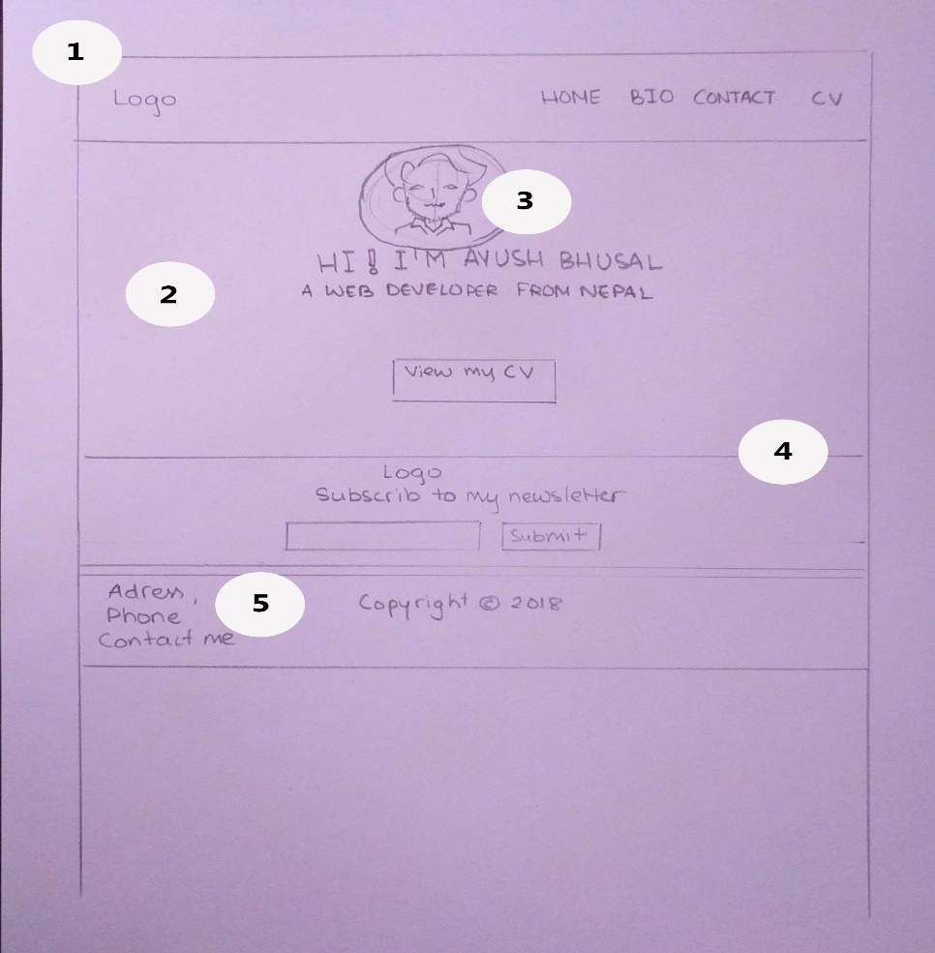

1. This section is the header of the page.
2. This section contains a background image for the contents.
3. This is a portrait image.
4. This is the footer of the page, which has a newsletter subscription option.
5. This section contains contact details.
6. Bio page

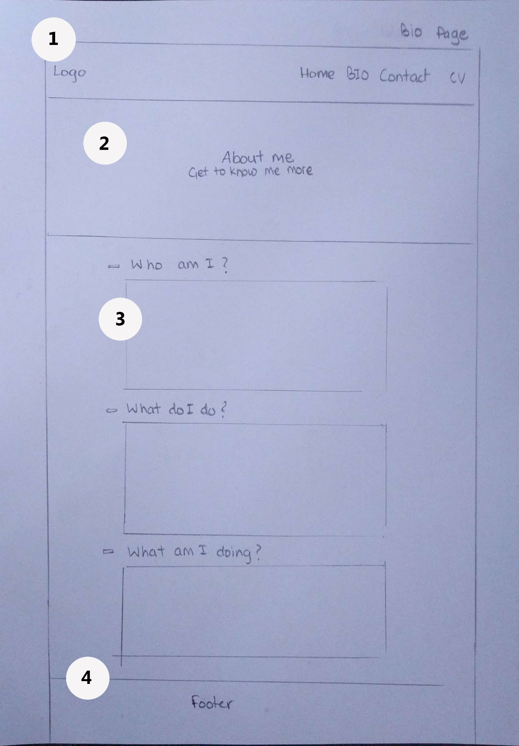

1. This section is the header of the page which contains a simple logo and the tabs buttons.
2. This section contains an image with a Title “About me”.
3. This section contains the content.
4. This is the footer of the page.
5. Contact page

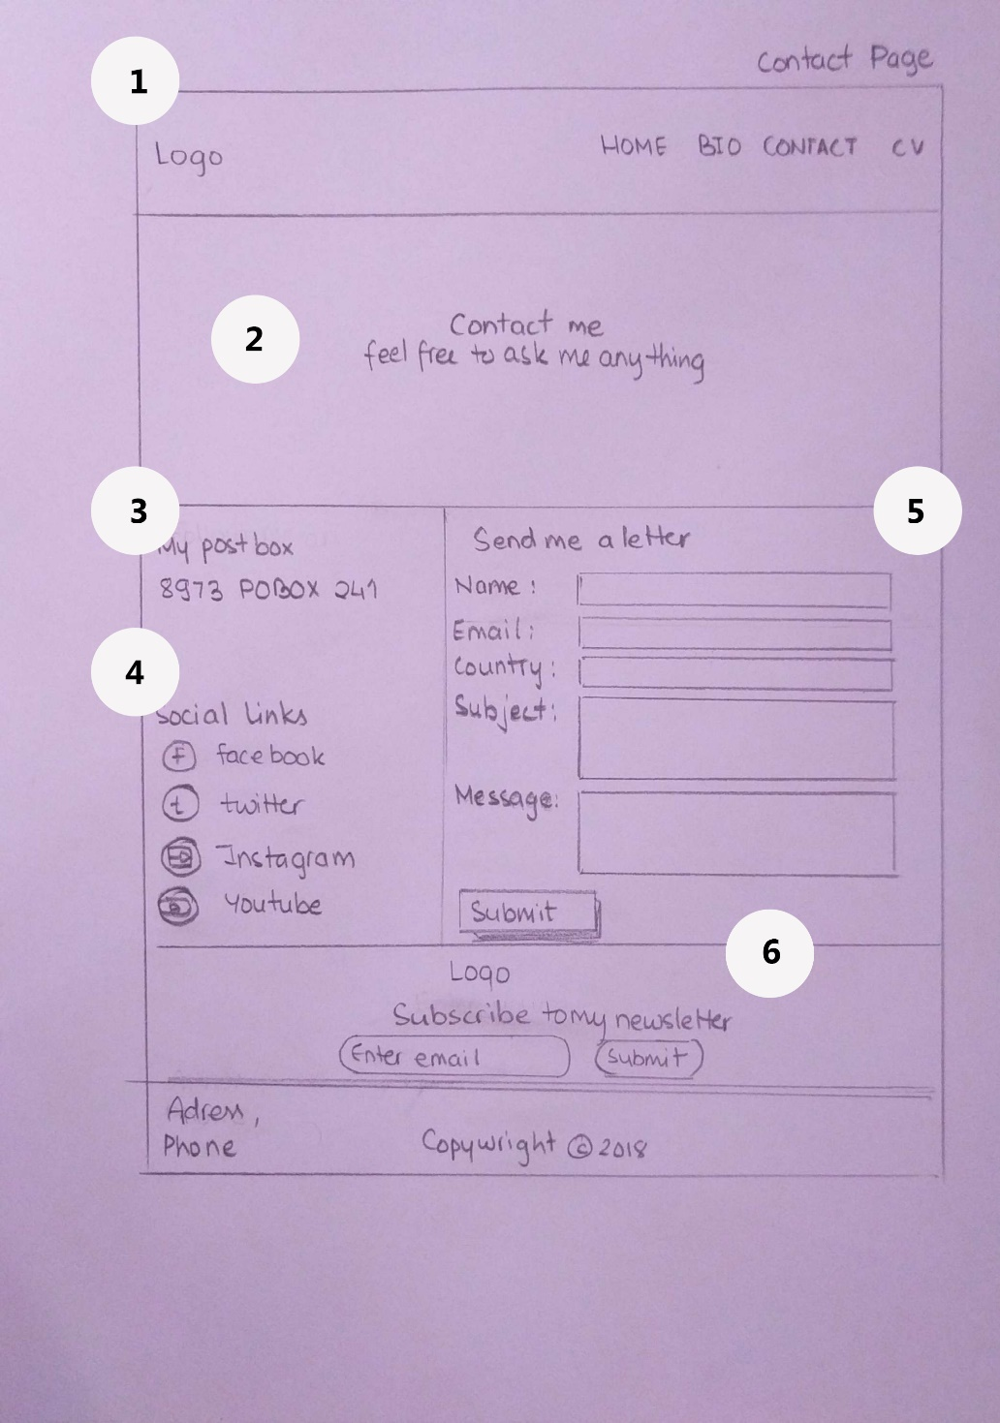

1. This section contains the header of the page.
2. This section has a background image with a title” Contact me”.
3. This contains my Postal address for sending mail.
4. This contains all my social links.
5. This is a form if the user wants to directly send me a mail online.
6. This is the footer of the page.
7. CV page

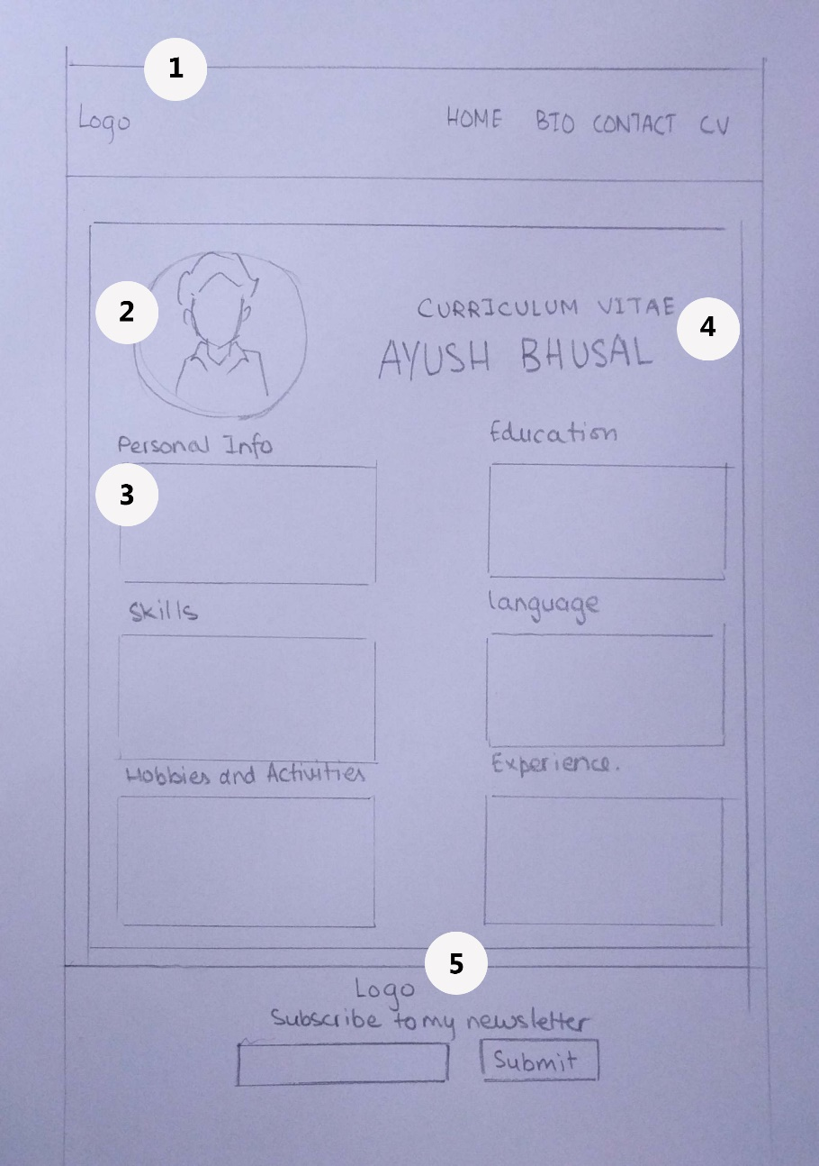

1. This is the header of the page.
2. This is my portrait image.
3. This contains the contents of the cv.
4. This is a title to the page “CURRICULUM VITAE”.
5. This is the footer of the page.

# Problems and solution

I faced different problems through different stages while creating the webpages. Firstly, I was not aware of design principles and conventions, for example, how fonts, color schemes were selected. I went through different articles and videos to have a clear understanding and used these practices in my website. For the design of the webpage I looked through different sites and adapted some of their qualities to complete my website.

It was easy to find solutions to design problems but was not the same for problems found in codes. Luckily, we were given validation links by our instructor. Using the link <https://validator.w3.org/>,for html codes and CSS codes were put on <https://jigsaw.w3.org/css-validator/> , these validators helped me find the errors while providing me information’s of errors in exact locations and problems to be fixed

## Validation

Problems found in the Index page:

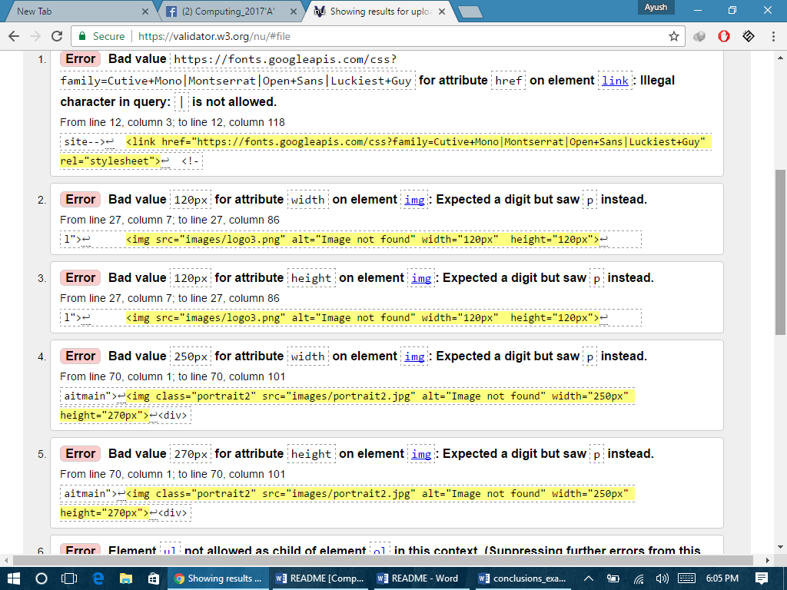

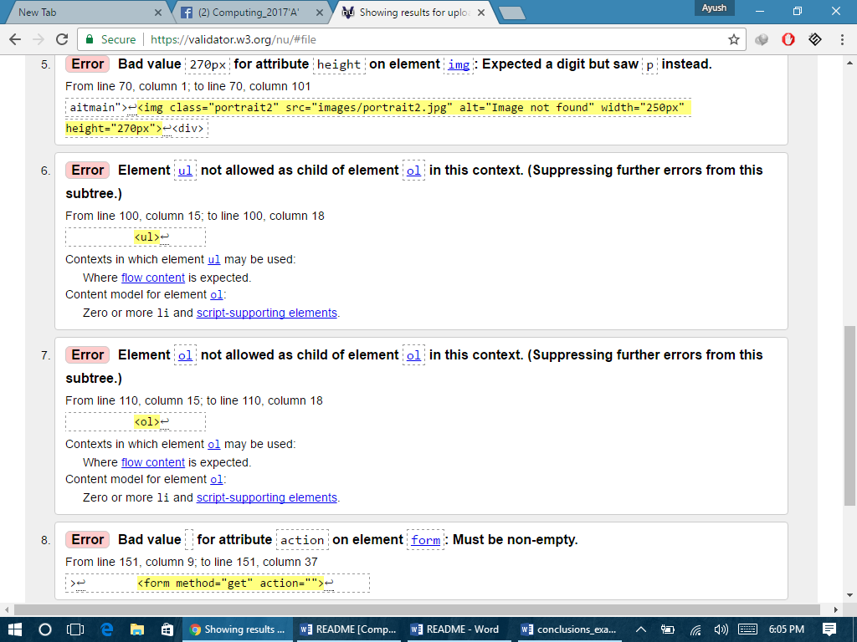

Errors like empty variable, bad value type, illegal nesting were found in the index page, which was then corrected as validator could help me specify exactly where the error was found.

Problems found in the Contact page:

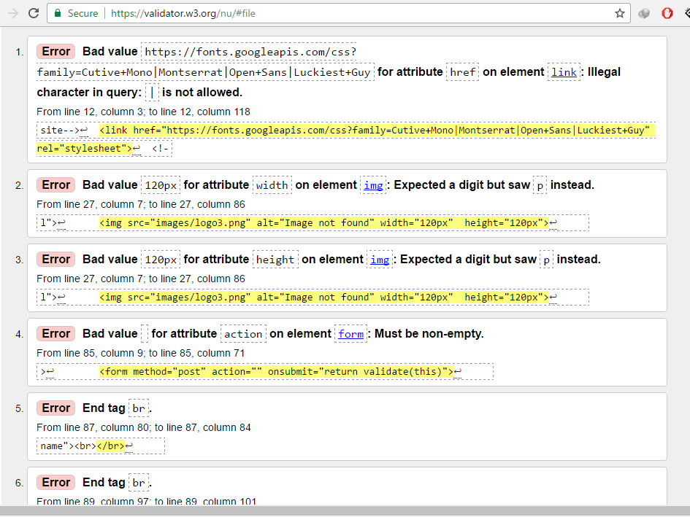

The Contact page had similar errors like in the index, with also error in missing end tag in attributes, empty element for form. I was also successful on correcting these.

Problems found in the Bio page:

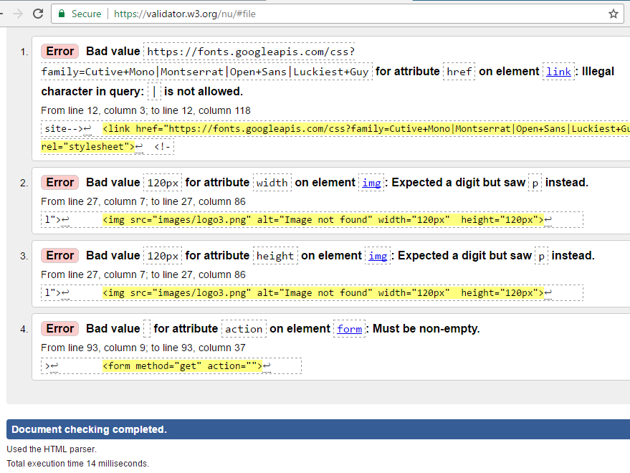

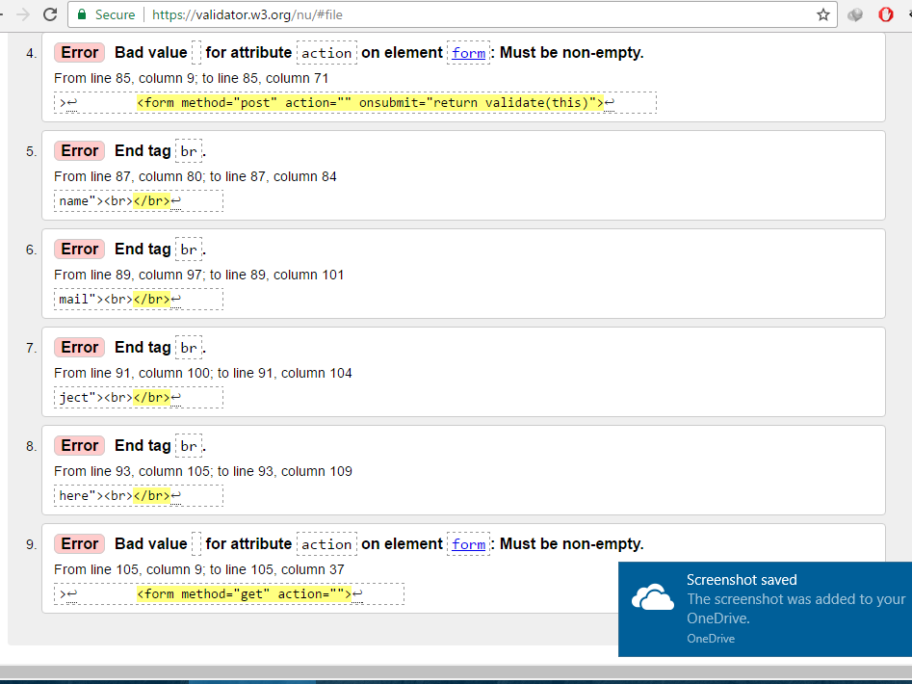

Problems found in the CV page:

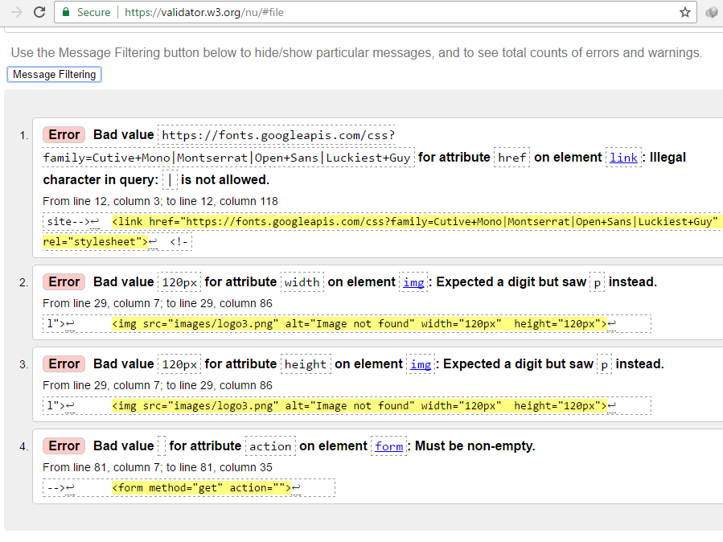

CSS error checking

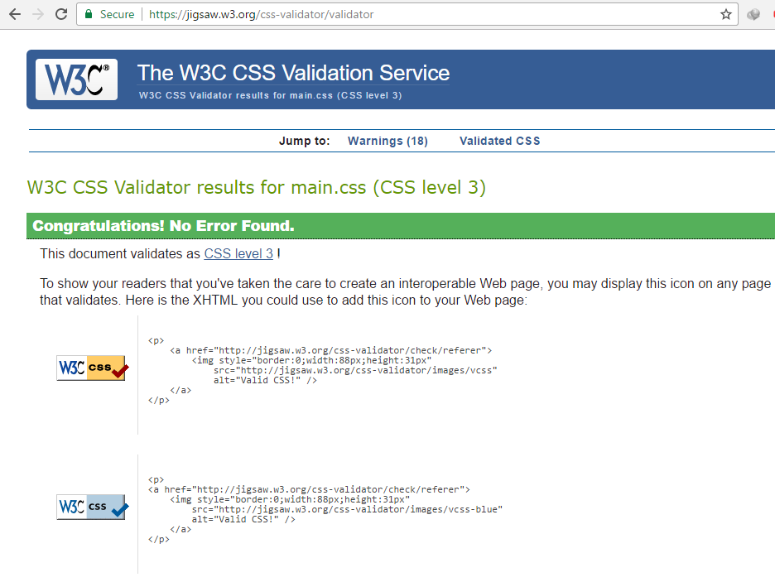

Successfully my CSS codes was error free, freeing me with less work.

Validation was done multiple times like this, So, my improved or later added codes were also error free. Doing this it was easier to manage the errors and I was able to make an error-free website.

# Conclusion

I knew that creating a website would be a hard task if not planned properly. So, I put my great effort on preliminary design process. I feared that creating a mockup highly aesthetic, might be hard to build so I focused myself on creating a minimalistic and simplistic design. This, made my work easy as I did not have to redesign the sketches halfway through the project, while changing the whole code from start. Doing this, I could improvise on the design later, rather than to fail because of having high expectations.

I worked on the assignment for 2 and a half week. I gave 3 hours of my time to design the webpages every day, that is 42 hours. Looking back, I found that developing a webpage is time consuming and iterative. I had to go through the codes every day, and improvise a little every day to make it simpler or advanced. Pages were reconstructed many times until the final result was achieved and I was satisfied. This gave me an insight to what process it took to build a website.