AI Usage DISCLOSURE FORM

1. Team Details
Team Name: VOID CREW
Project / Product Name: IntentOS
Organization / Institution (if any): Ramaiah Institute of Technology
Submission Date: 08-05-2026

2. AI Usage Declaration
Did your team use any Artificial Intelligence (AI) in developing this project? Yes / No
Yes

3. Purpose of AI Usage ( Brief Details)
Idea generation / brainstorming __________________
Code generation or assistance: Debugging, API integration help
UI / UX design: Dashboard layout ideas, component styling
Content creation ________________
Data analysis _______________
Testing / debugging: Error fixing, dependency troubleshooting
Other ________________________

4. Feature Origin Classification ( Please add/delete based on the number of the feature)
1. Feature Name: Workflow Automation System
2. Self-Generated/AI-Generated/Both: Self-Generated
3. Description ( include AI tools/platform Used, prompt used , Output Summary, Modification): Designed and implemented task execution flow, action sequencing, and recovery mechanism manually by the team.
1. Feature Name: Dashboard UI
2. Self-Generated/AI-Generated/Both: Both
3. Description (include AI tools/platform Used, prompt used , Output Summary, Modification) : Used AI tools for UI inspiration and layout suggestions. Final React components, styling, responsiveness, and workflow visualization were customized and modified manually. Platform Used : Antigravity, AI Tool: Claude Sonnet 4.6
1. Feature Name: Neural Workflow Memory
2. Self-Generated/AI-Generated/Both: Both
3. Description (include AI tools/platform Used, prompt used , Output Summary, Modification) : AI assisted in researching memory architecture concepts and optimization ideas. Core implementation logic and integration with the platform were developed and refined by the team. Gemini Flash 2.5 for LLM work & Sarvam AI for STT
1. Feature Name: Intent Parsing Engine
2. Self-Generated/AI-Generated/Both: Self-Generated
3. Description (include AI tools/platform Used, prompt used , Output Summary, Modification) : Designed and implemented the intent parsing architecture, workflow decomposition logic, and task routing system independently by the team.

5. Ethical & Compliance Confirmation
AI usage complies with guidelines and policies. Yes
No proprietary or copyrighted data misused. I Agree

6. Declaration & Sign-Off
Name of Team Representative: Ayush Kumar
Role: Team Leader
Signature: 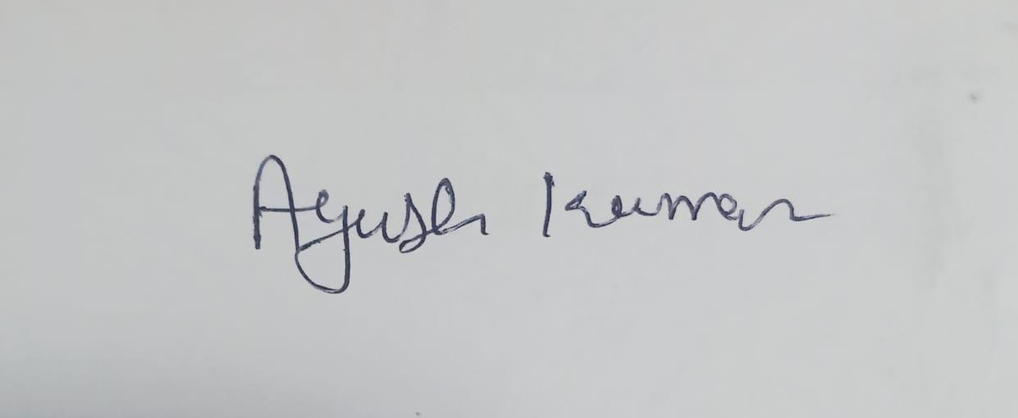

Date: 08-05-2026

