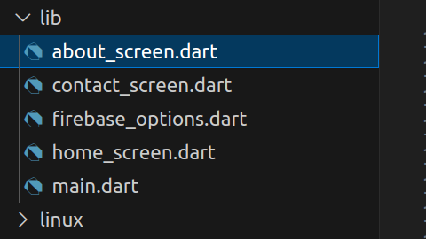

about_screen.dart

import 'package:flutter/material.dart';

class AboutScreen extends StatelessWidget {

@override

Widget build(BuildContext context) {

return Scaffold(

appBar: AppBar(title: Text('📄 My Resume')),

body: Padding(

padding: const EdgeInsets.all(16.0),

child: SingleChildScrollView(

child: Column(

crossAxisAlignment: CrossAxisAlignment.start,

children: [

Text("Brunda G", style: TextStyle(fontSize: 26, fontWeight: FontWeight.bold)),

Text("Assistant Professor | Technology Mentor", style: TextStyle(fontSize: 18)),

SizedBox(height: 20),

Text("📌 Professional Summary", style: TextStyle(fontSize: 20, fontWeight: FontWeight.bold)),

Text(

"I am an enthusiastic and innovative technology professional with expertise in empowering students and teams "

"through hands-on learning and practical projects. My work spans across mobile app development, cloud technologies, "

"DevOps automation, and AI-driven workflows. I believe in bridging the gap between academia and industry by "

"building real-world skills in learners.",

style: TextStyle(fontSize: 16),

),

SizedBox(height: 20),

Text("💼 Skills & Expertise", style: TextStyle(fontSize: 20, fontWeight: FontWeight.bold)),

Text(

"• Flutter & Mobile App Development\n"

"• DevOps, CI/CD & Cloud Deployment\n"

"• AI & Agentic Workflows\n"

"• Data Visualization (Python, Power BI, Tableau)\n"

"• Git, GitHub, and Agile Project Management\n"

"• Mentoring and guiding student projects to success",

style: TextStyle(fontSize: 16),

),

SizedBox(height: 20),

Text("🏆 Achievements", style: TextStyle(fontSize: 20, fontWeight: FontWeight.bold)),

Text(

"• Guided numerous student projects leading to internships and job offers.\n"

"• Conducted Faculty Development Programs on AI, DevOps, and automation tools.\n"

"• Developed academic tools integrating Agile and automation principles.\n"

"• Successfully implemented cloud-based and on-premise DevOps pipelines.",

style: TextStyle(fontSize: 16),

),

SizedBox(height: 30),

Center(

child: ElevatedButton.icon(

onPressed: () => Navigator.pop(context),

icon: Icon(Icons.home),

label: Text("Back to Home"),

),

),

],

),

),

),

);

}

}

contact_screen.dart

// lib/contact_screen.dart

import 'package:flutter/material.dart';

import 'package:cloud_firestore/cloud_firestore.dart';

class ContactScreen extends StatefulWidget {

@override

State<ContactScreen> createState() => _ContactScreenState();

}

class _ContactScreenState extends State<ContactScreen> {

final _formKey = GlobalKey<FormState>();

final _nameCtrl = TextEditingController();

final _emailCtrl = TextEditingController();

final _messageCtrl = TextEditingController();

bool _submitting = false;

@override

void dispose() {

_nameCtrl.dispose();

_emailCtrl.dispose();

_messageCtrl.dispose();

super.dispose();

}

Future<void> _submit() async {

if (!_formKey.currentState!.validate()) return;

setState(() => _submitting = true);

try {

await FirebaseFirestore.instance.collection('contacts').add({

'name': _nameCtrl.text.trim(),

'email': _emailCtrl.text.trim(),

'message': _messageCtrl.text.trim(),

'createdAt': FieldValue.serverTimestamp(),

});

if (!mounted) return;

ScaffoldMessenger.of(context).showSnackBar(

const SnackBar(content: Text('Thanks! Your message was sent.')),

);

_formKey.currentState!.reset();

_nameCtrl.clear();

_emailCtrl.clear();

_messageCtrl.clear();

} catch (e) {

if (!mounted) return;

ScaffoldMessenger.of(context).showSnackBar(

SnackBar(content: Text('Failed to submit: $e')),

);

} finally {

if (mounted) setState(() => _submitting = false);

}

}

@override

Widget build(BuildContext context) {

return Scaffold(

appBar: AppBar(title: const Text('📞 Contact Me')),

body: SafeArea(

child: Padding(

padding: const EdgeInsets.all(16.0),

child: Form(

key: _formKey,

child: ListView(

children: [

const Text(

"Get in Touch",

style: TextStyle(fontSize: 24, fontWeight: FontWeight.bold),

),

const SizedBox(height: 16),

// Name

TextFormField(

controller: _nameCtrl,

decoration: const InputDecoration(

labelText: 'Full Name',

prefixIcon: Icon(Icons.person),

border: OutlineInputBorder(),

),

validator: (v) =>

(v == null || v.trim().isEmpty) ? 'Enter your name' : null,

),

const SizedBox(height: 12),

// Email

TextFormField(

controller: _emailCtrl,

decoration: const InputDecoration(

labelText: 'Email',

prefixIcon: Icon(Icons.email),

border: OutlineInputBorder(),

),

keyboardType: TextInputType.emailAddress,

validator: (v) {

final text = v?.trim() ?? '';

final emailRegex = RegExp(r'^[^@\s]+@[^@\s]+\.[^@\s]+$');

if (text.isEmpty) return 'Enter your email';

if (!emailRegex.hasMatch(text)) return 'Enter a valid email';

return null;

},

),

const SizedBox(height: 12),

// Message

TextFormField(

controller: _messageCtrl,

decoration: const InputDecoration(

labelText: 'Message',

alignLabelWithHint: true,

prefixIcon: Icon(Icons.message),

border: OutlineInputBorder(),

),

minLines: 4,

maxLines: 6,

validator: (v) =>

(v == null || v.trim().isEmpty) ? 'Enter your message' : null,

),

const SizedBox(height: 20),

// Submit Button

SizedBox(

width: double.infinity,

child: ElevatedButton.icon(

onPressed: _submitting ? null : _submit,

icon: _submitting

? const SizedBox(

width: 18, height: 18, child: CircularProgressIndicator(strokeWidth: 2),

)

: const Icon(Icons.send),

label: Text(_submitting ? 'Sending...' : 'Send Message'),

),

),

const SizedBox(height: 12),

OutlinedButton.icon(

onPressed: () => Navigator.pop(context),

icon: const Icon(Icons.home),

label: const Text("Back to Home"),

),

],

),

),

),

),

);

}

}

home_screen.dart

import 'package:flutter/material.dart';

class HomeScreen extends StatelessWidget {

@override

Widget build(BuildContext context) {

return Scaffold(

appBar: AppBar(title: Text('🏠 Home')),

body: Padding(

padding: const EdgeInsets.all(16.0),

child: Column(

mainAxisAlignment: MainAxisAlignment.center,

children: [

CircleAvatar(

radius: 50,

child: Icon(Icons.person, size: 50, color: Colors.white),

backgroundColor: Colors.teal,

),

SizedBox(height: 20),

Text(

"Hi, I am Brunda 👋",

style: TextStyle(fontSize: 24, fontWeight: FontWeight.bold),

),

SizedBox(height: 10),

Text(

"A passionate educator, developer, and technology mentor, "

"helping students and professionals excel in modern tech skills.",

style: TextStyle(fontSize: 16),

textAlign: TextAlign.center,

),

SizedBox(height: 40),

ElevatedButton.icon(

onPressed: () => Navigator.pushNamed(context, '/about'),

icon: Icon(Icons.person),

label: Text("View My Resume"),

),

SizedBox(height: 10),

ElevatedButton.icon(

onPressed: () => Navigator.pushNamed(context, '/contact'),

icon: Icon(Icons.contact_mail),

label: Text("Contact Me"),

),

],

),

),

);

}

}

main.dart

// lib/main.dart

import 'package:flutter/material.dart';

import 'package:firebase_core/firebase_core.dart';

import 'firebase_options.dart';

import 'home_screen.dart';

import 'about_screen.dart';

import 'contact_screen.dart';

void main() async {

WidgetsFlutterBinding.ensureInitialized();

await Firebase.initializeApp(

options: DefaultFirebaseOptions.currentPlatform,

);

runApp(MyApp());

}

class MyApp extends StatelessWidget {

@override

Widget build(BuildContext context) {

return MaterialApp(

debugShowCheckedModeBanner: false,

title: 'Brunda - Flutter Demo',

theme: ThemeData(primarySwatch: Colors.teal),

initialRoute: '/',

routes: {

'/': (context) => HomeScreen(),

'/about': (context) => AboutScreen(),

'/contact': (context) => ContactScreen(),

},

);

}

}

In vs code:

dart pub add firebase_core cloud_firestore

After executing the above command

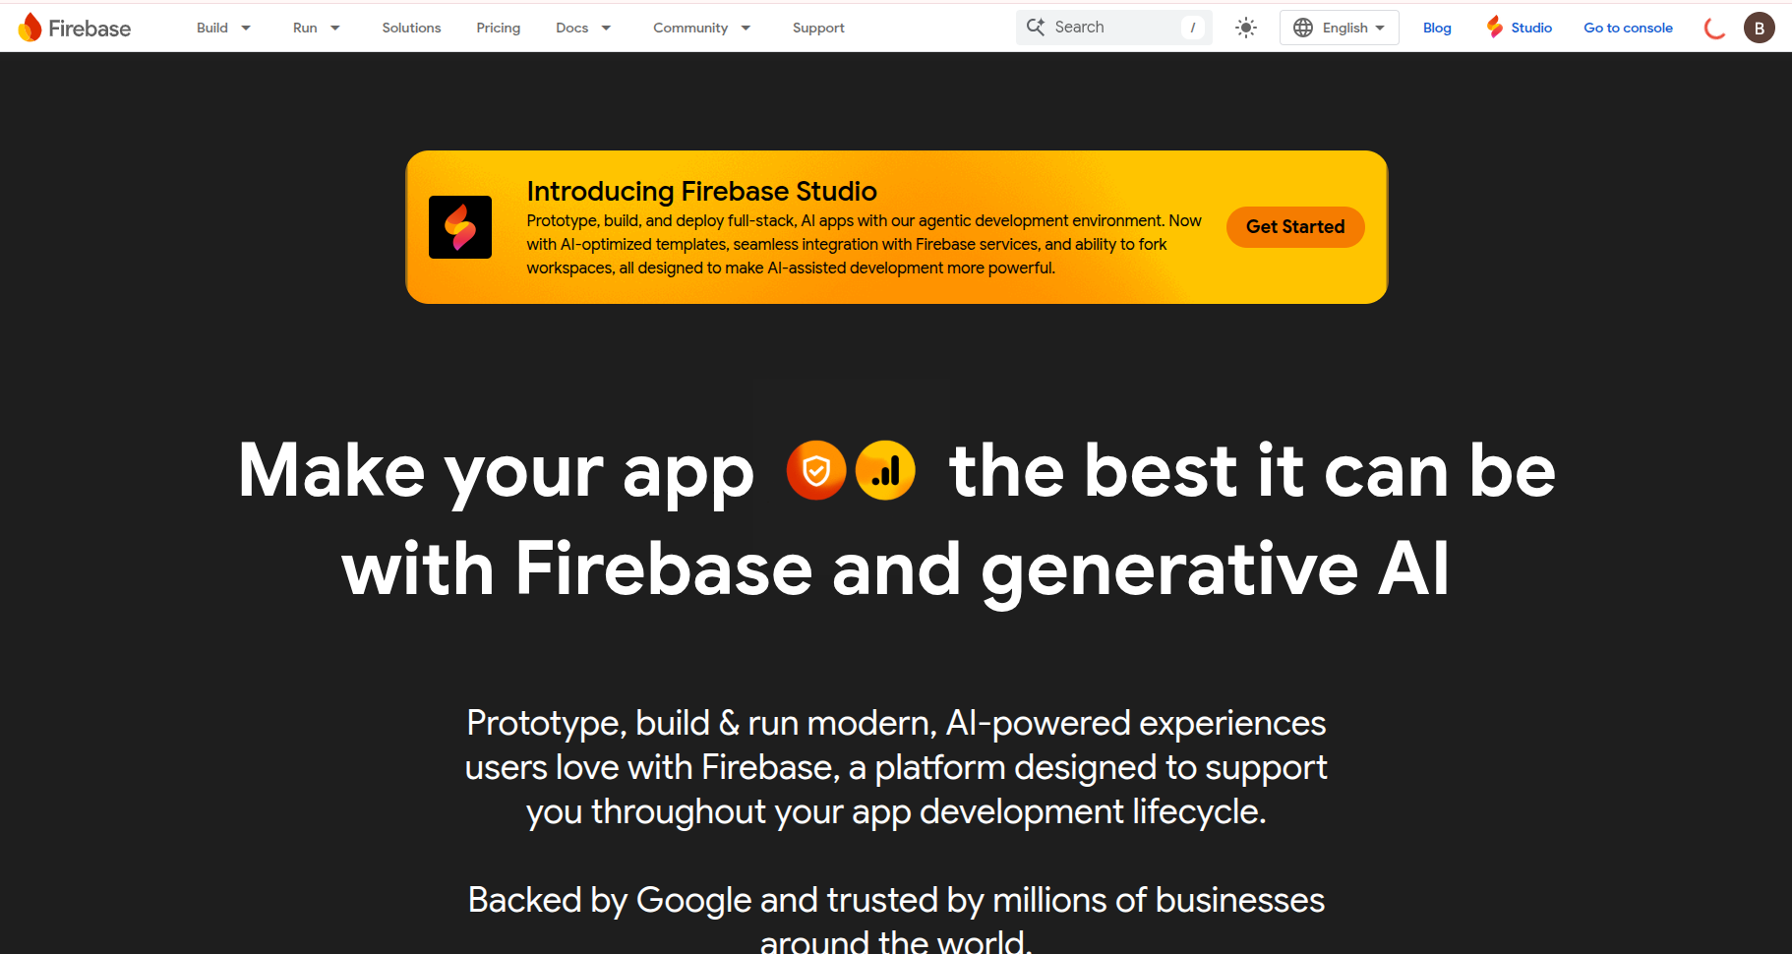

Create a project in flutter

Login to flutter

Then click on go to console

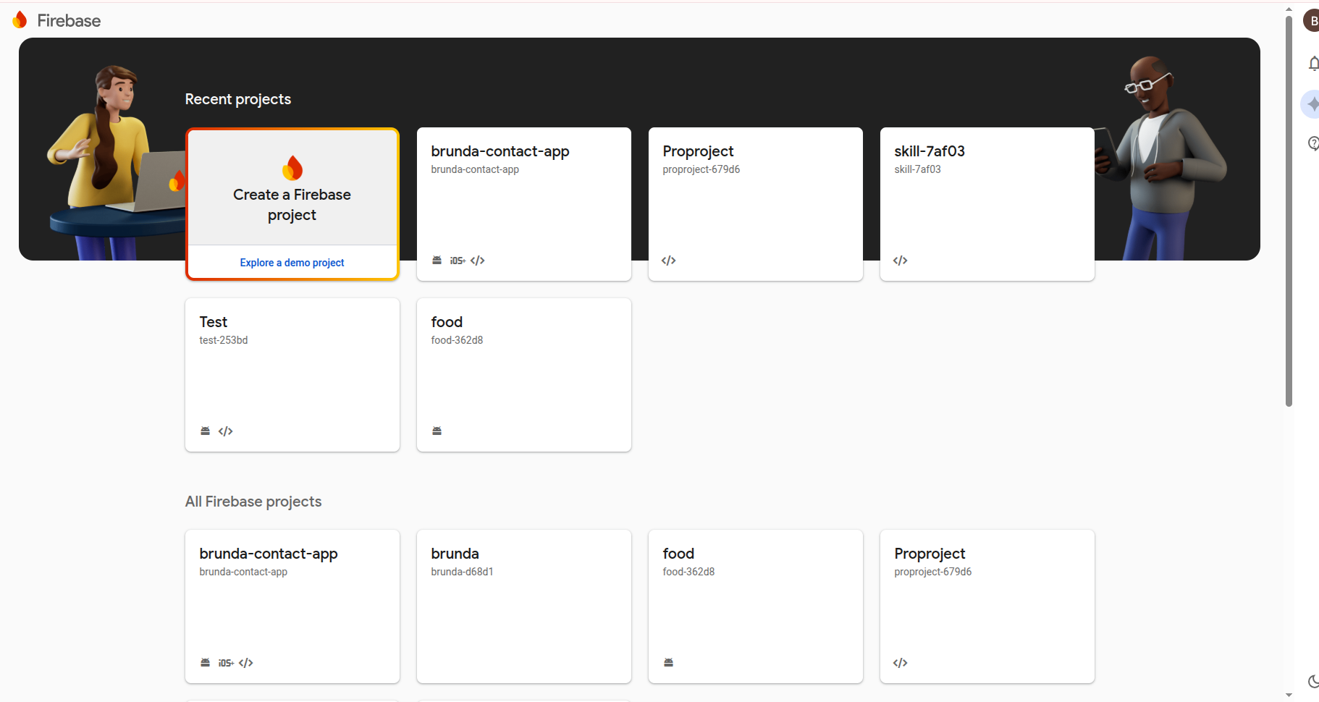

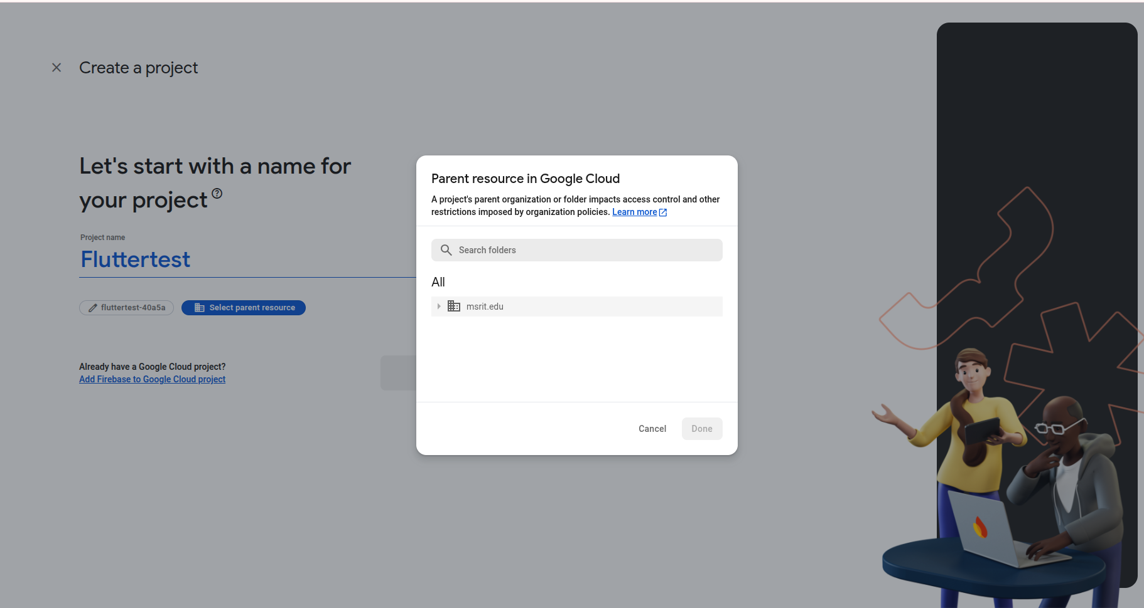

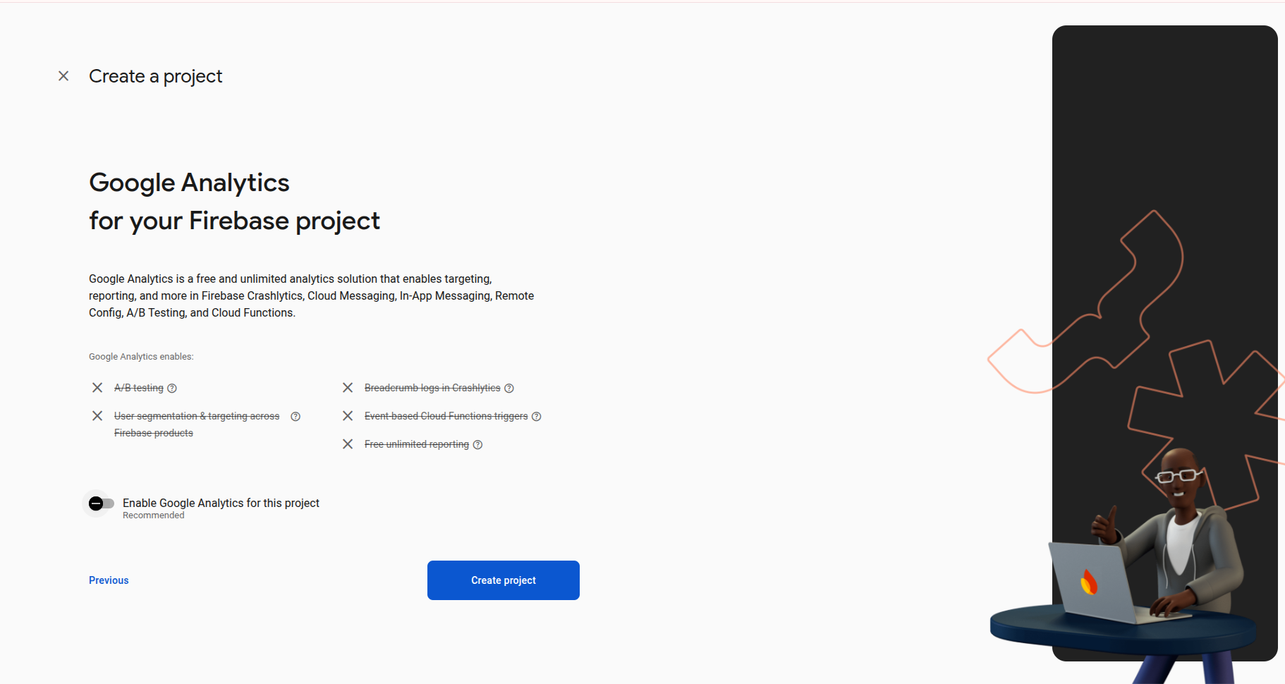

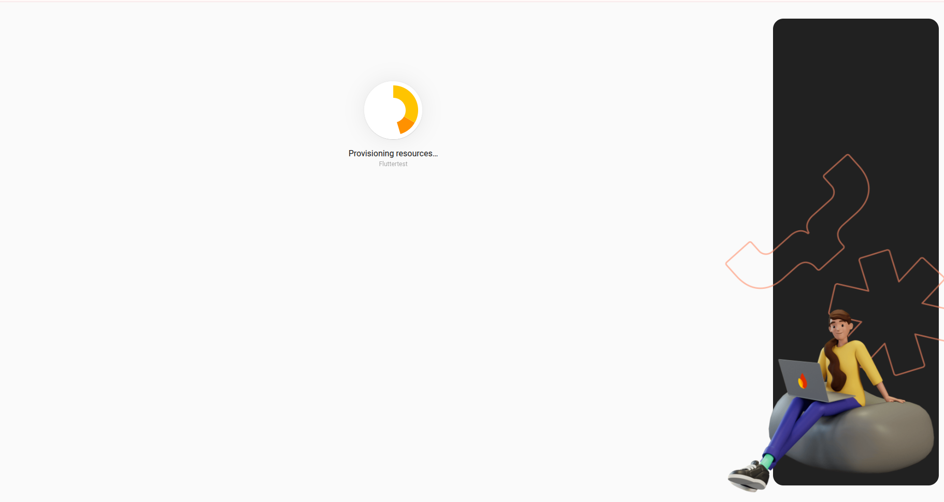

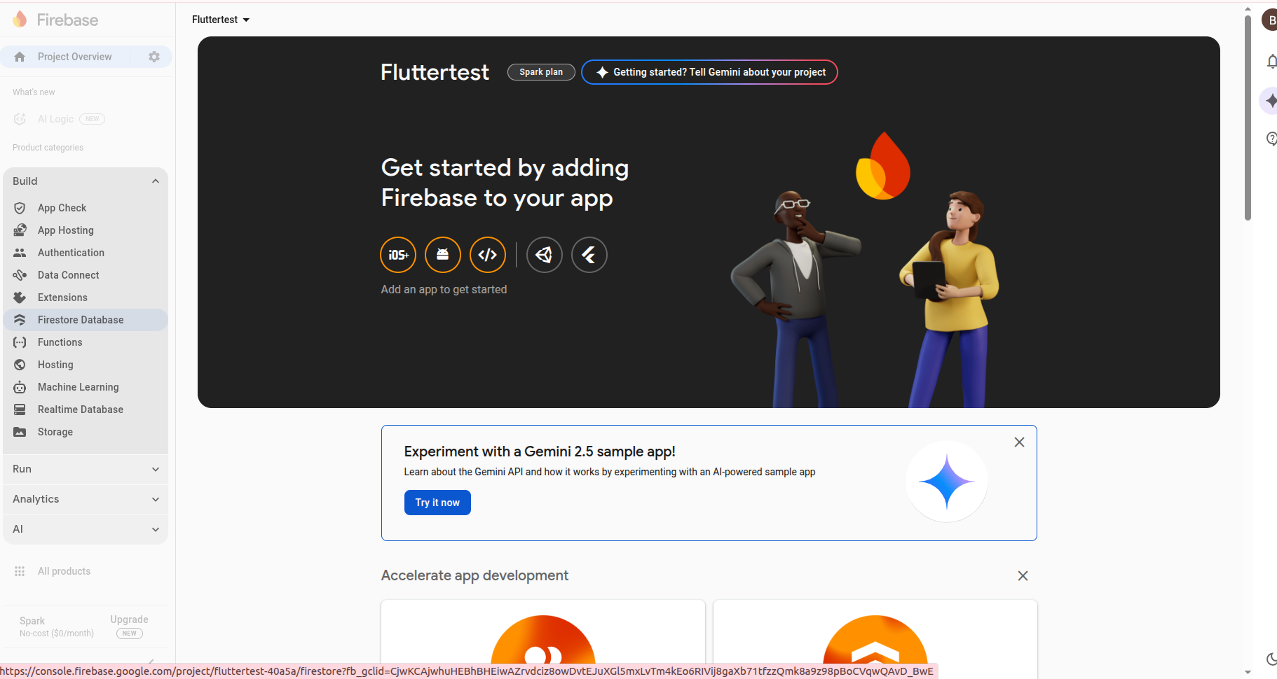

**In the above select the firebase database**

Now come back to vs code in terminal, execute the below command:

# install once

npm i -g firebase-tools

dart pub global activate flutterfire_cli

# log in

firebase login

# from your Flutter project root

flutterfire configure

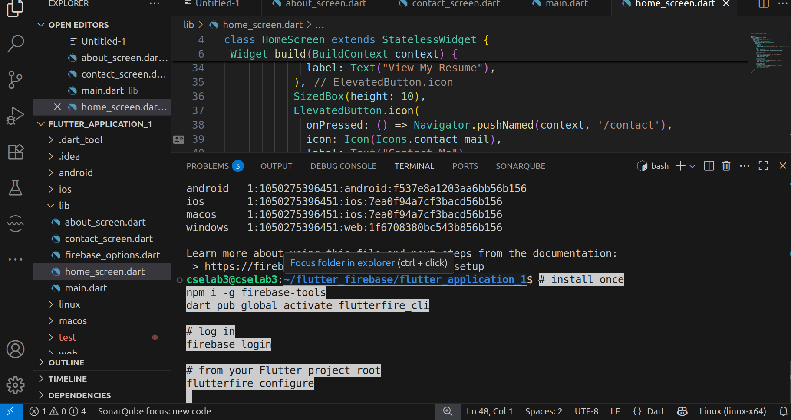

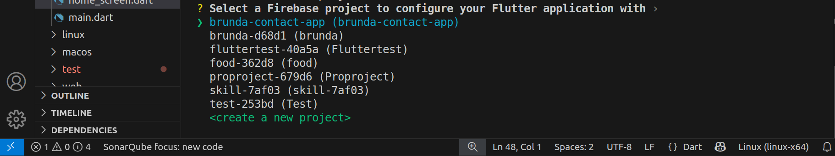

By using arrows, select the project you have created

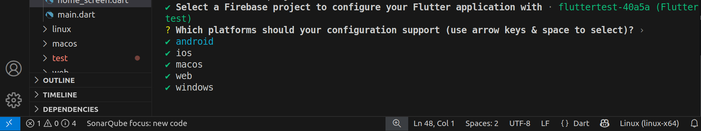

In the above select android and click enter

After this, i**t will create a firebase_options.dart file**

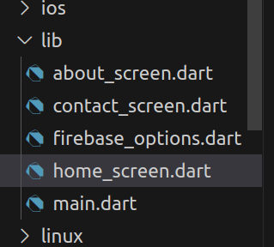

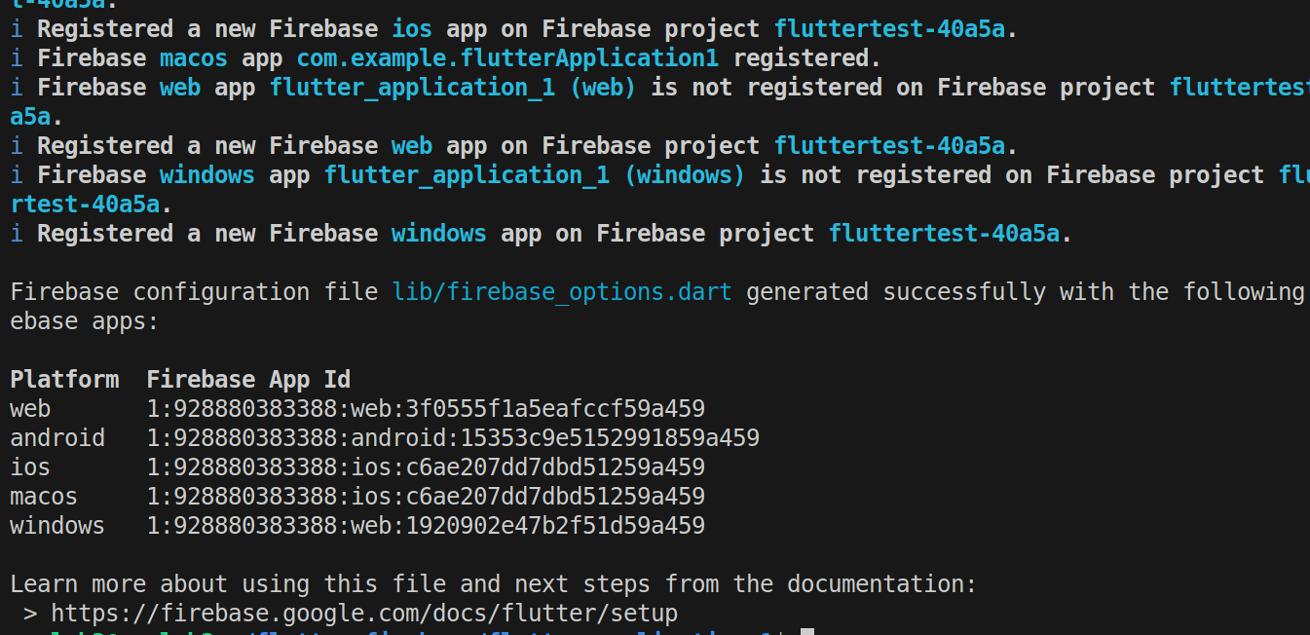

cselab3@cselab3:~/flutter_firebase/flutter_application_1$ **flutterfire --version**

1.3.1

cselab3@cselab3:~/flutter_firebase/flutter_application_1$

Now go to firebase login

In Firebase Console → left menu → **Firestore Database** → **Create database**

Choose **Start in test mode** (dev only) → pick region (e.g., asia-south1) → **Enable**.  
 Reply “done firestore” if that’s already done.

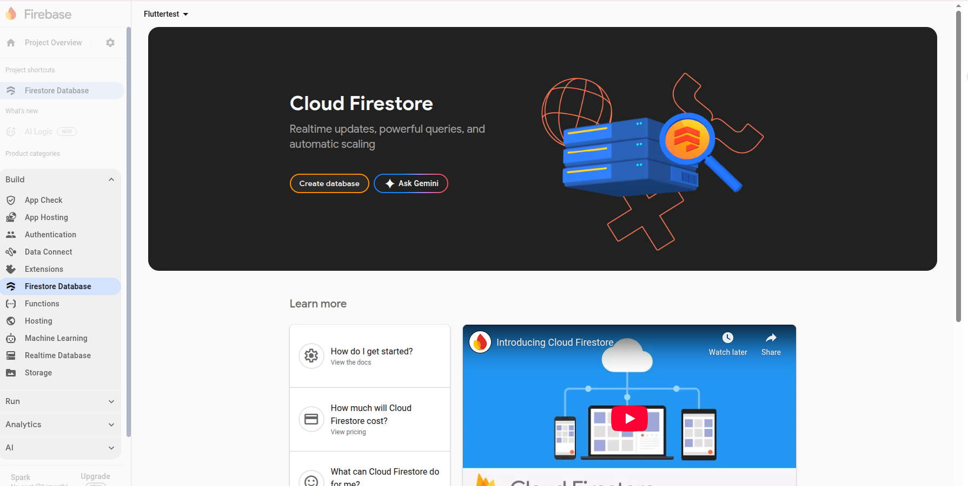

Choose **Start in test mode** (dev only) → pick region (e.g., asia-south1) → **Enable**.  
 Reply “done firestore” if that’s already done.

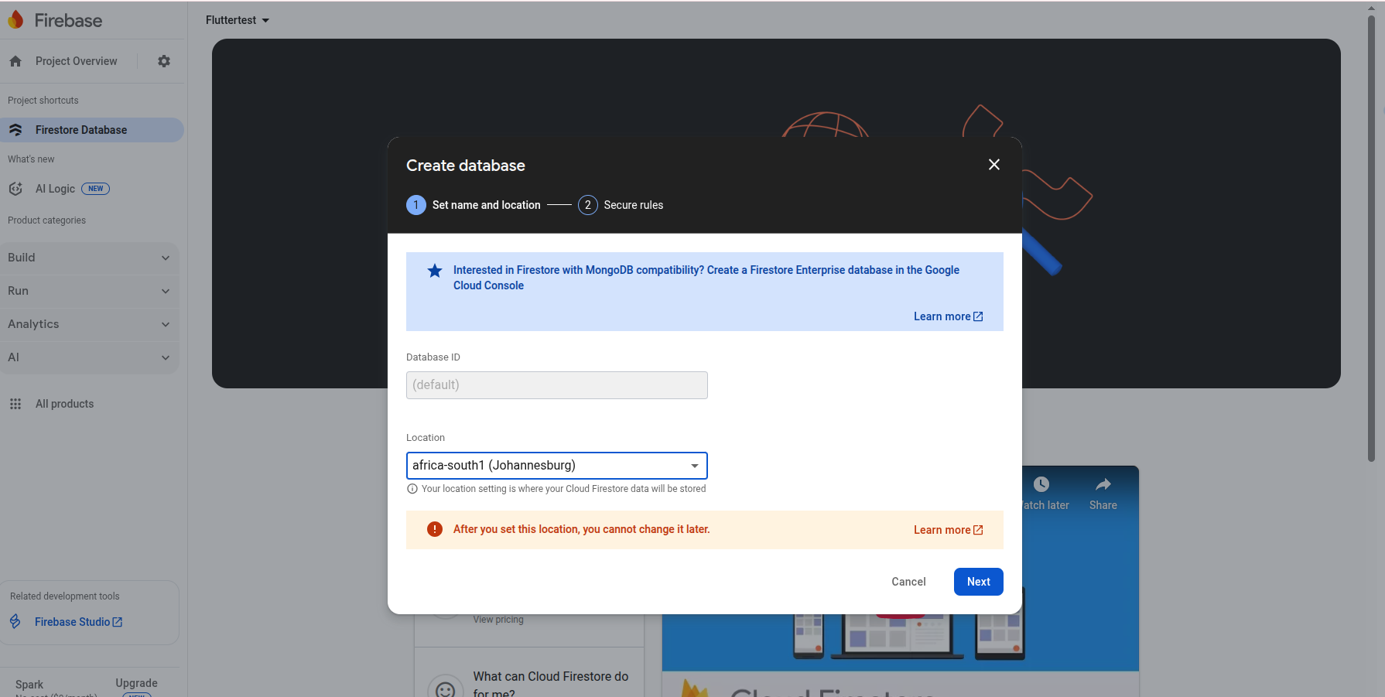

Select the start in test mode

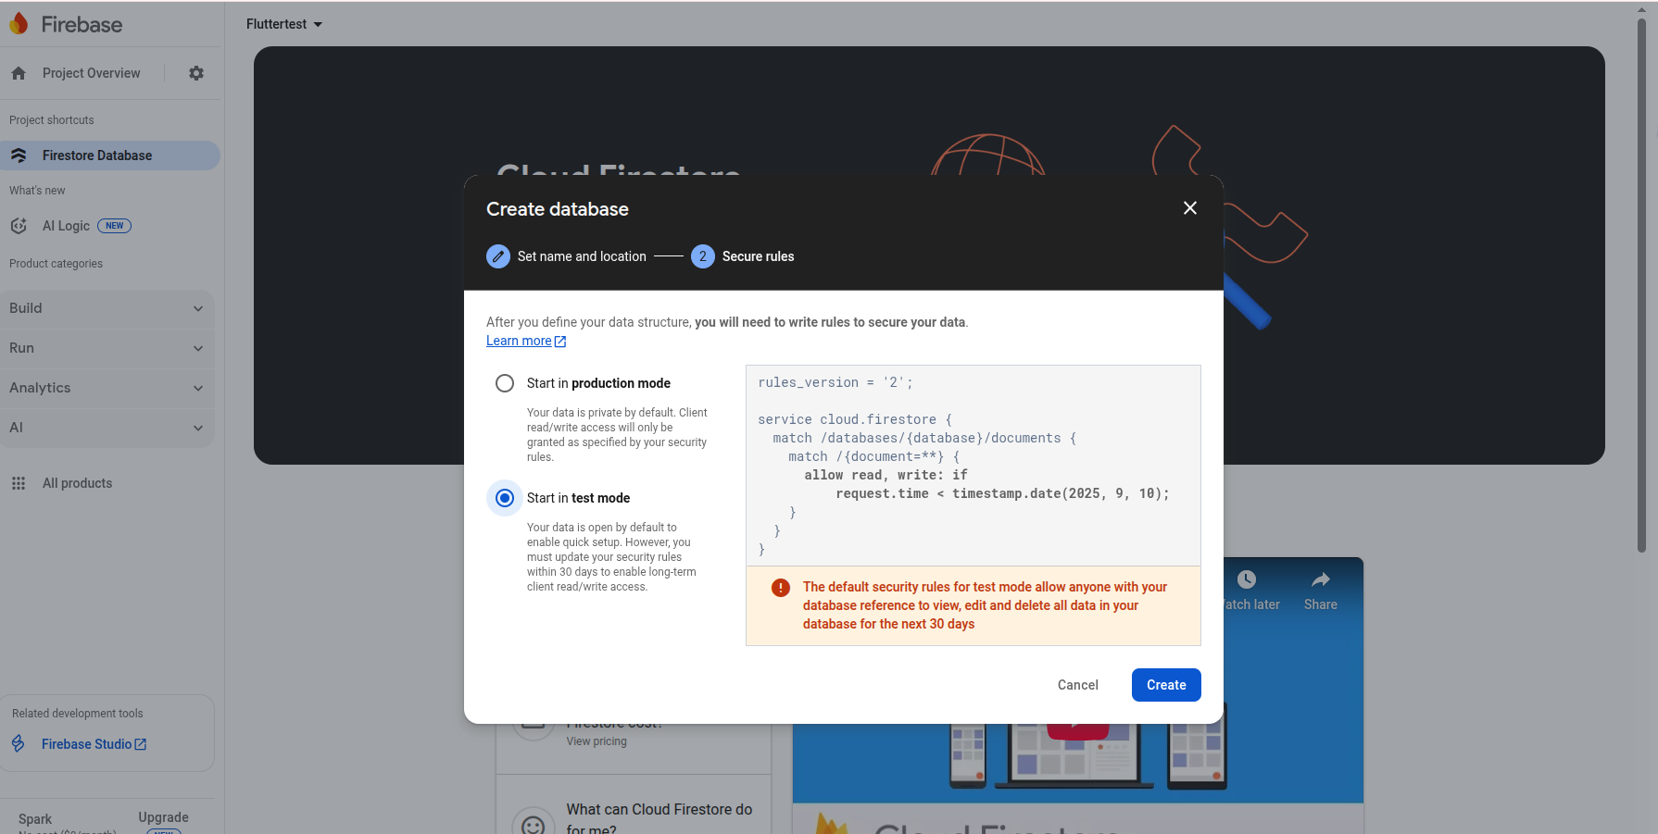

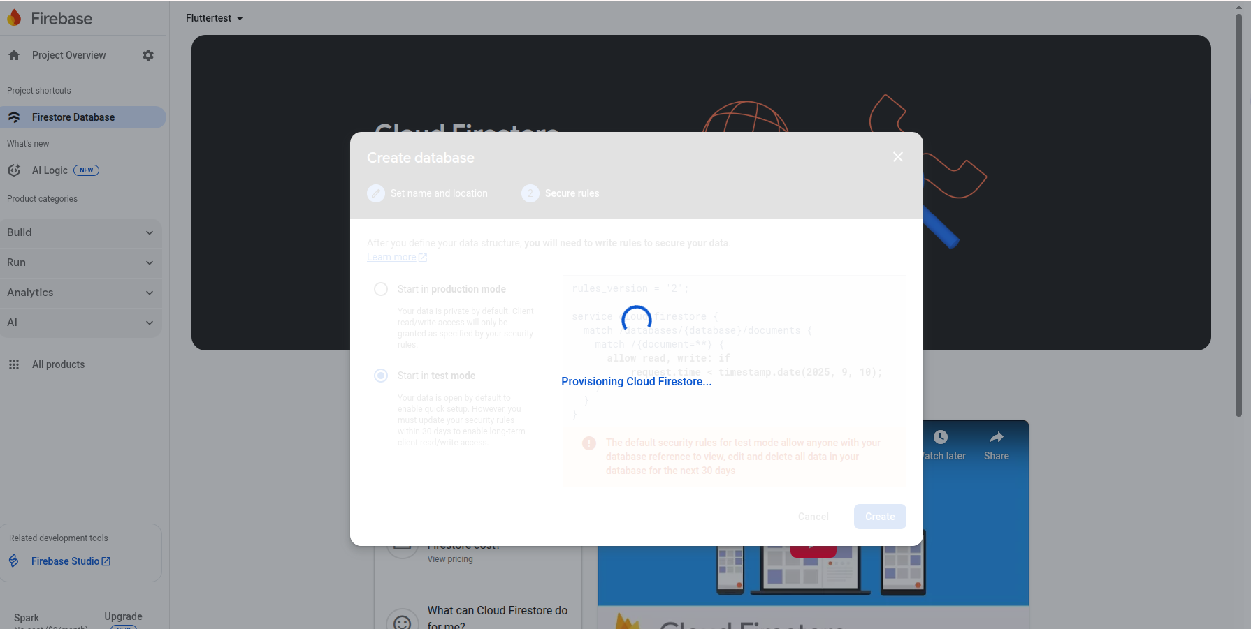

For development you can keep “test mode”. For a safer setup, use rules like this (Console → Firestore → Rules):

rules_version = '2';

service cloud.firestore {

match /databases/{db}/documents {

// Allow only creating new docs in `contacts` with basic validation.

match /contacts/{docId} {

allow create: if

request.resource.data.keys().hasOnly(['name','email','message','createdAt']) &&

request.resource.data.name is string &&

request.resource.data.email is string &&

request.resource.data.message is string &&

request.resource.data.name.size() > 0 &&

request.resource.data.email.matches('^[^@\\s]+@[^@\\s]+\\.[^@\\s]+$') &&

request.resource.data.message.size() > 0;

allow read, update, delete: if false;

}

// Everything else closed.

match /{document=**} {

allow read, write: if false;

}

}

}

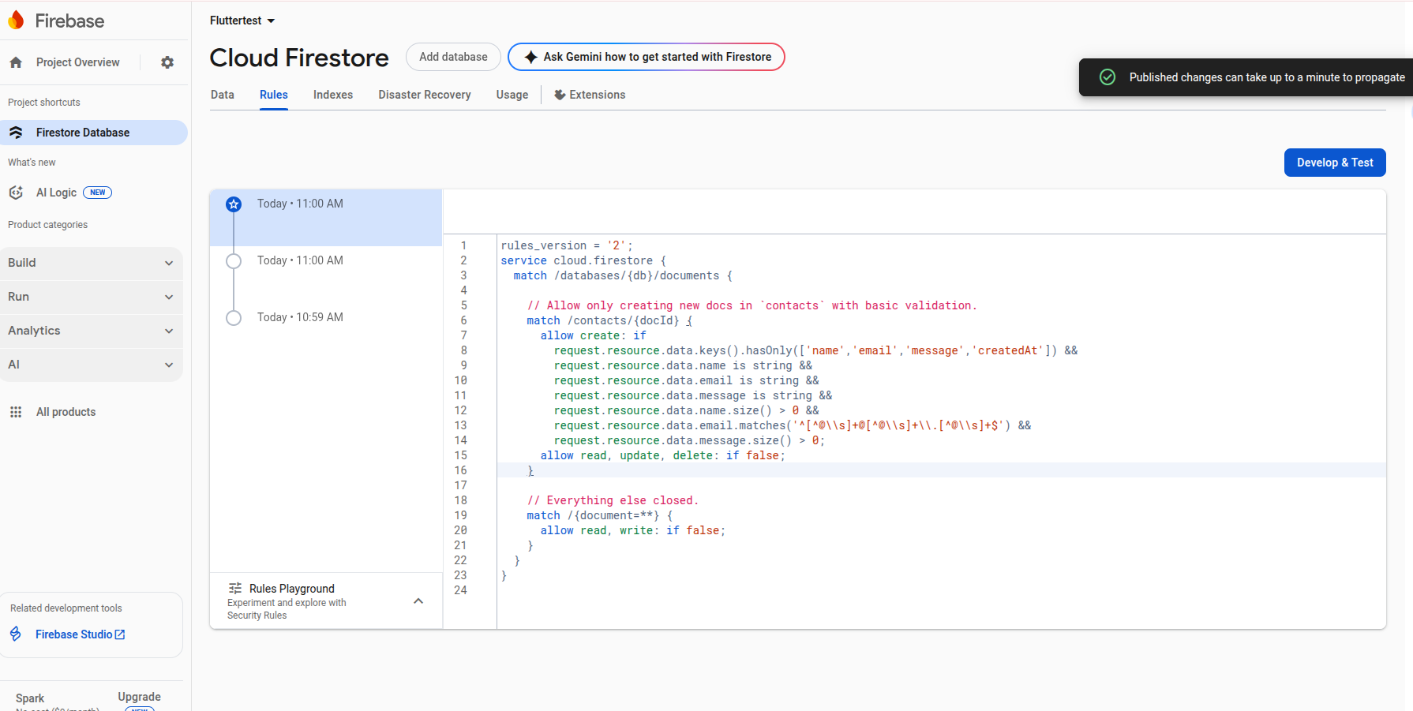

firebase init

flutter pub add firebase_core

flutter pub add cloud_firestore # for Firestore

# or

flutter pub add firebase_database # for Realtime Database

flutter run -d chrome