- Introduction:
This script implements a simple Retrieval-Augmented Generation pipeline. It either loads or builds a FAISS vector index using langchain from an edge computing text corpus file name - edge_computing_cleaned.txt, it retrieves the most relevant chunks (retrieving top 5 records) for a user question, and feeds those as context to a local large language model to produce a concise answer. To use the ollama, I need to install it on my local machine so that I can access it and can use ChatOllama to retrieve the data from file.
Fig1.1 and Fig1.2 Shows the main implementation of the RAG using langchain that shows how we upload the file, after that build a FAISS vector index to retrieve the relevant data and Fig2., shows how we are calling the main file and what information we want.
To run this code, you must use - python run_research_assistant.py command (as shown in output) this will call research_assistant.py file that contains runnable implementations.

- Code Screenshot:
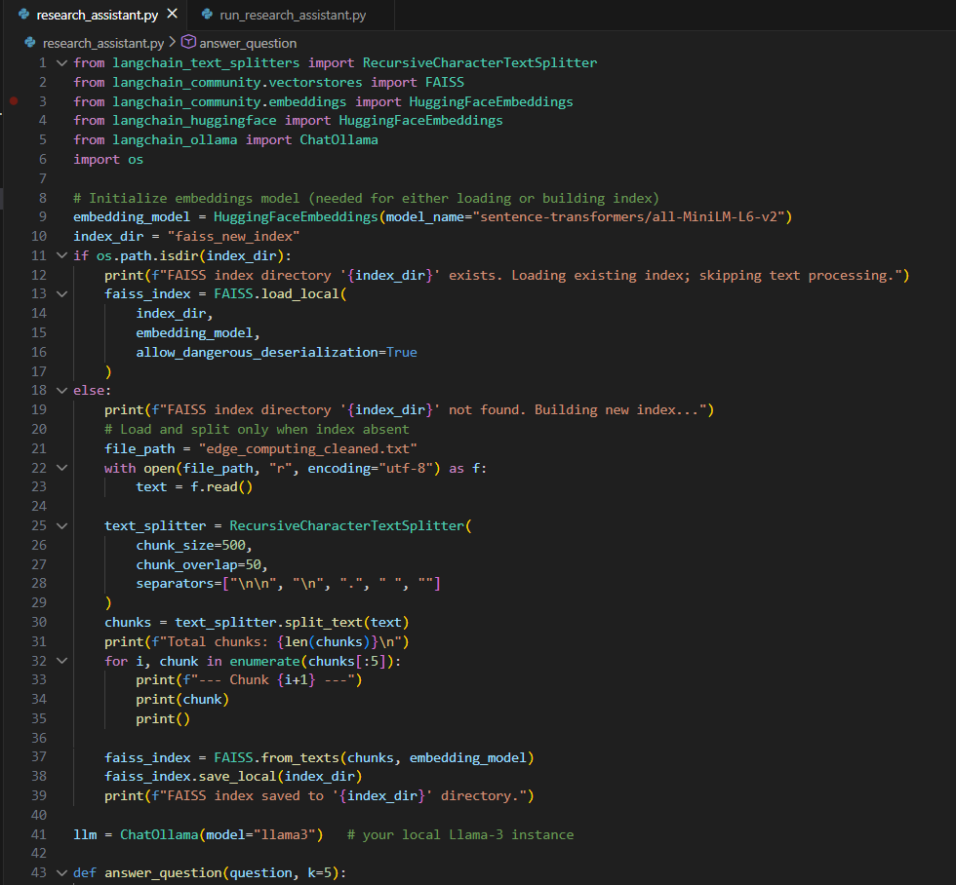
Fig1.1: Implementation Code
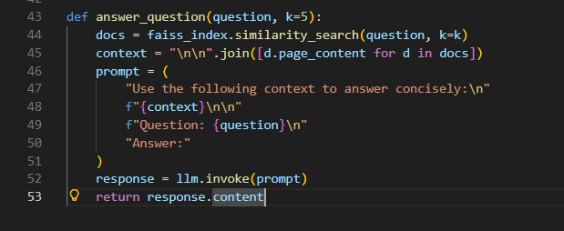
Fig1.2: Implementation Code

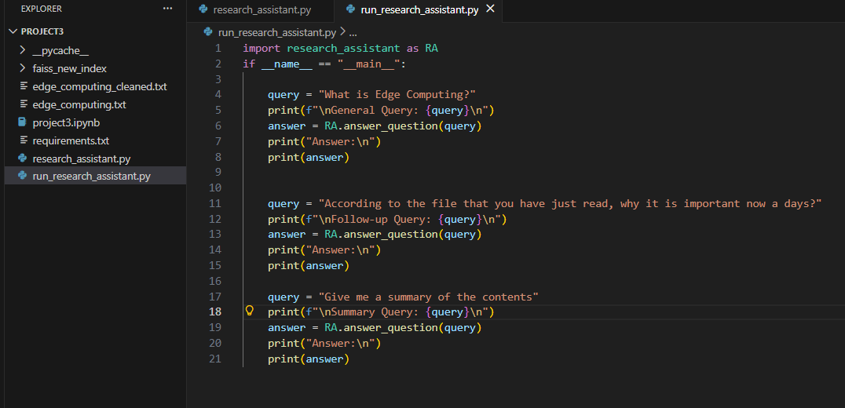
Fig2: Demonstrating Usage

- Output:
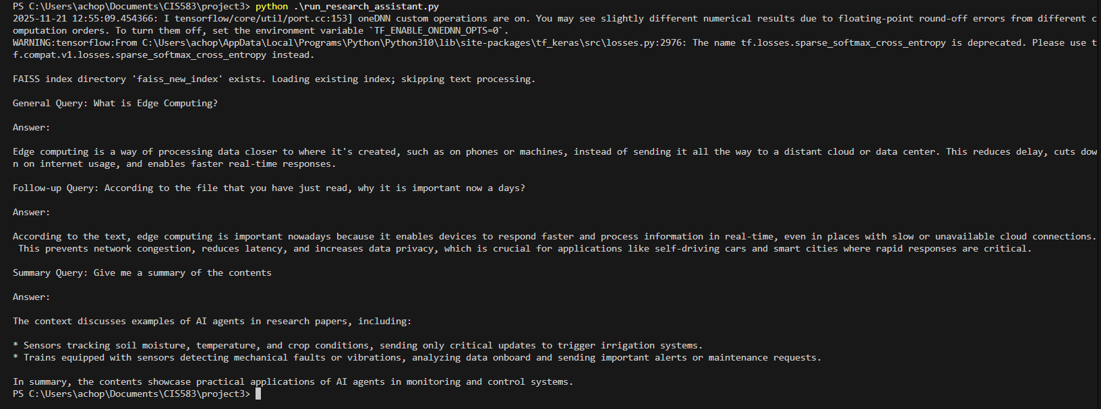

- How does the attention + retrieval mechanism in Transformers compare to the sequence-based memory of RNNs/LSTMs?

Sequential Based (RNN / LSTMs):
- RNNs process inputs one step at a time in sequence.
- They store memory in a hidden state passed from step to step.
- LSTMs add gates to better control what to remember or forget.
- Memory is compressed, so older information fades over time.
- Training is sequential and slow, since each step depends on the previous one.

Transformers (Attention + retrieval):
- Transformers process all tokens in parallel instead of step-by-step.
- Attention compares every token with every other token to find relevance.
- Memory is not a single vector the model can access the entire sequence directly.
- Long-range dependencies are easy because any token can look anywhere.
- Training is fast due to full parallelization and efficient gradient flow.
- With retrieval augmentation (RAG), Transformers gain external memory far beyond the model size.

RNNs remember by carrying a compressed hidden state through time, while Transformers remember by directly looking back at any token using attention.

