MIT School of Engineering Department of Computer Science and Engineering

Project Synopsis

Group ID: BCAIAA45
Project Title: AI-Driven Voice Cloning and Conversational Voice Agent Studio
Group Members:
Enrollment Number | Roll No. | Name of student | Email Id | Contact Number
ADT23SOCB0255 | AIA 1 – 16 | ATHARVA PRASHANT GAIKWAD | atharvagaikwas9999 @gmail.com | 7499961048
ADT23SOCB0187 | AIA 3 – 5 | ARNAV CHANDRAKANT RAUT | arnavraut390 @gmail.com | 8446185846
ADT23SOCB0276 | AIA 3 – 13 | AYUSH CHOUGULA | ayushchougula @gmail.com | 8788996295
ADT23SOCB0408 | AIA 7 - 9 | HARPALSING RAJPUT | harpalsingh007@gmail.com | 9373530347

Problem Statement: Enterprises, developers, and creators today face significant, often prohibitive hurdles in navigating the disjointed landscape of voice artificial intelligence technologies. While organizations increasingly seek to automate customer support, enhance interactive applications, and scale content creation with intelligent voice agents, existing solutions provide static, generalized pathways that fail to offer end-to-end, adaptable integration. Current platforms typically fall into two highly distinct silos. One silo consists of no-code conversational builders that excel at drag-and-drop conversational logic but intrinsically rely on third-party, generic text-to-speech engines without native voice synthesis or cloning capabilities. The other silo comprises specialized audio laboratories providing unparalleled voice synthesis and zero-shot cloning capabilities; however, these are sequestered behind restrictive paywalls, lack robust dialog orchestration capabilities, and operate as closed-source application programming interfaces (APIs).

Consequently, developers are forced to engineer fragile, highly complex middleware to connect automatic speech recognition (ASR) engines, natural language understanding (NLU) modules, and text-to-speech (TTS) systems. This fragmentation introduces severe network and processing latency, resulting in conversational agents that suffer from unnatural pauses, frequent user interruptions, and disjointed, robotic user experiences. Moreover, these disparate platforms rarely incorporate native telemetry for real-time latency monitoring, semantic conversation tracking, or sentiment analysis, making it exceptionally difficult to iteratively refine the agent's performance in production environments. Furthermore, in an era where synthetic media is increasingly weaponized for social engineering and fraud, existing commercial tools often lack built-in security mechanisms such as inaudible neural watermarking, presentation attack detection, or personal identifiable information (PII) redaction. Therefore, a critical need exists for an adaptive, fully integrated platform capable of seamlessly binding advanced voice cloning, low-latency conversational reasoning, and proactive security measures within a single, democratized workspace.

Abstract: The rapid expansion of artificial intelligence within audio synthesis and natural language processing has catalyzed a profound paradigm shift in human-computer interaction, driving the widespread proliferation of conversational voice agents. However, the prevailing technological ecosystem remains heavily fragmented, requiring practitioners to construct fragile pipelines that string together disparate, often proprietary systems for voice cloning, conversational logic design, real-time telephony, and performance analytics. This report details the comprehensive design, architecture, and implementation strategy of an end-to-end, AI-driven voice cloning and conversational voice agent studio. The proposed platform consolidates state-of-the-art open-weight models specifically Qwen3-TTS for high-fidelity, highly expressive voice cloning, Kokoro-82M for cost-efficient, high-concurrency speech synthesis, and large language models (LLMs) such as GPT-4o for dynamic dialog generation into a singular, unified, no-code workspace.

Unlike traditional platforms that suffer from high latency, rigid state machines, and disconnected analytics, the proposed architecture leverages an advanced Agentic AI orchestration layer operating over Web Real-Time Communication (WebRTC) and WebSocket transports to enable sub-500 millisecond conversational turnarounds. Furthermore, the system autonomously integrates proactive neural audio watermarking and cryptographic deepfake mitigation techniques to ensure ethical deployment in strict alignment with emerging global data protection regulations. The backend microservices architecture supports scalable cloud deployments, managing real-time asynchronous data flows from user speech capture to synthetic response generation. Ultimately, this project bridges the chasm between complex, high-latency machine learning audio architectures and intuitive graphical interfaces, empowering developers, creators, and enterprise organizations to deploy hyper-personalized, secure, and highly responsive conversational agents without extensive engineering overhead.

Market Landscape and Existing Solutions
The integration of voice artificial intelligence into enterprise and consumer applications is undergoing an explosive acceleration. Analytical models tracking corporate technology adoption indicate that approximately 85% of customer support leaders are in the active phases of piloting or deploying conversational voice AI solutions. These autonomous systems often colloquially termed "voice bots" or "virtual agents" rely on a complex cascade of speech recognition, language comprehension, and speech generation modules to conduct fluid, human-like telephone or web-based interactions. The market is currently dominated by a spectrum of specialized vendors addressing disparate components of this pipeline.

Companies such as Voiceflow provide sophisticated no-code interfaces for designing conversation trees and managing dialog state management, but they intrinsically rely on external APIs for actual audio generation, completely decoupling the conversational logic from the acoustic output. Conversely, specialized audio platforms like ElevenLabs supply unparalleled voice synthesis and zero-shot voice cloning capabilities across dozens of languages. Yet, they operate as closed-source, proprietary systems with prohibitive scaling costs, effectively barring widespread integration for high-volume, low-margin applications. Enterprise-grade telecommunications solutions such as PolyAI and Bland AI offer highly scalable infrastructure tailored for massive call centers, emphasizing rigorous compliance and reliability. However, these platforms demand intensive developer resources, command lengthy integration cycles, and require significant capital expenditure, making them inaccessible to small-to-medium businesses (SMBs) and independent creators.

This systemic market fragmentation presents a unique opportunity for an integrated, open-source-driven solution. While academic research and open-source communities have released immensely powerful foundational models capable of executing few-shot voice cloning from a mere three seconds of reference audio these models have not been elegantly packaged into consumer-ready platforms. The proposed unified voice AI platform targets this exact operational void. By leveraging recently released open-source models under permissive licenses, such as the Apache 2.0 licensed Kokoro-82M and the Qwen3-TTS architecture, the platform bypasses the artificial commercial scarcity of proprietary TTS endpoints.

Furthermore, the introduction of multimodal foundational models that can natively process interleaved audio and text streams promises to collapse the traditional multi-step pipeline into a singular, highly optimized inference architecture. The ripple effects of unifying these technologies extend beyond mere cost reduction; they enable novel capabilities such as real-time language translation, dynamic multi-speaker simulations, emotion-guided prosody control, and on-device offline fallback architectures. However, the democratization of hyper-realistic voice cloning inherently magnifies the risk of adversarial misuse, mandating that any comprehensive platform proactively embed security protocols, biometric voice consent workflows, and synthetic media watermarking directly into its core infrastructure.

Literature Survey:

The foundational technologies underpinning this unified system draw upon recent breakthroughs across multiple disciplines: large audio-language models, style-based diffusion processes, real-time network transport protocols, and deepfake detection algorithms. The following table synthesizes the critical academic and industrial literature that informs the proposed architecture and highlights the gaps this project seeks to bridge.

Citation | Year | Method / Technology | Key Results | Limitations / Gaps | Relevance to Project
Chu et al. | 2023 / 2024 | Qwen-Audio & Qwen2-Audio (Whisper encoder + LLM decoder) | Achieved state-of-the-art multi-modal audio understanding; simplified pre-training via natural language prompts. | High resource demands, vulnerability to adversarial audio, mode-switching latency. | Establishes the foundational architecture for the multi-lingual ASR and audio understanding modules.
Alibaba Cloud | 2026 | Qwen-Audio-3.0-TTS (Flow-matching with 12.5 Hz speech tokenizer) | Enables one-pass 3-minute synthesis, robust to noisy prompts, state-of-the-art free-form voice cloning. | Autoregressive decoding remains computationally intensive despite token reduction. | Serves as the primary heavy-duty voice cloning and expressive synthesis engine.
Li et al. | 2023 / 2024 | StyleTTS 2 (Style diffusion & adversarial training with WavLM) | Reached human-level naturalness, faster than pure diffusion by modeling only style as a latent variable. | Depends on pre-trained phonemizers, struggles with zero-shot generalization across distant languages. | Provides the theoretical and architectural basis for Kokoro-82M's highly efficient, style-guided synthesis pipeline.
Li et al. | 2024 | StyleTTS-ZS (Distilled time-varying style diffusion) | 10-20x faster sampling speed for zero-shot synthesis, highly accurate prosody matching. | Relies on high-quality discrete audio codecs that may not perfectly capture granular acoustic textures. | Informs architectural decisions for real-time, low-latency zero-shot voice cloning capabilities.
San Roman et al. | 2024 | AudioSeal (Localized, proactive neural audio watermarking) | Detects watermarks at a granular local level, highly resilient to noise and editing. | Susceptible to desynchronization attacks and unmatched watermark overlay attacks. | Core technology for the deepfake mitigation and synthetic media tracking components.
Wang et al. | 2025 | ASVspoof 5 & DeepMark Benchmark (Deep learning presentation attack detection) | Established unified datasets and benchmarks revealing degradation under neural compression schemes. | Existing detection models suffer severe performance drops on out-of-distribution adversarial data. | Highlightsthe necessity of multi-layered defense mechanisms against voice spoofing and replay attacks.
Liu et al. | 2025 | XAttnMark (Cross-attention robust audio watermark) | Bridges the gap between robust detection and accurate message attribution under generative editing. | Psychoacoustic temporal-frequency masking can introduce slight latency during synthesis. | Advances the watermarking pipeline beyond AudioSeal to ensure verifiable cryptographic attribution.
Fora Soft | 2025 | WebRTC + LiveKit Real-time API Integration | Achieved 800ms voice-to-voice latency, established WebRTC as superior to SIP for modern web apps. | High engineering complexity, strict requirement for robust client-side echo cancellation. | Dictates the selection of WebRTC and LiveKit for the platform's transport and orchestration layers.
Hamming AI | 2026 | Streaming STT/TTS Latency Optimization | Proved that <500ms TTFT is mandatory, optimizing VAD thresholds saves 200-400ms per turn. | Streaming architectures occasionally sacrifice minor transcription accuracy for speed. | Guides the aggressive optimization of Voice Activity Detection thresholds and streaming chunk sizes.
Speechmatics | 2026 | Five-Layer Voice AI Testing Framework | Formalized testing across infrastructure, simulation, observability, CI, and governance layers. | Framework implementation demands significant parallel telemetry infrastructure. | Drives the design of the analytics dashboard, ensuring comprehensive monitoring of live agents.

The literature reflects a pronounced shift from highly modularized, cascaded acoustic models toward unified, end-to-end generative foundations. Early text-to-speech architectures mandated complex intermediate steps such as grapheme-to-phoneme (G2P) conversion paired with distinct duration predictors which often introduced cascading errors, unnatural pacing, and robotic prosody. The introduction of style-based generative diffusion models, most notably StyleTTS 2, revolutionized this space. By modelling acoustic style as a latent random variable and sampling it through a probabilistic diffusion model, researchers successfully circumvented the necessity for reference audio in standard generation, simultaneously reducing the computational overhead compared to full-waveform diffusion. This methodology allows the injection of diverse, highly emotive paralinguistic features into synthetic speech, crossing the threshold into human-level comparative mean opinion scores (CMOS).

In parallel, large-scale multimodal models like the Qwen-Audio family have merged transformer-based audio encoders with massive LLM decoders. The subsequent evolution to Qwen-Audio-3.0-TTS integrated a flow-matching model tightly coupled with a language model, operating on a heavily compressed 12.5 Hz low-frame-rate speech tokenizer. This specific breakthrough drastically truncated inference latency, rendering real-time, zero-shot voice cloning from a minimal 3-second reference sample viable for production environments. However, as the literature comprehensively indicates, the real-world deployment of such instantaneous voice cloning requires extraordinary network engineering. Research surrounding real-time transport protocols demonstrates that traditional Session Initiation Protocol (SIP) telephony introduces unacceptable latency bounds for dynamic AI agents. Modern architectures must pivot toward Web Real-Time Communication (WebRTC) frameworks, such as LiveKit, combined with aggressive Voice Activity Detection (VAD) optimization, to compress the time-to-first-byte (TTFB) to human-perceptible thresholds.

Furthermore, the academic discourse overwhelmingly underscores the catastrophic security implications of unsecured voice cloning. The ASVspoof challenge series has consistently exposed the vulnerabilities of automatic speaker verification systems to presentation attacks, driving the development of complex countermeasure networks. More recently, the focus has shifted toward proactive defense via neural watermarking. Systems like AudioSeal utilize disjointed generator-detector networks to embed imperceptible, localized cryptographic signatures within the audio. While AudioSeal provides robust detection, subsequent evaluations (e.g., DeepMark) and advancements like XAttnMark demonstrate that adversarial attacks such as desynchronization and unmatched watermark injection necessitate continuous refinement of cross-attention mechanisms and temporal conditioning to maintain attribution integrity. This comprehensive body of literature forms the theoretical bedrock for the unified platform's architecture.

Proposed System

The proposed system, Auralis, follows a decoupled client-server architecture designed to combine multiple AI models for speech recognition, language understanding, and speech synthesis into a single usable platform. The frontend is built with Next.js and communicates with a FastAPI backend over REST endpoints and Server-Sent Events for streaming generation progress. The backend coordinates all AI processing, including transcription, retrieval-augmented response generation, and text-to-speech synthesis, while Supabase provides authentication, relational storage, vector search, and file storage in a single managed service.
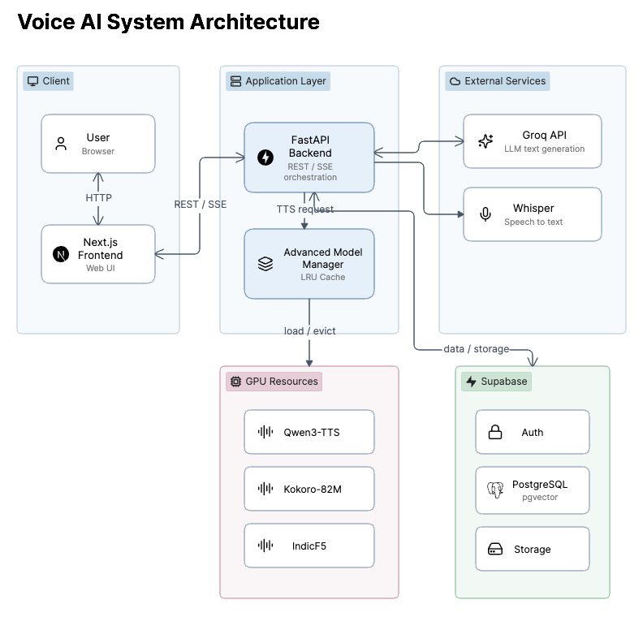

Figure 1: High-Level System Architecture

Client Interface and Frontend

The client interface is built using Next.js with React and styled with Tailwind CSS, with Zustand used for client-side state management. The interface provides dashboards for creating voice profiles, uploading reference audio for cloning, uploading documents for the knowledge hub, and interacting with the configured voice agent. Supabase Auth handles user authentication for the platform.

Backend and API Gateway

The backend is implemented in FastAPI and acts as the central gateway for all AI operations. It exposes REST endpoints for uploading audio and documents, and uses Server-Sent Events to stream progress updates back to the client during longer operations such as voice cloning or speech generation. This keeps the user interface responsive while heavier processing happens on the server.

Advanced Model Manager

Since multiple text-to-speech models are used in the platform, the backend includes an Advanced Model Manager that handles GPU memory efficiently. It uses a Least Recently Used caching strategy to keep frequently used models loaded in memory, while unloading idle models when GPU memory pressure increases. This allows several heavy models to be served from limited hardware without manual intervention.

Core Inference Engines

The platform integrates the following models for its core AI pipeline:

Speech-to-Text: OpenAI Whisper (Base) is used to transcribe user audio input into text.

Language Understanding and Generation: The Groq API, using the Llama-3.3-70B-versatile model, is used for fast conversational reasoning and generating text responses.

Text-to-Speech: The platform routes generation requests between Qwen3-TTS, Kokoro-82M, IndicF5, and Audio8-TTS depending on whether voice cloning, speed, or Indian language support is required.

Data and Storage

Supabase is used as the unified data layer for the platform. PostgreSQL stores relational data such as user accounts and voice profile metadata, the pgvector extension supports semantic search over document embeddings, and Supabase Storage holds uploaded audio files and the serialized voice embedding tensors used for cloning.

Voice Cloning and TTS Routing

When a user uploads a short reference audio sample, the backend extracts acoustic features and generates a PyTorch embedding tensor, which is saved to Supabase Storage along with its metadata in the database. During generation, the TTS router selects an engine based on the request: Kokoro-82M for fast, lightweight synthesis when cloning is not required, Qwen3-TTS or Audio8-TTS when a cloned voice embedding needs to be used as a reference, and IndicF5 when the target language is an Indian regional language.
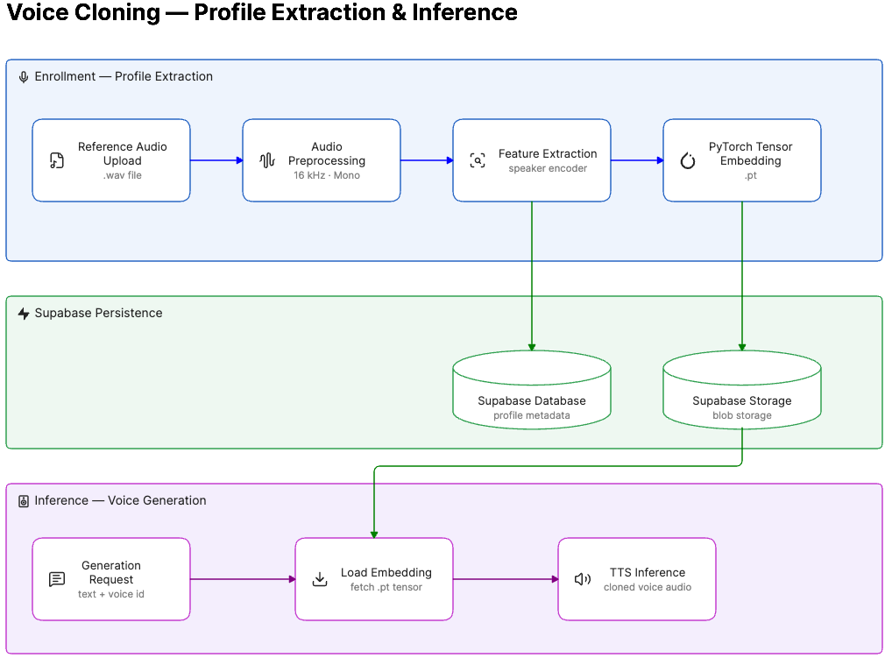

Figure 2: Voice Cloning Workflow

Retrieval-Augmented Generation and Knowledge Hub

To reduce hallucination in the language model's responses, the platform supports document upload and retrieval-augmented generation. Uploaded PDFs are parsed using pypdf and split into overlapping text chunks. Each chunk is embedded using the all-MiniLM-L6-v2 sentence transformer model and stored in Supabase using pgvector. When a user interacts with the agent, their query is embedded and a similarity search retrieves the most relevant chunks, which are added to the prompt sent to the language model as supporting context.
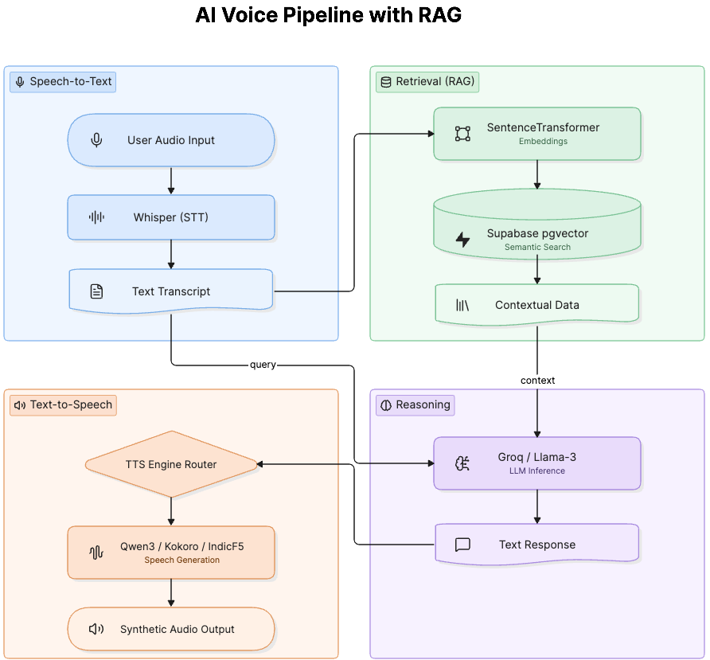

Figure 3: AI Voice Pipeline and RAG Workflow

User Flow

A complete session on the platform, from account creation to a finished conversation with a cloned voice agent, follows the sequence below.

Sign in: The user signs in through Supabase Auth and lands on the Voice Studio dashboard, which shows existing voice profiles, uploaded knowledge documents, and recent activity.

Create a voice profile: The user uploads a short reference audio sample, typically five to ten seconds long. The backend preprocesses the audio, extracts speaker features through the enrollment pipeline, and generates a PyTorch embedding tensor that captures the characteristics of that voice.

Store the profile: The generated embedding is saved to Supabase Storage, while its metadata, such as the profile name and the owning user, is written to the Supabase database so the profile can be looked up later during generation.

Build a knowledge base: The user can optionally upload one or more PDF documents to give the agent extra context. Each document is parsed with pypdf, split into overlapping chunks, embedded using the all-MiniLM-L6-v2 sentence transformer, and stored in Supabase using pgvector for later semantic search.

Start a conversation: The user sends a message to the agent, either as typed text or as recorded audio. If audio is sent, Whisper transcribes it to text before the request continues through the pipeline.

Retrieve context: The backend embeds the user's query and runs a similarity search against the stored document chunks in Supabase pgvector. The closest matching chunks are pulled back as supporting context for the response.

Generate a response: The transcript, along with the retrieved context, is sent to the Groq API running Llama-3.3-70B-versatile, which returns a text response grounded in the user's uploaded material.

Select a voice engine: The TTS Engine Router decides which synthesis model should handle the reply. Kokoro-82M is used for fast, lightweight generation when no cloned voice is needed, Qwen3-TTS or Audio8-TTS is used when the request calls for a cloned voice, and IndicF5 is used when the target language is an Indian regional language.

Manage GPU memory: Before running the selected model, the Advanced Model Manager checks whether it is already loaded. If it is not, and GPU memory is under pressure, the least recently used model is unloaded to make room, and the required model is loaded in its place.

Load the voice profile: If a cloned voice was requested, the corresponding .pt embedding tensor is fetched from Supabase Storage and passed into the TTS model as the acoustic reference for generation.

Stream the result: The backend synthesizes the audio and streams generation progress back to the frontend using Server-Sent Events, so the interface can show live status instead of a blank loading screen while the response is produced.

Play and reuse: The generated audio is returned to the user through the Next.js interface, where it can be played back, downloaded, and the same voice profile or knowledge base reused for future messages without repeating the setup steps.

Implementation Status

Decoupled Next.js and FastAPI architecture with REST and SSE communication.

Integration of Whisper, the Groq API, Qwen3-TTS, Kokoro-82M, and IndicF5.

Advanced Model Manager with LRU-based GPU memory management.

Supabase integration for authentication, database, storage, and RAG through pgvector.

Voice embedding extraction, storage, and reuse for cloned voice generation.

Future Work

Moving from REST and SSE to a real-time transport protocol such as WebRTC for lower-latency, full-duplex conversation.

Adding audio watermarking and basic safeguards against voice misuse.

Containerizing the platform with Docker to simplify deployment.

Testing Approach

The platform is tested at the module level for its core AI components, including the retrieval pipeline used for RAG, along with manual end-to-end testing of the voice cloning and generation flows. This helps verify that transcription, retrieval, and synthesis work correctly together before a new feature is considered complete.

Conclusion

Auralis brings together speech recognition, language reasoning, and multi-engine speech synthesis into a single platform, with a working solution for the practical problem of running several heavy AI models on limited GPU hardware through the Advanced Model Manager. Combined with a Supabase-backed RAG pipeline and a straightforward voice cloning workflow, the project demonstrates a functional foundation for building personalized AI voice agents, with clear directions identified for future improvement.

