App Dev Project Report

1. Student Details
Name: Ayush Prashant Dayal
Roll Number: 23f2001288
Email: 23f2001288@ds.study.iitm.ac.in
About Me: I am a passionate software and application developer focused on building scalable, secure, and high-performance digital solutions. I specialize in full-stack development, cloud-native applications, API design, and modern DevOps practices. I believe in writing clean, maintainable code with a strong emphasis on performance and user experience. With a constant drive to learn and innovate, I transform complex ideas into efficient, real-world applications. My goal is to create reliable, future-ready software that delivers meaningful impact.

2. Project Details

Project Title: FalcoVita App

Problem Statement:

To overcome inefficiencies in manual and disconnected hospital record systems, this project aims to build a centralized Hospital Management System (HMS) that enables role-based interaction among Admins, Doctors, and Patients for efficient healthcare management.

Approach:
Develop a secure, role-based web application using a centralized database and modular architecture to enable seamless interaction among Admins, Doctors, and Patients.

3. AI/LLM Declaration
I used ChatGPT (GPT-5) to assist in configurations, writing scripts for seeding the database with random fake entries, creating API documentation samples, and improving variable naming consistency. The extent of AI/LLM usage is around 10–15%, limited to code suggestions , documentation formatting, UI suggestions and error fixes with understanding the causes. All final implementation logic and debugging, were done manually.

4. Technologies and Frameworks Used
Technology / Library | Purpose
Flask | Core backend web framework
SQLAlchemy | ORM for SQLite database
Jinja2 | Template engine for dynamic HTML
Bootstrap 5 | Frontend styling & responsive design
Chart.js | Visualize trends (activity vs. time)
Celery, Redis | Async tasks & caching
Flask-Security-Too, Bcrypt, Argon2 | Authentication
SQLite | Lightweight local database
Vue.js 3 | Frontend framework
Vite | Build tool
Vuex | State management
Axios | HTTP client
Chart.js, vue-chartjs | Interactive charts
MailHog | Mail server
Google Chat Webhook | Notifications & daily reminders

5. Database Schema / ER Diagram
Tables:
- User — stores user authentication and profile details (id, name, email, password, role, contact_number, blacklisted, fs_uniquifier, active)
- Role — defines user roles like admin, doctor, patient (id, name, description)
- UserRoles — maps users to roles (id, user_id, role_id)
- Doctor — stores doctor-specific details (id, department_id, specialization, qualifications, experience)
- Patient — stores patient-specific details (id, dob, contact, medical_record_number, doctor_id)
- Department — stores hospital departments (id, name, overview)
- Appointment — logs appointments (id, patient_id, doctor_id, department_id, appointment_date, status)
- PatientHistory — records patient visit history (id, patient_id, doctor_id, department_id, appointment_id, visit_type, visit_date, diagnosis)
- Prescription — stores prescriptions linked to patient history (id, history_id, medicines, dosage, instructions)
- AvailabilitySlot — manages doctor availability slots (id, doctor_id, available_date, time_slot, status)
Relationships:
- One-to-One
- User ↔ Doctor (A user can be a doctor)
- User ↔ Patient (A user can be a patient)
- Appointment ↔ PatientHistory (An appointment results in one history record)
- One-to-Many
- Department → Doctor (One department has many doctors)
- Department → Appointment (One department has many appointments)
- Department → PatientHistory (One department has many history records)
- Doctor → Patient (One doctor is assigned to many patients)
- Doctor → Appointment (One doctor has many appointments)
- Doctor → PatientHistory (One doctor creates many history records)
- Doctor → AvailabilitySlot (One doctor has many availability slots)
- Patient → Appointment (One patient has many appointments)
- Patient → PatientHistory (One patient has many history records)
- PatientHistory → Prescription (One history record can have many prescriptions)
- Many-to-Many
- User ↔ Role (A user can have multiple roles, and a role can belong to multiple users handled via UserRoles table)

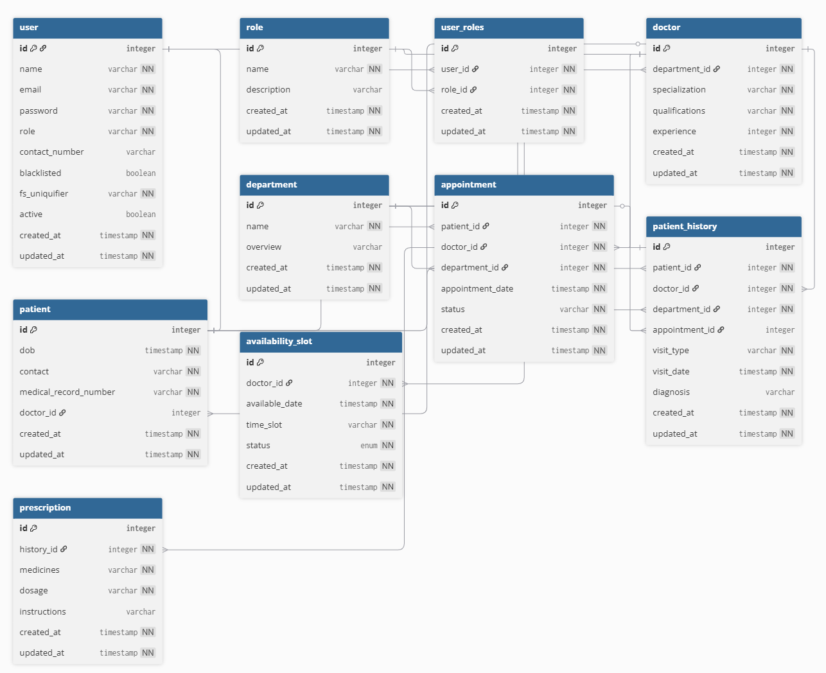
ER Diagram:

6. API Resource Endpoints
Endpoint | Method | Description
/api/auth/login | POST | Authenticate user
/api/auth/register | POST | Register user
/api/doctors/ | GET, POST | Manage doctors
/api/patients/ | GET, POST | Manage patients
/api/appointments/ | GET, POST | Book appointment
/api/appointments/<id> | GET, PUT, DELETE | Update appointment
/api/availability/ | GET, POST | Add slots
/api/availability/doctor/<doctor_id> | GET | Doctor slots
/api/history/ | GET, POST | Patient history
/api/history/patient/<patient_id> | GET | Get history
/api/prescriptions/ | GET, POST | Prescriptions
/api/departments/ | GET, POST | Departments

7. Architecture and Features (optional)

Architecture Overview

Backend:
- backend/app.py – Main Flask entry point and initialization.
- backend/models.py – SQLAlchemy database models.
- backend/resources/ – API endpoints and Blueprints.
- backend/services/ – Core business logic.
- backend/tasks.py – Celery background tasks.

Frontend:

frontend/src/views/ – Vue.js page views.

frontend/src/components/ – Reusable UI components.

frontend/src/router/ – Client-side routing configuration.

frontend/src/store/ – Vuex state management.

Implemented Features:
- Role-Based Auth: Secure login for Admins, Doctors, and Patients.
- Appointment System: Full scheduling, availability, and slot management.
- Medical Records: Patient history and prescription logging.
- Analytics: Interactive Admin Dashboard with Chart.js.
- Data Export: CSV export for appointments and medical history.
- Responsive UI: Modern Vue.js SPA with Bootstrap.
Additional Features:
- Export user logs as CSV

8. Video Presentation
Drive Link:
https://drive.google.com/file/d/your-video-link-here
(Accessible to all with “View” permission.)

Where should you be adding the report ?
- The report should be included in the zip file which you are submitting.

- Put the report in the drive link and paste the drive link in the viva portal while submitting the app.

Both the things are covered in the video. Please watch it once. How to Submit App Dev 1 & 2 Projects | Full Submission Guide + Viva Workflow | IITM BS

