### *REPORT FOR RESTAURANT MANAGEMENT SYSTEM*

As a project work for Course

**PYTHON PROGRAMMING (INT 213)**

Name : *Prashant kumar*

Registration Number : *12014595*

Name : *Ayush Solanki*

Registration Number : *12017126*

Program : *CSE B.Tech.*

Semester : *Third*

Branch : *School of Computer*  *Engineering* Name of the University : *LPU*

Date of submission :*30th Nov 2021*

Teacher : Upinder Kaur

Lovely Professional University Jalandhar, Punjab, India.

RESTAURANT MANAGEMENT SYSTEM

30th NOVEMBER 2021

## ABSTRACT:-

A restaurant management system is a collective term for software that helps streamline food business operations. Namely, restaurants, bars, bakeries, cafes, cloud (dark, virtual, ghost) kitchens, food trucks or delivery businesses.

It combines all things that are good about the traditional POS (Point of Sale) systems, with tools that manage your phone calls, take table reservations, streamline inventory management, handle billing, provide actionable analytics, and also help with marketing activities such as CRM, loyalty programs and building an online presence. It also works seamlessly with your existing restaurant technology systems (your accounting and employee management software) and uses open APIs that let you integrate with any third party tool.

***ACKNOWLEDGEMENT:-***

I would like to thank my mentor - Ms. Upinder Kaur for his advice and inputs on this project. Many thanks to my friends and seniors as well, who spent countless hours to listen and provide feedbacks

|  |  |  |  |
| --- | --- | --- | --- |
| *Table Of Contents* | | | |
|  | **1. ABSTRACT** | **2** | |
| **2. INTRODUCTION** | **4** | |
| **2.1 CONTEXT** |  | |
| **2.2 MOTIVATION** |  | |
| **2.3 IDEA** |  | |
| **3. TEAM MEMBERS WITH ROLES** | **5** | |
| **3.1 TEAM LEADER** |  | |
| **3.2 MEMBERS** |  | |
| **3.3 CONTRIBUTIONS** |  | |
| **4. LIBRARIES** | **6** | |
| **4.1 DIFFERENT TYPES** |  | |
| **4.2 WHY THEY ARE USED** |  | |
| **5.Proposed Modules** | **7** |  |
| **6.Screenshots** | **8** |
| **7.Linear Regression** | **11** |
| **8.Multiple Regression** | **17** |
| **9.Refrences** | **22** |
|  | | | |

***INTRODUCTION:-***

* 1. Context

This project has been done as part of my course for the CSE(H) at Lovely Professional University . Supervised by Upinder Kaur, I have two months to fulfill the requirements in order to succeed the module.

* 1. Motivations

Being extremely interested in everything having a relation with the Development, the group project was a great occasion to give us the time to learn and confirm our interest for this field. The fact that we can make estimations, predictions and give the ability for machines to learn by themselves is both powerful and limitless in term of application possibilities. That’s why I decided to conduct my project around the Development.

* 1. Idea:-

As a first experience, we wanted to make my project as much didactic as possible by approaching every different steps of the machine learning process and trying to understand them deeply. Known as ” toy problem” the problems that are not immediate scientific interest but useful to illustrate and practice, we chose to take house price Prediction as approach. The goal was to calculate the bill of a restaurant according to the market prices taking into account different “features” that will be developed in the following .

***TEAM MEMBERS:-***

Prashant Kumar:- Contributions:-

* + 1. Coding(joined)
    2. Multivariable Regressing
    3. GUI
    4. Development(joined)

Ayush Solanki:- Contributions:-

1. Coding(joined)
2. Datasets
3. Linear regression
4. Reports
5. Development(joined)

***LIBRARIES:-***

**Tkinter:-**

The [tkinter](https://docs.python.org/3/library/tkinter.html#module-tkinter) package (“Tk interface”) is the standard Python interface to the Tcl/Tk GUI toolkit. Both Tk and [tkinter](https://docs.python.org/3/library/tkinter.html#module-tkinter) are available on most Unix platforms, including macOS, as well as on Windows systems.

**PIL:-**

Pillow is the friendly PIL fork by [Alex Clark and Contributors](https://github.com/python-pillow/Pillow/graphs/contributors). PIL is the Python Imaging Library by Fredrik Lundh and Contributors.

**Barcode:-**

This library provides a simple way to create barcodes using only the Python standard lib. The barcodes are created as SVG objects.

**Random:-**

Python has a built-in module that you can use to make random numbers.

**Time:-**

The time() function returns the number of seconds passed since epoch.

**Request:-**

The requests module allows you to send HTTP requests using Python.

**JSON:-**

Python has a built-in package called json, which can be used to work with JSON data.

***PROPOSED MODULES:-***

**Dataset:-**

1.Enter dataset manually 2.Default dataset 3.Different datasets

**Data representation:-**

1.Restaurant Menu

2.Bill generation

3.Bill messaging

4.Payment Option

***SCREENSHOTS:-***

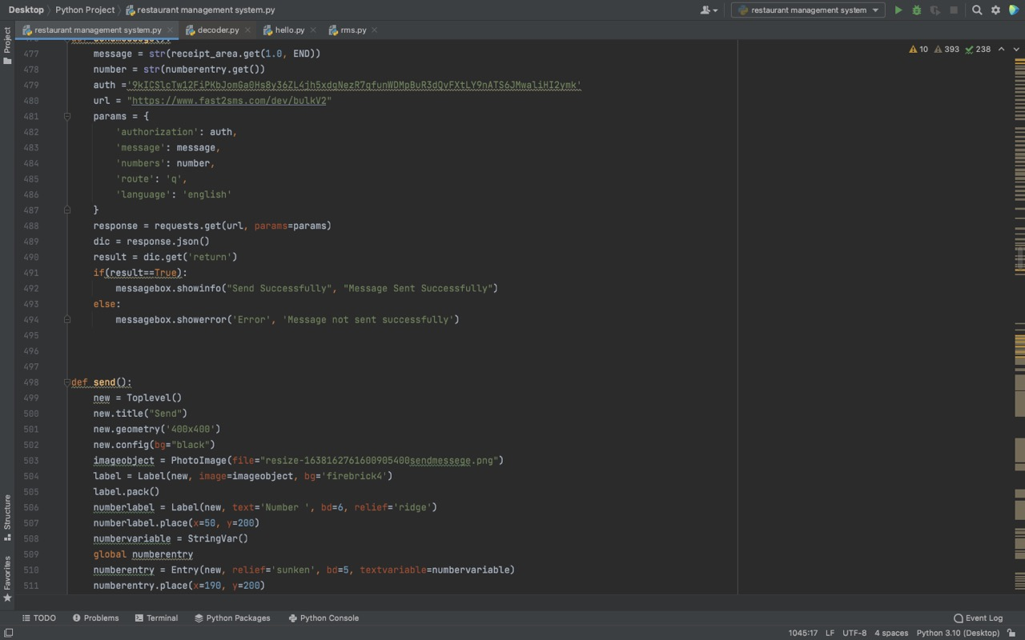

***GUI Development:-***

A graphical user interface builder (or GUI builder), also known as GUI designer, is a **software development tool** that simplifies the creation of GUIs by allowing the designer to arrange graphical control elements (often called widgets) using a drag-and-drop WYSIWYG editor.

# Flow Diagram:-

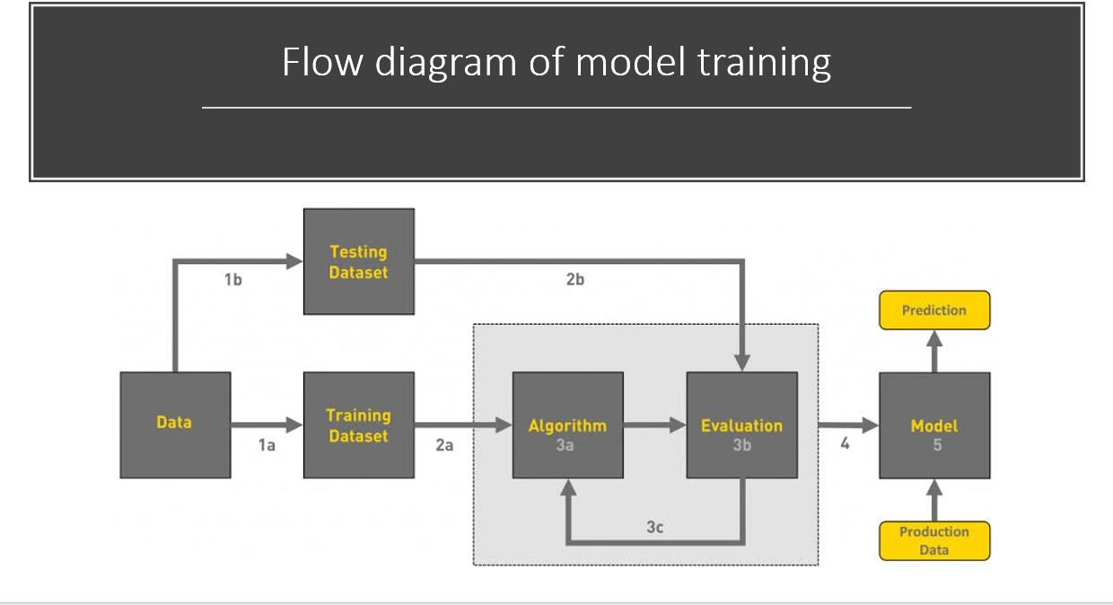

**Conclusions:-**

*It is our team’s hope that this document will be of huge help with understanding of our little project as we have used a different approach which has proved beneficial for us and easy for us to understand the vast ocean that is GUI Development.We have reached the maximum accuracy after data cleaning but we will work forward to increase this accuracy little by little.*

## REFRENCES:-

To conduct this project the following tools have been used :

* PyCharm IDE
* Tkinter (Library)

***1.Coursera:-***

We have used this side for our basis knowledge gain of the methods that will be used in the project

[***https://www.coursera.org/specializations/python***](https://www.coursera.org/specializations/python)

***2.Coding Ninja:-***

Learnt Python basics from Coding Ninja.

[***https://www.codingninjas.com/courses/python-data-structures-and-algorithms***](https://www.codingninjas.com/courses/python-data-structures-and-algorithms)

***3. Stackoverflow:-***

We have used this site for solving our different problems which has occurred during this project.