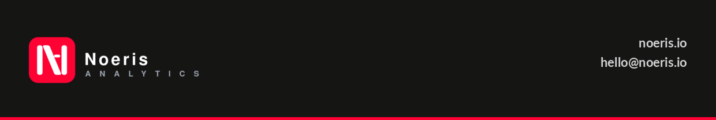
MONTHLY SERVICES AGREEMENT
Analytics Retainer - Indigo Insurance
SERVICE PROVIDER  Noeris Analytics  noeris.io  Representative: Ankita Jaiswal | CLIENT  Indigo Insurance (247 Indigo Pty Ltd)  247indigo.com  Representative: Nick Brierly

Effective Date: 5 August 2026 (or date of last signature, whichever is later)
This Monthly Services Agreement ("Agreement") is entered into between Noeris Analytics ("Service Provider") and Indigo Insurance / 247 Indigo Pty Ltd ("Client"). The parties agree as follows:
1. Services
The Service Provider will deliver analytics services as detailed in the Scope of Work. At a high level, the services comprise:
(a) Semantic model development, in coordination with the Client's in-house actuary.
(b) Report and dashboard development on top of those semantic models.
(c) Regular check-ins with Nick Brierly and Varsha to review progress and handle minor change requests.
The Service Provider will allocate a minimum of two resources: Ankita Jaiswal as lead, supported by one additional Noeris Analytics resource.
2. Term
This Agreement commences on the Effective Date and continues on a month-to-month basis. Either party may terminate by providing thirty (30) days' written notice. Termination does not affect any fees accrued prior to the termination date.
3. Fees and Payment
The Client shall pay a flat monthly retainer fee of USD $2,000 (exclusive of GST) per calendar month.
(a) Invoices will be issued at the start of each billing month.
(b) Payment is due within fourteen (14) days of invoice date.
(c) Any work outside the agreed scope requires a written variation agreed by both parties before commencement.

4. Client Obligations
The Client agrees to:
(a) Provide timely access to relevant data, systems, and personnel (including the in-house actuary).
(b) Designate Nick Brierly and Varsha as primary contacts for approvals, feedback, and change requests.
(c) Respond to requests for information or approval within five (5) business days.
5. Confidentiality
Each party agrees to keep confidential all non-public information received from the other party.
6. Variation
Any variation to this Agreement must be agreed in writing by both parties. Email confirmation from authorised representatives constitutes sufficient written agreement.
7. Entire Agreement
This Agreement and the attached Scope of Work constitute the entire agreement between the parties and supersede all prior discussions.
Signatures
By signing below, each party agrees to the terms of this Agreement.
NOERIS ANALYTICS  Signed: 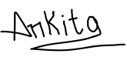  Name: Ankita Jaiswal  Title: CEO, Noeris Analytics  Date: 05 August 2026 | INDIGO INSURANCE  Signed: ________________________  Name: Nick Brierly  Title: ________________________  Date: ________________________

