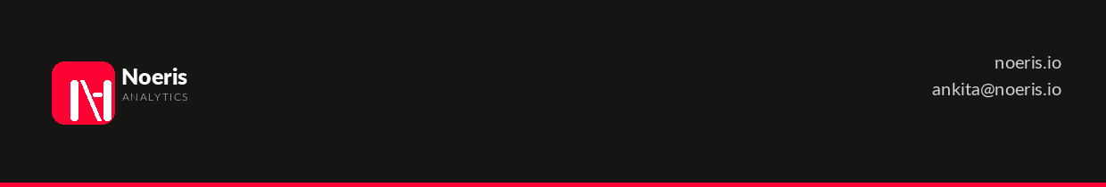
SCOPE OF WORK
Analytics & Reporting Retainer
Document Date | 5 August 2026
Prepared by | Noeris Analytics
Prepared for | Indigo Insurance (247 Indigo Pty Ltd)
Contact | Nick Brierly — nick@247indigo.com
Engagement | Monthly Analytics Retainer
Term | Month-to-month, commencing on execution of retainer agreement

1. Background
Indigo Insurance engaged Noeris Analytics following a discussion on 2 August 2026. The parties agreed to a monthly retainer arrangement to support Indigo's data and reporting function. This Scope of Work defines the services to be delivered under that arrangement.
2. Objectives
The engagement is designed to:
• Establish well-structured semantic models that serve as a clean, reusable foundation for all reporting and analytics.
• Deliver reports and dashboards built directly on top of those models, providing actionable visibility for Indigo's team.
• Maintain an ongoing support cadence to accommodate incremental change requests from Nick Brierly and Varsha.
3. Scope of Services
3.1 Semantic Model Development
Noeris Analytics will design and build semantic models in close coordination with Indigo's in-house actuary. This includes:
• Aligning on data definitions, hierarchies, and business logic with the actuary prior to model build.
• Constructing models so that the actuary's calculations and outputs connect cleanly to the reporting layer.
• Iterating on model structure as actuarial requirements are refined.
3.2 Report and Dashboard Development
On top of the agreed semantic models, Noeris Analytics will develop reports and dashboards as directed by Indigo. This includes:
• Building out initial report and dashboard assets agreed at the start of each month.
• Ensuring outputs are appropriate for the intended audience (management, operational, or actuarial).
• Refining visuals and layouts based on feedback from Nick and Varsha.
3.3 Regular Check-ins and Change Requests
Noeris Analytics will maintain a structured communication cadence with Indigo:
• Regular progress check-ins with Nick Brierly and/or Varsha (frequency to be agreed at commencement — suggested fortnightly).
• Handling small, in-scope change requests raised during or between check-ins.
• Change requests are expected to be minor in nature. Significant new deliverables outside this scope may require a separate agreement.
3.4 Resourcing
Ankita Jaiswal will serve as the lead on this engagement. One additional Noeris Analytics resource will be brought in to work alongside the lead.
4. Out of Scope
The following are explicitly excluded from this engagement unless separately agreed in writing:
• Data engineering, pipeline development, or source system integration.
• Infrastructure provisioning or administration.
• Training or enablement sessions for Indigo staff.
• Major new capability builds (new data domains, additional tools, platform migrations).
5. Deliverables and Acceptance
Deliverables will be agreed between the parties at the start of each monthly cycle. Acceptance is assumed unless Indigo raises written objection within five (5) business days of delivery.
6. Fees
The monthly retainer fee is AUD $2,000 (exclusive of GST) per month, payable in advance on the first business day of each month. Noeris Analytics will issue a tax invoice at the start of each billing period.
Included within the retainer:
• All services described in Section 3 above.
• Up to two named resources from Noeris Analytics.
• Regular check-in meetings.
7. Assumptions
• Indigo Insurance will provide timely access to data sources, the in-house actuary, and relevant stakeholders.
• Nick Brierly or Varsha will act as the primary point of contact for approvals and feedback.
• Noeris Analytics will have access to the necessary tooling and environments within one week of contract execution.
• This scope assumes stable, month-to-month working — significant scope shifts may affect capacity allocation.
8. Approval
By signing below, both parties agree that this Scope of Work accurately reflects the services to be provided under the Monthly Retainer Agreement.
Noeris Analytics  Signed: ________________________  Name: Ankita Jaiswal  Date: ________________________ | Indigo Insurance  Signed: ________________________  Name: Nick Brierly  Date: ________________________

