DATA 298A MSDA Project I
Workbook 2
Multiplayer Agents: A Shared Live Session Layer for Human-Agent Collaboration
Team 4. Ayush Gawai, Naman Vipul Chheda, Manav Patel, Shriram Dundigalla, Pramod Satya Dindukurthi. Section 21, Topic 4. Advisor: Prof. Simon Shim. November 11, 2026
Team member | Sections written
Naman Vipul Chheda | 3.1, 3.2, 3.3
Ayush Gawai | 3.4, 3.5, 4.2
Shriram Dundigalla | 3.6 and the figures in sections 3 and 4
Manav Patel | 4.1
Pramod Satya Dindukurthi | 4.3, 4.4, References

GitHub: https://github.com/ayushgawai/multiplayer-agent-sessions Linear: https://linear.app/data-298a-team-4/team/DAT/cycles
This workbook is report sections 3 and 4. Sections 1 and 2 are not rewritten; what has changed since Workbook 1 is recorded in the carry-forward table at the end. Table, figure and reference numbers continue from Workbook 1, which ended at Table 17, Figure 2 and reference [17]. Every count in section 3 was recomputed from the data files at commit fbb3fdf by docs/reports/t4a6_data_facts.py, and every figure is generated by a committed script, so each data count in this document can be traced to the file it came from.

3. Data Engineering

3.1 Data Process
The project uses three data sources, and each one answers a different question. MAST-Data [3] is the corpus of the published baseline we reproduce: it tells us whether our evaluation tooling can recover a published number. QMSum [2] is supervision for Model 1 only: it teaches query-focused summarisation of multi-party discussion. The product-session corpus, recorded on our own platform, is the only source that contains the task we actually care about, and it is the source that selects a winner for every model. The three paths are pinned and frozen separately and never mix, because mixing them is how a baseline number ends up scored against the wrong labels.
Every path follows the same five steps, which are also the five subsections that follow. Table 18 states what each step does, the tool that does it, and the artifact it leaves behind; Figure 3 shows the lineage.
Step | What happens | Tool or script | Artifact left in the repository
1. Collect (3.2) | Download from a pinned upstream revision. Verify a SHA-256 digest per file and the record count against the published count. Fail loudly on any mismatch. | data/scripts/download_mast.py  data/scripts/download_qmsum.py | data/mast/STATS.md  data/qmsum/STATS.md
2. Pre-process (3.3) | Validate schema and label domain, assert key uniqueness, normalise text fields, and exclude records that cannot be scored. Every rule reports how many rows it removed. | data/scripts/eda_mast.py stage 2  data/scripts/make_splits.py | data/mast/EDA_SUMMARY.json  data/mast/AUDIT_REPORT.md
3. Transform (3.4) | Reshape into the format the consumer needs: a flat label table for analysis, and ordered event inputs for Model 1. | data/scripts/eda_mast.py stage 3  eval/contracts/m1.py adapters | mast_clean_summary.csv  m1-input-v1 records
4. Prepare (3.5) | Fix train, validation and test membership, hash every split file, and commit the manifest. Run leakage checks. | data/scripts/make_splits.py --seed 13  data/scripts/verify_eval_manifest.py | data/splits/m1_v1/MANIFEST.json  data/mast/eval_manifest.json
5. Describe (3.6) | Compute counts, distributions, imbalance and correlation from the prepared files, and regenerate every figure. | docs/reports/t4a6_data_facts.py  docs/reports/generate_t4a6_figures.py  docs/reports/generate_t4a5_figures.py | docs/reports/t4a6_data_facts.json  docs/reports/figures/
Table 18. The data process: five steps, the tool behind each, and the artifact that proves it ran.
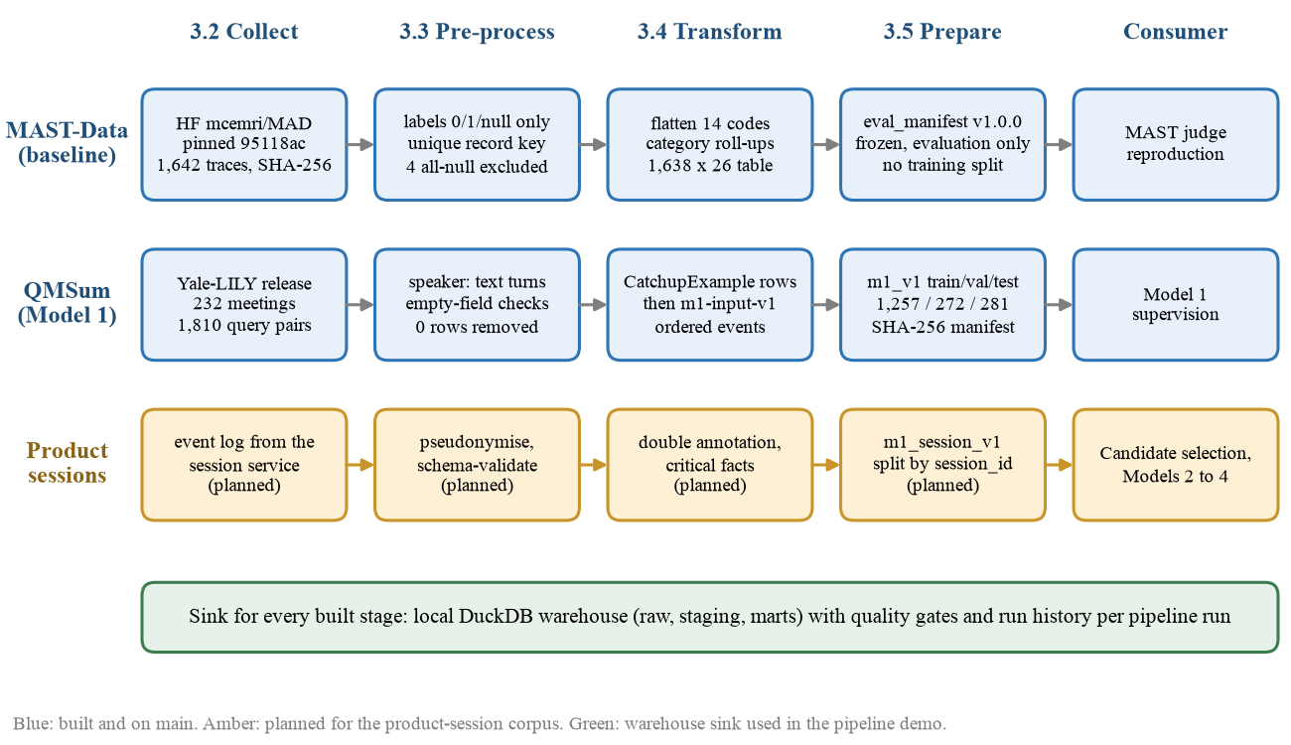
Figure 3. Data process and lineage for the three sources. Blue stages are built and on the main branch; amber stages belong to the product-session corpus and are planned. Generated by docs/reports/generate_t4a6_figures.py.
Three design rules govern the whole process. First, public data is never committed: it is reconstructed on demand from pinned revisions, and what is committed is the evidence that the reconstruction is byte-identical (digests, counts, manifests). Second, nothing is dropped silently: a malformed record is a hard error, and a legitimate exclusion is written to a committed summary with its key and its reason. Third, test data is read once: validation data is used for prompts, thresholds, early stopping and hyperparameters, and the test split is opened only for the final frozen comparison (ADR-005, rule 4).
The same five steps also run as one orchestrated pipeline that lands its output in a local analytical warehouse, which is what the data pipeline demonstration shows. infra/warehouse/pipeline.py (pull request #33) executes ingest, clean and validate, transform, and quality gates in a fixed order and stops at the first failure. It writes three layers into a DuckDB [24] database: raw (records as landed, with source digest and load time), staging (validated and cleaned), and marts (a star schema of fact and dimension tables for analysis). Two further tables make the pipeline observable: meta.quality_checks holds the expected and actual value of every gate, and meta.pipeline_runs appends one row per stage per run with start time, duration, rows in, rows out, status and git commit, so run history accumulates across runs. One run on the real data takes about 6 seconds and all 19 quality checks pass; the transcript of two consecutive runs and the report is committed as infra/warehouse/SAMPLE_RUN.md. Table 19 lists the tables it produces.
Layer | Table | Rows | Columns | Content
raw | mast_traces | 1,642 | 10 | One row per landed MAST record: key, framework, model, benchmark, trajectory length and preview, raw labels, source digest, load time
raw | qmsum_examples | 1,810 | 10 | One row per example per split, as landed
staging | mast_traces_clean | 1,638 | 7 | Validated traces; the 4 all-null records excluded
staging | mast_labels_long | 22,932 | 4 | One row per trace per failure code (1,638 x 14)
staging | qmsum_examples_clean | 1,810 | 9 | Trimmed text with word counts
marts | fact_trace | 1,638 | 11 | Trace facts with keys to the four dimensions, failure and category counts
marts | fact_trace_failure | 5,141 | 2 | One row per positive label
marts | fact_m1_example | 1,810 | 7 | Split, span count, query, reference and context word counts
marts | dim_failure_mode, dim_framework, dim_llm, dim_benchmark | 14, 7, 5, 8 | 3, 2, 2, 2 | Dimensions of the star schema
meta | quality_checks | 19 per run | 6 | Check name, expected, actual, passed
meta | pipeline_runs | 4 per run | 10 | Stage, start, finish, duration, rows in and out, status, git commit, error
Table 19. Warehouse layers produced by one pipeline run on the real data. Row and column counts are pasted from the run transcript in infra/warehouse/SAMPLE_RUN.md.

3.2 Data Collection
Table 20 lists the raw sources with their parameters and quantities. Both public sources are sufficient for their purpose in DATA 298A: the MAST release is the complete corpus used in the paper we reproduce, so there is no larger set to collect, and the QMSum release is the complete benchmark. The source that is not yet sufficient is our own, and section 3.6 says so plainly.
Source | Origin and pinned revision | Quantity retrieved | Parameters (fields) | Licence | Role
MAST-Data [3] | Hugging Face dataset mcemri/MAD, commit 95118ac9. Taxonomy text from the MAST GitHub repository, commit a70542e5. | 1,642 annotated traces (199.6 MB), equal to the paper's stated 1,642. 19 human-labelled traces (2.7 MB). 2 taxonomy files. | mas_name, llm_name, benchmark_name, trace_id, trace {index, key, trajectory}, mast_annotation {14 failure codes 1.1 to 3.3, each 0, 1 or null} | CC-BY-4.0 | Published baseline corpus. Evaluation only.
QMSum [2] | Yale-LILY/QMSum public release, official train, validation and test files. | 232 meetings (162 / 35 / 35), 129,177 transcript turns, 1,810 query-summary pairs: 1,576 specific and 234 general. | meeting_transcripts [{speaker, content}], specific_query_list [{query, answer, relevant_text_span}], general_query_list [{query, answer}], topic_list | MIT | Model 1 supervision and a separately reported benchmark.
Smoke fixtures | Generated by data/scripts/make_m1_smoke.py --seed 13 from 12 scripted sessions (DAT-53). | 18 examples from 12 sessions, 5 scenario types. | example_id, session_id, query, events[], critical_facts[], event_labels, reference | Team-authored | Pipeline validation only. Never an evaluation split.
Product sessions | Append-only event log of our session service (PostgreSQL). | 0 sessions recorded as of 11 Nov 2026. Target about 30. | SessionEvent (ADR-001): event_id, seq, type, actor, payload, timestamps | Team-owned, pseudonymised | Winner selection for Model 1; training data for Models 2 to 4.
Table 20. Raw data sources, parameters and quantities.
Collection is scripted end to end. download_mast.py is idempotent, re-validates every digest on each run, and refuses to proceed if a count or a hash differs from the pinned value. The digests of the five MAST files (three data files and two taxonomy files) and of the three QMSum files are recorded in the two STATS.md files, and the MAST digests are repeated in the frozen evaluation manifest. Figure 4 shows what the MAST corpus is made of: seven multi-agent frameworks, five underlying language models and eight benchmarks, with three frameworks contributing only 30 traces each.
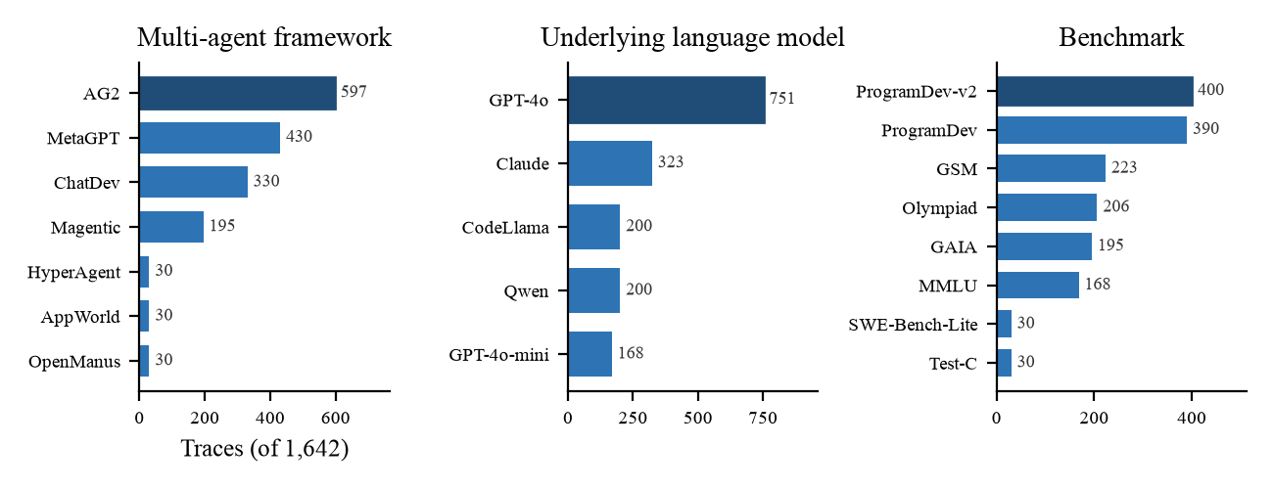
Figure 4. Composition of the 1,642 raw MAST traces by framework, underlying language model and benchmark. Counts are parsed from data/mast/DATA_DICTIONARY.md by docs/reports/generate_t4a5_figures.py.

Samples from the raw datasets
Table 21 shows one raw MAST record and Table 22 one raw QMSum meeting, both abbreviated only where a field is long. The MAST trajectory is a single string holding the whole logged interaction, between 1,262 and 2,004,123 characters; the QMSum transcript is a list of speaker turns with disfluency markers left in by the original transcribers.
Field | Raw value
mas_name | AG2
llm_name | Claude
benchmark_name | GSM
trace_id | 190
trace.key | AG2_GSM_Plus_Claude
trace.trajectory | {'content': ["Let's use Python to solve a math problem.", '', 'Query requirements:', "You should always use the 'print' function for the output and use fractions/radical forms instead of decimals.", ... (string continues)
mast_annotation | {"1.1": 0, "1.2": 0, "1.3": 0, "1.4": 0, "1.5": 0, "2.1": 0, "2.2": 0, "2.3": 0, "2.4": 0, "2.5": 0, "2.6": 1, "3.1": 0, "3.2": 1, "3.3": 1}
Table 21. One raw MAST record from MAD_full_dataset.json (record index 400).
Field | Raw value (first meeting of the QMSum training file)
meeting_transcripts[0] | {"speaker": "Project Manager", "content": "Yep . Soon as I get this . Okay . This is our last meeting . Um I'll go ahead and go through the minutes from the previous meeting . Uh and then we'll have a , the prototype presentation . {vocalsound} Um then we will um do an evaluation . ..."}
specific_query_list[0] | {"query": "How Did Project Manager and User Interface introduce the prototype of the remote control?", "answer": "Project Manager introduced that the prototype incorporated fashion trends that people prefer fancy looking products like fruit and vegetable. ...", "relevant_text_span": [...]}
general_query_list[0] | {"query": "Summarize the whole meeting.", "answer": "Firstly, Project Manager reviewed the overall process that the team designed the remote control that they had viewed the fashion trends and incorporated the key features. ..."}
topic_list[0] | {"topic": "Remote control prototype introduction", "relevant_text_span": [["0", "53"]]}
Table 22. One raw QMSum meeting record.

3.3 Data Pre-processing
Pre-processing is where a dataset is either trusted or not, so each rule is implemented as an executable check rather than as a convention, and each check reports its effect. Table 23 lists every rule, the tool that enforces it, and the number of rows it removed or changed on the pinned data. The most important number in the table is how few rows were removed: four from MAST and none from QMSum. That is a finding about the sources, not an absence of cleaning. Both are curated research releases, so the value of pre-processing here is the guarantee that the properties we depend on actually hold, and the precise handling of the one case where they do not.
# | Dataset | Rule | Enforced by | Effect on the pinned data
1 | MAST | File digest and record count must equal the pinned values. | download_mast.py | Pass. 1,642 of 1,642; 0 removed.
2 | MAST | Every record must carry trace.key, an integer trace_id and an annotation object. A violation is a hard error, not a drop. | eda_mast.py stage 2 | Pass. 0 violations.
3 | MAST | The record key (trace.key, trace_id) must be unique. trace_id alone is not: it has 206 distinct values and restarts in every source run. | eda_mast.py, verify_eval_manifest.py | 1,642 unique keys; 0 duplicates.
4 | MAST | Each of the 14 labels must be exactly 0, 1 or null. Any other value is a hard error. | eda_mast.py stage 2 | 0 invalid cells in 22,988 raw cells (1,642 x 14).
5 | MAST | A null label stays null. It is never read as 0, because a missing judgement is not a negative judgement. | eda_mast.py stage 2 | 56 null cells preserved, all in 4 records.
6 | MAST | A record is excluded from scoring only if all 14 labels are null. A partly null record would be kept. | eda_mast.py stage 2 | 4 records removed (0.24%). 0 partly null records exist.
7 | MAST | Strip surrounding whitespace from mas_name, llm_name, benchmark_name. | eda_mast.py stage 2 | 0 values changed.
8 | QMSum | File digests and counts must equal the pinned values. | download_qmsum.py | Pass. 232 meetings; 0 removed.
9 | QMSum | Render each turn as Speaker: content with content stripped; strip queries and answers. | make_splits.py | 129,177 turns rendered; 0 removed.
10 | QMSum | A specific query whose relevant span list is empty falls back to the whole meeting as context. | make_splits.py | 0 of 1,576 specific queries needed the fallback; 0 rows removed.
11 | QMSum | Query, context and reference summary must be non-empty; example ids must be unique. | t4a6_data_facts.py, data/tests/ | 0 empty fields; 0 duplicate ids in 1,810 rows.
Table 23. Pre-processing rules, the tool enforcing each, and the rows each one removed or changed.
The four excluded MAST records are named in the committed summary rather than merely counted: they are traces 4, 72, 73 and 81 of the run ChatDev_ProgramDev-v2_CodeLlama. The quality gate that closes the pre-processing stage re-derives ten properties from the data and compares each with the value stored in the frozen manifest; on the pinned data all ten pass and the script ends with the line QUALITY GATE: all checks passed. Two consecutive runs produce byte-identical summary files, which we use as a regression check that the stage is deterministic.

Samples before and after pre-processing
Record key | Before (raw mast_annotation) | After pre-processing
AG2_GSM_Plus_Claude, 190 | {"1.1": 0, ..., "2.6": 1, "3.1": 0, "3.2": 1, "3.3": 1} | Kept. 14 valid labels, 3 positive, 0 null. Key verified unique.
ChatDev_ProgramDev-v2_CodeLlama, 4 | {"1.1": null, "1.2": null, ..., "3.3": null} | Excluded from scoring (rule 6). Listed in EDA_SUMMARY.json under excluded_records. Labels remain null.
ChatDev_ProgramDev_GPT4o, 0 | {"1.1": 0, "1.2": 0, ..., "3.3": 0} | Kept. A trace with no failure is a valid negative, not a missing record.
Table 24. MAST records before and after pre-processing.
Field | Before (raw QMSum) | After pre-processing
Transcript turn | {"speaker": "Grad B", "content": "And they wouldn't look pretty . So ."} | "Grad B: And they wouldn't look pretty . So ."
Query | "How would the middle layer work?" | "How would the middle layer work?" (stripped; unchanged)
Relevant spans | [["start", "end"], ...] index ranges into the transcript | 8 context spans: the turns those ranges select, in transcript order
Table 25. A QMSum example before and after pre-processing (qmsum_test_9_s3).
Transcript disfluencies such as {vocalsound} and {disfmarker} are deliberately not removed. They are part of the published benchmark text, the reference summaries were written against them, and stripping them would make our QMSum numbers incomparable with any published figure.

3.4 Data Transformation
Transformation changes the shape of the data without changing what it says. Table 26 gives each transformation with the reason it exists, because a transformation without a reason is one nobody can safely remove later.
Dataset | Transformation | Output | Reason
MAST | Flatten the nested mast_annotation object into 14 columns fail_1_1 to fail_3_3. | 14 label columns; null is an empty cell | A flat table can be aggregated, plotted and joined; a nested object per record cannot.
MAST | Derive n_failures, n_null_labels and the pipe-joined failure_codes. | 3 columns | Per-trace failure load is the first thing a reader asks for and the basis of Figure 8.
MAST | Roll the 14 codes up into the paper's 3 categories: specification, inter-agent misalignment, task verification. | cat_specification, cat_misalignment, cat_verification | The paper reports at category level, so category counts are needed to compare with it.
MAST | Replace the trajectory string by its length trace_chars. | 1 column | The analysis table must stay small (142 KB against 199.6 MB); the full text is read from the pinned file when the judge needs it.
QMSum | Emit one CatchupExample per query: id, query, context_spans, reference_summary. | 1,810 rows, 4 columns | Model 1 answers one query at a time; the raw file is organised per meeting.
QMSum | Deterministic ids qmsum_<split>_<meeting>_<s|g><n>. | id | A stable id is what makes a prediction traceable to its input across seeds and reruns.
QMSum | Adapt each row to m1-input-v1: every context span becomes an ordered doc_update event with id <row-id>:span:<index>; the session id is qmsum:<split>:<meeting>. | M1Input record | All four Model 1 candidates must consume the same event-shaped input as live product sessions, and every output claim must cite event ids.
QMSum | The reference summary is kept outside the input record. | Evaluation target only | A target inside the input would leak the answer to the model.
Sessions | Map a native SessionEvent to an M1Event: seq to sequence, type to event_type, actor.id to actor_id, payload.text to text. | M1Event | One adapter owned by the evaluation layer, so no candidate invents its own mapping (ADR-005).
Table 26. Transformations applied, with the reason for each.

Samples from the transformed datasets
trace_key | trace_id | mas_name | llm_name | benchmark | trace_chars | n_failures | failure_codes | cat spec / mis / ver
AG2_MMLU_GPT4o_Mini | 59 | AG2 | GPT-4o-mini | MMLU | 7,412 | 3 | 2.2|2.6|3.2 | 0 / 2 / 1
ChatDev_ProgramDev2_GPT4o | 39 | ChatDev | GPT-4o | ProgramDev | 267,208 | 5 | 1.1|2.3|2.5|2.6|3.2 | 1 / 3 / 1
ChatDev_ProgramDev-v2_CodeLlama | 38 | ChatDev | CodeLlama | ProgramDev-v2 | 743,062 | 11 | 1.1|1.3|1.4|1.5|2.1|2.2|2.3|2.5|2.6|3.2|3.3 | 4 / 5 / 2
ChatDev_ProgramDev_GPT4o | 0 | ChatDev | GPT-4o | ProgramDev | 345,536 | 0 | (empty) | 0 / 0 / 0
Table 27. Four rows of the transformed MAST table mast_clean_summary.csv (26 columns; the 14 fail_ columns are omitted here because failure_codes carries the same information).
Field of the m1-input-v1 record | Transformed value
schema_version | m1-input-v1
example_id | qmsum_test_9_s3
session_id | qmsum:test:9
query | How would the middle layer work?
events[0] | {"event_id": "qmsum_test_9_s3:span:0000", "sequence": 0, "event_type": "doc_update", "actor_id": null, "text": "Grad B: And they wouldn't look pretty . So ."}
events[1] | {"event_id": "qmsum_test_9_s3:span:0001", "sequence": 1, "event_type": "doc_update", "actor_id": null, "text": "Grad C: Yeah , they 'd all be like pointing to the one node ."}
events[2..7] | six further ordered events
memory_version, approved_memory | null, [] (memory is disabled during candidate selection)
Table 28. One QMSum row after transformation to the Model 1 input contract, produced by eval.contracts.m1.qmsum_row_to_m1_input.

3.5 Data Preparation
Model 1 is the model built in DATA 298A, so its splits are the ones fixed here. They live in data/splits/m1_v1/ as three JSON Lines files with a manifest that records the row count, byte size and SHA-256 digest of each file and the seed (13) of the generating command. The files were committed on 21 October 2026 (commit 330603f) and have not changed since; the manifest digests were recomputed for this workbook and all three match.
The partition is not ours and is not stratified. m1_v1 inherits the official QMSum partition, which assigns whole meetings to train, validation or test. We kept it for two reasons: splitting by meeting is the correct grouping for this data, since eight or so queries share one transcript and a row-level split would put the same meeting on both sides, and keeping the published partition is what makes a QMSum number comparable with the literature. Because we did not stratify, we checked afterwards whether the splits resemble each other, and Figure 6 in section 3.6 shows that they do.
Split | Rows | % of total | Stratified on | Leakage check and result
Train | 1,257  (162 meetings) | 69.4% | Not stratified. Grouped by meeting (official QMSum partition). | Meeting transcripts hashed with SHA-256: 0 of 162 appear in validation or test. 0 example ids, 0 context sets and 0 (query, reference) pairs shared with another split.
Validation | 272  (35 meetings) | 15.0% | Not stratified. Grouped by meeting. | 0 of 35 meetings shared with train or test. 0 shared ids, contexts or (query, reference) pairs. Two of its reference-summary strings recur elsewhere, one in train and one in test (see text).
Test | 281  (35 meetings) | 15.5% | Not stratified. Grouped by meeting. | 0 of 35 meetings shared with train or validation. 0 shared ids, contexts or (query, reference) pairs. Read only for the final frozen comparison.
Table 29. Prepared Model 1 splits (data/splits/m1_v1/, 1,810 rows in total) and the leakage checks run by docs/reports/t4a6_data_facts.py.
The leakage check found one thing worth reporting. No meeting, example id, context or query-and-reference pair crosses a split boundary, but two reference-summary strings each occur in two splits: the summary of qmsum_train_69_g0 is repeated verbatim as qmsum_val_6_g0, and the summary of qmsum_val_6_s2 as qmsum_test_30_s2, in both cases attached to a different query and a different transcript. These are duplicates in the upstream release, where consecutive meetings of one project were summarised with the same text. They involve 4 of 1,810 rows (0.22%). We left them in place so that the partition stays the published one, and we record them here so that nobody mistakes them for a split error later.
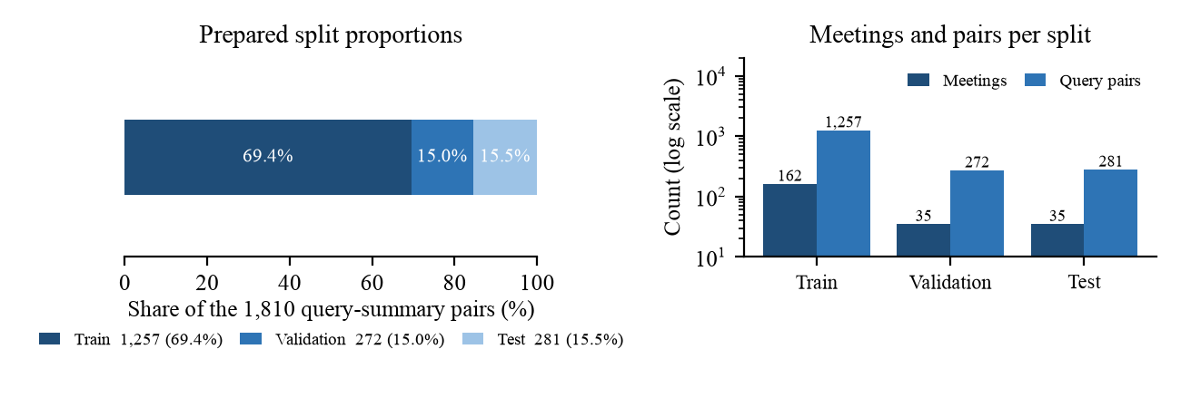
Figure 5. Prepared Model 1 split proportions and the number of meetings and query pairs in each split. Generated from data/splits/m1_v1/MANIFEST.json by docs/reports/generate_t4a5_figures.py.

Samples from the prepared datasets
Split | id | query | context | reference_summary (start)
Train | qmsum_train_145_s1 | Did the Professor agree with Grad G on cross-lingual data? | 17 spans. First: "PhD G: Yeah , and perhaps , um {disfmarker} {pause} We were thinking that perhaps the cross - language issue is not , uh , so big of a issue . ..." | Grad G thought that the multi-lingual aspect of the model was not very important. The professor disagreed. He explained that the point of the project was to have something robust that could apply to many languages.
Validation | qmsum_val_4_s0 | Summarize the presentations on working design, technical functions, functional requirements. | 260 spans. First: "Project Manager: All hooked up . {vocalsound} Okay , so now we are here at the functional design meeting . ..." | Firstly, Industrial Designer presented on working design, identifying a few basic components of the remote. From the functional design perspective, Industrial Designer introduced what exactly the components were ...
Test | qmsum_test_9_s3 | How would the middle layer work? | 8 spans. First: "Grad B: And they wouldn't look pretty . So ." | The values these nodes take feed into the middle layer nodes identified as hidden variables of the user/device interaction, such as whether the user is on tour, running an errand or in a hurry. ...
Table 30. One sample from each prepared split.
Two other prepared sets exist and neither is a training split. The MAST evaluation manifest (data/mast/eval_manifest.json, version 1.0.0, status FROZEN) fixes the 1,638 scorable records and the 19 human-labelled records as evaluation-only references, and records for each which label source it carries, so that agreement with the released judge labels can never be reported as agreement with human experts. MAST has no train split because the baseline is an inference-only judge. The smoke fixtures (data/m1_smoke/fixtures/, 12 train, 3 dev and 3 hold-out examples, split by session_id with seed 13) carry the full product schema including critical facts and evidence event ids; they exist to exercise the pipeline end to end and are barred by their own manifest from ever being used as an evaluation split.
Table 31 shows what a record of the product schema looks like, using one smoke fixture. It carries what QMSum lacks: typed events with actors, gold critical facts with a status category, and the event ids that justify each fact. The annotated product-session split will have exactly this shape.
Field | Value (smoke example smoke-s01-x1, session smoke-s01, 16 events, 5 critical facts)
query | Catch me up on what happened while I was away.
events[11] | {"source_event_id": "smoke-s01-e011", "sequence": 11, "event_type": "tool_result", "actor_id": "agent-beacon", "text": "4 passed, 1 failed: test_large_payload exceeds the 2 s timeout."}
events[12] | {"source_event_id": "smoke-s01-e012", "sequence": 12, "event_type": "agent_step", "actor_id": "agent-beacon", "text": "test_large_payload needs the archive fixture, which only Omar can provision. I cannot continue that test."}
critical_facts[3] | {"fact_id": "smoke-s01-f04", "category": "blocked", "text": "test_large_payload is blocked on the archive fixture", "evidence_event_ids": ["smoke-s01-e011", "smoke-s01-e012"]}
reference.blocked[0] | {"text": "Beacon is blocked on test_large_payload because only Omar can provision the archive fixture.", "source_event_ids": ["smoke-s01-e011", "smoke-s01-e012"]}
Table 31. One smoke-fixture record in the product schema (data/m1_smoke/fixtures/train.jsonl). Scripted, not recorded; never an evaluation split.
The split that will select the Model 1 winner, data/splits/m1_session_v1/, is not prepared yet because the sessions it is made from are not recorded yet. Its rules are already frozen in ADR-005: split by session_id so that no session appears in more than one split, freeze files, critical facts, evidence links and manifest hashes before the first comparative run, and admit synthetic examples to training only.

3.6 Data Statistics
Table 32 summarises what each stage produced. Read down a column and the row counts reconcile: MAST loses exactly the four unscorable records between raw and pre-processed and nothing afterwards, and the 1,810 QMSum queries present in the raw files are the 1,810 rows of the prepared splits.
Stage | Rows | Columns | Notes
Raw | MAST: 1,642 traces (+19 human-labelled)  QMSum: 232 meetings, 129,177 turns | MAST: 6 top-level fields, 14 nested labels  QMSum: 4 fields | Pinned revisions; SHA-256 per file; MAST count equals the paper's 1,642.
Pre-processed | MAST: 1,638 scorable (4 removed)  QMSum: 232 meetings (0 removed) | Unchanged | 56 null label cells preserved, all in the 4 excluded records; 0 invalid labels; 0 duplicate keys.
Transformed | MAST: 1,638  QMSum: 1,810 examples | MAST: 26  QMSum: 4 (7 as m1-input-v1) | MAST flat table with category roll-ups. QMSum: 1,576 specific and 234 general queries.
Prepared | MAST: 1,638 + 19, evaluation only  QMSum: 1,257 / 272 / 281  Smoke: 12 / 3 / 3 | MAST: manifest v1.0.0  QMSum: 4  Smoke: 8 | Frozen and hashed. QMSum grouped by meeting, 0 meetings shared across splits.
Table 32. Data preparation results by stage.

Model 1 supervision: QMSum
Statistic (words unless stated) | Train | Validation | Test
Rows | 1,257 | 272 | 281
Specific / general queries | 1,095 / 162 | 237 / 35 | 244 / 37
Reference summary: median (Q1 to Q3), max | 66 (47 to 90), 238 | 68 (50 to 86), 188 | 59 (43 to 81), 188
Query: median (Q1 to Q3) | 11 (8 to 15) | 10 (7 to 15) | 11 (7 to 15)
Context spans per example: median, 95th percentile, max | 29, 588, 1,832 | 31, 624, 1,259 | 33, 678, 1,368
Context length: median, 95th percentile, max | 660, 10,368, 26,338 | 696, 11,210, 24,573 | 671, 10,280, 25,244
Table 33. Descriptive statistics of the prepared Model 1 splits.
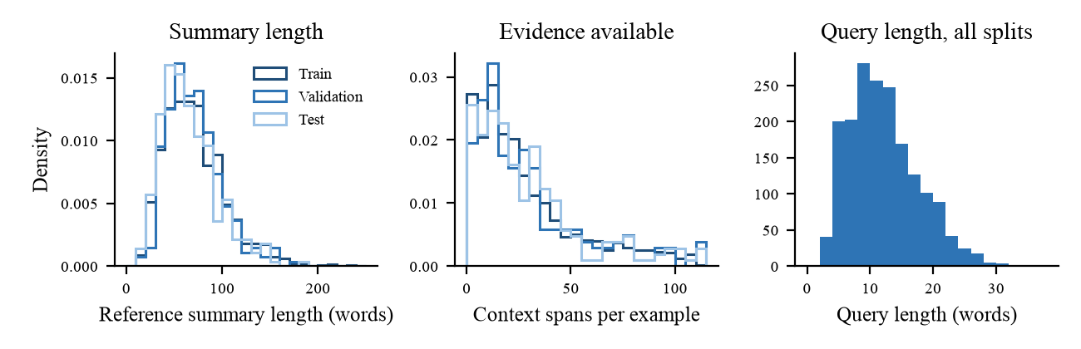
Figure 6. Distributions of reference-summary length, context spans per example and query length in the prepared Model 1 splits. Generated from data/splits/m1_v1/ by docs/reports/generate_t4a5_figures.py.
Three properties of these distributions changed decisions elsewhere in this workbook. Reference summaries are short and tightly clustered, with a median near 65 words, so one omitted fact is a large share of an answer; that is the argument for ranking candidates on critical-fact recall ahead of text overlap in section 4.4. Context size is heavily right-skewed: the median example has about 660 words of context and the 95th percentile more than 10,000, because general queries take the whole meeting as context. A 4,096-token input therefore truncates the long tail, which is why truncated is a named failure code and why latency is committed at the 95th percentile as well as the median. And the three splits sit almost on top of one another in Figure 6, which matters because we inherited the partition instead of stratifying it.

Baseline corpus: MAST
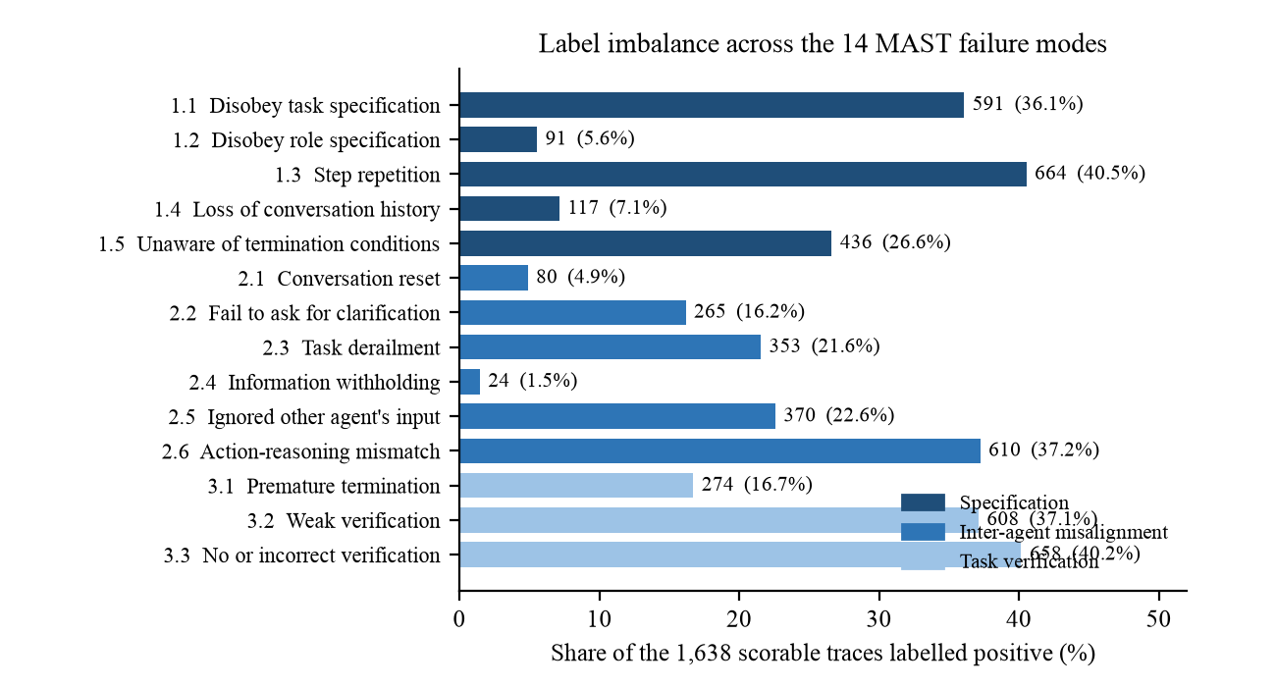
Figure 7. Label imbalance across the 14 MAST failure modes on the 1,638 scorable traces. Generated from mast_clean_summary.csv by docs/reports/generate_t4a6_figures.py.
The labels are imbalanced in two ways (Figure 7). Across failure modes, prevalence ranges from 40.5% for step repetition (1.3) down to 1.5% for information withholding (2.4), which is 664 positive traces against 24, a ratio of about 28 to 1; four modes are positive on fewer than one trace in ten. Within a trace, 401 of the 1,638 traces (24.5%) carry no failure at all and the remaining 1,237 (75.5%) carry between 1 and 14, with a mean of 3.14 and a median of 2 (Figure 8). The consequence for evaluation is direct: with 24 positive examples of mode 2.4, a judge that never predicts it loses almost nothing on accuracy, so the baseline is reported with precision, recall, F1 and Cohen's kappa beside accuracy, as the original paper does.
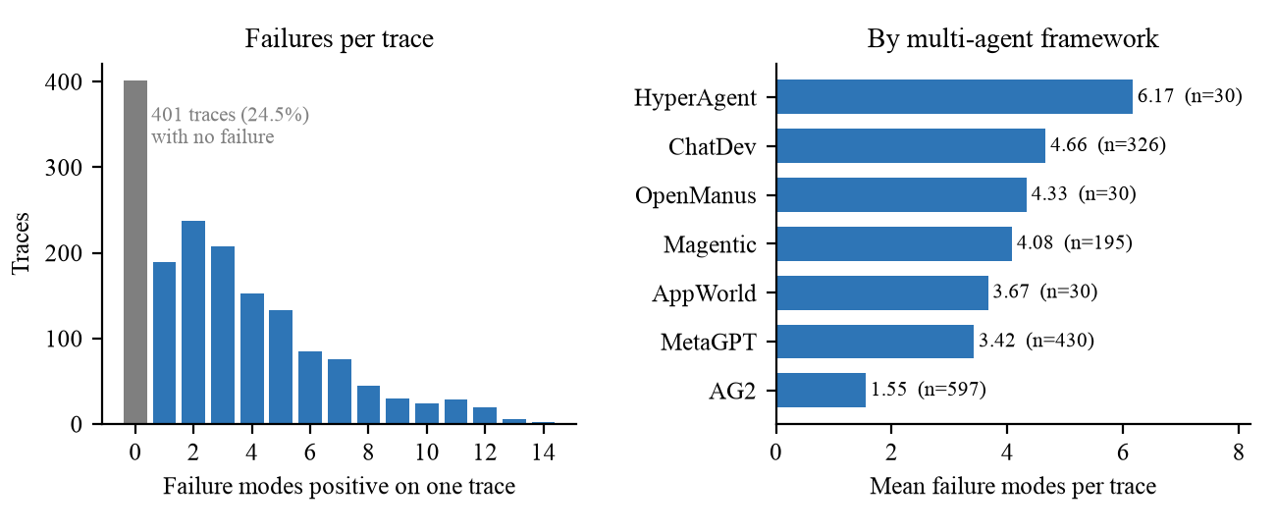
Figure 8. Left: number of failure modes positive on a trace. Right: mean failure modes per trace by multi-agent framework, with the number of scorable traces. Generated by docs/reports/generate_t4a6_figures.py.
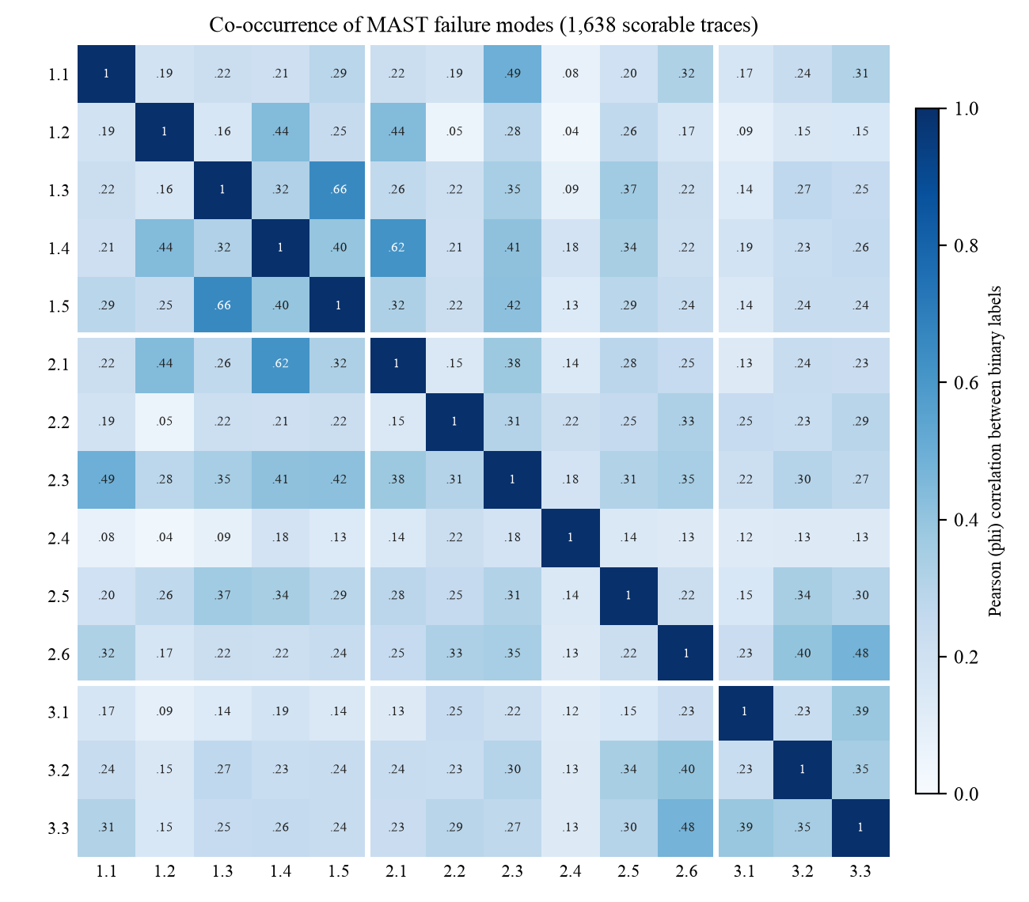
Figure 9. Correlation (phi coefficient) between the 14 binary failure labels. White lines separate the three categories. Generated by docs/reports/generate_t4a6_figures.py.
Failure modes do not occur independently (Figure 9). Every pairwise correlation is positive, between 0.04 and 0.66. The strongest pairs are step repetition with unawareness of termination conditions (1.3 and 1.5, 0.66) and loss of conversation history with conversation reset (1.4 and 2.1, 0.62), the second of which crosses a category boundary; task derailment (2.3) correlates with disobeying the task specification (1.1) at 0.49. Trace length and failure count are also associated (Spearman 0.54): longer traces tend to carry more failure labels, which is an association and not evidence that length causes failure. Two cautions follow. Failure counts per trace must not be read as independent events, and a framework comparison is confounded by trace length and by benchmark: AG2 has the lowest mean failure count (1.55) but was run mostly on short mathematics problems, while HyperAgent has the highest (6.17) on only 30 software traces.

Population and coverage gaps
Gap | Evidence | Who it would disadvantage if the system were deployed | What we do about it
QMSum is English-only meeting speech from three settings: product-design role play, academic research groups, and parliamentary committees. | Source description [2]; samples in Tables 22 and 30. | Teams working in other languages or in mixed-language sessions, and teams whose sessions are terse tool calls and code edits instead of long spoken turns. | QMSum is supervision only and cannot select the winner. Selection uses product sessions (ADR-005).
QMSum has no status categories, owners, or claim-level evidence labels. | Schema in Table 20. | Any user relying on the catch-up to say what is blocked or who owns an action: a model tuned only on QMSum can be fluent and wrong about status. | Safety gates are measured on annotated product sessions; relevance labels derived from QMSum are weak supervision and are never presented as human labels.
MAST is dominated by three frameworks (82.6% of scorable traces) and one model family (GPT-4o, 45.8%); three frameworks have 30 traces each. | Figure 4. | Users of under-represented frameworks: a judge validated mainly on AG2, MetaGPT and ChatDev traces may mislabel failures elsewhere. | Report per-framework results with sample sizes; do not claim the taxonomy transfers to our sessions without our own annotation.
MAST traces contain agents only. No trace has several humans steering one agent. | Paper [3]; Workbook 1, Table 10. | Exactly the teams this project targets, whose failures include conflicting human instructions. | MAST is the baseline and a taxonomy source, not training data for Models 2 to 4.
The human-labelled MAST set has 19 records. | eval_manifest.json. | Anyone reading a reproduced agreement figure as precise. | Report sample size and a 95% confidence interval beside every value.
No product sessions are recorded yet; the first ones will come from the five team members. | data/sessions/raw/ is empty on 11 Nov 2026. | Non-expert users, larger teams, and domains other than software work would be unrepresented in the first corpus. | State the population with every result; widen recruitment only after the IRB question is answered.
Table 34. Population and coverage gaps in the data.

4. Model Development

4.1 Model Proposals
The project proposes four learned models, each of which removes one coordination cost identified in section 2.2.1, and reproduces one published baseline that is deliberately not one of the four. Table 35 lists them. Model 1 is built in DATA 298A and Models 2 to 4 in DATA 298B.
# | Model | Concept / architecture | Built in | Owner
1 | M1 Session-state catch-up | Given the ordered event log of a session and a query, produce a structured catch-up in five categories (completed, in progress, blocked, decisions, pending actions) in which every claim cites the event ids that support it. Four candidates: BM25 extractive, ModernBERT extractive selector, Phi-4-mini with QLoRA, Qwen3.5-4B with QLoRA. | 298A | Ayush
2 | M2 Intent attribution | Classify which participant an instruction addresses. Pairwise scoring of (instruction, candidate participant, recent context). Four candidates: TF-IDF classical control, DeBERTaV3 and ModernBERT cross-encoders, Qwen with a classification head. | 298B | Naman
3 | M3 Merge arbitration | Given two conflicting instructions to one agent, decide accept A, accept B, merge, or escalate to a human. Four candidates: last-writer-wins rule, ModernBERT pairwise cross-encoder, Qwen3.5-4B with LoRA and a four-way head, few-shot prompted Qwen3.5-4B. | 298B | Manav
4 | M4 Decomposition and routing | Decompose a task into a directed acyclic graph of subtasks and route each to a participant or agent. Four candidates: rules-only router, LLM planner with a learned router, LLM planner alone, single-prompt planner and router. | 298B | Shriram
— | Reproduced baseline: MAST LLM-as-a-Judge | Cemri et al., NeurIPS 2025 [3], Table 2, row o1 (few shot): accuracy 0.94, recall 0.77, precision 0.833, F1 0.80, Cohen's kappa 0.77 against expert annotation. Inference only. | 298A | Pramod
Table 35. The four models and the separately listed reproduced baseline.
Each model is developed as a bake-off of four candidates that share frozen data, one input and output contract, one evaluation harness and three seeds (13, 29, 47). A candidate is a configuration file under eval/configs/ that pins the model repository and a full 40-character revision, so a result can be re-run exactly. Counting candidates, the project proposes sixteen model configurations plus the baseline; the architectures named below are candidates under evaluation, not selections.

Model 1: session-state catch-up (298A)
Problem. A participant or agent who joins a session in progress must learn its state without reading the whole history. Input is an m1-input-v1 record: a query and the ordered events of the session, each with a stable event id. Output is an m1-output-v1 record: five lists of claims, where every claim has non-blank text and one or more source_event_ids drawn from the input. Free text is invalid until it parses into that schema. Table 36 gives the four candidates.
ID | Candidate | Architecture and algorithm | Features and training | Role in the comparison
m1-a | BM25 event ranker + fixed template | Okapi BM25 [18] scores each event against the query using term frequency, inverse document frequency and length normalisation; the top-ranked events fill a fixed structured template. No learned parameters, CPU only. | Sparse lexical features over event text. No training; no GPU settings. | Transparent floor. Every claim is a verbatim event, so it sets the matched-seed bar for unsupported claims.
m1-b | ModernBERT-base selector + the same template | ModernBERT-base [15], a 149M-parameter bidirectional encoder with an 8,192-token context, fine-tuned as a relevance scorer over (query, event); selected events fill the same template as m1-a. | Contextual embeddings. Full fine-tuning, 3 epochs, 4,096 tokens, effective batch 16, learning rate 2e-5. Relevance labels are weak labels derived from QMSum. | Learned extractive arm. Isolates what learned relevance adds over BM25 while staying unable to invent text.
m1-c | Phi-4-mini-instruct + QLoRA | Phi-4-mini [19], a 3.8B-parameter decoder-only transformer, quantised to 4-bit NF4 with low-rank adapters (QLoRA [20], LoRA [10]) on the projection layers named in m1-c.yaml; generates the JSON output directly. | Instruction prompt with the event list and ids. 3 epochs, 4,096 tokens, effective batch 16; adapters only are trained and checkpointed. | Compact generative family. Tests whether abstraction improves coverage at a size that fits a 16 GB GPU.
m1-d | Qwen3.5-4B + QLoRA | Qwen3.5-4B [21], a 4B-parameter model that ADR-005 records as loading through a conditional-generation class, 4-bit NF4 with LoRA rank 16, alpha 32, dropout 0.05, learning rate 2e-4; generates the JSON output directly. | Same prompt, data and limits as m1-c. A separate trainer path, because this architecture must not pass through the causal-LM-only trainer. | Larger generative family. Tests whether more capacity buys recall without raising unsupported claims.
Table 36. The four Model 1 candidates frozen in ADR-005 and eval/configs/m1-a.yaml to m1-d.yaml.

What is new in Model 1
Three elements of Model 1 go beyond the published systems surveyed in section 1.5. First, the output is evidence-cited by construction: a claim without a valid source event id is not a low-scoring answer, it is an invalid one. Query-focused summarisers such as the QMSum baseline [2] return free text that a reader cannot check. Second, selection is safety-gated before it is quality-ranked: a candidate that is fluent but unsupported on any one seed is ineligible, however good its mean. Third, the model can use approved memory, a versioned list of human-approved behavioural lessons that may change how it writes but can never serve as evidence for a session fact; the selected candidate is measured with memory disabled and enabled, and test feedback is barred from entering memory.

Models 2 to 4 (298B)
Table 37 gives the candidates for the three models built in DATA 298B. In each, candidate (a) is a control with no learned language model, so that the learned arms have something concrete to beat. The Model 3 configurations are already committed as eval/configs/m3-a.yaml to m3-d.yaml; those for Models 2 and 4 follow the same schema and are written at the start of 298B. Training data for all three comes from the annotated product-session corpus.
Model | Input features and output | (a) Control | (b) | (c) | (d)
M2 intent attribution | Instruction text, explicit mentions, each participant's role and recent activity. Output: one score per participant present; the highest is the addressee. | TF-IDF features with a linear classifier | DeBERTaV3 [11] cross-encoder over (instruction, participant context) | ModernBERT [15] cross-encoder, same input | Qwen backbone with a classification head
M3 merge arbitration | Two conflicting instructions, their authors and roles, timing, and document state. Output: accept A, accept B, merge, or escalate. | Last-writer-wins rule | ModernBERT-base pairwise cross-encoder, fine-tuned | Qwen3.5-4B with LoRA and a four-way head | Few-shot prompted Qwen3.5-4B, no training
M4 decomposition and routing | Task text, participant skills, current workload and cost. Output: a directed acyclic graph of subtasks, each assigned to a participant or agent. | Rules-only router | LLM planner with a learned gradient-boosted router | LLM planner that also routes | Single-prompt planner and router
Table 37. Candidates for Models 2 to 4.
Three design points distinguish these models. Model 2 is framed as pairwise ranking instead of multi-class classification because the set of participants changes from session to session, and a model that scores one (instruction, participant) pair at a time works for any roster. Model 3 treats escalation as a first-class output, so the model can abstain when a wrong merge would be harmful; last-writer-wins is what every current product does implicitly and is therefore the arm to beat. Model 4 rejects any plan that is not a valid directed acyclic graph before a quality metric is computed, because an invalid plan cannot be executed.

The reproduced baseline
The baseline is the LLM-as-a-Judge annotation pipeline of MAST [3]: a language model reads an execution trace, the 14 failure-mode definitions and few-shot examples, and emits 14 binary labels. We reproduce the configuration in Table 2 of the paper, row o1 (few shot). It is kept apart from the four models for a reason: it is the external reference point that tells us whether our prompt, parser, batch runner and metric code can recover a published number, and none of our models is claimed to improve on it. The prompt (mast-judge-v1), deterministic parser (mast-parser-v1.1), resumable batch runner, provenance record and classification metrics are on the main branch.

4.2 Model Supports
Figure 10 shows the supporting platform in four planes, and Table 38 lists the environment and tools behind each model. One rule holds across the diagram: components owned by different people communicate through a network call or a committed file format, never through shared process memory, which is what lets five people build in parallel against frozen contracts.
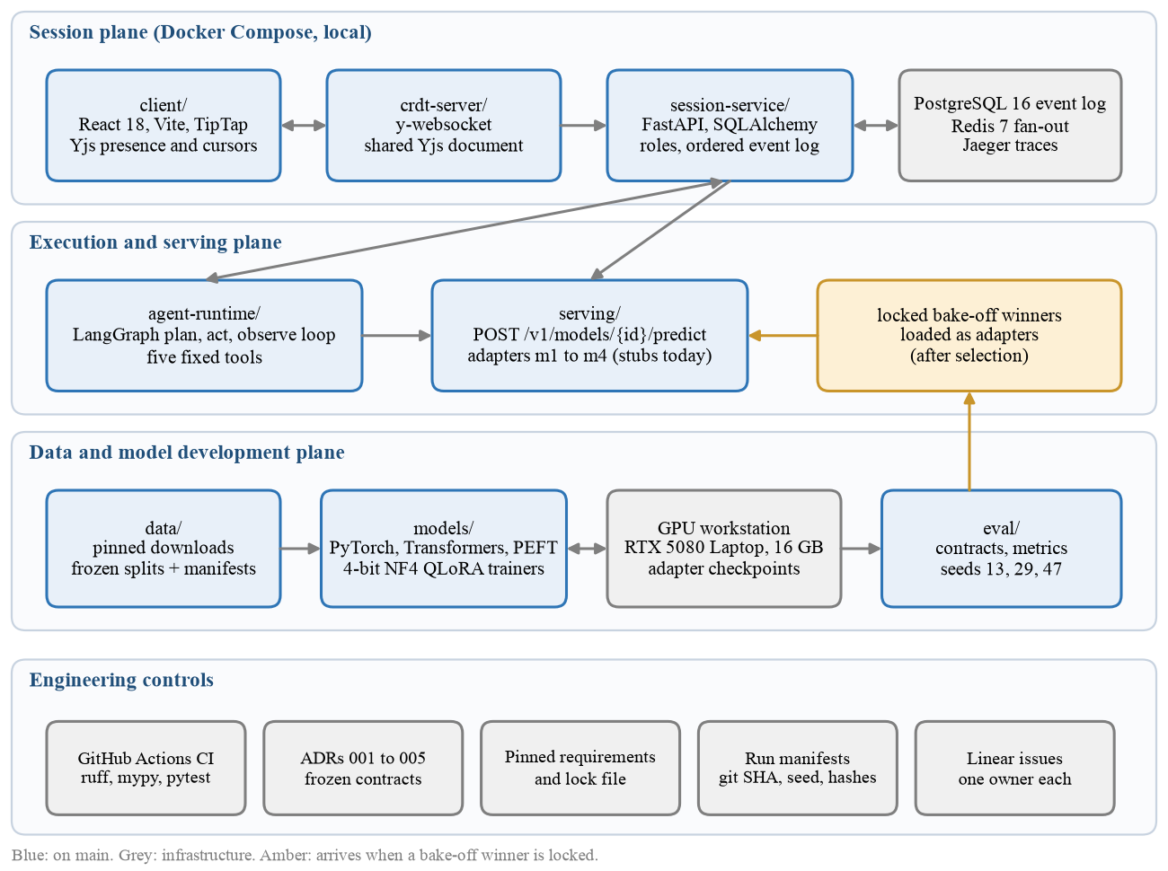
Figure 10. Supporting platform architecture: session plane, execution and serving plane, data and model development plane, and the engineering controls that apply to all of them. Generated by docs/reports/generate_t4a6_figures.py.
Model | Development environment | Libraries and tools | Execution and serving
M1 catch-up | Python 3.11 locally and in CI; training on one RTX 5080 Laptop GPU (16 GB) in the university lab at $0, PyTorch with CUDA. | Transformers, PEFT, bitsandbytes 4-bit NF4, the BM25 ranker in models/m1_catchup/bm25.py (DAT-58, in review), shared checkpoint utility models/common/checkpointing.py. | Winner loaded behind POST /v1/models/m1/predict; called by the session service on join and hand-off.
M2 attribution | Same GPU and harness. | Transformers encoders, scikit-learn for the TF-IDF control. | POST /v1/models/m2/predict, called per instruction event.
M3 arbitration | Same GPU and harness; the rule arm needs no GPU. | Transformers, PEFT; configurations already in eval/configs/m3-*.yaml. | POST /v1/models/m3/predict, called when the control plane detects a conflict.
M4 routing | Same GPU for the planner arms (Qwen or Gemma family); CPU for the rules arm and the learned router. | LangGraph [13] for plan execution, LightGBM for the learned router. | POST /v1/models/m4/predict, called by the agent runtime.
MAST baseline | No GPU. API inference with the paper's o1 few-shot configuration. | models/baseline_mast/: prompt, parser, resumable batch runner, provenance; eval/metrics/classification.py. | Offline batch; results as immutable run directories.
All models | GitHub Actions on every pull request: ruff, mypy, pytest for the session service, serving, data, evaluation and the baseline. | Pinned requirements.txt with a lock file; ADR-001 to ADR-005; candidate YAML with pinned model revisions. | Docker Compose: PostgreSQL 16, Redis 7, Jaeger, session service, serving.
Table 38. Platform, environment and tools supporting each model.
The session plane is what produces our own data. The React client edits a shared Yjs document through the CRDT server, and every action that matters is posted to the session service, a FastAPI application that enforces roles and appends a totally ordered SessionEvent to PostgreSQL, an event-sourced log from which state is derived by replay [23], with Redis fanning events out to connected clients. The agent runtime is a LangGraph plan, act, observe loop restricted to five fixed tools. The serving layer exposes one predict route per model; today the four adapters are stubs that honour the frozen interface, and each is replaced by a real model only when its bake-off winner is locked.
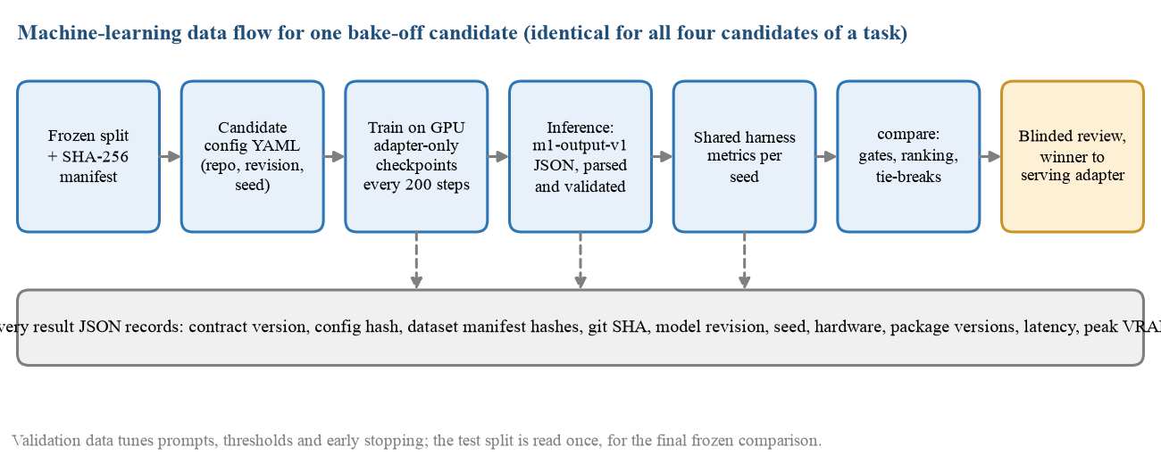
Figure 11. Machine-learning data flow for one bake-off candidate, from frozen split to serving adapter. Generated by docs/reports/generate_t4a6_figures.py.
Figure 11 traces one candidate through the model plane. Training is adapter-only and writes a checkpoint every 200 steps through one shared utility (local paths today; object-store URIs in pull request #32), so an interrupted lab session costs at most the work since the last checkpoint. The GPU path itself has been exercised: an earlier 50-step QLoRA run on a 1.7B-parameter Qwen3 model loaded in 4-bit NF4, checkpointed, resumed and reduced training loss from 3.90 to 2.14 (docs/verification/m1_verification/). That run is infrastructure evidence only. The model is not one of the four candidates and the loss is not a result. The same check for each real candidate (load at the pinned revision, memory at 4,096 tokens, checkpoint, resume, share of outputs that parse) is in progress on branch m1-candidate-train-infer and is required by ADR-005 before the bake-off.

Why the platform is local, and why there is no workflow scheduler
We were asked to consider Amazon Web Services and Apache Airflow [22] for the data pipeline. We evaluated both against what the pipeline actually has to do and chose not to adopt either in DATA 298A. Table 39 records the reasoning, because a tool that is declined should be declined for stated reasons.
Question | What our workload looks like | Decision
Is anything scheduled? | No. Both public datasets are static, pinned to a commit and verified by digest. They do not change, so there is no daily or hourly run, no backfill and no late-arriving data. The pipeline runs when a person changes it. | A scheduler would be idle. The pipeline is one idempotent command, and the events that should trigger it are code changes, which GitHub Actions already handles.
Is the dependency graph complex? | Four stages in a straight line: ingest, clean and validate, transform, quality gates. No branching, no fan-out, no cross-team dependencies. | A fixed ordered list with fail-fast in infra/warehouse/pipeline.py expresses it completely. Each stage is a plain function, so wrapping each in an Airflow task later is a mechanical change.
Do we lack monitoring without Airflow? | Every run appends per-stage start time, duration, rows in, rows out, status and git commit to meta.pipeline_runs, and every gate to meta.quality_checks. | Run history and data-quality results are queryable in SQL and reported by pipeline.py --report. That is the monitoring we need at this size.
Is the data too large for one machine? | About 220 MB raw in total. The analytical tables are a few thousand rows. | DuckDB [24] on a laptop runs the whole pipeline in about 6 seconds and answers the analytical queries interactively. A cloud warehouse would add cost, credentials and network latency and no capability.
Do we need cloud compute? | Training needs one 16 GB GPU, which the university lab provides at $0. The baseline is API inference. | No cloud GPU. This was already the decision in Workbook 1, section 2.3.
Why not a lightweight scheduler, such as Airflow run locally or a scheduled GitHub Actions job? | Airflow run locally still needs a metadata database, a scheduler process and a web server to execute four functions in order on data that never changes. A scheduled CI job is nearly free, but there is nothing new for it to ingest. | Not yet. The cheapest scheduler that fits is a scheduled GitHub Actions job, and that is what we will add first when ingestion becomes recurring; Airflow follows only if the graph grows branches or backfills.
Who is told when the pipeline breaks? | The pipeline's tests run in GitHub Actions on every pull request, and a failed stage or gate exits non-zero. | A failure is a red check on the pull request and an email to its author. Monitoring is therefore passive between changes, which is acceptable only because the data does not change between changes.
Does it help reproducibility? | A grader or teammate can clone the repository and run the whole pipeline with two commands and no account. | Local-first is the more reproducible choice. A cloud dependency would make the pipeline unverifiable by anyone without our credentials.
Table 39. Evaluation of a cloud platform and a workflow scheduler against the actual workload.
The decision is scoped, not permanent, and the design keeps the door open. The checkpoint utility is being extended to accept s3:// URIs (pull request #32), so adapter checkpoints can move to object storage without touching a trainer. The pipeline layers map one to one onto managed services: raw files to object storage, the stage functions to scheduled tasks, and the warehouse schemas to a cloud warehouse. Two conditions would change the decision, and both are expected in DATA 298B. The first is recurring ingestion: once product sessions are recorded more often than weekly, a nightly export from the PostgreSQL event log to the warehouse becomes a real schedule with a freshness requirement, and a scheduler earns its place. That export is the one ingestion path the warehouse does not have yet, because no session exists to export. The second is the first participant outside the team: the controlled study in DATA 298B needs the platform reachable beyond the team, which is when the cloud deployment promised as FR-8 is due.

4.3 Model Comparison and Justification
Table 40 compares the four models and the baseline; Table 41 compares the four Model 1 candidates, which is the comparison that will actually be run this semester.
Model | Targeted problem | Input features | Approach | Strengths | Limitations
M1 catch-up | Late joiner cannot cheaply learn session state | Ordered event text, event ids, query | Statistics (BM25), deep learning (encoder; QLoRA generators) | Every claim is checkable against cited events; safety-gated selection | Needs annotated sessions to select; long sessions exceed 4,096 tokens
M2 attribution | Unclear whom an instruction addresses | Instruction text, mentions, roles, recent activity | Machine learning (TF-IDF + linear), deep learning (cross-encoders) | Cheap per-event inference; per-class F1 exposes weak classes | Bounded by annotator agreement on what an instruction meant
M3 arbitration | Two actors redirect one agent at once | Both instructions, authors and roles, timing, document state | Rule (last-writer-wins), deep learning (cross-encoder, LoRA, few-shot) | Can escalate instead of guessing; rule control is trivial to audit | Conflicts are rare, so data is scarce and partly synthetic
M4 routing | Subtasks assigned by availability alone | Task text, participant skills, workload, cost | Rules, LLM planning, gradient-boosted router | DAG-validity gate stops malformed plans early | Plans are costly to label; planner quality is sensitive to the prompt
MAST baseline | Do we measure failures correctly? | Trace text, 14 definitions, few-shot examples | Prompted LLM judge, no training | Published target to hit; inference only | 19 human-labelled traces limit precision of any agreement figure
Table 40. Comparison of the four models and the baseline.
 | m1-a BM25 | m1-b ModernBERT | m1-c Phi-4-mini QLoRA | m1-d Qwen3.5-4B QLoRA
Approach | Statistical retrieval | Deep learning, extractive | Deep learning, generative | Deep learning, generative
Trainable parameters | None | All (149M) | LoRA adapters only | LoRA adapters only (r = 16)
Hardware | CPU | GPU, small | GPU, 4-bit, fits 16 GB | GPU, 4-bit, fits 16 GB
Can invent a claim? | No. Output is verbatim events | No. Output is verbatim events | Yes | Yes
Can rephrase and merge events? | No | No | Yes | Yes
Assigns status categories | By template rule | By template rule | Learned | Learned
Expected strength | Cannot emit an unsupported claim; no GPU; fully explainable | Better relevance than lexical match when wording differs | Concise, readable state at low memory cost | Highest capacity for recall and status reasoning
Expected limitation | Misses paraphrase; verbose; status only as good as the template | Weak labels from QMSum; cannot summarise across events | May emit invalid JSON or unsupported claims | Slowest and largest; same generative risks
Justification | The floor every learned arm must beat, and the matched-seed reference for the unsupported-claim gate | Separates the value of learning from the value of generation | Tests generation at the smallest credible size | Tests whether capacity, not architecture, is the limit
Table 41. Comparison of the four Model 1 candidates.
The justification for the matrix as a whole is that each neighbouring pair of candidates isolates one question. From m1-a to m1-b the template is held fixed and only the ranker changes, so any difference is the value of learned relevance. From m1-b to m1-c the model stops copying and starts writing, so any difference is the value, and the risk, of generation. From m1-c to m1-d the method is held fixed and capacity changes. A comparison built from unrelated models could tell us which one scored highest but not why. The same logic justifies the controls in Models 2 to 4: a learned arbitration model is only interesting if it produces fewer harmful outcomes than last-writer-wins, and a learned router only if it beats rules.
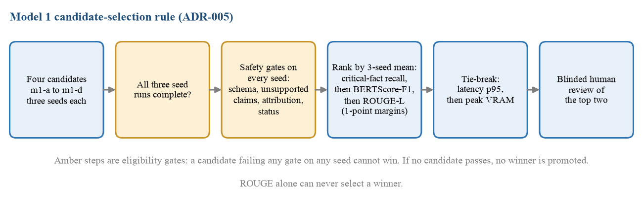
Figure 12. The Model 1 candidate-selection rule frozen in ADR-005. Generated by docs/reports/generate_t4a6_figures.py.

Preferred model, and when it would lose
No winner exists and none is claimed. Our working preference, stated before any comparative result so that it can be held against us, is a generative QLoRA candidate, m1-c or m1-d, because a catch-up has to merge several events into one statement of state and assign it a status, and an extractive template cannot do either. That preference would lose to the extractive candidates under four conditions, all of which the selection rule in Figure 12 enforces.
• If a generative candidate exceeds 2% unsupported claims, or is worse than m1-a on unsupported claims for the same seed, on any one of the three seeds. It is then ineligible and its quality scores are irrelevant. An extractive candidate cannot fail this gate by construction.
• If it falls below 98% schema-valid outputs, 95% attribution accuracy or 95% status consistency on any seed.
• If its critical-fact recall is within 0.01 of an extractive candidate's. The tie then passes to BERTScore-F1 and ROUGE-L, and after those to latency at the 95th percentile and peak memory, where BM25 on a CPU wins.
• If the product-session corpus turns out to be small. With few training sessions the weakly supervised and parameter-free arms have less to lose than a generator that must learn the status categories.
If no candidate passes every gate, ADR-005 requires us to report that no model is promotable and to keep the extractive control in service while the failures are corrected. Between m1-c and m1-d we hold no preference; m1-d would lose to m1-c whenever their recall is within the margin, because the smaller model is faster.

4.4 Model Evaluation Methods
All metrics are computed in one place, the shared evaluation layer under eval/, so that no model reports a number through its own code path. Each learned candidate is run with three seeds (13, 29 and 47). Results are reported as the per-seed values, their mean, and a 95% confidence interval; predictions are never pooled across seeds before a metric is computed, and the contract requires eligibility gates to hold on every seed individually so that one unsafe seed cannot be hidden by two good ones. With three seeds the interval has two degrees of freedom and is wide by construction; it describes seed-to-seed variation, not sampling error over test examples, which is why the per-seed values are always shown beside it. Each result file records the contract version, configuration hash, dataset manifest hashes, git commit, model revision, seed, hardware and package versions.
The metrics in Table 42 are committed here, before any comparative result exists. As of 11 November 2026 no Model 1 candidate has been scored on a test split and no baseline agreement figure has been computed. The Model 1 definitions are machine-readable in eval/configs/m1-contract.yaml, and ADR-005 states that the definitions and the winner policy cannot change after test results are seen without a new contract version.
Metric | Why this metric | Benchmark or split it is measured on | Committed on
M1 critical-fact recall (primary) | A catch-up that omits the blocker has failed, however fluent. Counts gold critical facts that are covered by a claim supported by its cited events. | Annotated product-session test split (session_test) | 22 Oct 2026 (ADR-005); merged 11 Nov 2026
M1 unsupported-claim rate (gate: at most 0.02, and no worse than m1-a) | Measures invention: claims not supported by the events they cite, over emitted claims. | session_test, every seed | 22 Oct 2026 (ADR-005)
M1 attribution accuracy (gate: at least 0.95) | A correct fact citing the wrong event cannot be verified by the reader. | session_test, every seed | 22 Oct 2026 (ADR-005)
M1 status consistency (gate: at least 0.95) | Reporting blocked work as completed is the most damaging single error. | session_test, every seed | 22 Oct 2026 (ADR-005)
M1 schema-valid rate (gate: at least 0.98) | An output that does not parse cannot be shown or scored. | session_test, every seed | 22 Oct 2026 (ADR-005)
M1 BERTScore-F1 [26] | Semantic similarity that tolerates paraphrase. Pinned: roberta-large, layer 17, no IDF, no rescaling. | session_test for ranking; QMSum test reported separately | 22 Oct 2026 (ADR-005)
M1 ROUGE-L, with ROUGE-1 and ROUGE-2 [25] | Lexical overlap, comparable with published QMSum figures. Macro F1 under convention m1_rouge_macro_v1. | QMSum test (281 rows) and session_test | 22 Oct 2026 (ADR-004)
M1 latency p50 and p95, peak VRAM | A catch-up is read at the moment of joining. Tail latency is set by the long-context minority (section 3.6). | Same examples, after warm-up, on the recorded GPU | 22 Oct 2026 (ADR-005)
M1 human edit rate | Token edits a reviewer needs to make an output acceptable: the cost a user actually pays. | Blinded review of the top two candidates | 22 Oct 2026 (ADR-005)
M1 training and validation loss | Convergence and early-stopping signal only. Never used to compare candidates. | QMSum train and validation | 11 Nov 2026 (this workbook)
M2 macro-F1, with per-class F1 | Classes are imbalanced, and accuracy would hide a class that is never predicted. | Held-out session-level test split | 7 Oct 2026 (Workbook 1)
M3 macro-F1; harmful-merge rate; escalation precision and recall | A wrong merge is worse than an escalation, so harm is measured directly and compared with last-writer-wins. | Held-out conflict cases | 8 Oct 2026 (m3-*.yaml)
M4 DAG validity (gate); routing accuracy; completion; latency; cost | An invalid plan cannot be executed, so validity gates everything else. | Held-out routing test split | 7 Oct 2026 (Workbook 1)
Baseline accuracy, precision, recall, F1, Cohen's kappa [27] | The five figures the paper reports, at the same scale: 0.94, 0.833, 0.77, 0.80, 0.77. Kappa corrects for chance agreement under imbalance. | 19 human-labelled MAST traces, with sample size and 95% CI | 7 Oct 2026 (Workbook 1; mast_binary_label_cells_v1)
Baseline agreement with released judge labels | Pipeline fidelity at scale. Not a reproduction of the human-agreement result and never reported as one. | 1,638 scorable MAST traces | 7 Oct 2026 (Workbook 1)
Table 42. Evaluation metrics committed before results.
Three choices in that table depart from common practice and are argued for here. ROUGE-L is not the primary metric for Model 1, although it is the metric named on the topic slide and the one Workbook 1 selected on. The reason is in the data: reference summaries are about 65 words long, and a summary can score well on overlap while omitting the one blocker that mattered or assigning an action to the wrong person. ROUGE-L and BERTScore-F1 are still reported and still used for ranking, but only after the safety gates and only to separate candidates that are tied on recall. Second, a candidate that emits no claims does not earn a perfect safety score: it fails recall, and its attribution accuracy, which would otherwise be undefined at zero claims, is recorded as zero by contract convention. Third, results on QMSum are reported separately and cannot select the winner, because QMSum contains none of the labels the gates need.
Evaluation ends with two further steps for every model. An ablation varies the context budget (512, 1,024 and 2,048 tokens) and, for Model 1, approved memory on and off. And every failure is assigned one of seven frozen failure codes (invalid schema, missing critical fact, unsupported claim, wrong attribution, wrong status, generic output, truncated), which feeds the categorised failure analysis required by AI-8.

4.5 First Model Implementation

4.6 Baseline Reproduction

References
References [1] to [17] are listed in Workbook 1 and keep their numbers. The sources introduced in sections 3 and 4 are added below.
[18] S. Robertson and H. Zaragoza, "The probabilistic relevance framework: BM25 and beyond," Found. Trends Inf. Retr., vol. 3, no. 4, pp. 333-389, 2009.
[19] Microsoft, "Phi-4-mini technical report: Compact yet powerful multimodal language models via mixture-of-LoRAs," arXiv:2503.01743, 2025. [Online]. Available: https://arxiv.org/abs/2503.01743.
[20] T. Dettmers, A. Pagnoni, A. Holtzman, and L. Zettlemoyer, "QLoRA: Efficient finetuning of quantized LLMs," in Advances in Neural Information Processing Systems 36, 2023.
[21] Qwen Team, "Qwen3.5-4B," Hugging Face model card. [Online]. Available: https://huggingface.co/Qwen/Qwen3.5-4B. [Accessed: Nov. 11, 2026].
[22] Apache Software Foundation, "Apache Airflow documentation." [Online]. Available: https://airflow.apache.org/docs/. [Accessed: Nov. 11, 2026].
[23] M. Kleppmann, Designing Data-Intensive Applications. Sebastopol, CA, USA: O'Reilly Media, 2017.
[24] M. Raasveldt and H. Muhleisen, "DuckDB: An embeddable analytical database," in Proc. ACM SIGMOD Int. Conf. Manage. Data, 2019, pp. 1981-1984.
[25] C.-Y. Lin, "ROUGE: A package for automatic evaluation of summaries," in Text Summarization Branches Out: Proc. ACL-04 Workshop, 2004, pp. 74-81.
[26] T. Zhang, V. Kishore, F. Wu, K. Q. Weinberger, and Y. Artzi, "BERTScore: Evaluating text generation with BERT," in Proc. Int. Conf. Learn. Representations (ICLR), 2020.
[27] J. Cohen, "A coefficient of agreement for nominal scales," Educ. Psychol. Meas., vol. 20, no. 1, pp. 37-46, 1960.

Submission checklist (not part of the report)
Check | Yes / No
Every section above is written as report prose, not as notes | Yes
Splits are fixed, version-controlled, and the leakage check is reported | Yes for Model 1 supervision: data/splits/m1_v1/, commit 330603f; Table 29. The product-session split is not yet prepared (section 3.5).
Metrics were committed before any results existed | Yes. ADR-004, ADR-005; Table 42
Four models named, with the reproduced baseline listed separately | Yes. Table 35
Every claim links to a commit, run, dataset version or Linear issue | Yes for every count, split, metric and decision (docs/reports/t4a6_data_facts.json at commit fbb3fdf; ADRs; pull requests). Interpretive statements are argued in the prose.
Each section names the team member who wrote it | Yes. Title page

Self-assessment and gap register
Report section | Our rating | If below good: what is missing | Owner | Lands by
3.1 to 3.6 | Good | Not below good, but not excellent: the product-session corpus that selects the Model 1 winner has no recorded sessions, so sections 3.2 to 3.5 describe it as planned. | Naman | 2 Dec 2026
4.1 to 4.4 | Good | Not below good. Models 2 and 4 have no committed configuration files yet; their candidates are described from Workbook 1. | Naman, Shriram | 298B, cycle 1
References | Excellent |  | Pramod

Carry-forward from Workbook 1
Item | Why it did not land, or what changed | Owner | New target
Model 1 candidate matrix (sections 1.1, 1.4; Tables 1 and 8) | Changed. Workbook 1 named an extractive ModernBERT control with Qwen and Gemma LoRA generators. ADR-005 freezes BM25, ModernBERT-base, Phi-4-mini with QLoRA and Qwen3.5-4B with QLoRA, adding a parameter-free floor and replacing Gemma. | Ayush, Pramod | Done, 11 Nov 2026
Model 1 selection metric (sections 1.1, 1.2 AI-3, 2.2.2) | Changed. Workbook 1 selected on validation ROUGE-L under a factuality guardrail. Selection now applies per-seed safety gates and then ranks on critical-fact recall, BERTScore-F1 and ROUGE-L, on annotated product sessions. ROUGE-L is still reported on QMSum test against 28.2, the published QMSum BART score used as a reference floor in Workbook 1, but it no longer selects. | Pramod | Done, 11 Nov 2026
QMSum size (DR-1; Table 9) | Corrected. Workbook 1 quoted the published 1,808 query-summary pairs. The pinned release yields 1,810, and the splits are built from those. | Naman | Done
Pilot session corpus (DR-2, DR-3) | Not landed. No session has been recorded, because the end-to-end integration gate has not been passed. The risk-register trigger of fewer than five sessions by late October has fired; the documented fallback of internal sessions plus scripted cases is in effect, and 18 scripted smoke examples exist (DAT-53). | Naman | First sessions by 2 Dec 2026
Harness runs one candidate end to end (Progress Report 1) | Not landed. The shared Model 1 harness is in review (DAT-61); review found the comparison step applying gates to the three-seed mean instead of each seed, which must be corrected before merge. | Pramod | 18 Nov 2026
Model 1 bake-off and winner (AI-3) | At risk. Training and inference paths and GPU feasibility are in progress, but ADR-005 forbids a selection run until the annotated product-session split is frozen. The final report will carry either the winner or the documented shortfall. | Ayush | 7 Dec 2026
MAST judge environment and final runs (DAT-25, DAT-26, DAT-27, DAT-36) | Not landed. Prompt, parser, batch runner, provenance and metrics are on main; the pinned o1 judge environment and the clean-environment smoke test are open. | Ayush, Shriram | 2 Dec 2026
Cloud deployment (FR-8; Table 16) | Deferred. The prototype runs locally under Docker Compose and no cloud cost has been incurred. Deployment is needed when participants outside the team join, which is the 298B controlled study (section 4.2). | Ayush | 298B
Branch protection (DAT-10) | Not landed. Reviews are enforced by convention, not by a repository rule. | Ayush | 18 Nov 2026

