**Food Mood Analysis**

**(Minor Project Report)**

By

Urvi Bhanushali

Roll No: 2016140005

Harsh Dave

Roll No:2016140010

Ayush Ghanekar

Roll No: 2016140015

Supervisor

Kailas.K.Devadkar

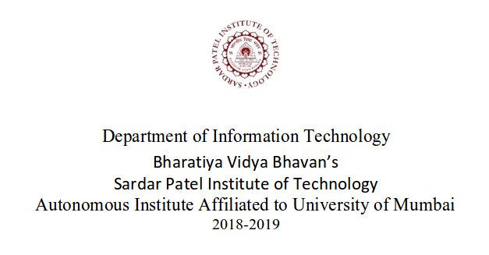

**Abstract**

Are you constantly plagued by daily decisions of what to eat? And, do you live just by yourself where you have no one to cook for you? You sit with your phone and open a food app and see hundreds of option and you cant decide which leads to multiple thoughts, frustration and maybe you end up ordering food that was not the best choice for you. What if, you have an all-time companion who will suggest you food items based on a lot of parameters including knowing the emotions and sentiments of the person? Hence, the FoMos (Food Moods) app is a high power analyzing engine used to suggest relevant food items which contain certain nutritional contents that are required to stabilize the emotions of humans. The key result is basically giving a customer caring experience.

Contents

1. Introduction 1

1.1. Motivation 1

1.2. Problem Statement 9

1.3. Challenges 10

1.4. Objectives 10

1.5. Outcomes 10

2. Literature Survey

3. Planning 12

3.1. Project Scope

3.2. Project Milestones

3.3. Project Timeline

4. Design 12

4.1. System Architecture

5. Implementation 18

5.1. Technologies Used 18

5.2. Prototype Implementation 29

5.3. Test Cases for Prototype 30

5.4. Plagiarism Report** 30

6. References 32

1. **Introduction**

**1.1 Motivation**

Are you constantly plagued by daily decisions of what to eat? And, do you live just by yourself where you have no one to cook for you? You sit with your phone and open a food app and see hundreds of option and you can’t decide which leads to multiple thoughts, frustration and maybe you end up ordering food that was not the best choice for you.

What if, you have an all-time companion who will suggest you food items based on a lot of parameters including knowing the emotions and sentiments of the person?

Hence, the FoMos (Food Moods) app is a high power analyzing engine used to suggest relevant food items which contain certain nutritional contents that are required to stabilize the emotions of humans. The key result is basically giving a customer caring experience.

**1.2 Problem Statement**

Studies show that the average person makes around 250 decisions about food every day breakfast or no breakfast? Pop-tart or bagel? Part of it or all of it? Kitchen or car? Yet out of these 200+ food decisions, most we cannot really explain.

The key to getting a handle on food is to become aware of the series of choices you make each and every day. Food is considered to be the most important elements of not only survival but also the mentally or emotional stability of humans.

It is proven that there is a high correlation between the food and the mood. The mood changes indicate nothing but the want of certain nutritional contents that would stabilize our emotions. We face this dilemma of what we should eat a lot.

**1.3 Challenges**

This problem either gets solved by the person taking the same food item again or if he is suggested a food item by someone else which is a challenge because the person makes the decision because he/she wants to get done with it and doesn’t want to put efforts because they are hungry.

Challenge is that sometimes the mood that you are in craves for a particular nutrient(s) that your body needs, however people like us are unaware about this biological aspect and hence they don’t bother about it.

**1.4 Objectives**

Finally, in a harried and hurried world, a lot of our poor food choices really boil down to poor planning. You can’t eat healthy food if there’s no healthy food in the house. And waiting until you are half-starved to start thinking about what you are going to eat doesn’t tend to lead to great decision making, either. Deciding when and what you are going eat (and taking steps to procure and prepare it ahead of time can make a huge difference in how well you eat.

Hence the objective of the application is the help customer get involved more in the fact of what they should eat and why.

It gives a detailed nutritional value information to create personalized awareness in the person’s body.

Moreover it does a computer vision analytics to find out the emotion of the person so that the nutritional needs can be defined.

* 1. **Outcomes**

The FoMos (Food Moods) app is a high power analyzing engine used to suggest relevant food items which contain certain nutritional contents that are required to stabilize the emotions of humans. The key result is basically giving a customer caring experience.

This dilemma could be removed by someone who could sense and analyze you and your emotions and based on that suggest you delicious and your favorite food items that only take care of the dilemma issue.

**Literature Survey**

**1) Title of Paper**

Food and Mood: Just-in-Time Support for Emotional Eating (<https://www.microsoft.com/en-us/research/wp-content/uploads/2016/10/foodandmood_final.pdf>)

**2) Authors**

1. Erin A. Carroll
2. Mary Czerwinski, Asta Roseway,
3. M.c. schraefel

**3) When it was published?**

2016

**4) Where was it published?**

United States of America

**5) Which type of paper is it?**

Research paper

**6) How is it related to your project?**

This paper is quite relevant to our topic as both talk about the relationship between food and mood. We talk about how different moods can affect the food you should be eating. The paper is related because ultimately we are talking about the same concept of emotional eating. The only difference between the both is that we plan to detect the emotions and sentiments based on the software CV mechanism and we plan to incorporate a lot of related things to this small application as well. The paper just talks emotional detection using a hardware detection

**7) A Brief Summary of what you understood after reading the paper**

The paper basically talks about the fact that behavior modification in health is difficult, as habitual behaviors are extremely well-learned, by definition. This research is focused on building a persuasive system for behavior modification around emotional eating. In this paper, we make strides towards building a just-in-time support system for emotional eating in three user studies. The first two studies involved participants using a custom mobile phone application for tracking emotions, food, and receiving interventions. The paper found lots of individual differences in emotional eating behaviors and that most participants wanted personalized interventions, rather than a pre-determined intervention.

Finally, they also designed a novel, wearable sensor system for detecting emotions using a machine learning approach. This system consisted of physiological sensors which were placed into women’s brassieres. We tested the sensing system and found positive results for emotion detection in this mobile, wearable system.

**3. Planning**

**3.1. Project Scope**

The app handles instant care of what the user should consume based on certain factors like emotions and sentiments. However as a future scope, integrating this app with a healthy me kind of an app would make the entire purpose of leading a healthy and a planned and known life in terms of food complete. Basically instead of just tracking each food transaction independently, incorporating the historical data to guide the user that he/she should watch out on certain things as its not good for health. Moreover we can integrate this app with the fine dine restaurants as Book a table.

What this can do is give insights to the restaurants as people coming to this restaurant generally come with so and so emotions and sentiments. So the restaurant can use this personalized information about the customers to know that their overall popularity is rising or falling and they can also get to know the kinds of people coming to the restaurants. Finally this entire idea is capable of creating and integrating four different business, all in one. Self FoMos app business, business from the apps like Swiggy, Zomato and foodpanda (who are the online ordering platforms), business from the healthify me kind of apps and business with the fine dine restaurants via book a table.

Since the mood and emotions that carry can define the food that we should consume, this App can help a lot of people with that one question of ”what should we have ?” and the user’s can benefit from the suggestion as it indirectly takes care of the health of the person and prevents them from making irrational decisions. Thus the FoMos app.

**3.2. Project Milestones**

There are three different milestones to the project.

The first one is the use the Computer vision mechanism to detect, process and display the emotions the face.

The second one is to create a research based database of what are the basic elemental needs in different emotions.

The third is to apply these elements to an API that would suggest different food items and home-made recipe.

The fourth is to create a User Interface to display all the

**3.3. Project Timeline**

The project will take an overall of 2 months to develop with initial 3 weeks going into determining the project requirements and making UML diagrams that are essential in actualizing the project. Post that, another 1 week to procure all the required hardware components and sensors required for analysis. Finally, one month goes into calibrating the camera and coding in python to make sure the data is being passed correctly then being processed systematically. Thus, the project requires 2 months for completion.

**4. Design**

**4.1. System Design and working**

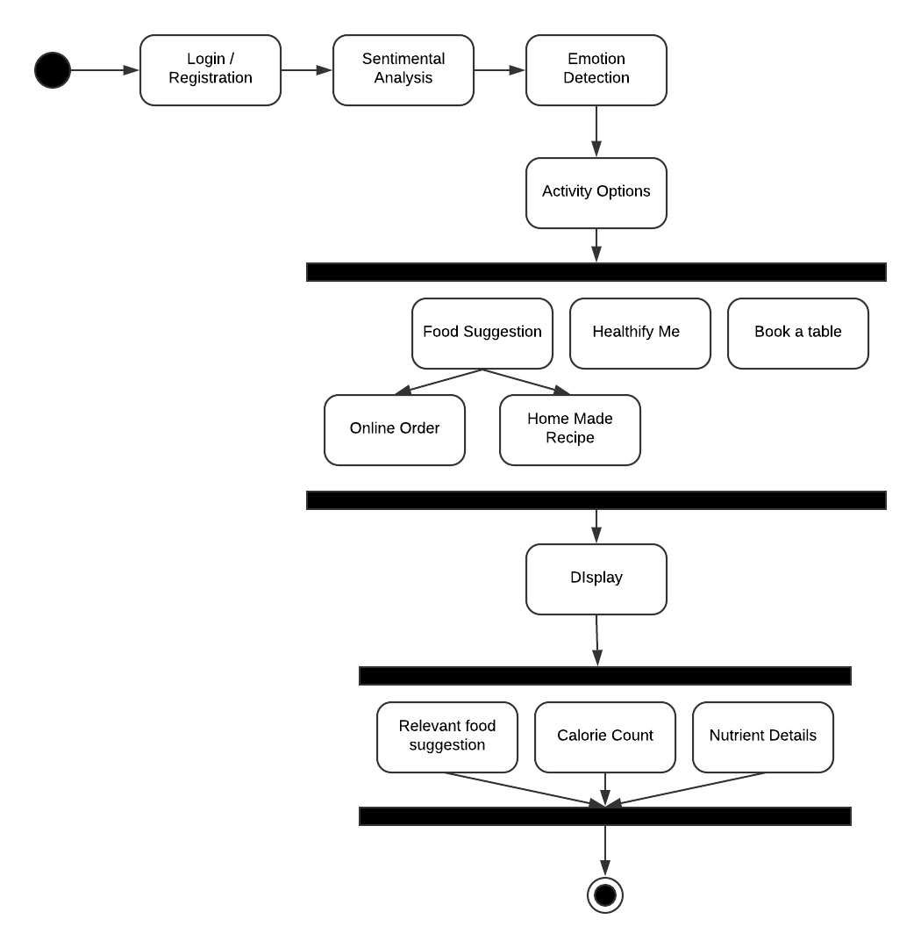

5. Implementation

5.1. Technologies Used

* Django
* Html
* CSS
* Bootstrap
* Computer Vision
* Python Tensor flow
* SQLite3
* Firebase
* API

5.2. Prototype Implementation

1. Emotion detection

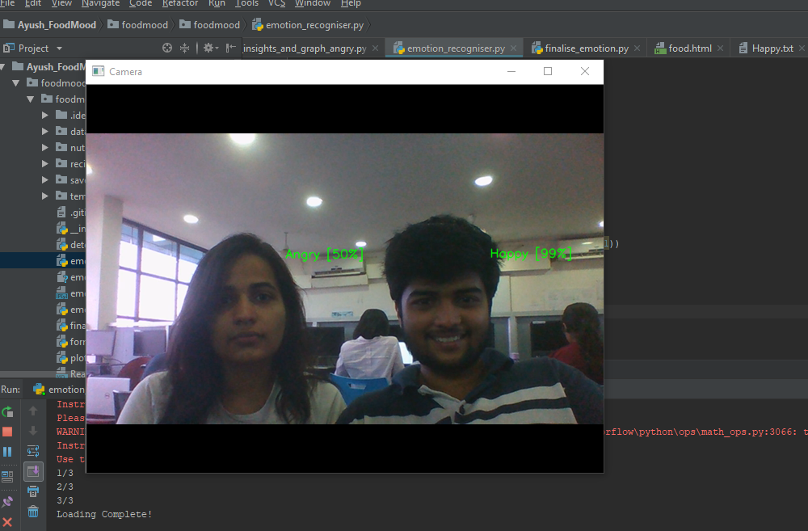

1. Elemental food Database

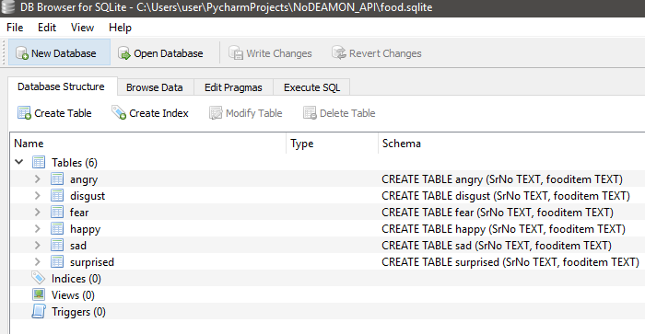

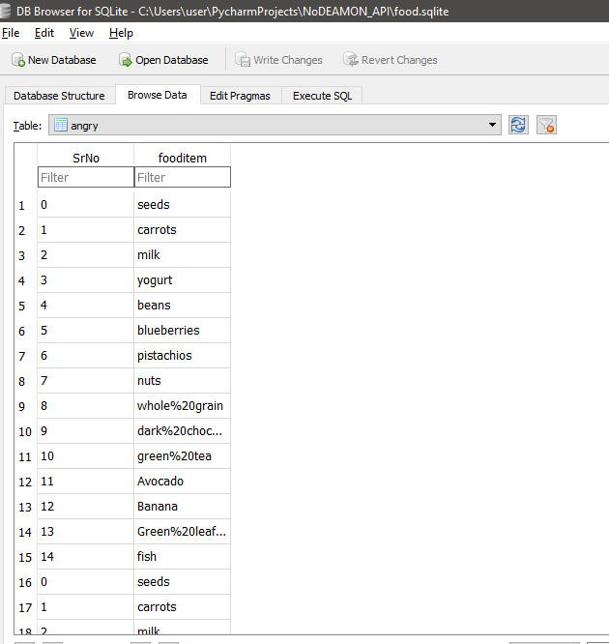

1. Food Recipe API

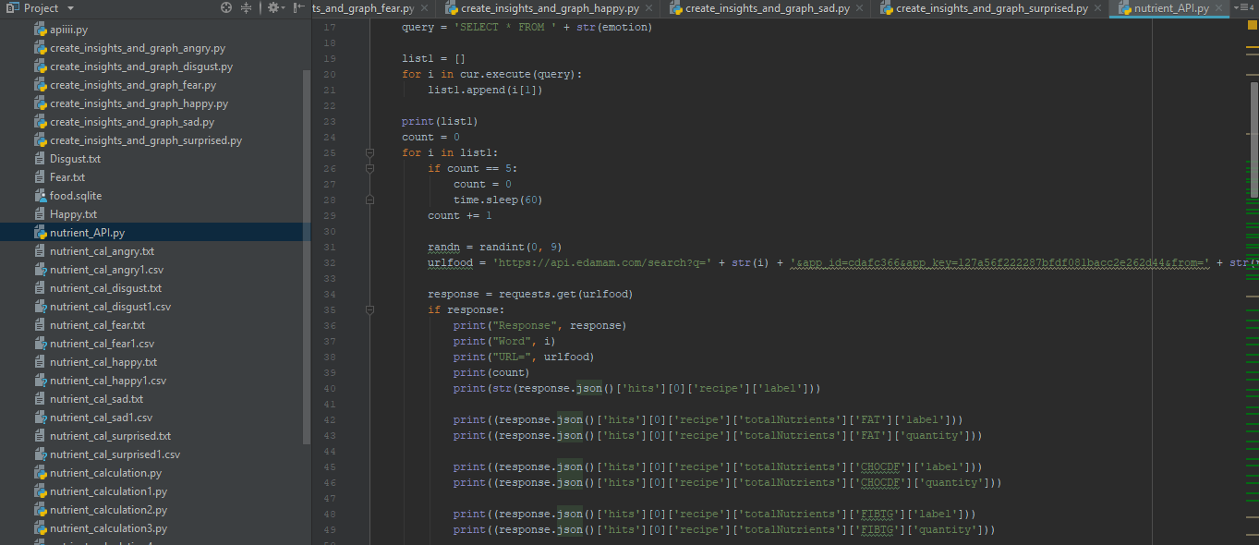

1. Nutrient Gap in the body insight

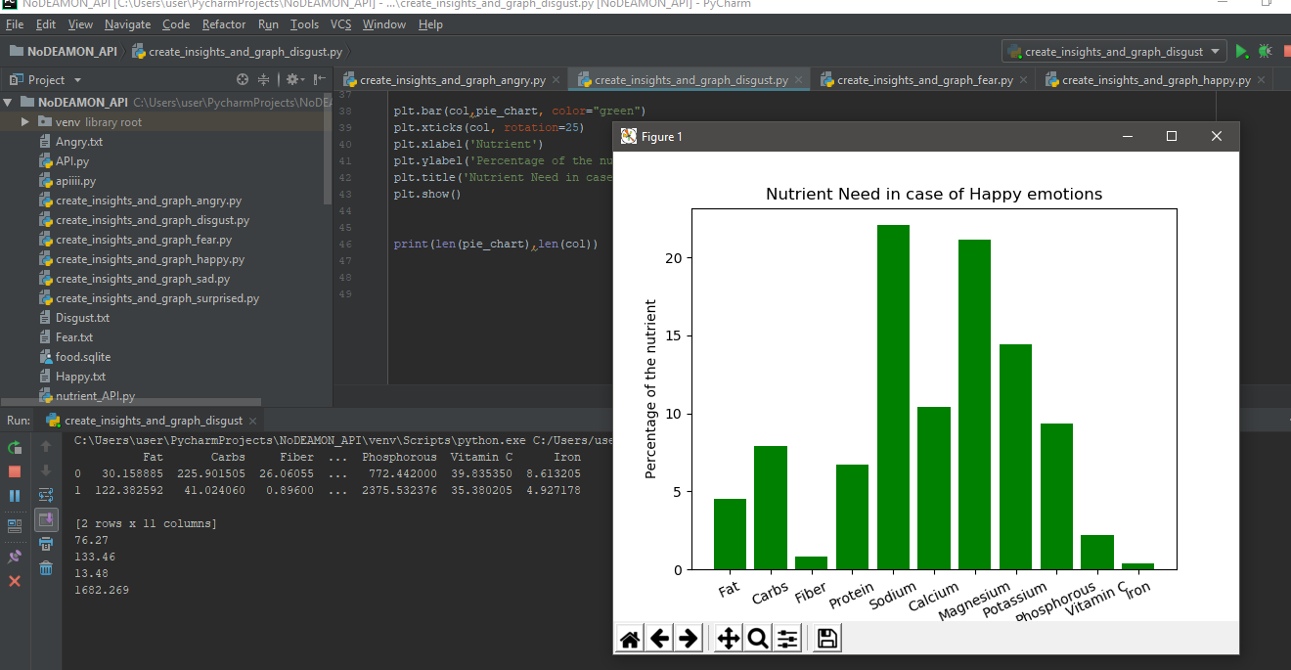

1. User Interface of the food suggestion engine

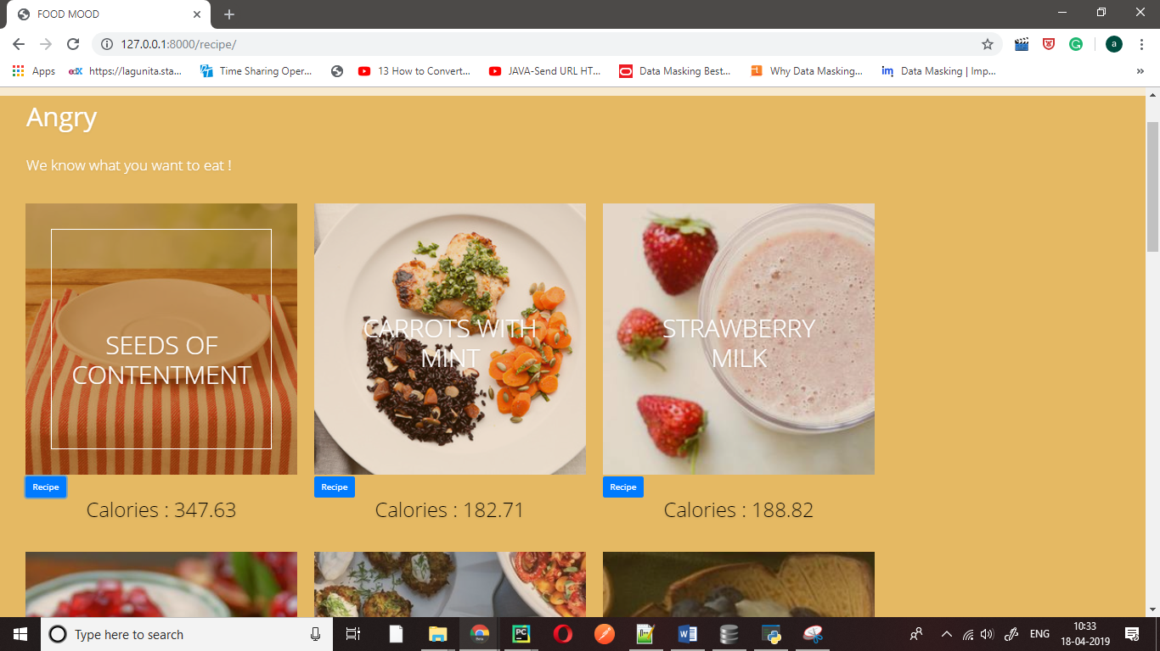

References:

[1] https://www.ncbi.nlm.nih.gov/pmc/articles/PMC6002740/

[2] <https://www.vumc.org/health-wellness/news-resource-articles/feedingyour-feelings-how-emotions-affect-eating-habits>

[3] https://anxietyexit.com/mood-affects-food-choices/